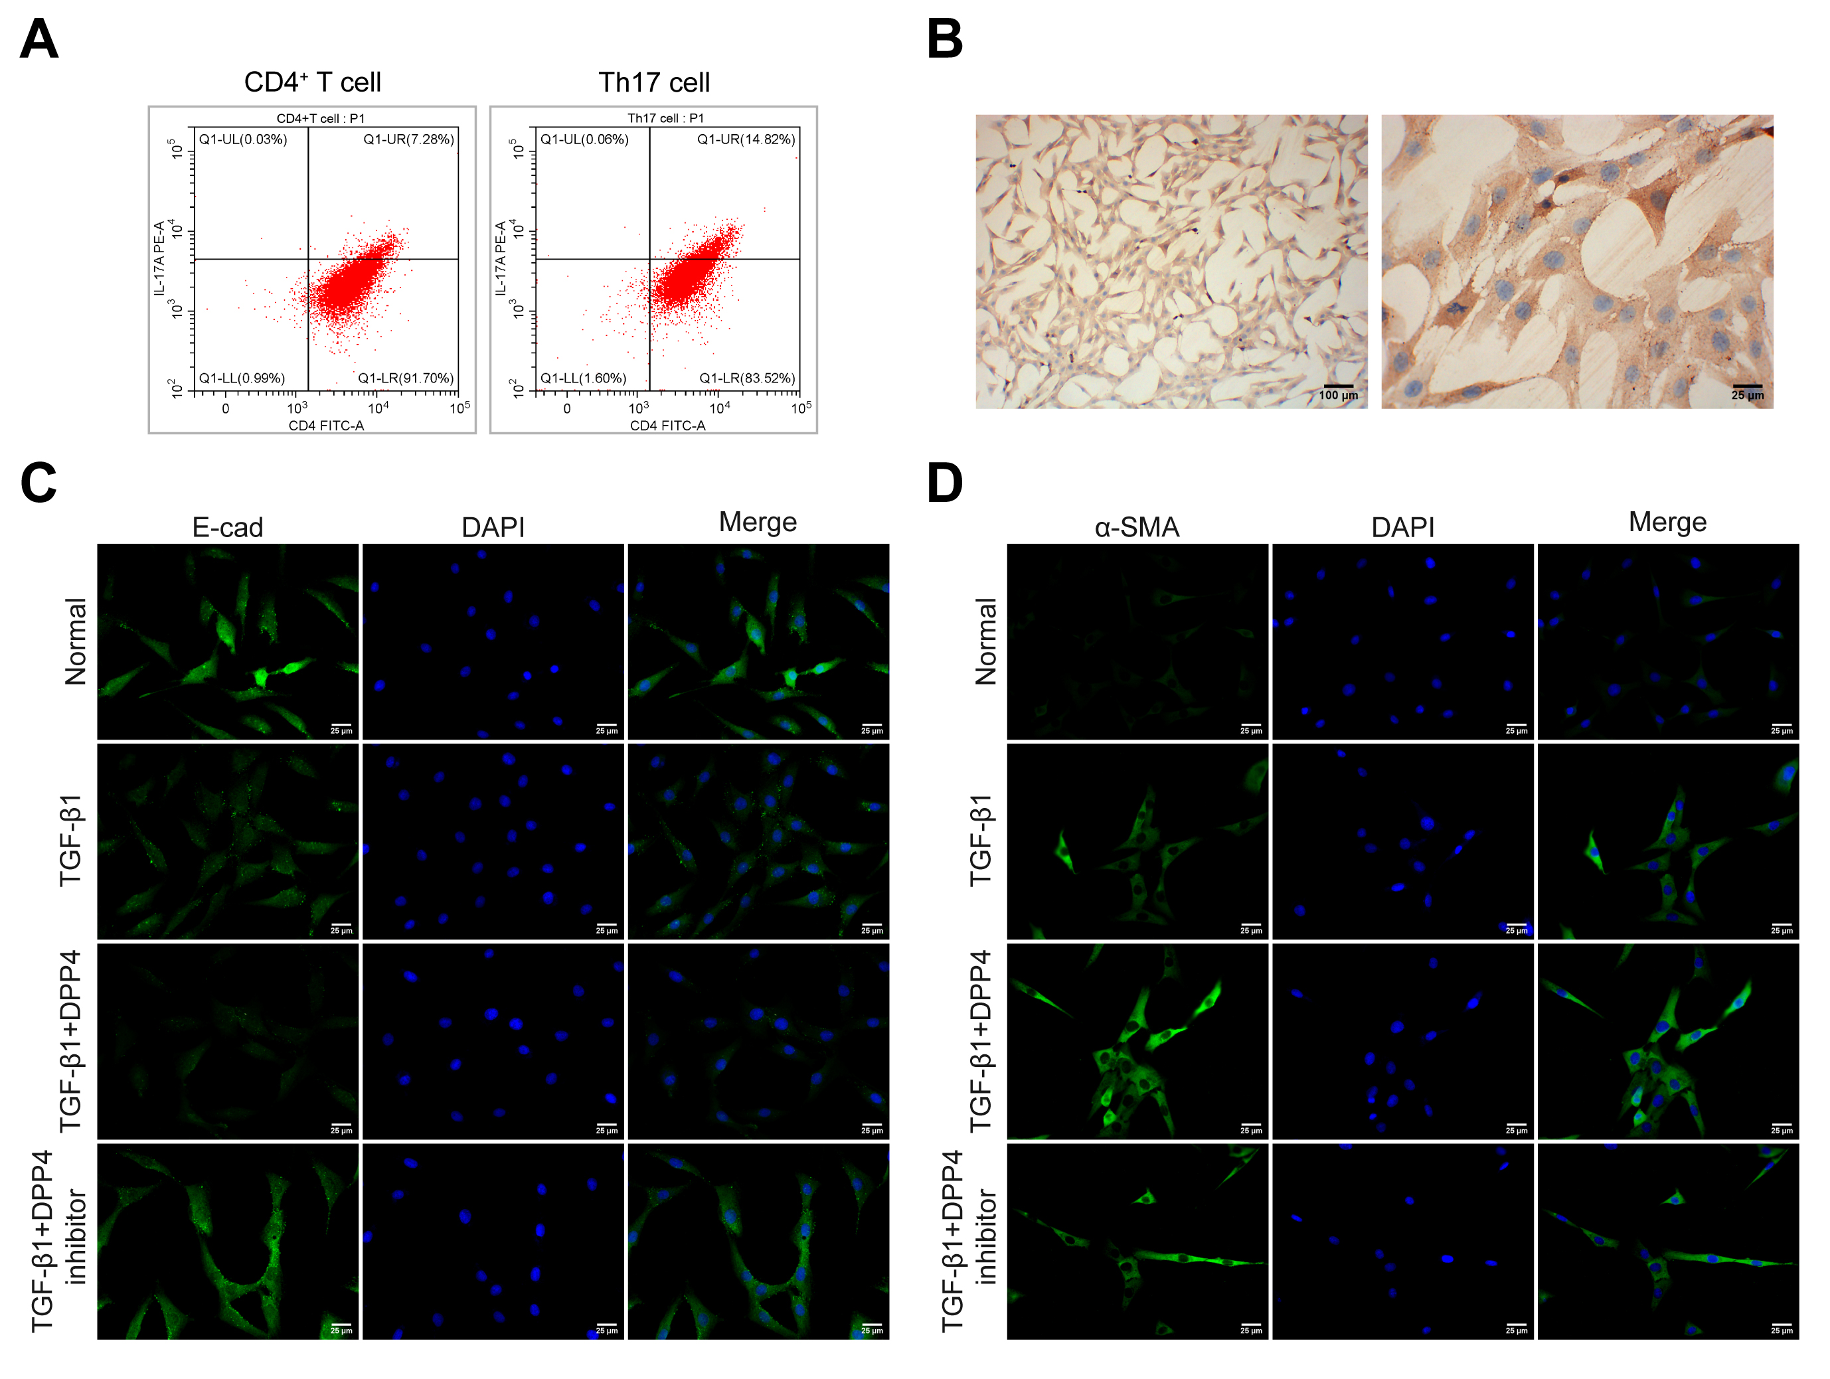Supplementary Fig. 1. (A) The ratio of CD4⁺ T cells and Th17 cells was detected by flow cytometry. (B) The expression of KRT8 in BECs was assessed by ICC. The picture on left was magnified for 100 times, while the picture on right was magnified for 400 times. (C,D) The expression of E-cad and α-SMA expression in BECs treated with sCD26/sDPP4 or DPP4 inhibitor was analyzed by IF. The pictures were magnified for 400 times. E-cad, E-cadherin.

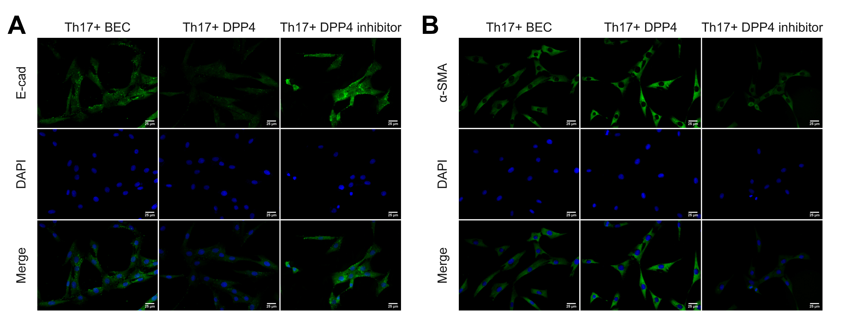
Supplementary Fig. 2. (A,B) The E-cad and α-SMA expression in BECs co-cultured with Th17 at the ratio of 1:10 and treated with sCD26/sDPP4 or DPP4 inhibitor was evaluated by IF. The pictures were magnified for 400 times. E-cad, E-cadherin.

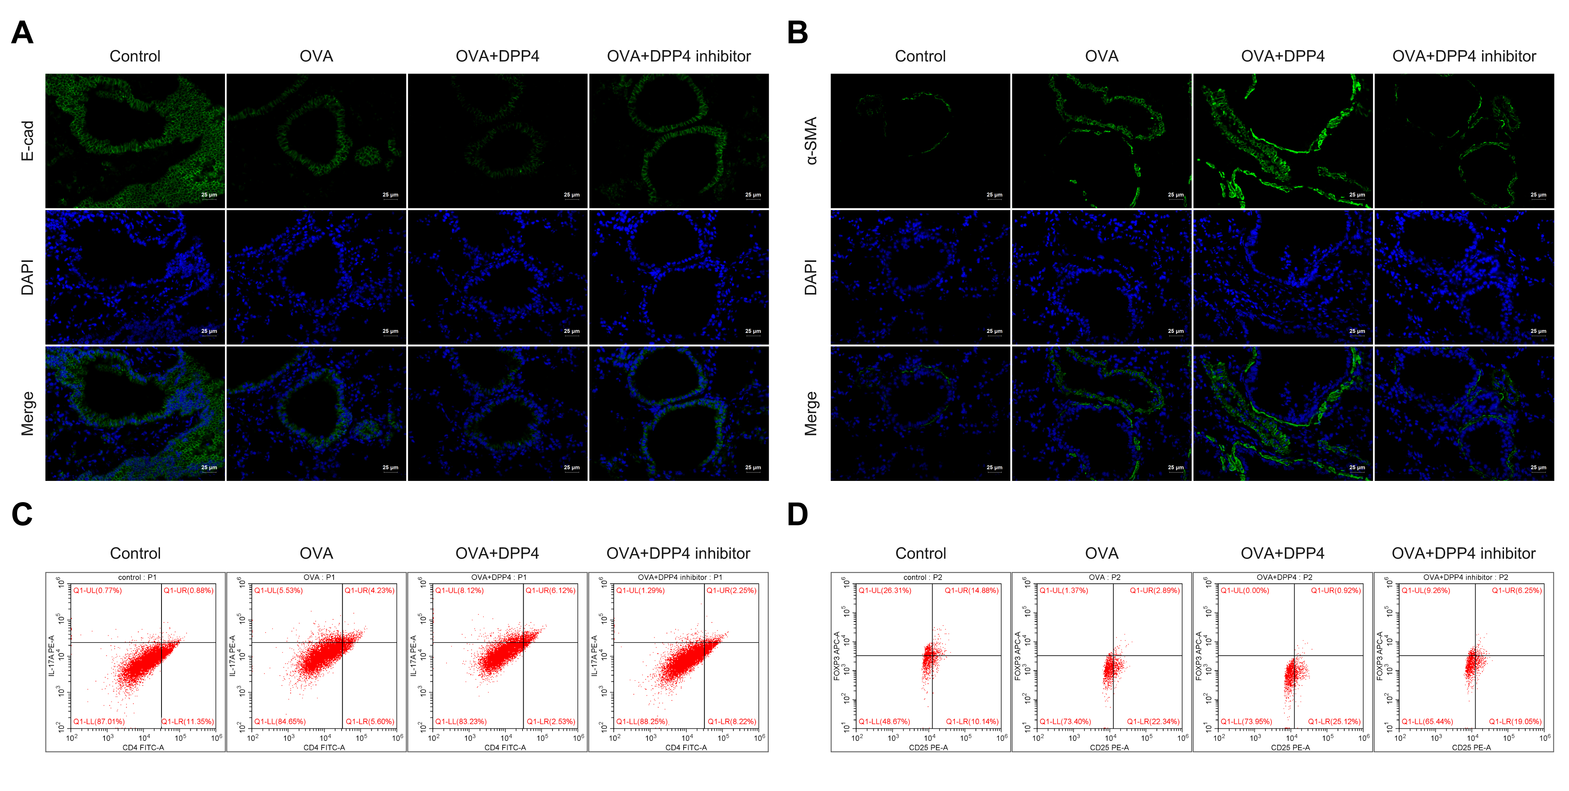
Supplementary Fig. 3. (A,B) The E-cad and α-SMA expression in lungs-bronchi of mice was measured by IF. The pictures were magnified for 400 times. (C,D) The ratio of Th17 and Treg cells in the airways of mice was detected by flow cytometry. E-cad, E-cadherin.

