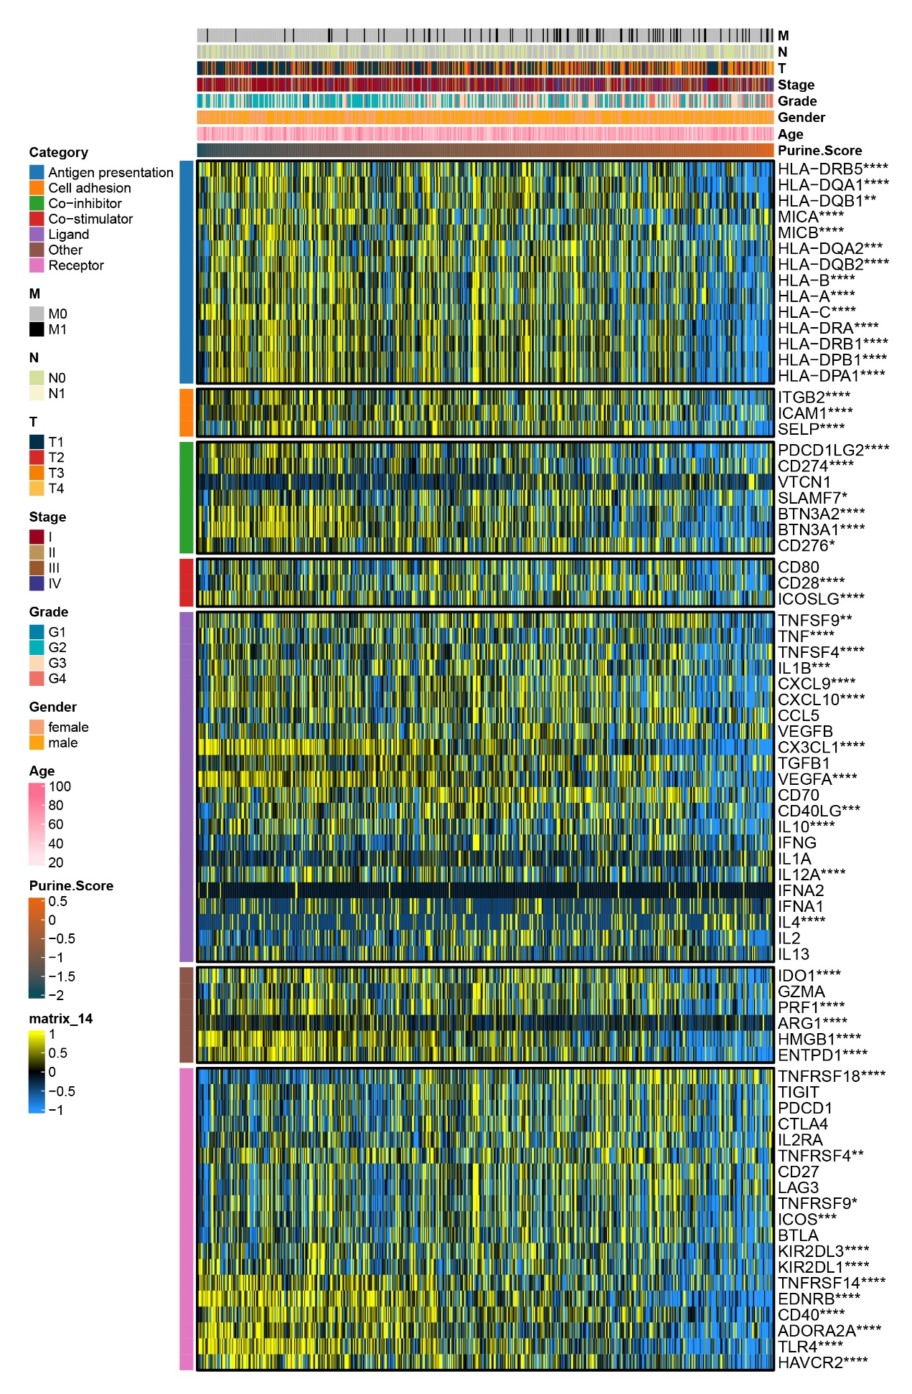
Supplementary Fig. 1. Analysis of immune checkpoints.
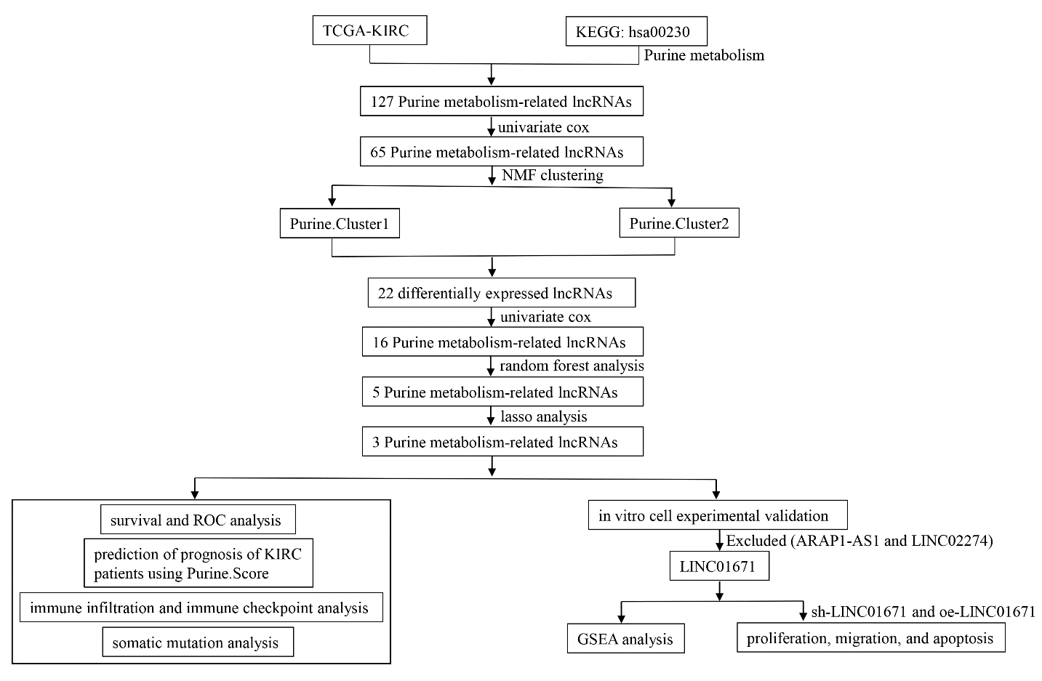
Supplementary Fig. 2. Study flow chart.

