Supplementary Figure 1. IC50 of juglone in breast and colorectal cancer cells
(A) | 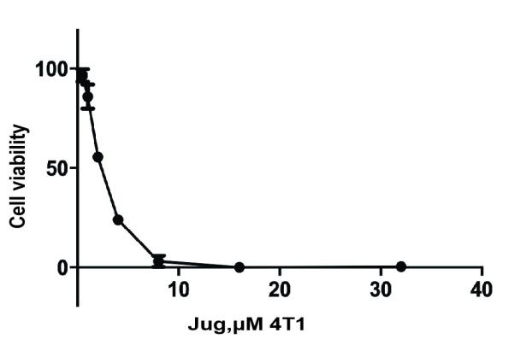 | 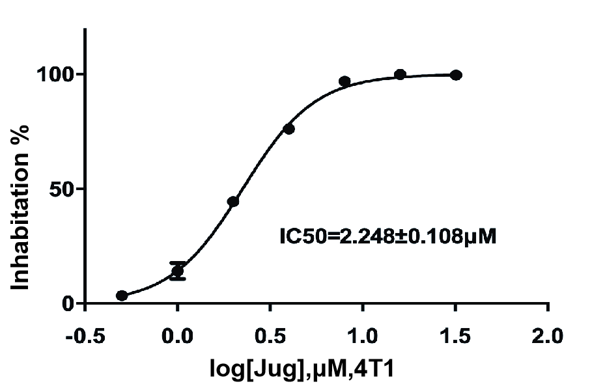
(B) | 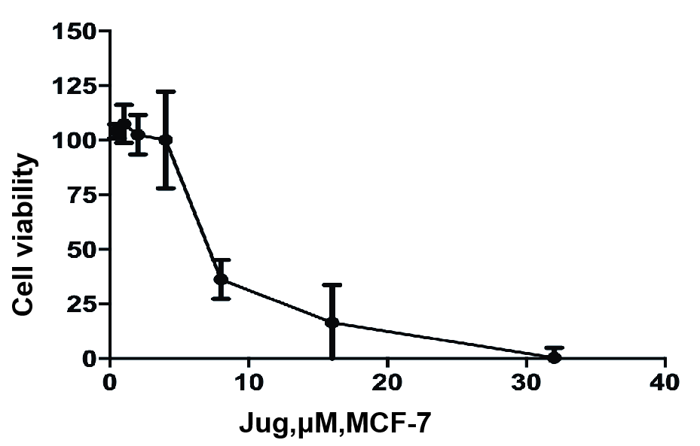 | 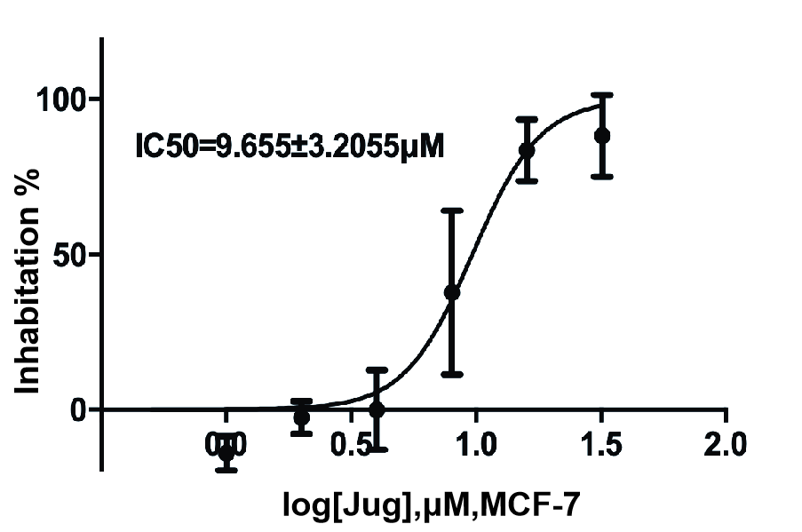
(C) | 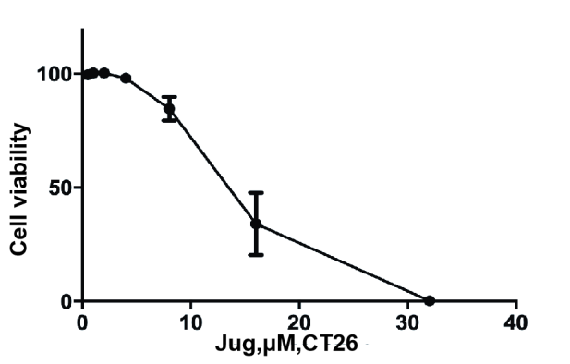 | 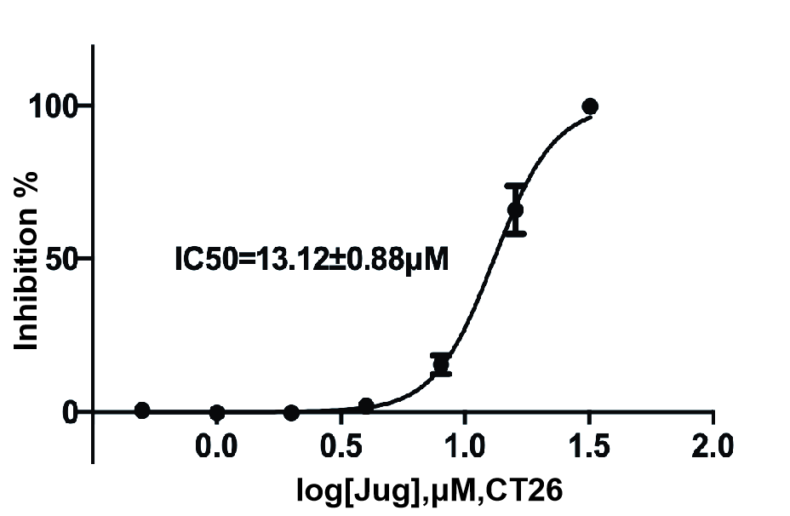
(D) | 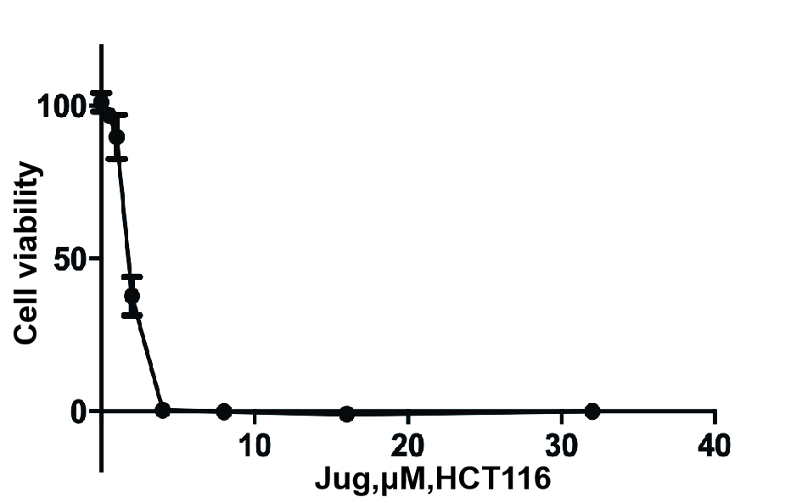 | 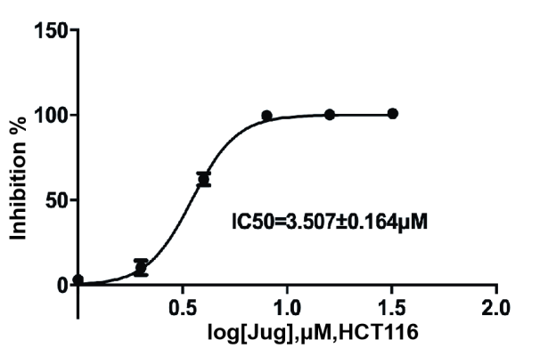
Supplementary Fig. 1. IC50 of juglone in breast and colorectal cancer cell lines. Cell viability was tested using the cell counting kit-8 (CCK8). The cells were seeded at a density of 1× 10³/well in 100 μL of medium into 96-well microwell culture plates and treated with indicated concentrations of juglone (0, 0.5, 1, 2, 4, 8, 16, 32, and 64 μM) for 24h. The viability and IC50 were calculated using the equation calculated by [(As-Ab)/(Ac-Ab)] ×100% (As: absorbance of experimental group; Ac: absorbance of control group; Ab: absorbance of blank group). IC50: 4T1 (2.248±0.108μM), MCF7 (9.655±3.2055μM), CT26 (13.12±0.88μM) and HCT116 (3.507±0.164μM).

Supplementary Figure 2. The gray values of western blot analysis
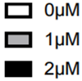
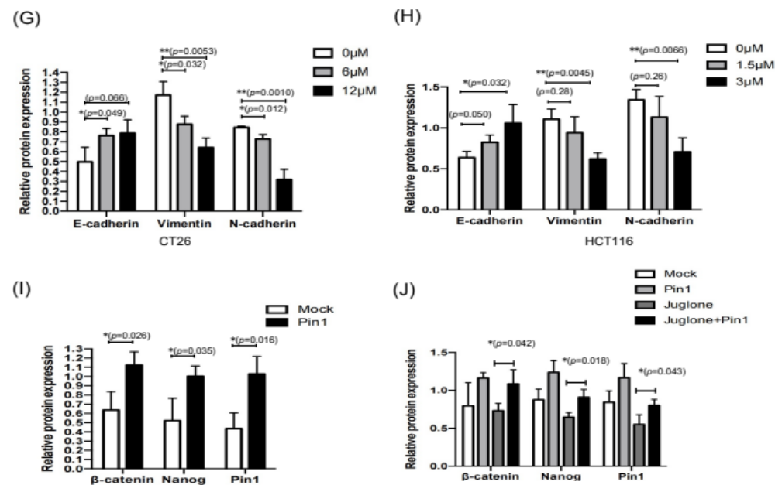
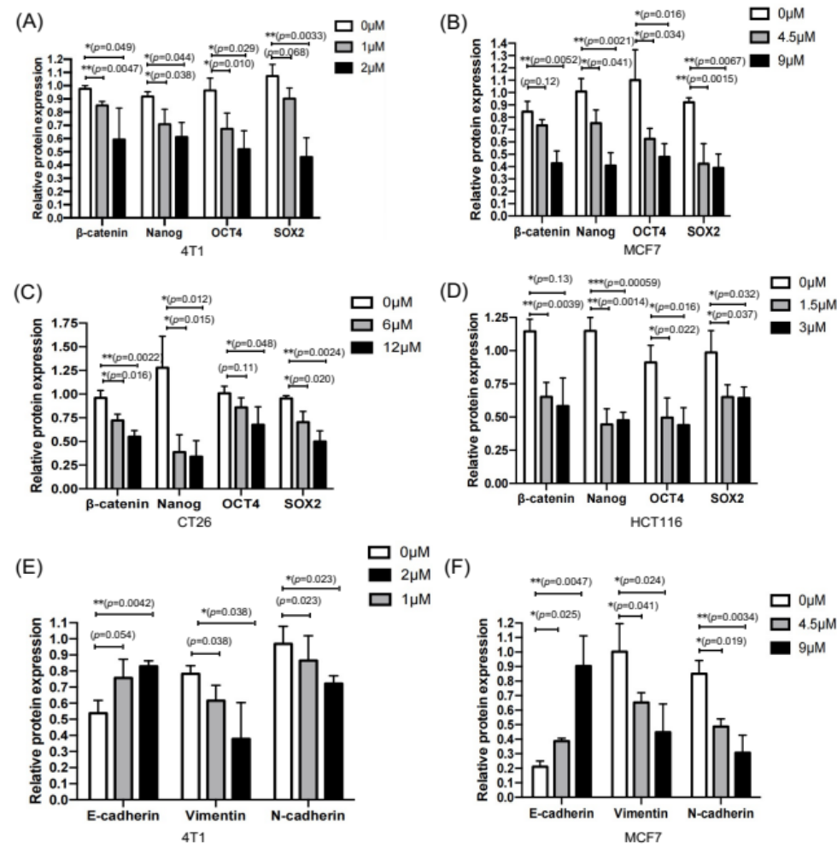
Supplementary Fig. 2. The gray values of western blot analysis. The gray values of the western blot were calculated by software Image J. The relative protein expression was calculated by dividing the target protein value by the reference protein value. (A-D) is for the western blot analysis in Fig.2 (A). (E-H) is for the western blot analysis in Fig.2 (C). (I) is for the western blot analysis in Fig.4(B). (J) is for the western blot analysis in Fig.4(G). *p< 0.05, **p< 0.01, ***p< 0.001
Supplementary Table 1. The antibodies used in the study
Target | Species | Dilution | Manufacture
E-cadherin | Rabbit | 1: 500 | CST, USA (#3195)
GAPDH | Mouse | 1: 1000 | Thermo Fisher Scientific, USA(AM4300)
N-cadherin | Rabbit | 1: 500 | CST, USA (#13116S)
Vimentin | Rabbit | 1: 1000 | CST, USA (#5741S)
β-catenin | Rabbit | 1: 1000 | CST, USA (#8480)
Nanog | Rabbit | 1: 1000 | CST, USA (#3589)
OCT4 | Rabbit | 1: 1000 | Abcam, USA (ab19857)
SOX4 | Rabbit | 1: 1000 | CST, USA (#3579)
Pin1 | Mouse | 1: 1000 | Santa Cruz Biotechnology, USA (sc-46660)

Supplementary Table 2. The p-value of Fig. 1 to Fig. 4 in the study
Figure number |  | Group |  | p-value
Figure 1(A)-up |  | 0μM v.s. 4.5μM, MCF7 |  | 0.0271
Figure 1(A)-up |  | 0μM v.s. 9μM, MCF7 |  | 0.0033
Figure 1(A)-below |  | 0μM v.s. 4.5μM, MCF7 |  | 0.00014
Figure 1(A)-below |  | 0μM v.s. 9μM, MCF7 |  | 0.00031
Figure 1(B)-up |  | 0μM v.s. 1.5μM, HCT116 |  | 0.0136
Figure 1(B)-up |  | 0μM v.s. 3μM, HCT116 |  | 0.0044
Figure 1(B)-below |  | 0μM v.s. 1.5μM, HCT116 |  | 0.0005
Figure 1(B)-below |  | 0μM v.s. 3μM, HCT116 |  | 0.00011
Figure 3(A) |  | 0μM v.s. 1μM, 4T1 |  | 0.0029
Figure 3(A) |  | 0μM v.s. 2 μM, 4T1 |  | 1.18025e-05
Figure 3(B) |  | 0μM v.s. 6μM, CT26 |  | 8.06159E-08
Figure 3(B) |  | 0μM v.s. 12M, CT26 |  | 9.30883E-08
Figure 3(C) |  | 0μM v.s. 4.5μM, MCF7 |  | 3.7297E-05
Figure 3(C) |  | 0μM v.s. 9μM, MCF7 |  | 1.81085E-07
Figure 3(D) |  | 0μM v.s. 1.5μM, HCT116 |  | 0.0048
Figure 3(D) |  | 0μM v.s. 3μM, HCT116 |  | 3.10692E-05
Figure 3(F) |  | liver weight v.s. body weight |  | 0.0226
Figure 4(D) |  | Mock v.s. Pin1 |  | 0.0008
Figure 4(F) | Pin1 v.s. Juglone+Pin1 |  | 0.0033
Figure 4(F) | Juglone v.s. Juglone + Pin1 |  | 0.00014

