Fate Determination and Characterization of Food Additive Silicon Dioxide and Titanium Dioxide in Commercial Foods
Ri-Ye Kwon^{1, †}, Su-Bin Kim^{1, †}, Su-Min Youn¹, and Soo-Jin Choi^{1,}*
¹Division of Applied Food System, Major of Food Science & Technology, Seoul Women’s University, Seoul 01797, Republic of Korea
*Correspondence: sjchoi@swu.ac.kr; Tel.: +82-2-970-5634
†These authors contributed equally.
Table S1. Operating conditions of the ICP-AES instrument
Instrument parameter | Operating conditon
Instrument parameter | SiO₂ | TiO₂
RF(radio frequency) power (W) | 1000 | 1300
Gas flow (L/min) | 12 | 12
Nebulizer flow (mL/min) | 0.75 | 0.75
High voltage (V) | 990 | 650
Wavelengths (nm) | 212.412 | 334.941

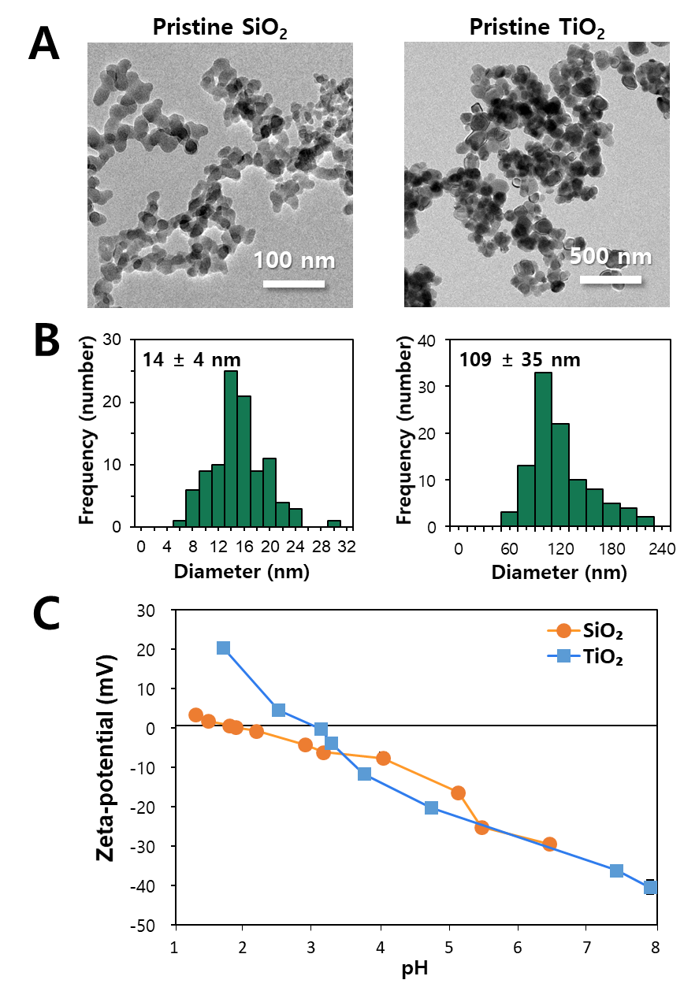
Figure S1. (A) Transmission electron microscopy (TEM) images and (B) size distribution of pristine food additive SiO₂ and TiO₂. Size distributions were obtained by randomly selecting 100 particles from the TEM images. (C) Zeta-potentials of SiO₂ and TiO₂ suspension as a function of pH.

