Supplementary Material
LC-ESI-QTOF-MS² characterization of phenolic compounds in different lentil (Lens culinaris M.) samples and their antioxidant capacity
Menglu Xia¹, Minhao Li¹, Thaiza Serrano Pinheiro de Souza¹, Colin Barrow², Frank Dunshea^{1,3} and Hafiz Ansar Rasul Suleria^{1,2}*
¹School of Agriculture and Food, Faculty of Science, The University of Melbourne, Parkville, 3010, VIC, Australia
²Centre for Chemistry and Biotechnology, School of Life and Environmental Sciences, Deakin University, Waurn Ponds, 3217, VIC, Australia
³Faculty of Biological Sciences, The University of Leeds, Leeds, UK
*Correspondence: hafiz.suleria@unimelb.edu.au (Hafiz Ansar Rasul Suleria)
Abstract
Background: Lentil (Lens culinaris M.) is a legume widely consumed worldwide. It is rich in bioactive compounds, including polyphenolic compounds that contribute to positive health benefits. Methods: This study aimed to determine the phenolic content and antioxidant activity of black, red, green, and brown whole lentils. Towards this end, the lentils' phenolic compounds were evaluated regarding their total phenolic content (TPC), total flavonoid content (TFC), total tannin content (TTC), total condensed tannin (TCT), total proanthocyanin content (TPAC), total anthocyanin content (TAC). For the antioxidant activity 2,2-diphenyl-1-picrylhydrazyl (DPPH), ferric reducing antioxidant power (FRAP), 2,2′-azinobis-3-ethylbenzothiazoline-6-sulfonic acid (ABTS), hydroxyl radical scavenging activity (·OH-RSA), ferrous ion chelating activity (FICA), reducing power assay (RPA) and phosphomolybdate (PMA) assay were accessed. To identify individual phenolic compounds, liquid chromatography-electrospray ionization quadrupole time-of-flight mass spectrometry (LC-ESI-QTOF-MS²) was used. Results: The results showed that green lentils exhibited the highest TPC (0.96 mg GAE/g) while red lentils presented the highest TFC (0.06 mg QE/g). Black lentils were noted with the highest TCT (0.03 mg CE/g), TPAC (0.009 mg CCE/g), and TAC (3.32 mg/100g) contents. While the greatest TTC (2.05 mg TAE/g) was observed in the brown lentil. Regarding the total antioxidant capacity, red lentils (4.01 mg AAE/g) had the highest value, while the lowest was found in the brown samples (2.31 mg AAE/g). The LC-ESI-QTOF-MS² tentatively identified a total of 22 phenolic compounds, including 6 phenolic acids, 13 flavonoids, 2 lignans, and 1 other polyphenol. The relationships among phenolic compounds by Venn Diagram showed a high number of overlapping compounds in brown and red lentils (6.7%), and a low number of overlapping compounds between the green, brown, and black lentils (2.6%). Flavonoids were the most abundant phenolic compound within the studied whole lentils, with the brown lentils being the richest in phenolic compounds, especially flavonoids. Conclusions: This study emphasized a comprehensive understanding of the antioxidant potential of lentils and disclosed the phenolic distribution across various lentil samples. This may increase interest in the development of functional food products, nutraceutical ingredients, and pharmaceutical applications with lentils.
Keywords
Lentil; Phenolic compound; Flavonoid; Antioxidant activity; Saponin; LC-ESI-QTOF-MS²

(a)

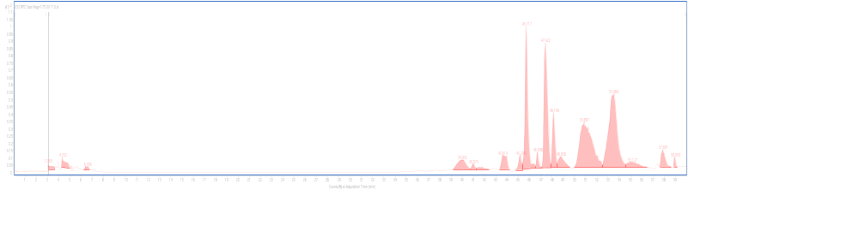

(b)

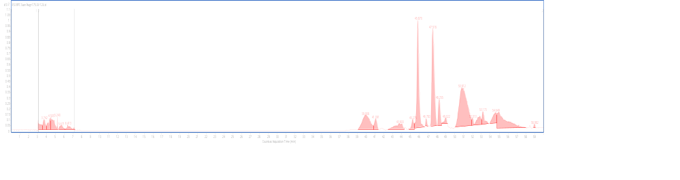

(c)

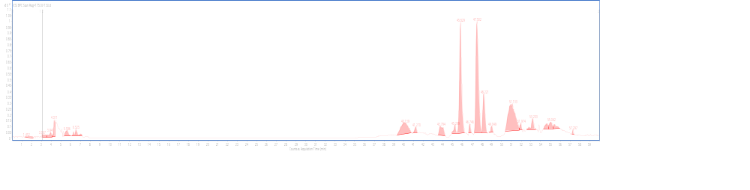

(d)

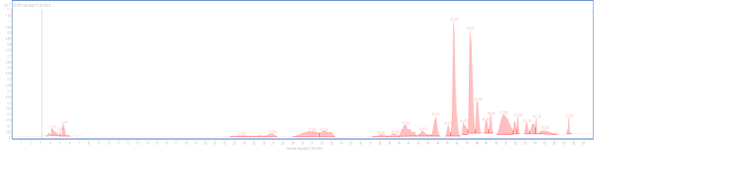

(e)

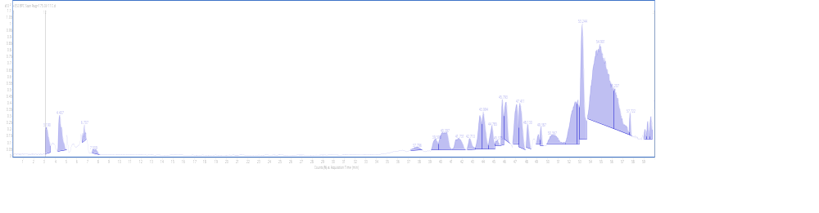

(f) 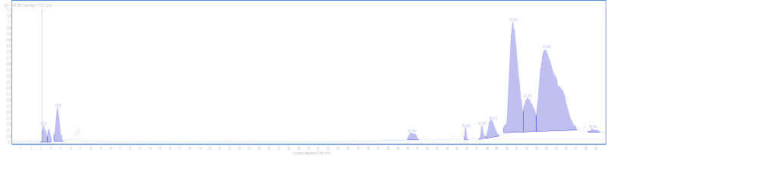

(g)

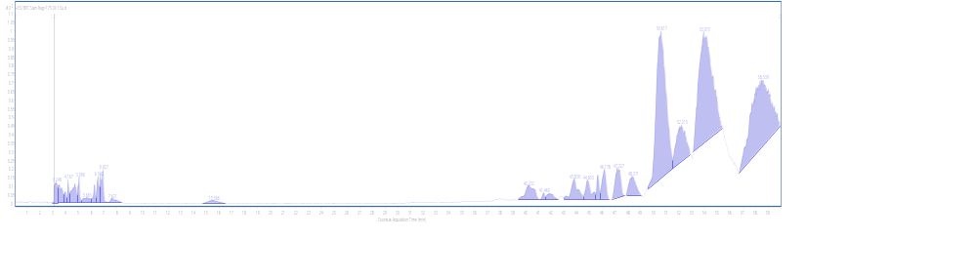

(h)
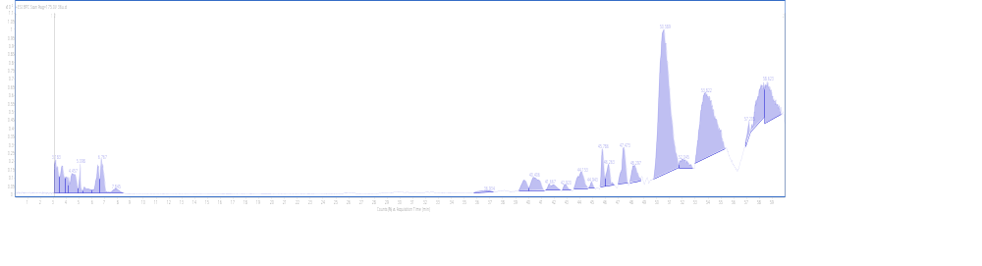

Fig. S1. LC-ESI-QTOF-MS/MS basic peak chromatograph (BPC) for characterization of phenolic compounds of different lentil samples. (a) Black whole lentils in negative ionization mode; (b) Green whole lentils in negative ionization mode; (c) Red whole lentils in negative ionization mode; (d) Brown whole lentils in negative ionization mode; (e) Black whole lentils in positive ionization mode; (f) Green whole lentils in positive ionization mode; (g) Red whole lentils in positive ionization mode; (h) Brown whole lentils in positive ionization mode.

