Investigating endocrine disrupting impacts of nine disinfection byproducts on human and zebrafish estrogen receptor alpha
Table S1 Docking residues of amino acids for the DBPs to both ERαs
Receptor | Ligand | Hydrogen bond interaction | Hydrophobic interaction | Van der Waals interaction
Receptor | Ligand | Amino acids | Amino acids | Amino acids
zERα-LBD | E2 | GLU321, ARG362, HIS492 | LEU314, ALA318, LEU352, LEU355, MET356, LEU359, PHE372, ILE392, LEU493 | MET311, THR315, MET317, MET389, PHE393, LEU396, GLY489, MET496
zERα-LBD | IAA | GLU321 | - | LEU355, MET356, LEU359, ARG362, PHE372, LEU396
zERα-LBD | IAM | GLY321, LYS417 | - | PRO292, MET325, VAL354, LEU355, GLY358, LEU359, ARG362, PHE413
zERα-LBD | IAN | - | LEU314, LEU493 | MET311, THR315, ALA318, HIS492, LEU508, TRP351
zERα-LBD | CAA | GLU321, ARG362 | - | LEU355, MET356, LEU359, PHE372, LEU396
zERα-LBD | CAM | VAL354, LYS417 | TRP328 | PRO292, GLU321, MET325, LEU355, GLY358, ARG362
zERα-LBD | CAN | - | LEU314, LEU493 | MET311, THR315, ALA318, TRP351, MET389, HIS492, LEU508
zERα-LBD | BAA | GLU321, ARG362 | - | ALA318, LEU352, LEU355, MET356, LEU359, PHE372
zERα-LBD | BAM | VAL354, LYS417 | - | PRO292, GLU321, MET325, LEU355, ILE357, GLY358, ARG362
zERα-LBD | BAN | HIS492 | - | MET311, LEU314, THR315, ALA318, LEU352, MET389, LEU493
hERα-LBD | E2 | GLU353, ARG394, HIS524 | ALA350,MET388, LEU387, PHE404, LEU391 | LEU349,LEU384 ILE424, PHE425, LEU428, GLY521, LEU525
hERα-LBD | IAA | HIS524, GLY521 | - | MET343, THR374, TRP383, LEU384, MET388, ILE424, LEU525
hERα-LBD | IAM | GLU353 | - | ALA350, LEU384, LEU387, MET388, LEU391, PHE404
hERα-LBD | IAN | ARG394 | LEU391, LEU387, MET388 | GLU353, LEU384, PHE404
hERα-LBD | CAA | LEU387, ARG394 | - | ALA350, GLU353, LEU391, MET388, PHE404
hERα-LBD | CAM | GLU353, LEU387 | - | LEU346, LEU349, ALA350, MET388, LEU391, ARG394, PHE404
hERα-LBD | CAN | HIS524 | TRP383, LEU384, LEU525 | MET388, GLY521
hERα-LBD | BAA | MET388 | - | LEU346, ALA350, LEU384, LEU387, LEU391, ARG394, PHE404
hERα-LBD | BAM | THR347 | - | MET343, LEU346, ALA350, TRP383, LEU384, LEU387, PHE404, MET421, LEU525, LEU540
hERα-LBD | BAN | HIS524 | TRP383, LEU384, LEU525 | MET388, GLY521

Table S2. The P-value of estrogenic responses
Estrogenic | z-IAA | z-IAM | z-IAN | z-CAA | z-CAM | z-CAN | z-BAA | z-BAM | z-BAN | h-IAA | h-IAM | h-IAN | h-CAA | h-CAM | h-CAN | h-BAA | h-BAM | h-BAN
z-IAA | 0.000 | 0.000 | 0.000 | 0.010 | 0.313 | 0.121 | 0.000 | 0.000 | 0.002 | 0.223 | 0.186 | 0.563 | 0.818 | 0.434 | 0.002 | 0.002 | 0.106 | 0.000
z-IAM | 0.000 | 0.000 | 0.000 | 0.071 | 0.361 | 0.086 | 0.006 | 0.000 | 0.004 | 0.150 | 0.291 | 0.671 | 0.716 | 0.427 | 0.069 | 0.028 | 0.445 | 0.013
z-IAN | 0.000 | 0.000 | 0.000 | 0.002 | 0.073 | 0.101 | 0.005 | 0.003 | 0.001 | 0.320 | 0.622 | 0.925 | 0.584 | 0.730 | 0.002 | 0.001 | 0.290 | 0.000
z-CAA | 0.010 | 0.071 | 0.002 | 0.000 | 0.743 | 0.027 | 0.039 | 0.232 | 0.000 | 0.109 | 0.217 | 0.551 | 0.301 | 0.820 | 0.147 | 0.270 | 0.142 | 0.071
z-CAM | 0.313 | 0.361 | 0.073 | 0.743 | 0.000 | 0.600 | 0.899 | 0.690 | 0.428 | 0.980 | 0.053 | 0.567 | 0.435 | 0.099 | 0.508 | 0.135 | 0.067 | 0.493
z-CAN | 0.121 | 0.086 | 0.101 | 0.027 | 0.600 | 0.000 | 0.013 | 0.061 | 0.024 | 0.003 | 0.395 | 0.335 | 0.015 | 0.699 | 0.664 | 0.936 | 0.479 | 0.948
z-BAA | 0.000 | 0.006 | 0.005 | 0.039 | 0.899 | 0.013 | 0.000 | 0.003 | 0.006 | 0.093 | 0.185 | 0.209 | 0.489 | 0.274 | 0.305 | 0.093 | 0.889 | 0.161
z-BAM | 0.000 | 0.000 | 0.003 | 0.232 | 0.690 | 0.061 | 0.003 | 0.000 | 0.269 | 0.061 | 0.692 | 0.103 | 0.303 | 0.406 | 0.503 | 0.031 | 0.449 | 0.200
z-BAN | 0.002 | 0.004 | 0.001 | 0.000 | 0.428 | 0.024 | 0.006 | 0.269 | 0.000 | 0.056 | 0.360 | 0.406 | 0.334 | 0.727 | 0.197 | 0.144 | 0.681 | 0.067
h-IAA | 0.223 | 0.150 | 0.320 | 0.109 | 0.980 | 0.003 | 0.093 | 0.061 | 0.056 | 0.000 | 0.089 | 0.003 | 0.000 | 0.342 | 0.032 | 0.926 | 0.517 | 0.177
h-IAM | 0.186 | 0.291 | 0.622 | 0.217 | 0.053 | 0.395 | 0.185 | 0.692 | 0.360 | 0.089 | 0.000 | 0.267 | 0.132 | 0.012 | 0.013 | 0.677 | 0.008 | 0.039
h-IAN | 0.563 | 0.671 | 0.925 | 0.551 | 0.567 | 0.335 | 0.209 | 0.103 | 0.406 | 0.003 | 0.267 | 0.000 | 0.003 | 0.552 | 0.016 | 0.445 | 0.171 | 0.112
h-CAA | 0.818 | 0.716 | 0.584 | 0.301 | 0.435 | 0.015 | 0.489 | 0.303 | 0.334 | 0.000 | 0.132 | 0.003 | 0.000 | 0.883 | 0.001 | 0.048 | 0.399 | 0.011
h-CAM | 0.434 | 0.427 | 0.730 | 0.820 | 0.099 | 0.699 | 0.274 | 0.406 | 0.727 | 0.342 | 0.012 | 0.552 | 0.883 | 0.000 | 0.311 | 0.161 | 0.153 | 0.288
h-CAN | 0.002 | 0.069 | 0.002 | 0.147 | 0.508 | 0.664 | 0.305 | 0.503 | 0.197 | 0.032 | 0.013 | 0.016 | 0.001 | 0.311 | 0.000 | 0.030 | 0.012 | 0.000
h-BAA | 0.002 | 0.028 | 0.001 | 0.270 | 0.135 | 0.936 | 0.093 | 0.031 | 0.144 | 0.926 | 0.677 | 0.445 | 0.048 | 0.161 | 0.030 | 0.000 | 0.576 | 0.008
h-BAM | 0.106 | 0.445 | 0.290 | 0.142 | 0.067 | 0.479 | 0.889 | 0.449 | 0.681 | 0.517 | 0.008 | 0.171 | 0.399 | 0.153 | 0.012 | 0.576 | 0.000 | 0.004
h-BAN | 0.000 | 0.013 | 0.000 | 0.071 | 0.493 | 0.948 | 0.161 | 0.200 | 0.067 | 0.177 | 0.039 | 0.112 | 0.011 | 0.288 | 0.000 | 0.008 | 0.004 | 0.000

Table S3. The P-value of anti-estrogenic responses
Anti-estrogenic | z-IAA | z-IAM | z-IAN | z-CAA | z-CAM | z-CAN | z-BAA | z-BAM | z-BAN | h-IAA | h-IAM | h-IAN | h-CAA | h-CAM | h-CAN | h-BAA | h-BAM | h-BAN
z-IAA | 0.000 | 0.326 | 0.777 | 0.150 | 0.001 | 0.524 | 0.957 | 0.022 | 0.055 | 0.168 | 0.032 | 0.272 | 0.053 | 0.124 | 0.074 | 0.216 | 0.779 | 0.061
z-IAM | 0.326 | 0.000 | 0.479 | 0.958 | 0.305 | 0.565 | 0.691 | 0.866 | 0.113 | 0.112 | 0.971 | 0.776 | 0.938 | 0.874 | 0.213 | 0.639 | 0.082 | 0.667
z-IAN | 0.777 | 0.479 | 0.000 | 0.083 | 0.673 | 0.901 | 0.346 | 0.718 | 0.669 | 0.815 | 0.369 | 0.033 | 0.185 | 0.107 | 0.808 | 0.163 | 0.149 | 0.341
z-CAA | 0.150 | 0.958 | 0.083 | 0.000 | 0.153 | 0.572 | 0.761 | 0.125 | 0.371 | 0.361 | 0.026 | 0.037 | 0.054 | 0.003 | 0.179 | 0.129 | 0.219 | 0.087
z-CAM | 0.001 | 0.305 | 0.673 | 0.153 | 0.000 | 0.775 | 0.757 | 0.046 | 0.103 | 0.260 | 0.050 | 0.185 | 0.044 | 0.150 | 0.132 | 0.231 | 0.845 | 0.087
z-CAN | 0.524 | 0.565 | 0.901 | 0.572 | 0.775 | 0.000 | 0.020 | 0.214 | 0.493 | 0.499 | 0.267 | 0.944 | 0.568 | 0.332 | 0.418 | 0.361 | 0.225 | 0.386
z-BAA | 0.957 | 0.691 | 0.346 | 0.761 | 0.757 | 0.020 | 0.000 | 0.627 | 0.640 | 0.602 | 0.818 | 0.311 | 0.802 | 0.958 | 0.682 | 0.906 | 0.665 | 0.858
z-BAM | 0.022 | 0.866 | 0.718 | 0.125 | 0.046 | 0.214 | 0.627 | 0.000 | 0.139 | 0.364 | 0.003 | 0.237 | 0.088 | 0.085 | 0.245 | 0.193 | 0.328 | 0.166
z-BAN | 0.055 | 0.113 | 0.669 | 0.371 | 0.103 | 0.493 | 0.640 | 0.139 | 0.000 | 0.011 | 0.214 | 0.864 | 0.503 | 0.435 | 0.041 | 0.849 | 0.712 | 0.312
h-IAA | 0.168 | 0.112 | 0.815 | 0.361 | 0.260 | 0.499 | 0.602 | 0.364 | 0.011 | 0.000 | 0.377 | 0.981 | 0.598 | 0.420 | 0.007 | 0.850 | 0.679 | 0.242
h-IAM | 0.032 | 0.971 | 0.369 | 0.026 | 0.050 | 0.267 | 0.818 | 0.003 | 0.214 | 0.377 | 0.000 | 0.095 | 0.031 | 0.014 | 0.200 | 0.092 | 0.198 | 0.084
h-IAN | 0.272 | 0.776 | 0.033 | 0.037 | 0.185 | 0.944 | 0.311 | 0.237 | 0.864 | 0.981 | 0.095 | 0.000 | 0.044 | 0.059 | 0.667 | 0.115 | 0.205 | 0.247
h-CAA | 0.053 | 0.938 | 0.185 | 0.054 | 0.044 | 0.568 | 0.802 | 0.088 | 0.503 | 0.598 | 0.031 | 0.044 | 0.000 | 0.016 | 0.236 | 0.008 | 0.254 | 0.015
h-CAM | 0.124 | 0.874 | 0.107 | 0.003 | 0.150 | 0.332 | 0.958 | 0.085 | 0.435 | 0.420 | 0.014 | 0.059 | 0.016 | 0.000 | 0.164 | 0.027 | 0.116 | 0.026
h-CAN | 0.074 | 0.213 | 0.808 | 0.179 | 0.132 | 0.418 | 0.682 | 0.245 | 0.041 | 0.007 | 0.200 | 0.667 | 0.236 | 0.164 | 0.000 | 0.382 | 0.985 | 0.043
h-BAA | 0.216 | 0.639 | 0.163 | 0.129 | 0.231 | 0.361 | 0.906 | 0.193 | 0.849 | 0.850 | 0.092 | 0.115 | 0.008 | 0.027 | 0.382 | 0.000 | 0.100 | 0.027
h-BAM | 0.779 | 0.082 | 0.149 | 0.219 | 0.845 | 0.225 | 0.665 | 0.328 | 0.712 | 0.679 | 0.198 | 0.205 | 0.254 | 0.116 | 0.985 | 0.100 | 0.000 | 0.433
h-BAN | 0.061 | 0.667 | 0.341 | 0.087 | 0.087 | 0.386 | 0.858 | 0.166 | 0.312 | 0.242 | 0.084 | 0.247 | 0.015 | 0.026 | 0.043 | 0.027 | 0.433 | 0.000

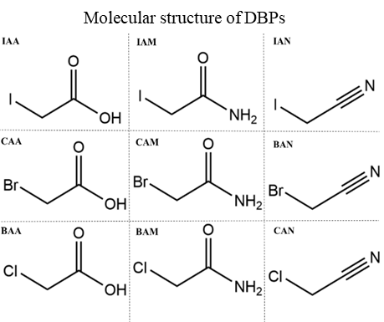
Figure S1

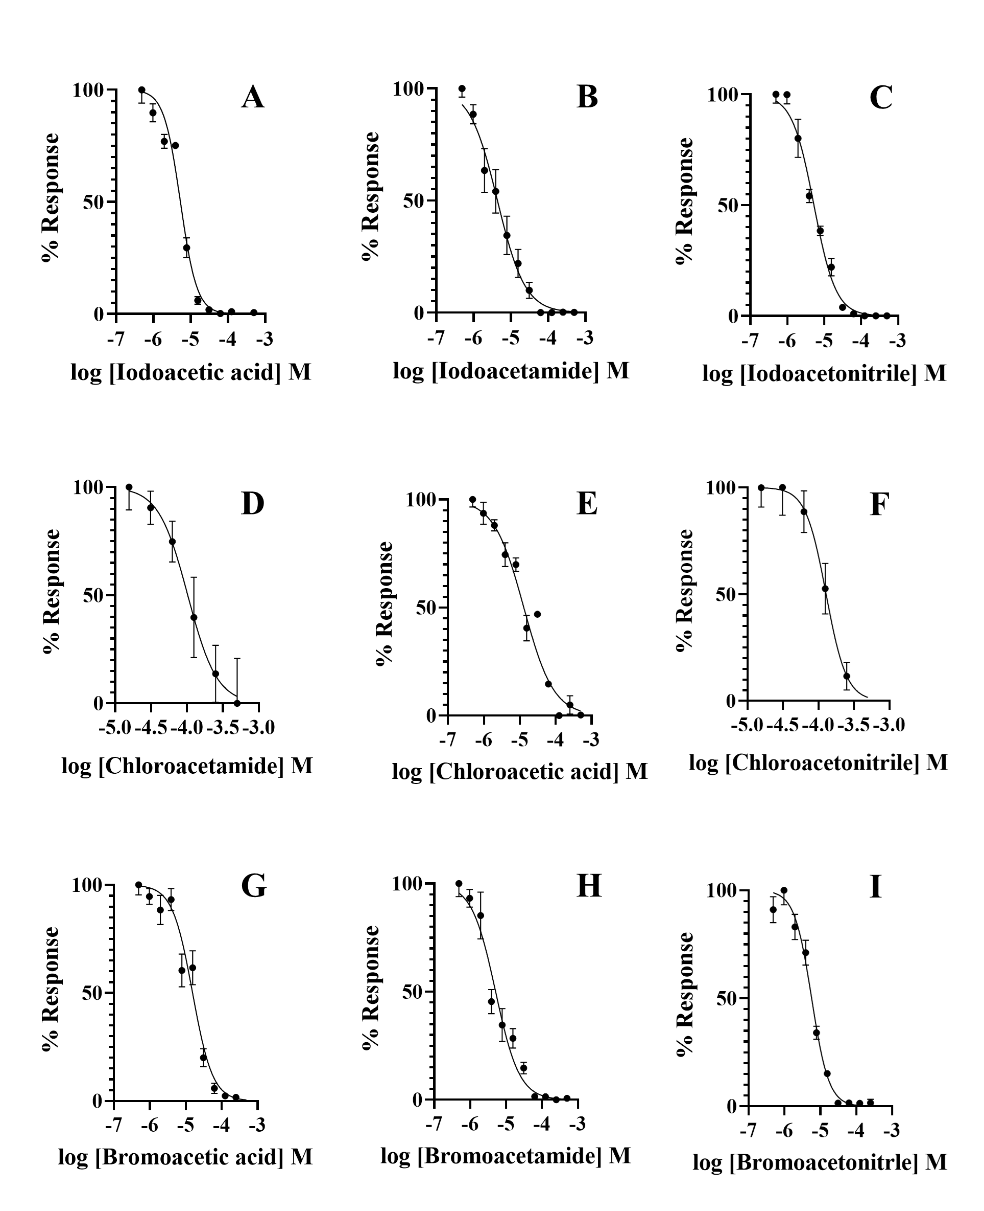
Figure S

