Supplementary Figure Legends:
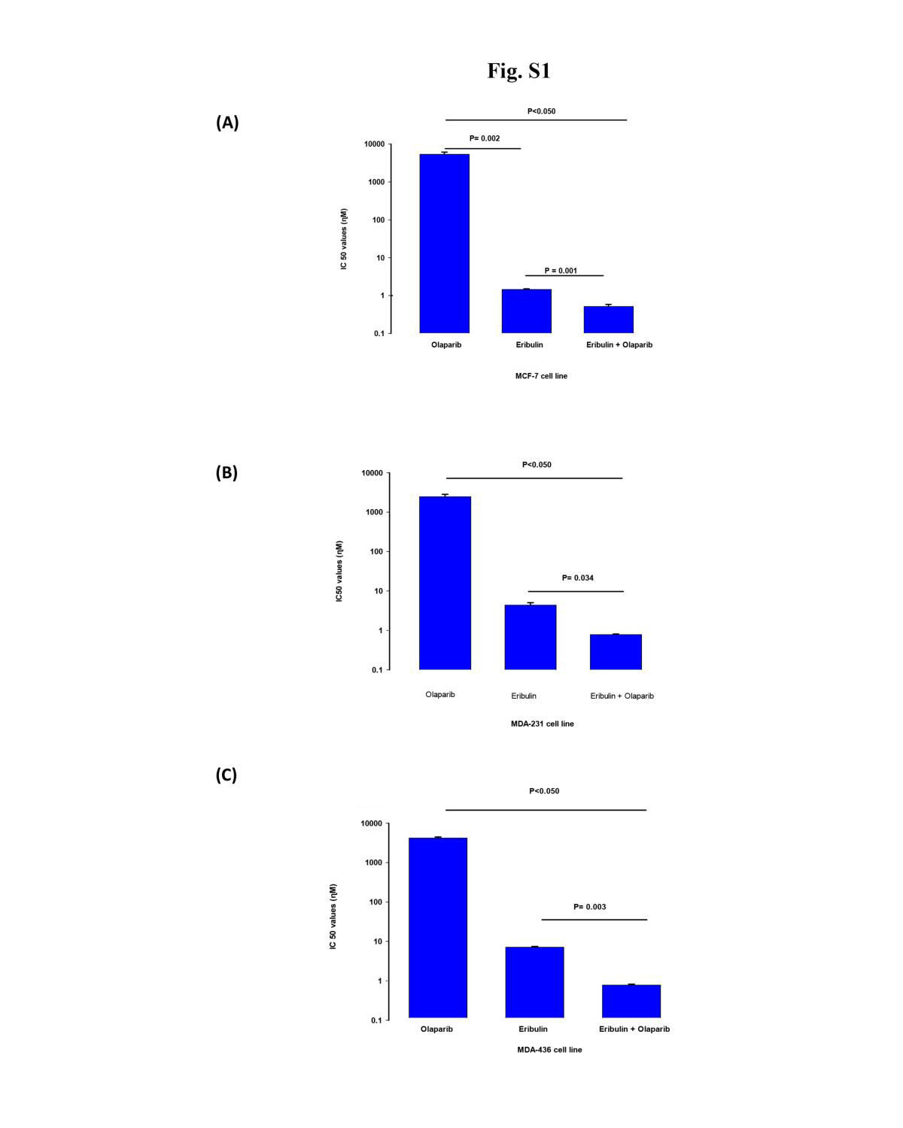
Supplementary Fig 1. A non-cytotoxic concentration of olaparib enhances eribulin cytotoxicity. The IC₅₀ values of olaparib, eribulin and the combination of eribulin plus a non-cytotoxic concentration of olaparib (2 µM) were obtained using the SRB assay as described in material and methods in an ER+/HER2- breast cancer cell line (A) MCF-7 and two triple negative breast cancer cell lines (B) MDA-231 and (C) MDA-436 cell line. Data are presented as mean ± standard error (n = 3). Statistical differences were assessed by analysis of variance followed by t-test for each cell line. Statistical significances are indicated (p values <0.05).

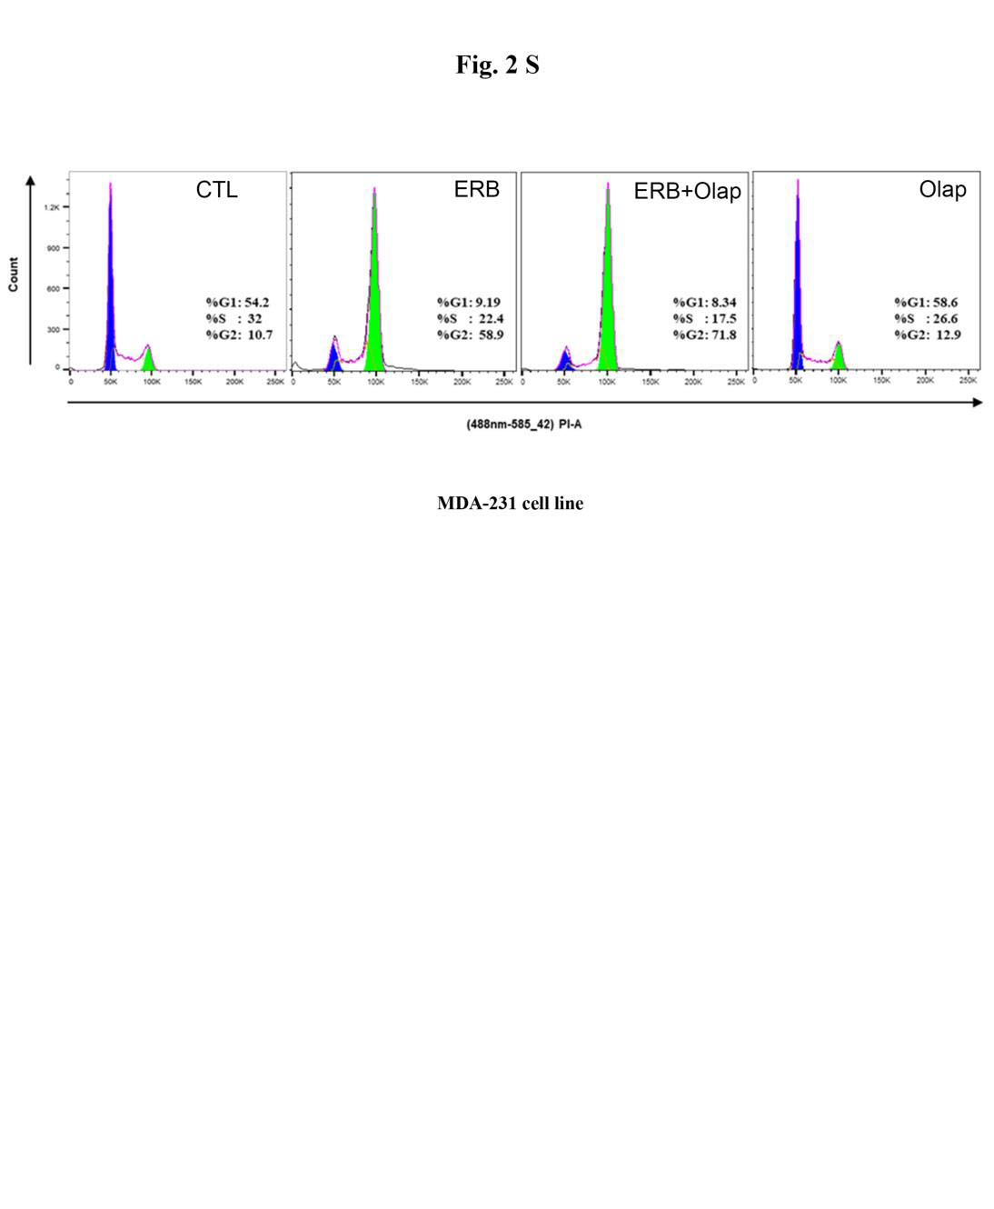
Supplementary Fig 2. Representative analyses of cell cycle progression in the MDA-231 cell line as described in material and methods using PI staining after a 24h treatment with vehicle (CTL), eribulin IC₅₀ concentration as defined in Supplementary Fig. 1 alone (ERB) or in combination with 2 µM of olaparib (ERB + Olap).

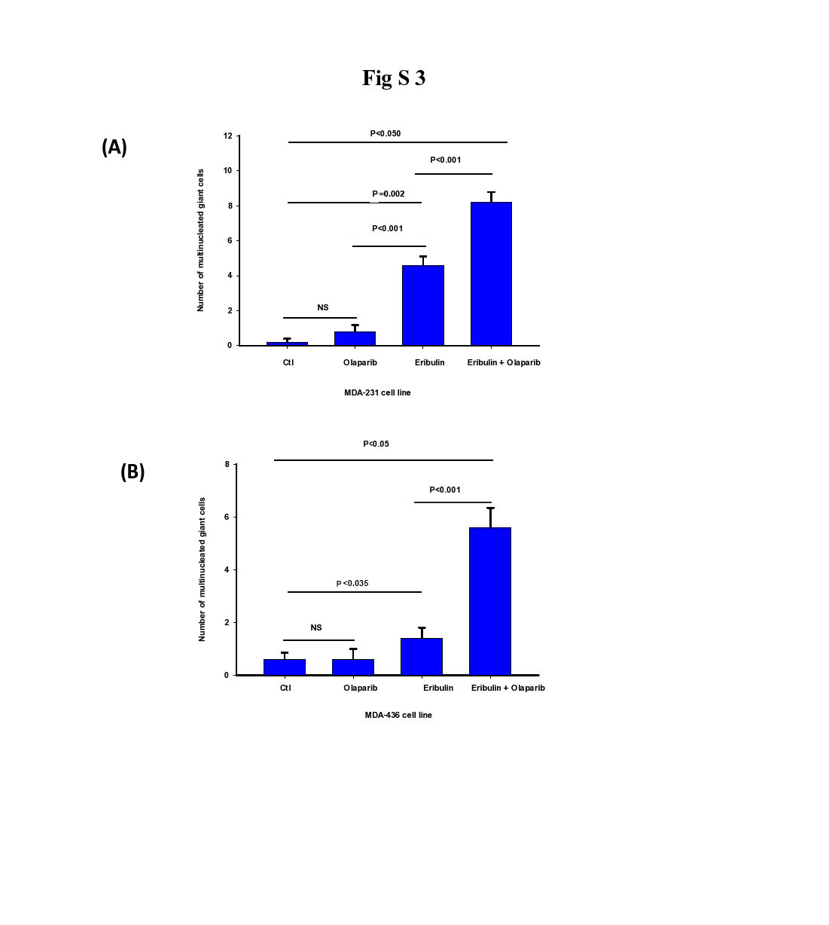
Supplementary Fig 3. Quantitative comparative analysis of polynucleated giant cells in (A) MDA-231 and (B) MDA-436 cell lines 24h after treatment with vehicle (CTL), 2 µM of olaparib, eribulin IC₅₀ or eribulin IC₅₀ plus 2 µM of olaparib as indicated. The analysis was performed in five microscopic fields per group as described in material and methods. The bars represent the mean value of total polynucleated giant cells ± standard error (n = 3). Statistical differences were assessed by analysis of variance (ANOVA), followed by t-test. Statistical significances are indicated (p values <0.05). NS indicates a p>0.05).

