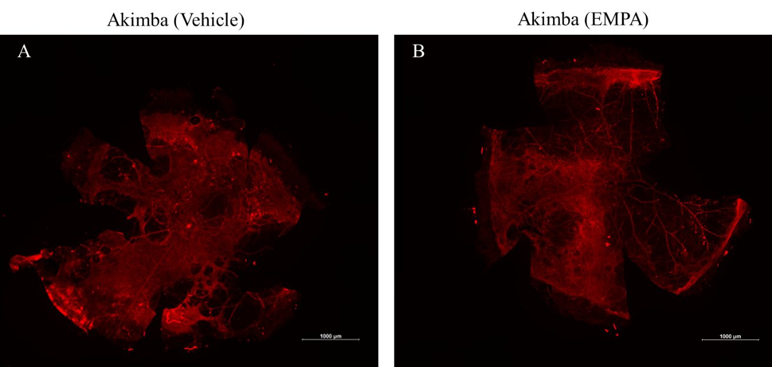
Supplementary Fig. 1. SGLT2 inhibition with EMPA did not affect severe retinal abnormalities in diabetic Akimba mice. Representative photomontages of isolectin-B4 and Cy-3-stained retinal tissue from Akimba mice treated with (A) vehicle or (B) EMPA. Diffused staining represents retinal vascular leakage. Scale bar 100 μm; EMPA, Empagliflozin.

