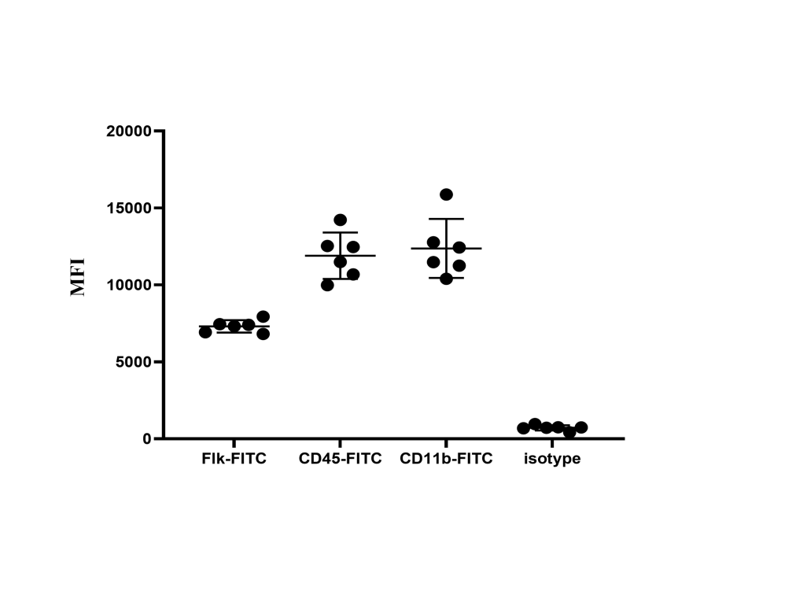
Supplementary Fig. 1. MFI of Flk-FITC, CD45-FITC, CD11c-FITC.
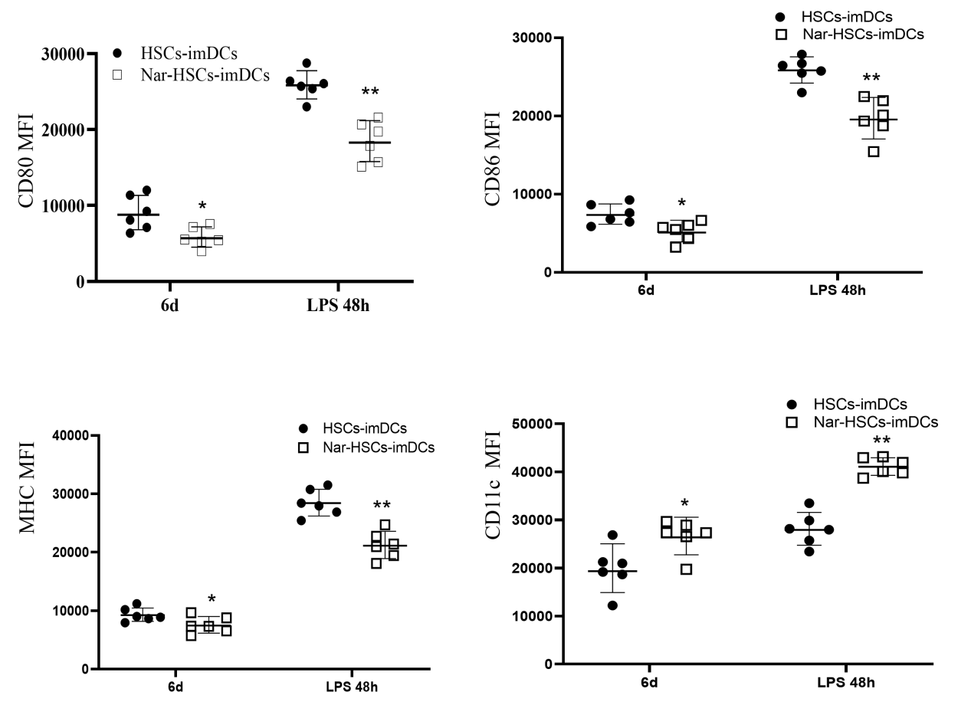
Supplementary Fig. 2 MFI of CD80, CD86, MHC, CD11c in HSCs-imDCs and Nar-HSCs-imDCs. Compared with the HSCs-imDCs group at the same time, *p < 0.05, **p < 0.01. Each experiment contains six biological replicates.

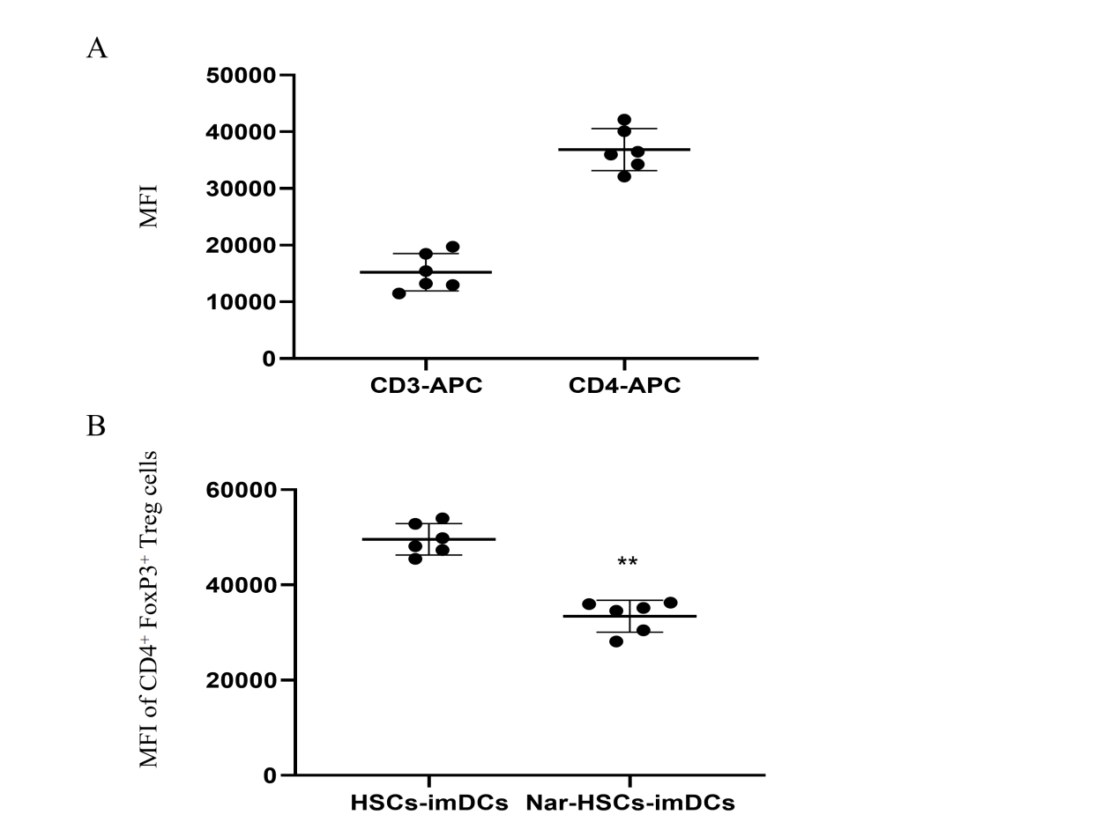
Supplementary Fig. 3. MFI of T cells. A. MFI of CD3 and CD4 B. MFI of CD4⁺ FoxP3⁺ in HSCs-imDCs and Nar-HSCs-imDCs. Compared with the HSCs-DCs group, *p < 0.05, **p < 0.01. Each experiment contains six biological replicates.
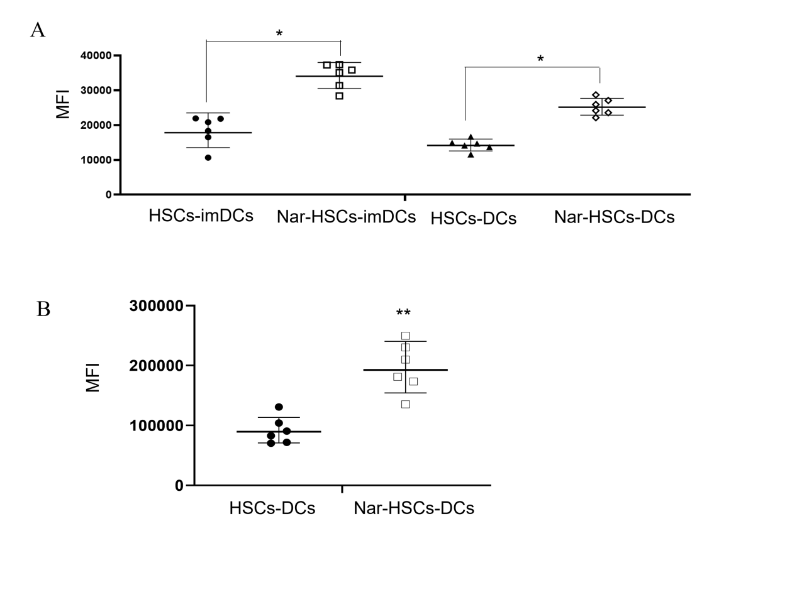
Supplementary Fig. 4. MFI of Endocytosis and apoptosis in Nar-HSCs-imDCs and Nar-HSCs-DCs. A. MFI of Endocytosis. B. MFI of apoptosis. Compared with the HSCs-DCs group, *p < 0.05, **p < 0.01. Each experiment contains six biological replicates.

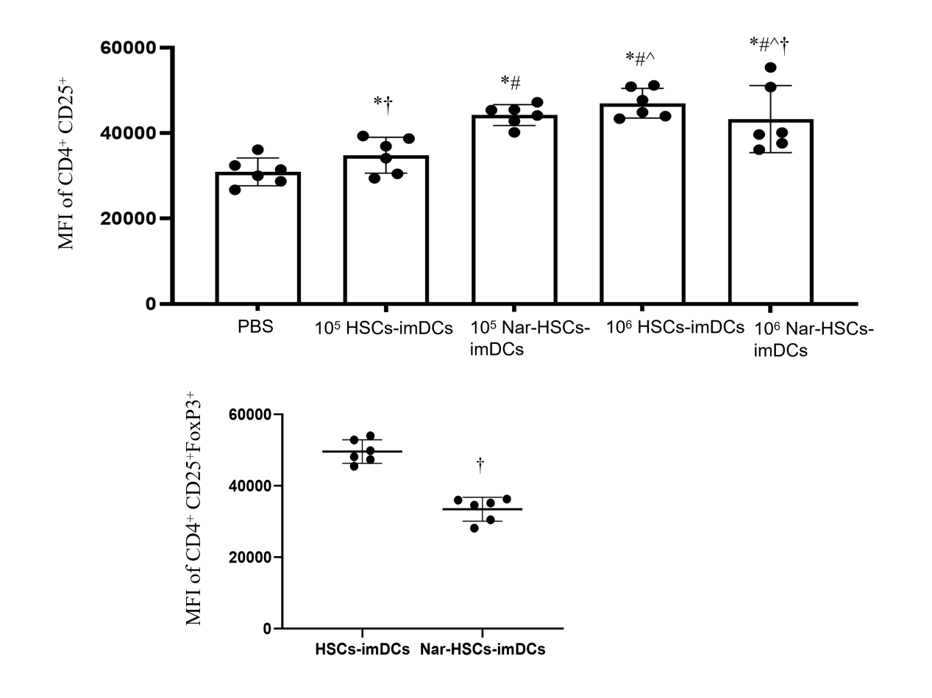
Supplementary Fig. 5. MFI of CD4⁺ CD25⁺ Treg and CD4⁺ CD25⁺ FoxP3⁺ Treg. A. MFI of CD4⁺ CD25⁺ Treg in all animal groups. B. MFI of CD4⁺ CD25⁺ FoxP3⁺ Treg in 10⁵ Nar-HSCs-imDCs and 10⁶ Nar-HSCs-imDCs group. Compared with the PBS group, *p < 0.05. Compared with the 10⁵ HSCs-imDCs group, #p < 0.05. Compared with the 10⁶ HSCs-imDCs group, ^p < 0.05. Compared with the 10⁶ Nar-HSCs-imDCs group, †p < 0.05. Compared to third-party lymphocytes, ▲p < 0.05. Each experiment contains six biological replicates.

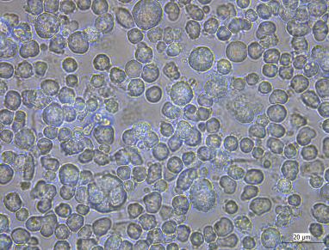
Supplementary Fig. 6. The morphology of Nar-HSCs-imDCs under phase contrast microscope after cultured with LPS for 48h (x400).

