Supplementary Information
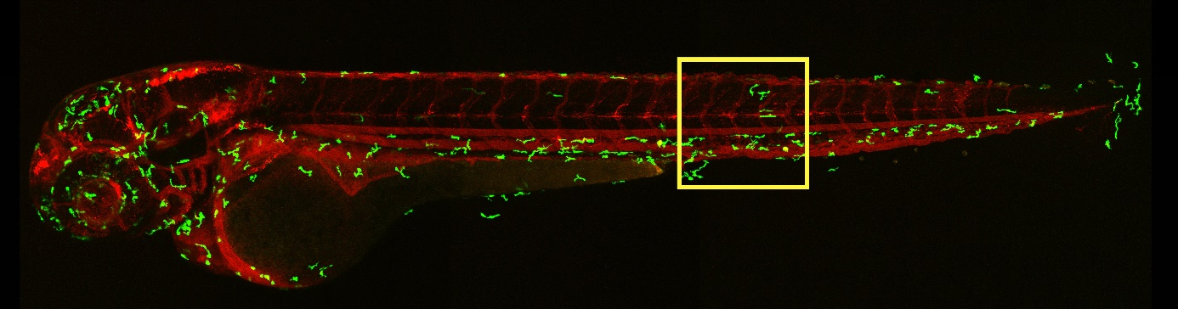
Figure S1: Overview image of the zebrafish embryo animal model. The yellow box indicates the location where zebrafish imaging was carried out. The picture shows the macrophages (green) and a freely-circulating DiI-labeled liposomal formulation (red) to visualize the vasculature.
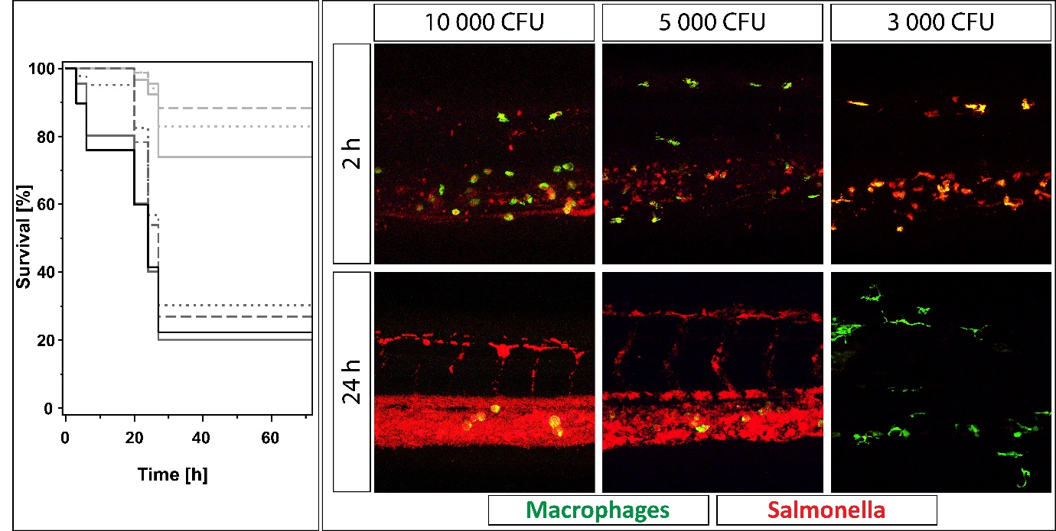
Figure S2: Evaluation of the amount of injected cfu. The confocal images on the right side show representative images of different doses of bacteria after 2 and 24 h. While the fish survive a dose of 3.000 CFU, higher doses are associated with massive replication of bacteria within the vasculature after 24 h. The Kaplan-Meier survival plot on the left side shows the survival of zebrafish treated with different doses of bacteria. Light grey dotted line: 1.500 CFU, light grey dashed line: 3.000 CFU, light grey solid line: 5.000 CFU, dark grey dotted line: 7.500 CFU, dark grey dashed line: 10.000 CFU, dark grey solid line: 20.000 CFU, black solid line: 30.000 CFU. While 1.500 CFU, 3.000 CFU, and to a certain extent 5.000 CFU are still well tolerated, higher doses are associated with rapid death of fish. The survival analysis showed a dose-dependency.
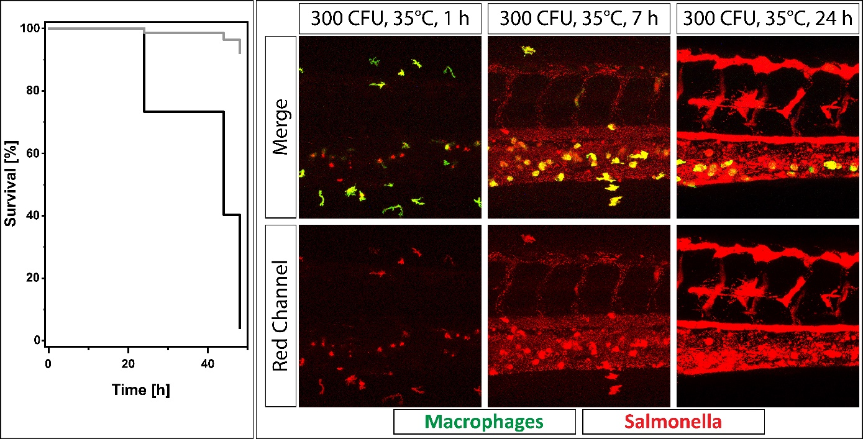Figure S3: Temperature evaluation. The figure shows confocal images (right) and the survival analysis (upper left) of zebrafish embryos injected with 300 CFU and maintained at 35°C. Despite the lower dose injected into zebrafish embryos, Salmonella replication is accelerated due to the higher temperature. Consequently, images taken after 24 h are similar for 300 CFU at 35°C and 5.000 - 10.000 CFU at 28°C. Moreover, survival analysis showed a lower survival at 35°C (solid black line) compared to zebrafish maintained at 28°C (solid grey line), which reflects the observations during confocal imaging well.
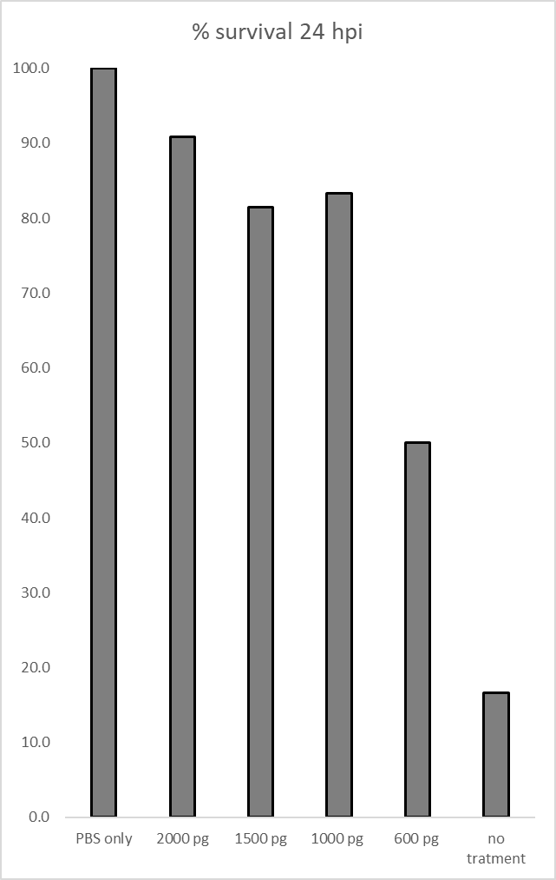
Figure S4: Zebrafish embryo survival of infected zebrafish treated with different doses of tobramycin. Embryos were injected i.v. with 300 CFU of salmonella and treated with an i.v. injection of the indicated amount of Tobramycin 1h after Salmonella injection. Fish were kept at 35°C, n≥11. Survival criterium of the embryos was an observable heartbeat.

