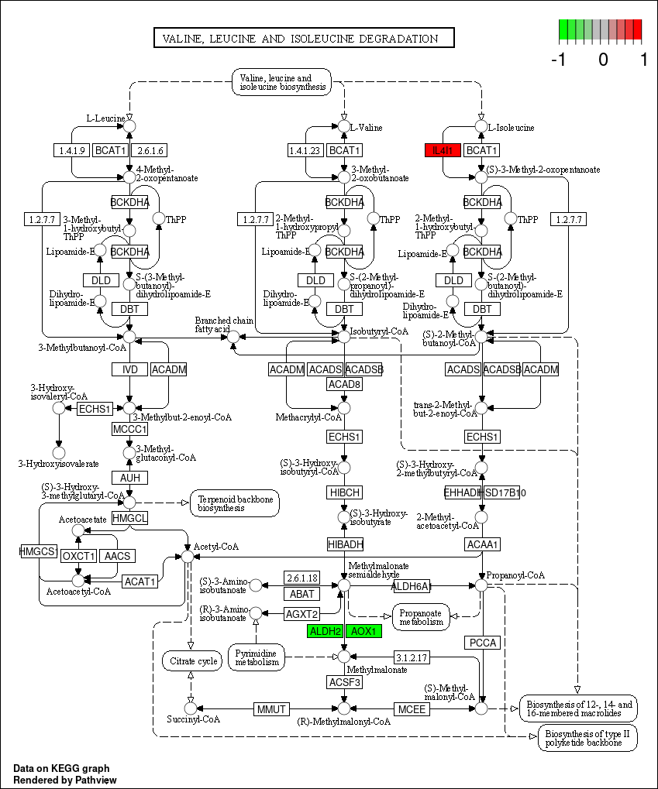
Supplementary Figure 1 Catabolic pathway of branched chain amino acids in KEGG
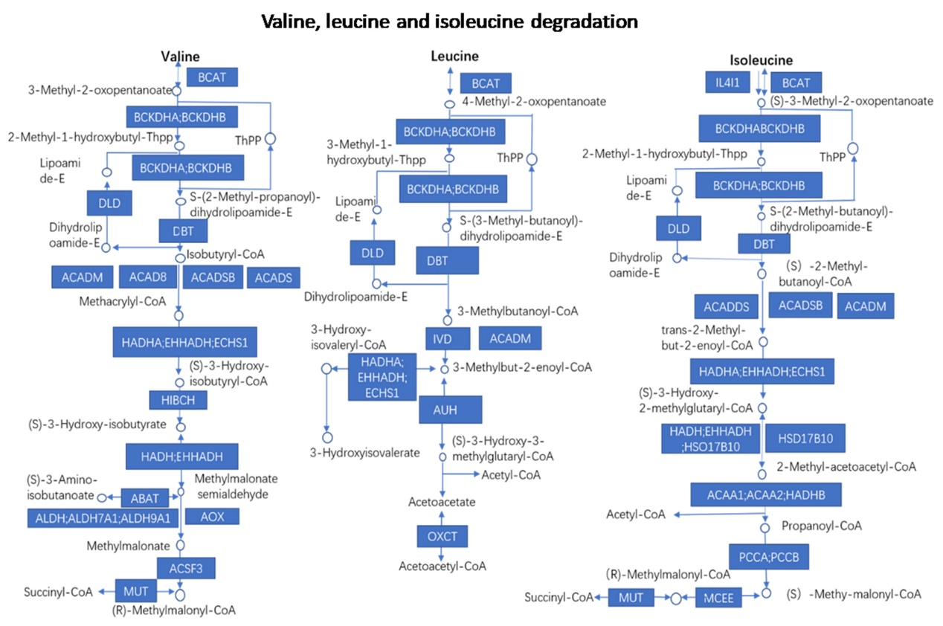
Supplementary Figure 2 Valine, leucine and isoleucine degradation pathway

