Supplementary Table 1. The 63-gene panel and mutation types
Mutation type | Gene
Point mutations, insertions, and deletions | ABL1, AKT1, ALK*, APC, AR, ATM, BRAF*, CDH1, CDK4*, CDK6*, CDKN2A, CSF1R, CTNNB1, DDR2, DNMT3A, EGFR*, ERBB2, ERBB4*, ESR1*, EZH2, FBXW7, FGFR1, FGFR2, FGFR3, FLT3, GNA11, GNAQ, GNAS, HNF1A, HRAS*, IDH1, IDH2, JAK2*, JAK3, KDR, KIT*, KRAS*, MAP2K1, MET, MLH1, MPL, MYC, NPM1, NRAS*, PDGFRA*, PIK3CA*, PIK3R1, PTEN*, PTPN11, RB1, RET, SMAD4, SMARCB1, SMO, SRC, STK11*, TERT, TP53*, VHL
Rearrangement | ALK, BRAF, BCR, EGFR, FGFR3, NTRK1, PDGFRA, PDGFRB, RET, ROS1
Copy number changes | CDK4, CDK6, EGFR, ERBB2, FGFR1, MET, MYC, PIK3CA

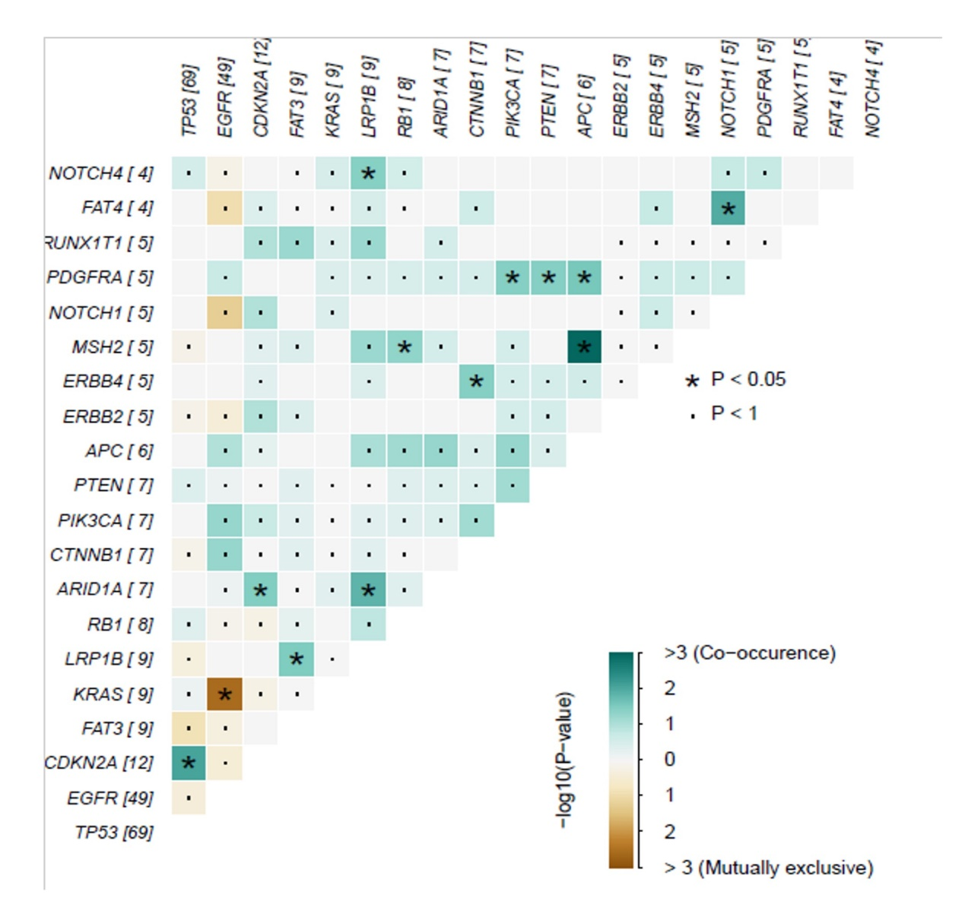
Supplementary Fig. 1. Co-occurring mutations and mutually exclusive mutations between gene pairs. Co-occurring mutations are indicated by green squares and mutually exclusive mutations by brown. The intensity of the color is proportional to the –log10. P-values were determined using Fisher’s exact test.
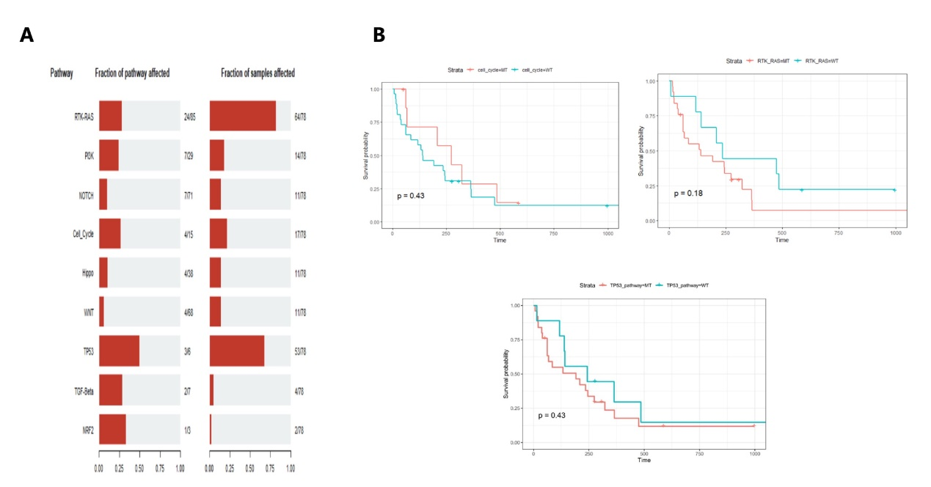
Supplementary Fig. 2. The correlation of enriched KEGG pathways with the PFS of patients. (A) The enriched pathways associated with the mutated genes in 78 patients with stage IV NSCLC. (B) The association of cell_cycle, RTK-RAS, and TP53 pathways with the survival of patients. MT, mutation; WT, wild-type.

