Supplementary Table 1. The targets corresponding to the active components of AOH.
The targets corresponding to the active components of AOH
F2 | FNTB | GABRA2 | AURKB | PYGM | GSTM2 | POR | gyrB | GRK6 | CHRNB1
CHRM1 | SLC6A9 | GABRA5 | CA6 | CHEK1 | RPS6KA2 | ODC1 | CXCL11 | PFKFB3 | CHRNA3
ESR1 | GSK3B | APP | CA14 | NCOA1 | ALPL | CASP8 | CXCL2 | CFTR | MAPK9
AR | F10 | MDM2 | CA9 | F7 | ADAM17 | TOP1 | DCAF5 | IKBKB | TRPV1
PTGS2 | SLC13A5 | LRRK2 | CA13 | ACHE | CA5B | SOD1 | NR1I3 | NTRK2 | GRM2
SLC6A2 | GABRB3 | MPI | CA5A | MAOB | TUBB1 | PRKCA | CHEK2 | NAE1 | C5AR1
ADRB2 | GABRA3 | PHOSPHO1 | CA1 | CYP101 | TUBB3 | HIF1A | INSR | ST6GAL1 | CTRB1
SLC6A3 | GABRG2 | PTGS1 | SYK | RELA | CDK4 | STAT1 | CLDN4 | ADRA2A | FABP1
SLC6A4 | GABRA1 | CHRM3 | ALOX15 | NCF1 | MMP7 | RUNX1T1 | PPARA | ADRA2C | RGS4
HSD11B1 | HTR6 | ADRB1 | ABCB1 | OLR1 | MMP8 | HERC5 | HSF1 | PLG | IDH1
CDC25A | HCRTR1 | PDE3A | MAPT | CHRM5 | ALPG | GRP 78 | CRP | CTRC | KCNA5
CPA3 | ADORA2B | ADRA1A | KDM4E | CHRM4 | MBD2 | ACACA | CXCL10 | ELANE | GPR55
HMGCR | BRD4 | ADRA1B | GLO1 | HTR2A | PLAA | HMOX1 | CHUK | CMA1 | MTNR1A
PTGFR | BRD2 | DPP4 | CA3 | CHRM2 | TNKS2 | CYP3A4 | SPP1 | CTSG | GRK2
PTGER1 | BRD3 | LTA4H | PKN1 | OPRM1 | TNKS | CYP1A2 | RUNX2 | HTR2B | CHRNA1
PTGER2 | MTNR1B | PPARG | NEK6 | MAPK10 | KDM4C | CAV1 | RASSF1 | TBXAS1 | CHRNG
PRSS1 | AVPR1A | SCN5A | PLA2G1B | CHRNA7 | KCNMA1 | MYC | E2F1 | ADRA2B | CHRND
HSD17B3 | DRD2 | NOS3 | APEX1 | RET | DGAT1 | F3 | E2F2 | TACR2 | GABRB2
PPARD | MAP3K8 | RXRA | AKR1C2 | LCK | CLK1 | GJA1 | ACP3 | ADRB3 | PPP3CA
PTGER3 | GPBAR1 | ADRA1D | AKR1C1 | MAP2K1 | CLK3 | CYP1A1 | CTSD | CYP2D6 | SLPI
CNR1 | PRKDC | HSP90AB1 | AKR1C4 | WEE1 | DYRK2 | ICAM1 | IGFBP3 | CYP2C9 | AMY1A
CNR2 | GPR119 | RXRB | AKR1A1 | PDE4D | HSD17B14 | IL1B | IGF2 | CYP2C19 | NPC1L1
DRD4 | TSPO | NCOA2 | CXCR1 | MKNK1 | IRAK4 | CCL2 | CD40LG | PTPN2 | NR1H3
CPA1 | AKR1C3 | CALM | MAOA | MMP1 | RPS6KA5 | SELE | IRF1 | TRPM8 | RORC
CPB2 | PTAFR | ABCG2 | CCNB3 | DAO | GRIA1 | VCAM1 | ERBB3 | CXCR2 | SHBG
P2RX7 | PIK3CA | AKR1B1 | BCHE | MAPKAPK2 | ROCK2 | CXCL8 | PON1 | TRPC6 | SREBF2
PARP1 | CYP19A1 | CA12 | PTK2 | EIF4A1 | CCND1 | PRKCB | DIO1 | TRPC3 | CYP51A1
PDE5A | DRD1 | CA7 | HSD17B1 | ERN1 | CCND2 | BIRC5 | PCOLCE | CTSK | RORA
PDE10A | MAPK14 | CA2 | ABCC1 | HDAC2 | TOP2 | DUOX2 | NPEPPS | CTSL | SERPINA6
PLA2G7 | PIM2 | CA4 | TERT | HTT | VEGFA | HSPB1 | HK2 | CTSB | G6PD
SCN2A | FASN | CYP1B1 | MPO | COMT | BCL2 | TGFB1 | NKX3-1 | TRPV4 | NR1H2
SCN10A | DYRK1A | ALOX5 | AKT1 | MIF | BCL2L1 | EST | RASA1 | PGR | PTGES
HRH4 | PLK1 | NOX4 | CDK6 | LNPEP | FOS | MGAM | GSTM1 | C1R | VDR
PSEN1 | PREP | PIM1 | ARG1 | FGFR1 | CDKN1A | IL2 | IGF1R | ECE1 | DHCR7
GRIA2 | CLK4 | KDR | CSNK2A1 | CCND3 | EIF6 | NR1I2 | DAPK1 | MAPK8 | SQLE
KCNA3 | FLT3 | ADORA3 | ALK | CASP3 | BAX | PLAT | PYGL | PLA2G2A | PTPN6
CTSS | KCNK3 | XDH | ALOX12 | CASP7 | CASP9 | THBD | NEK2 | METAP2 | CES2
SMO | JAK1 | PIK3R1 | MCL1 | VCP | PLAU | SERPINE1 | CAMK2B | TRPA1 | GLRA1
UGCG | JAK2 | CDK1 | AVPR2 | TYMS | MAPK1 | COL1A1 | NUAK1 | PDE7A | UGT2B7
JAK3 | CCKBR | MYLK | CDK5R1 | RAF1 | IL10 | IFNG | GPR35 | GRM5 | POLB
DRD3 | CDK2 | HSD17B2 | OPRD1 | CYP17A1 | EGF | PTEN | PTPRS | PABPC1 | CHRNA2
KCNH2 | TYK2 | MET | AXL | ABL1 | RB1 | IL1A | MPG | HCRTR2 | MAP2
PSEN2 | HNF4A | BACE1 | KIT | MTOR | TNF | TOP2A | SLC22A12 | PGGT1B | FDFT1
TNK2 | ADORA1 | MMP9 | CDK5 | PIK3CD | JUN | HAS2 | TYR | CACNA1C | NR3C1
NPY5R | ADORA2A | MMP2 | CCNB1 | PIK3CB | IL6 | NFE2L2 | ESRRA | HTR1A | NR3C2
CYP11B1 | TGFBR1 | MMP13 | CCNB2 | HCK | CDKN2A | NQO1 | TTR | FAAH | CDC25B
CYP11B2 | ERBB2 | MMP3 | NOS2 | PDE4A | AHSA1 | AHR | MMP12 | KIF11 | SHH
PTPN1 | NQO2 | EGFR | ESR2 | PDE4B | TP53 | PSMD3 | CD38 | GALR3 | HSD11B2
CRHR1 | MGLL | SRC | PRKACA | PDE4C | ELK1 | SLC2A4 | AKR1B10 | PRKCD
FNTA | MCHR1 | PIK3CG | CCNA2 | GSTP1 | NFKBIA | COL3A1 | CBR1 | MEN1
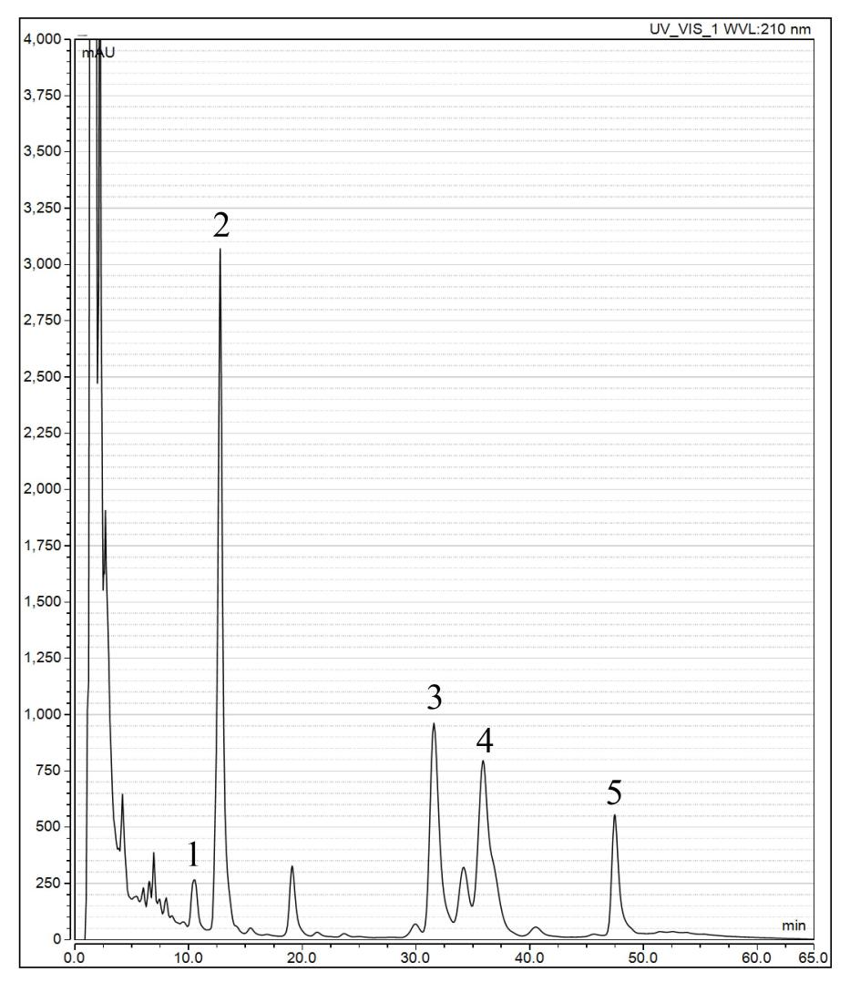
Supplementary Fig. 1. The representative chromatogram of phytochemical compounds in Alpinia officinarum Hance granules. (1) Kaempferol; (2) 5-hydroxy-1-phenyl-7-(4-hydroxy-3-methoxyphenyl)-3-heptanone; (3) Galangin; (4) 7-(4-hydroxy-3-methoxyphenyl)-1-phenylhept-4-en-3-one; (5) 5-hydroxy-1,7-diphenyl-3-heptanone.

