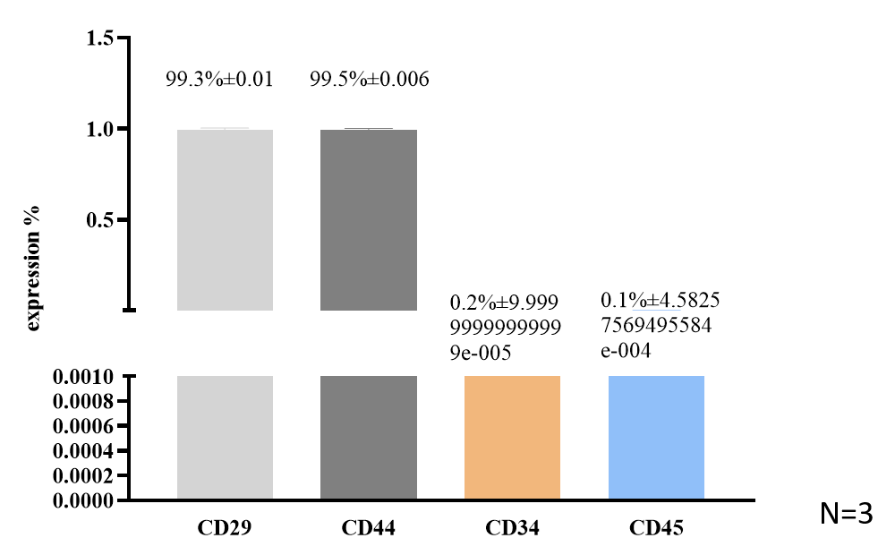
Supplementary Fig. 1. The N number and the % ± S.D results of Stem cell identification.

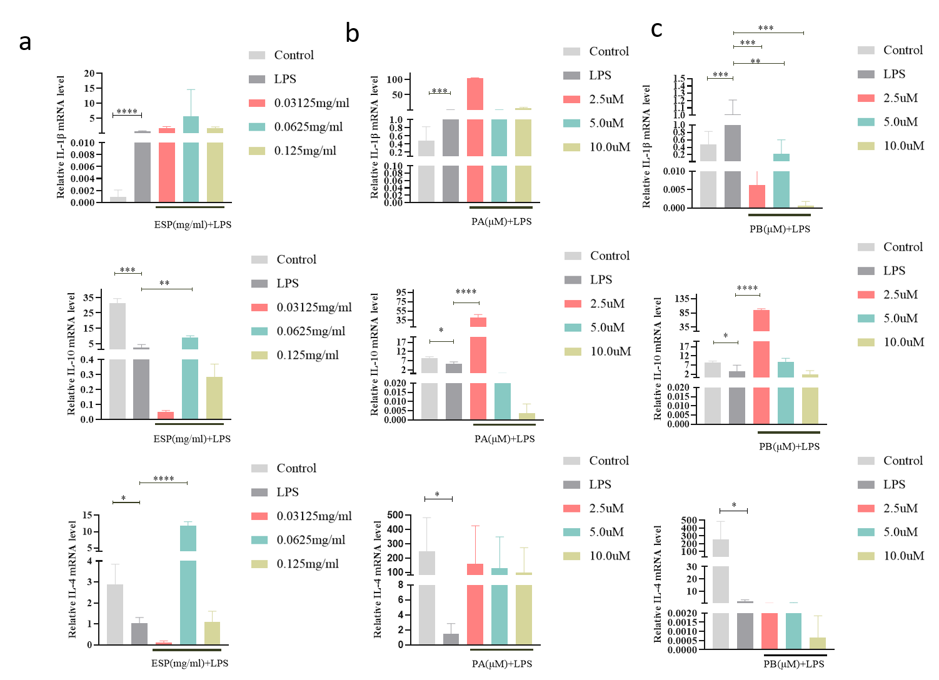
Supplementary Fig. 2. Effects of ESP, PA and PB on the inflammatory response of PDLSCs. The RNA expression of IL-1β, il-4 and il-10 with ESP at 0.03125 mg/ml 0.0625 mg/ml and 0.125 mg/ml in PDLSCs contrasted with that of the control groups (a). The mRNA expression of IL-1β, Il-4 and Il-10 with PA and PB at 2.5 μM, 5 μM and 10 μM in PDLSCs compared to the controls (b, c). Each bar represents the mean ± standard deviation (𝑛=3). ∗𝑃 <0.05; ∗∗𝑃 <0.01; ∗∗∗𝑃 < 0.001. ∗∗∗∗𝑃 < 0.0001

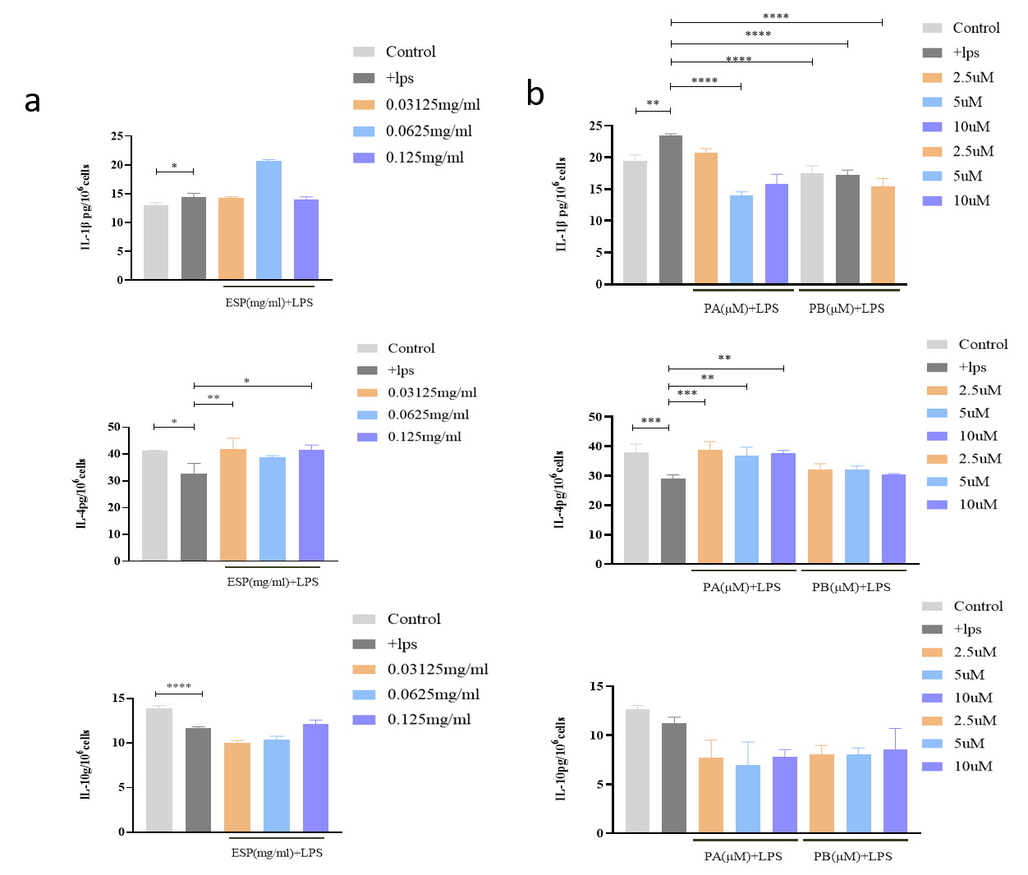
Supplementary Fig. 3. Effects of ESP, PA and PB on the inflammatory response of PDLSCs. The secretion protein expression of IL-1β, Il-4 and Il-10 with ESP at 0.03125 mg/ml 0.0625 mg/ml and 0.125 mg/ml in PDLSCs contrasted with that of the control groups (a). The secretion protein expression of IL-1β, Il-4 and Il-10 with PA and PB at 2.5 μM, 5 μM and 10 μM in PDLSCs compared to the controls (b, c). Each bar represents the mean ± standard deviation (𝑛=3). ∗𝑃 <0.05; ∗∗𝑃 <0.01; ∗∗∗𝑃 < 0.001. ∗∗∗∗𝑃 < 0.0001

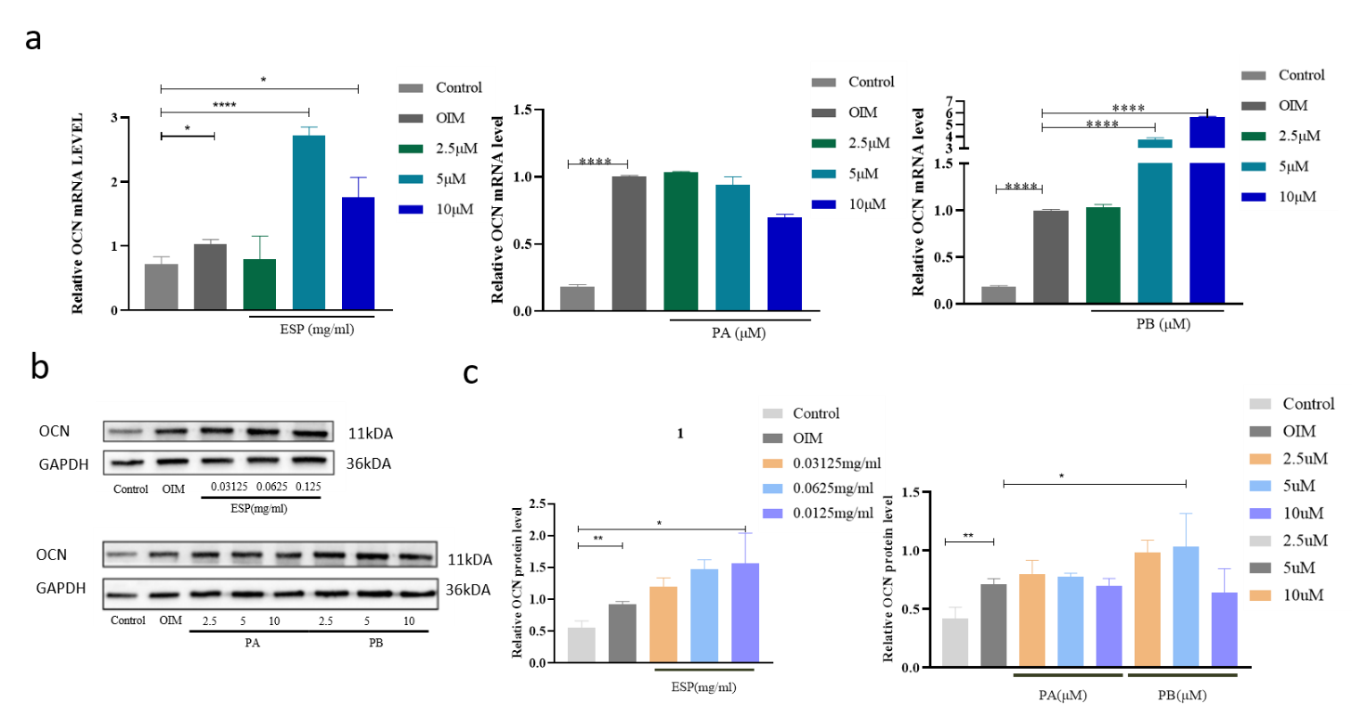
Supplementary Fig. 4. Effects of ESP, PA and PB on osteogenesis of PDLSCs. The mRNA and protein expression of OCN with ESP at 0.03125 mg/ml 0.0625 mg/ml and 0.125 mg/ml in PDLSCs vs. the control cells after osteogenic induction for 14 days (a, b, c). The mRNA and protein expression of OCN with PA and PB at 2.5 μM, 5 μM and 10 μM in PDLSCs compared to the controls after osteogenic induction for 14 days (a, b, c). Each bar represents the mean ± standard deviation (𝑛=3). ∗𝑃 <0.05; ∗∗𝑃 <0.01; ∗∗∗∗𝑃 < 0.0001.

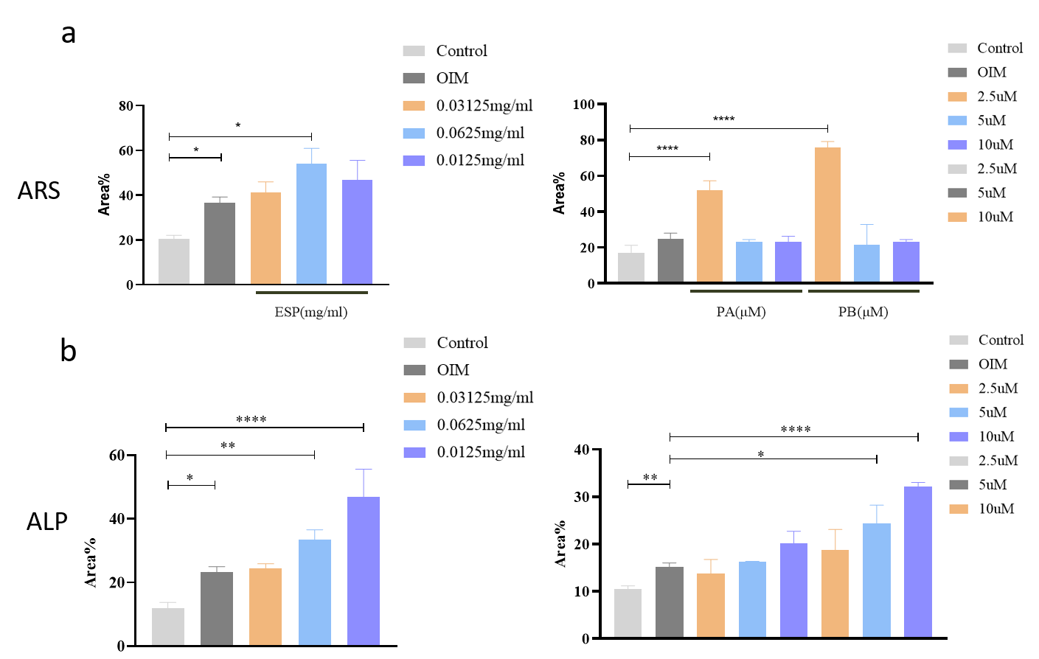
Supplementary Fig. 5. Effects of ESP, PA and PB on osteogenesis of PDLSCs. The quantitative data for AR staining and ALP staining) with with ESP at 0.03125 mg/ml 0.0625 mg/ml and 0.125 mg/ml and PA and PB at 2.5 μM, 5 μM and 10 μM in PDLSCs vs. the control cells after osteogenic induction for 14 days. Each bar represents the mean ± standard deviation (𝑛=3). ∗𝑃 <0.05; ∗∗𝑃 <0.01; ∗∗∗∗𝑃 < 0.0001.
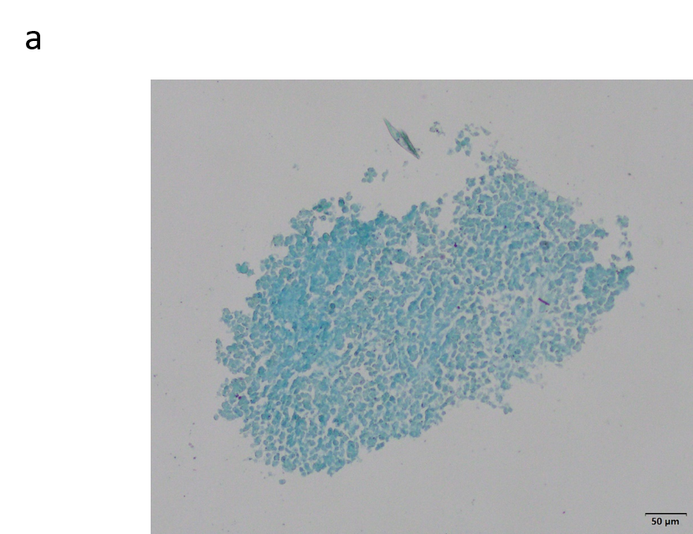
Supplementary Fig. 6. Chondrogenic differentiation of PDLSCs. PDLSCs (P3) formed a spiral arrangement in a fusiform shape (scale 200 μm) (a).

