Supplemental Material

Supplementary Material 1
Biological properties of putative CSC markers in this study
Putative CSC marker | Biological properties | References
CD133  (Prominin-1) | Widely proposed as a CSC marker, it has been found in the CSC fraction of a large variety of human malignancies including melanoma. CD133 can influence cell polarity, migration and interaction of CSCs with surrounding cells, contributing to metastatic potential. | [1]
CD271  (Low affinity Nerve Growth Factor Receptor, LNGFR) | Expression has been found on a number of human neural crest derived tissues and in some human cancers including melanomas. It has been shown to drive melanoma initiation and metastasis, thus endowing melanoma cells with stem-like properties. | [2,3]
CD44 (v7/8 and v10)  (CD44 isoforms v7/8 and v10) | CD44 is a multifunctional cell-surface glycoprotein with a variety of biological roles, some which are associated with the pathological activities of cancer cells such as migration, proliferation and survival signaling. It has been implicated in the progression and metastasis of several human tumours including melanoma. Due to alternative splicing, a number of CD44 isoforms exist, some which have been associated with tumour growth and metastasis. | [4]
ALDH1A1  (ALdehyde DeHydrogenase 1 family, member A1) | ALDH1A1 is a detoxifying enzyme responsible for the oxidation of intracellular aldehydes, thereby mediating self-protection and resistance to alkylating agents used in cancer therapy. This protein has received considerable attention as a marker for cells with enhanced tumourigenic/metastatic potential and elevated therapeutic resistance in several cancers of epithelial origin including melanoma. | [5]
Nestin | Nestin is a type VI intermediate filament protein expressed in organ-specific sites where it serves as a quiescent resource of cells capable of proliferation, differentiation and migration. Nestin has been reported to be present in various neoplasms and was shown to be over-expressed in advanced stages and to correlate with poor prognosis in melanoma patients. | [6]
ABCG2  (ATP Binding Cassette transporter G2) | Is the second member of the G family of ABC transporters, which transport molecules across extra- and intra-cellular membranes and are involved in drug efflux. It is therefore thought to contribute to multidrug resistance in cancer. ABCG2 expression has been associated with the enhanced tumourigenic potential of cancer cells. | [7]

Supplementary Material 2

Supplementary Material 3
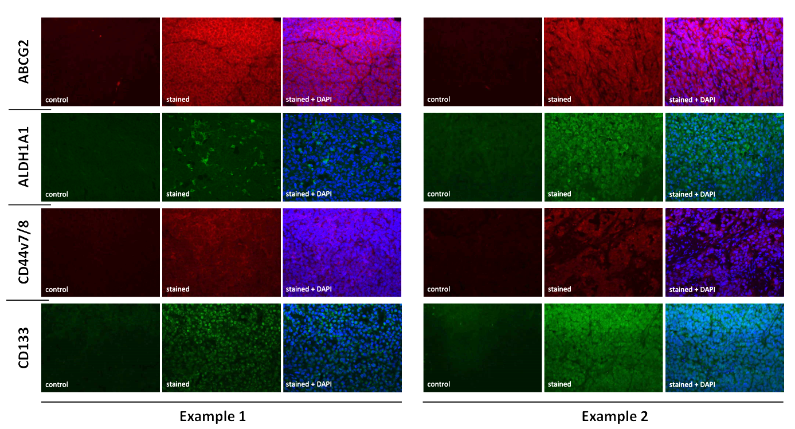

Supplementary Material 4
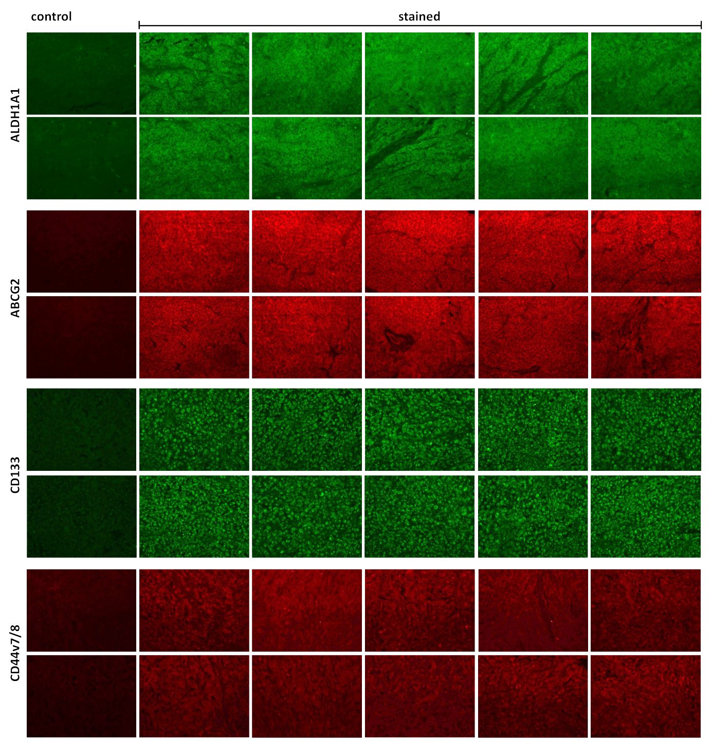

Supplementary Material 5
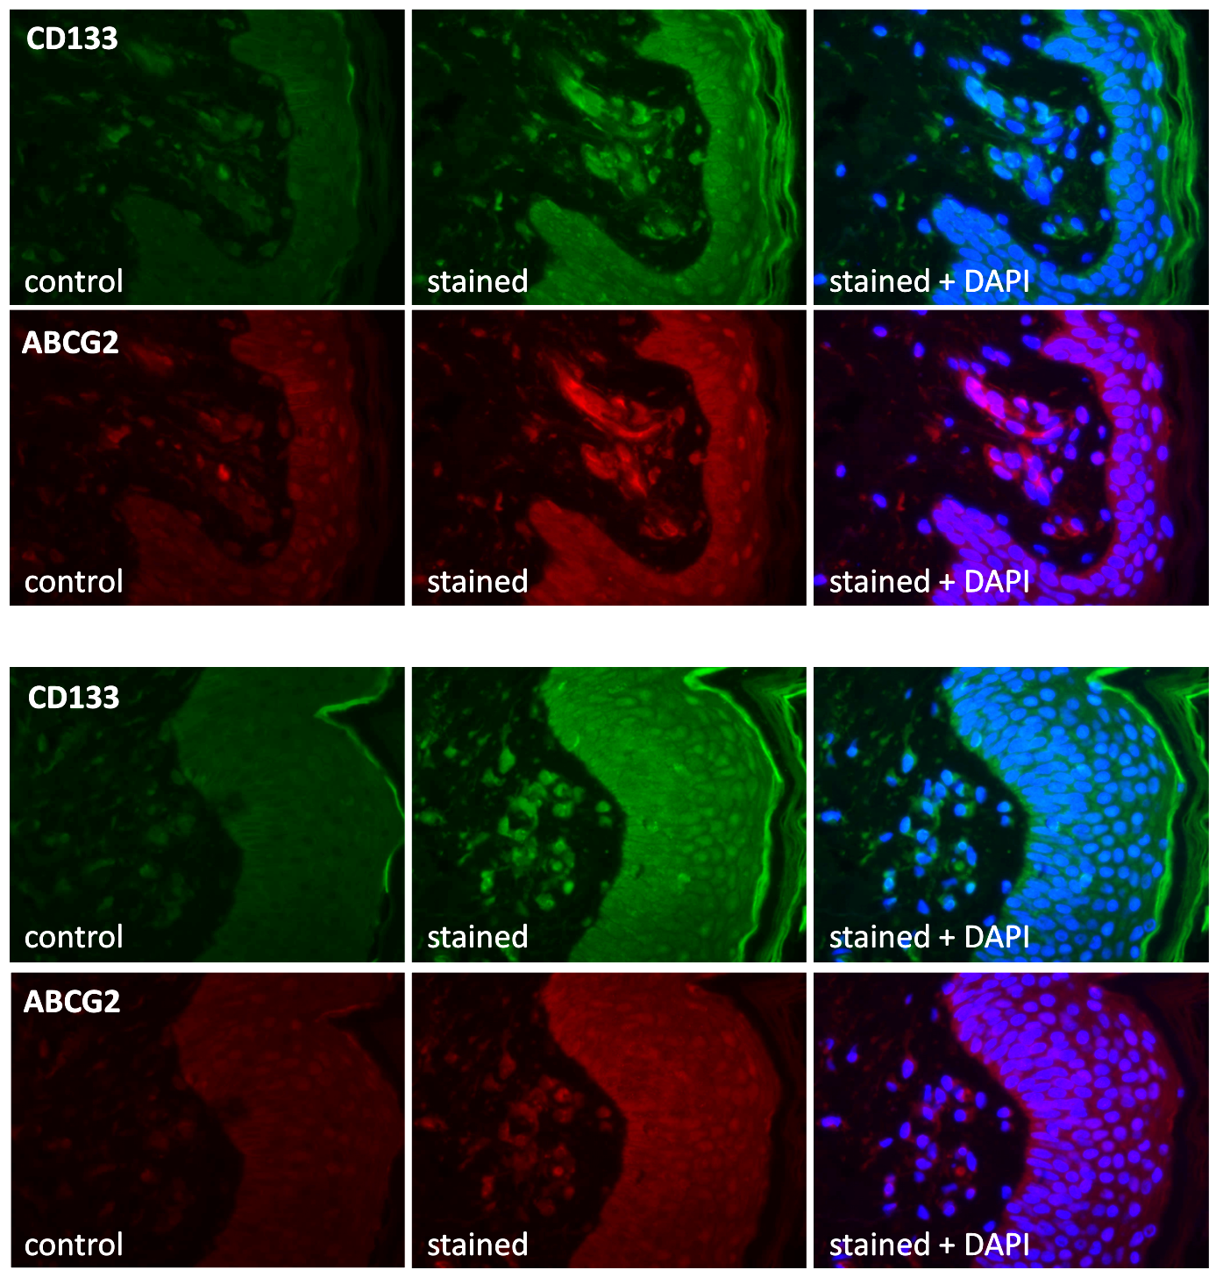

Supplementary Table 1
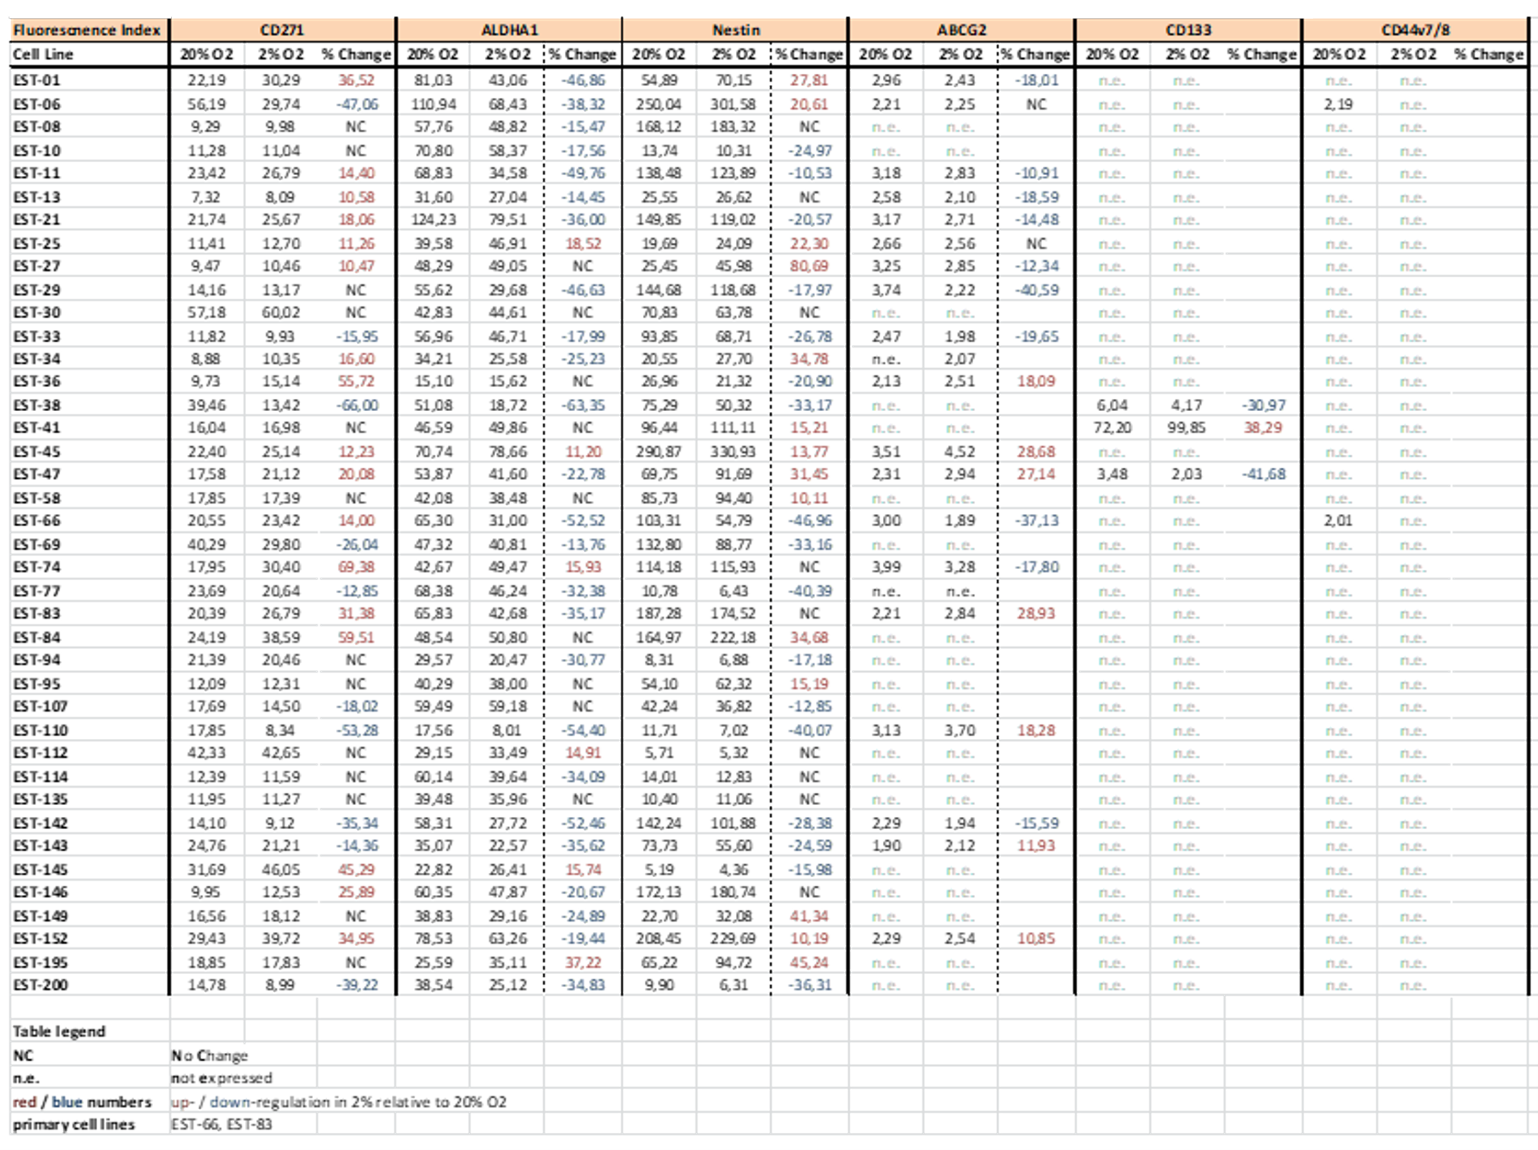

Reference
[1] Kloskowski T, Jarząbkowska J, Jundziłł A, Balcerczyk D, Buhl M, Szeliski K, et al. CD133 Antigen as a Potential Marker of Melanoma Stem Cells: In Vitro and In Vivo Studies. Stem Cells International. 2020; 2020: 8810476.
[2] Boiko AD, Razorenova OV, van de Rijn M, Swetter SM, Johnson DL, Ly DP, et al. Human melanoma-initiating cells express neural crest nerve growth factor receptor CD271. Nature. 2010; 466: 133–137.
[3] Civenni G, Walter A, Kobert N, Mihic-Probst D, Zipser M, Belloni B, et al. Human CD271-positive melanoma stem cells associated with metastasis establish tumor heterogeneity and long-term growth. Cancer Research. 2011; 71: 3098–3109.
[4] Dietrich A, Tanczos E, Vanscheidt W, Schöpf E, Simon JC. High CD44 surface expression on primary tumours of malignant melanoma correlates with increased metastatic risk and reduced survival. European Journal of Cancer. 1997; 33: 926–930.
[5] Luo Y, Dallaglio K, Chen Y, Robinson WA, Robinson SE, McCarter MD, et al. ALDH1A isozymes are markers of human melanoma stem cells and potential therapeutic targets. Stem Cells. 2012; 30: 2100–2113.
[6] Piras F, Perra MT, Murtas D, Minerba L, Floris C, Maxia C, et al. The stem cell marker nestin predicts poor prognosis in human melanoma. Oncology Reports. 2010; 23: 17–24.
[7] Monzani E, Facchetti F, Galmozzi E, Corsini E, Benetti A, Cavazzin C, et al. Melanoma contains CD133 and ABCG2 positive cells with enhanced tumourigenic potential. European Journal of Cancer. 2007; 43: 935–946.

