Supplementary Fig.s
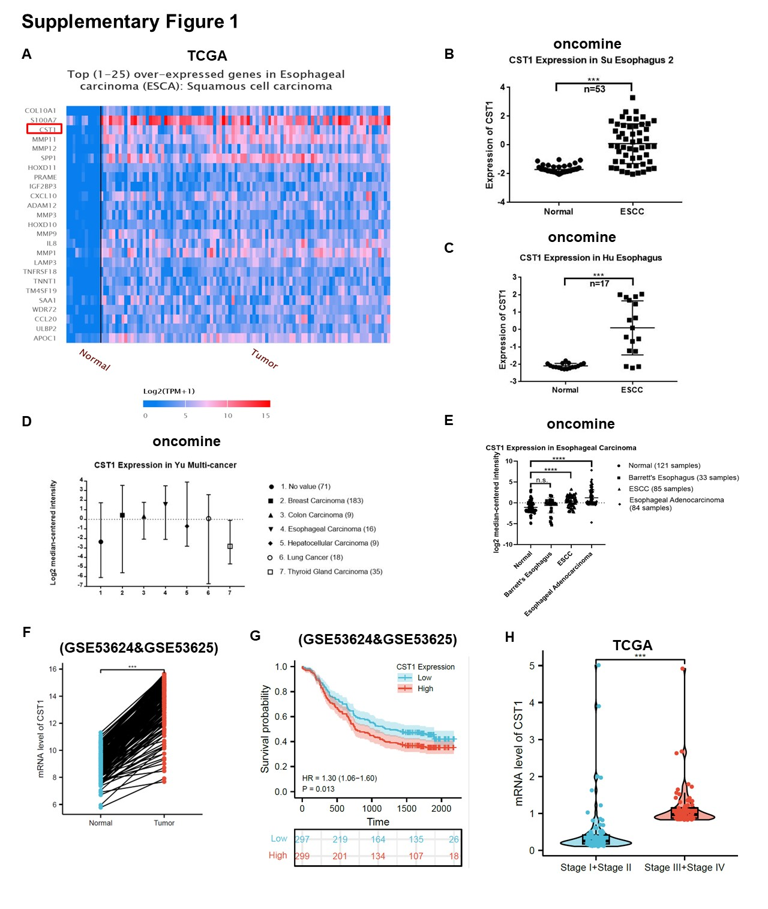
Supplementary Fig. 1 CST1 up-regulated in a variety of tumors which was associated with relatively poor survival.
A, a differential expression heatmap showed the top 25 overexpressed genes in ESCC based on the UALCAN database. B ~E, B, Among those cancers, esophageal cancer showed the highest mean expression of CST1. in the ONCOMINE database. C-E, In the ONCOMINE database, data from different investigators also showed that the expression level of CST1 in ESCC tissues was higher than that in normal tissues, and the difference was statistically significant. F, We found CST1 expression was significantly higher in the ESCA group than in the normal group based on GEO (Gene Expression Omnibus) datasets (GSE53624 & GSE53625). G, The high expression of CST1 was closely associated with poor overall survival (OS) of ESCA patients based on datasets (GSE53624 & GSE53625). H, The mRNA expression level of CST1 in advanced clinical stage III/IV was higher than in early stage I/II based on 180 samples in TCGA.

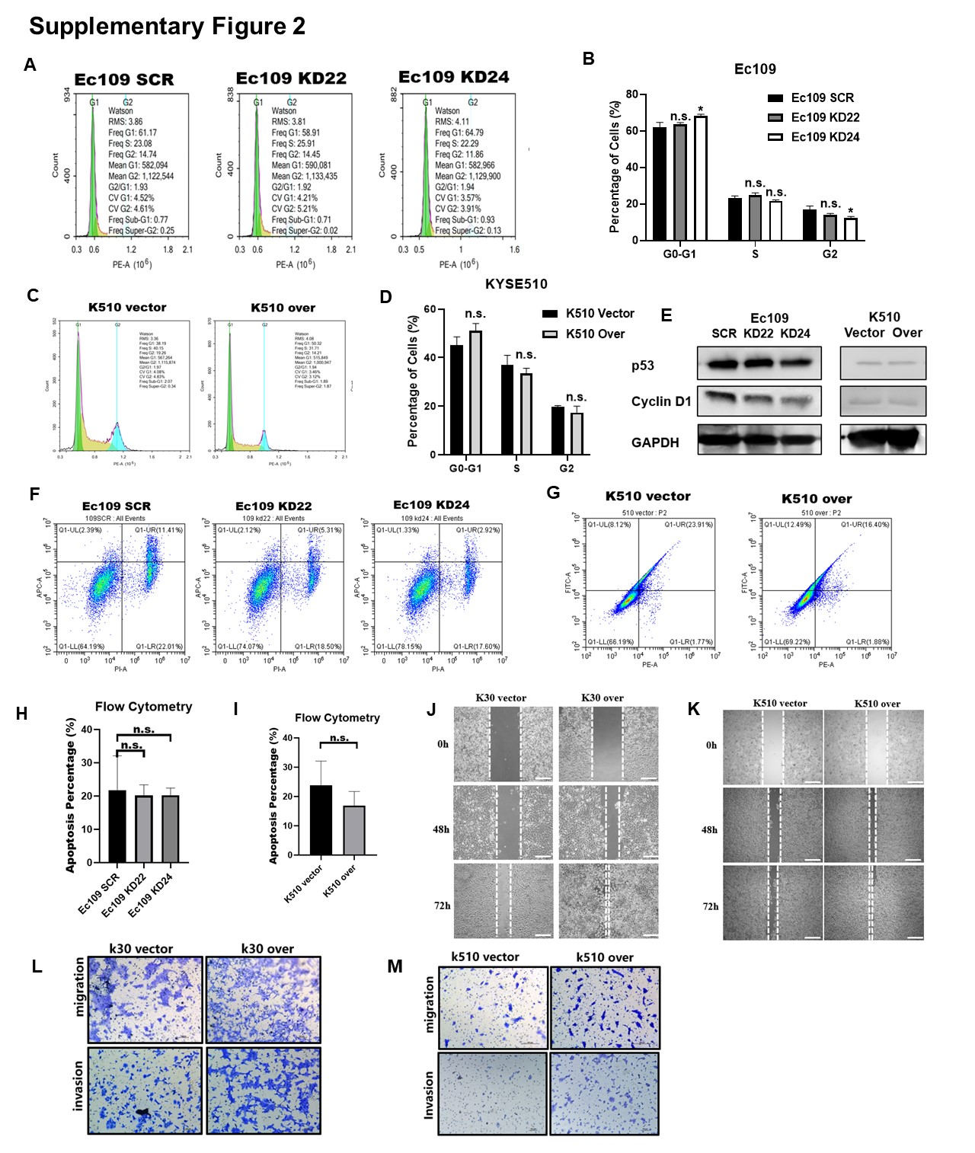
Supplementary Fig. 2 Over-expression of CST1 facilitated proliferation in vitro and in vivo not by influence ESCC apoptosis or cell cycle arrest.
A~I, We examined cell cycle and early apoptosis in CST1 knockdown and overexpressing stable cell lines by flow cytometry (FCM) and we found there were not significantly difference in cell cycle arrest (Supplementary Fig. 2A, B) or early apoptosis (Supplementary Fig. 2F and H) or between CST1 stable knockdown cells with its control. And there were not significantly difference in cell cycle arrest (Supplementary Fig. 2C and D) or early apoptosis (Supplementary Fig. 2G and 2I) in CST1 stable overexpressing cells with its control. The cell cycle arrest biomarker p53 and cyclinD1 seems like not obviously change by Western blot (Supplementary Fig. 2E).
Data were presented as the mean$±$s.d. of three independent experiments. *p < 0.05, **p < 0.01, ***p < 0.001 by student’s t-test.

