- Supplementary Materials –

Antiproliferative Activity of Lignans from Olea ferruginea: in vitro Evidence Supported by Docking Studies
Abdur Rauf ^{1,2}*, Umer Rashid³, Aniqa Atta^{4,} Ishaq Khan^{4,5}, Zafar Ali Shah¹, Bushra Mobeen², Aneela Javed⁶, Taghrid S. AlOmar¹, Najla Almasoud¹, Saima Naz⁷, Zubair Ahmad¹, Giovanni Ribaudo⁸*
¹ Department of Chemistry, College of Science, Princess Nourah bint Abdulrahman University, P.O. Box 84427, Riyadh 11671, Saudi Arabia
² Department of Chemistry, University of Swabi, Swabi, Anbar, 23430, Khyber Pakhtunkhwa (K.P.), Pakistan
³ Department of Chemistry, COMSATS University Islamabad, 22060 Abbottabad, Pakistan
⁴ Cancer Cell Culture & Precision Oncomedicine Lab, Institute of Basic Medical Sciences, Khyber Medical University, Peshawar 25100, Pakistan
⁵ Dept. of Pharmaceutical Sciences, Taxes A&M Health Science Center, Joe H. Reynolds Medical Sciences Build, College Station, TX 77843, USA
⁶ Molecular Immunology laboratory, Department of Healthcare Biotechnology, Atta-ur-Rahman School of Applied Biosciences, National University of Sciences and Technology, Islamabad 44000, Pakistan
⁷ Institute of Biotechnology & Microbiology, Bacha Khan University Charsadda, Khyber Pakhtunkhwa (K.P.), Pakistan
⁸ Department of Molecular and Translational Medicine, University of Brescia, Brescia, Italy

*Correspondence:
Prof. Abdur Rauf; Dr. Giovanni Ribaudo

Email: abdurrauf@uoswabi.edu.pk; giovanni.ribaudo@unibs.it

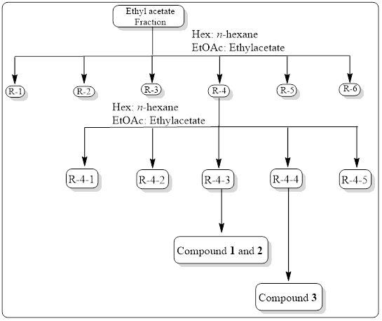
Supplementary Fig. 1. Scheme depicting the isolation and purification processes of compounds from the ethyl acetate fraction of O. ferruginea extract.

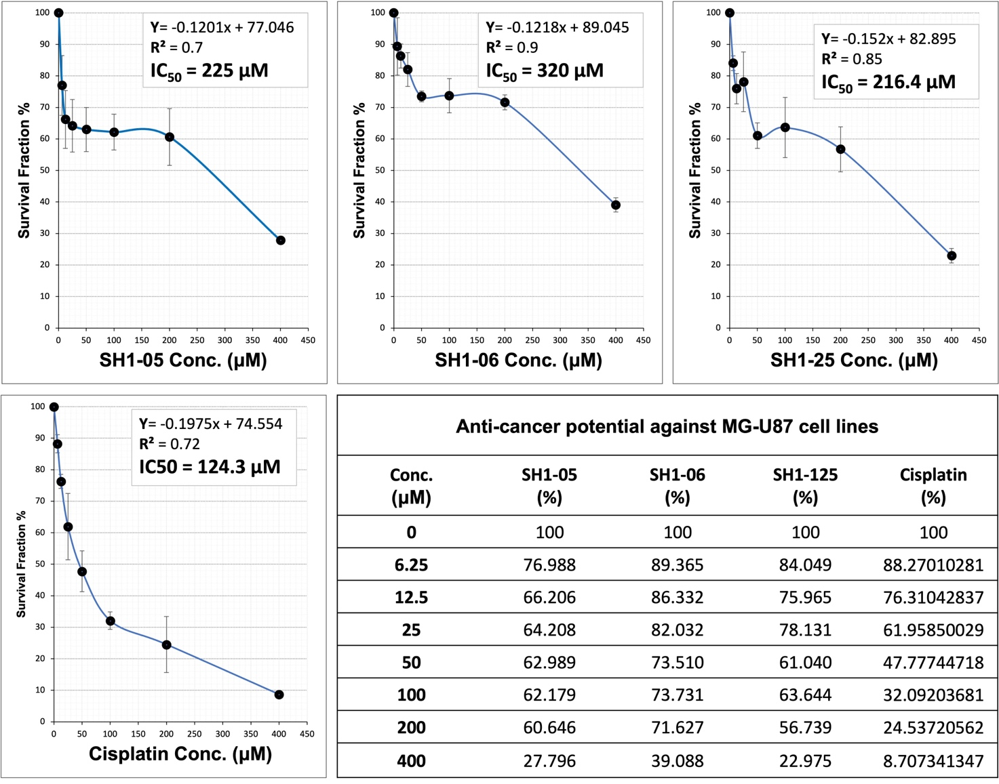
Supplementary Fig. 2. Cell survival after treatment with different concentrations (from 6.25 to 400 µM) of the tested compounds (SH1-05 = 1, SH1-06 = 2, SH1-25 = 3) and cisplatin, which was used as a reference.

