Supplementary Materials

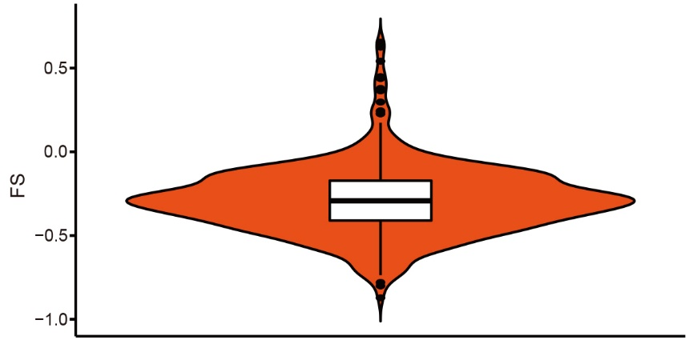
Supplementary Fig. 1. Ranges of FSs in COAD patients.

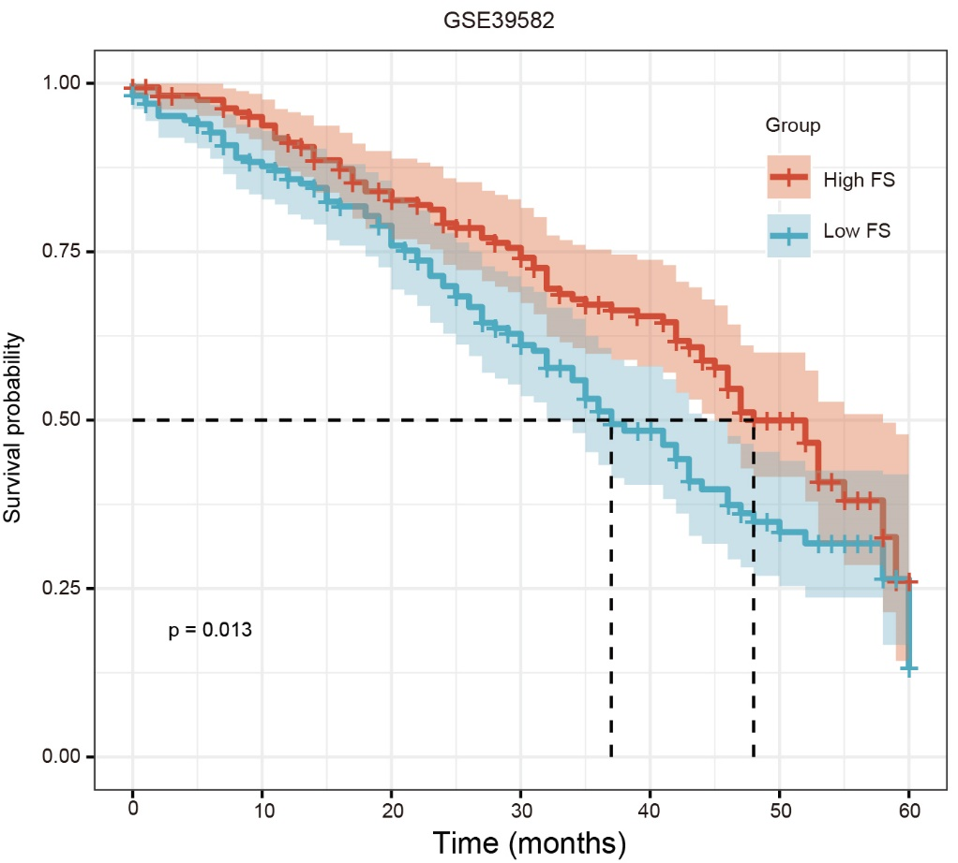
Supplementary Fig. 2. Correlation between FS and COAD survival was repeated in an independent COAD cohort from GSE39582.

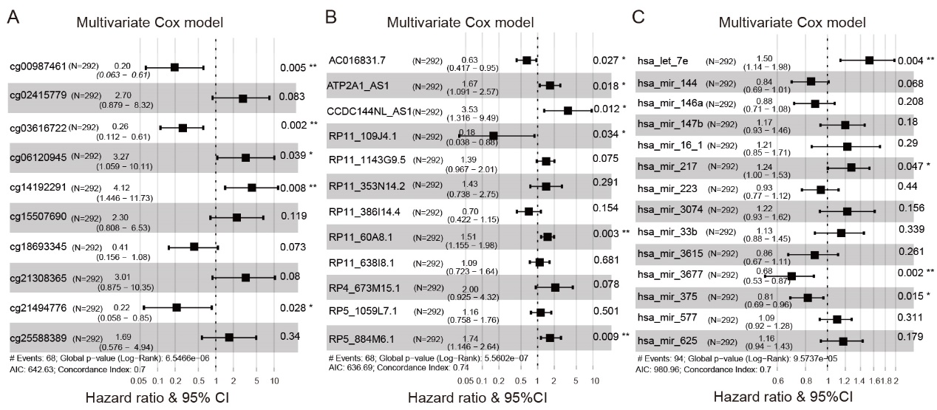
Supplementary Fig. 3. Forest plot of variables for multivariate Cox regression analysis of each DNAm (A), lncRNA (B), and miRNA signature (C).

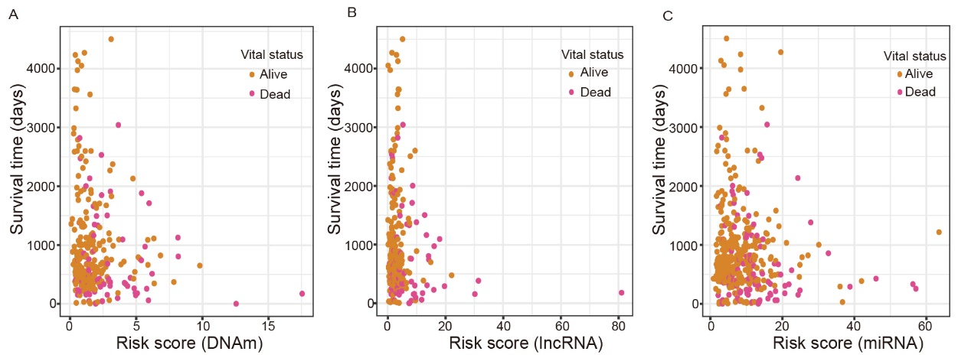
Supplementary Fig. 4. Vital status of COAD patients in high- and low-risk groups based on signatures at three molecular levels, i.e., DNAm (A), lncRNA (B), and miRNA (C).

Supplementary Table 1. Correlations between risk rscores and methylation and expression levels of the 10 DMCs, 12 lncRNAs, and 14 miRNAs in corresponding three signatures.
Variable | Pearson correlation coefficient | P value
DNAm signature
cg00987461 | -0.21352 | 0.000237
cg02415779 | 0.107022 | 0.06782
cg03616722 | -0.37817 | 2.32E-11
cg06120945 | 0.185212 | 0.001478
cg14192291 | 0.203271 | 0.000474
cg15507690 | 0.192529 | 0.000944
cg18693345 | -0.21393 | 0.000231
cg21308365 | 0.280905 | 1.07E-06
cg21494776 | -0.23586 | 4.69E-05
cg25588389 | 0.072788 | 0.214932
lncRNA signature
AC016831.7 | -0.22303 | 0.000121
ATP2A1_AS1 | 0.285465 | 7.02E-07
CCDC144NL_AS1 | 0.547455 | 3.12E-24
RP11_109J4.1 | -0.17279 | 0.003053
RP11_1143G9.5 | 0.297399 | 2.25E-07
RP11_353N14.2 | 0.208393 | 0.000337
RP11_386I14.4 | -0.18609 | 0.001402
RP11_60A8.1 | 0.192191 | 0.000964
RP11_638I8.1 | 0.180472 | 0.001961
RP4_673M15.1 | 0.177203 | 0.002373
RP5_1059L7.1 | 0.108019 | 0.065285
RP5_884M6.1 | 0.140758 | 0.016087
miRNA signature
hsa_let_7e | 0.256136 | 8.58E-08
hsa_mir_144 | -0.34333 | 3.35E-13
hsa_mir_146a | -0.2582 | 6.70E-08
hsa_mir_147b | 0.011633 | 0.811004
hsa_mir_16_1 | 0.008781 | 0.856762
hsa_mir_217 | 0.321042 | 1.21E-11
hsa_mir_223 | -0.20462 | 2.13E-05
hsa_mir_3074 | 0.057835 | 0.234135
hsa_mir_33b | 0.018309 | 0.706645
hsa_mir_3615 | -0.17001 | 0.000431
hsa_mir_3677 | -0.37841 | 6.44E-16
hsa_mir_375 | -0.29602 | 4.82E-10
hsa_mir_577 | 0.045709 | 0.347198
hsa_mir_625 | -0.04667 | 0.337106

