Supplementary data

Supplementary Fig. 1. Next-generation sequencing results for non-transfected A549 cells using gRNA1 and gRNA2 adapter primers as well as non-transfected Huh7 cells and gRNA1 transfected Huh7 cells using gRNA1 adapter primers. Panel (A) represents non-transfected A549 cells analyzed with gRNA1 adapter primers, while panel (B) represents non-transfected A459 cells analyzed with gRNA2 adapter primers. Panels (C) and (D) represent non-transfected Huh7 cells and gRNA1-transfected Huh7 cells, respectively, both analyzed using gRNA1 adapter primers. The pie charts illustrate the percentage and number of reads, indicating unmodified alleles (blue) and modified alleles (orange).

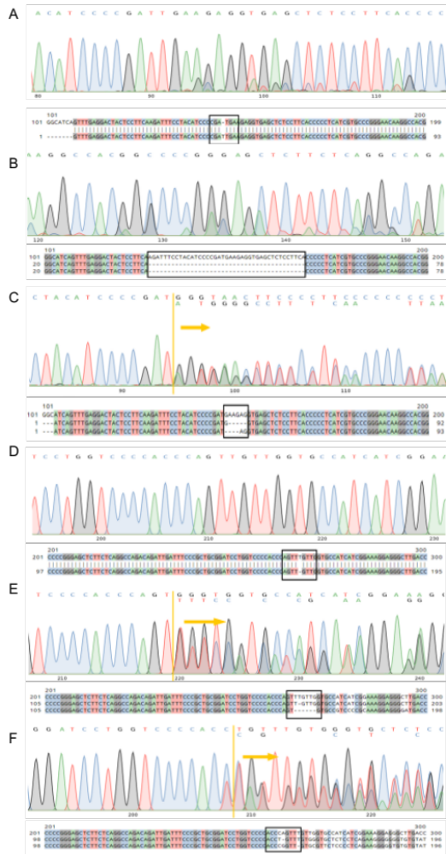
Supplementary Fig. 2. Mutations observed through Sanger sequencing in LLC1 IMP2 knockout clones resulting from the CRISPR/Cas9 approach. The sequencing chromatograms and corresponding sequence alignments with wild-type reference are presented above, depicting different editing events in the Igf2bp2 target locus. Panels show (A) biallelic T insertion (clone bKO6), (B) biallelic 41 bp deletion (clone bKO5), (C) biallelic editing with different mutations per allele (AAGAGG deletion in one allele and GAAG deletion in the other allele (clone bKO1), (D) biallelic T deletion (clone bKO4), (E) biallelic editing with different mutations per allele T deletion in one allele and TTGTTG deletion in the other allele (clone bKO3), and (F) biallelic editing with different mutations per allele like CA deletion in one allele and A deletion in the other allele (clone bKO2). The first line of the alignment represents the reference sequence, while the line/lines below represent the edited sequence. The site of editing is highlighted by a black frame. The yellow arrow highlights the start site of the edit in the clone. Nucleotides are visually represented using the following color codes; A: adenine (green), C: cytosine (blue), G: guanine (black), and T: thymine (red). A missing DNA base is indicated by a dash (-).
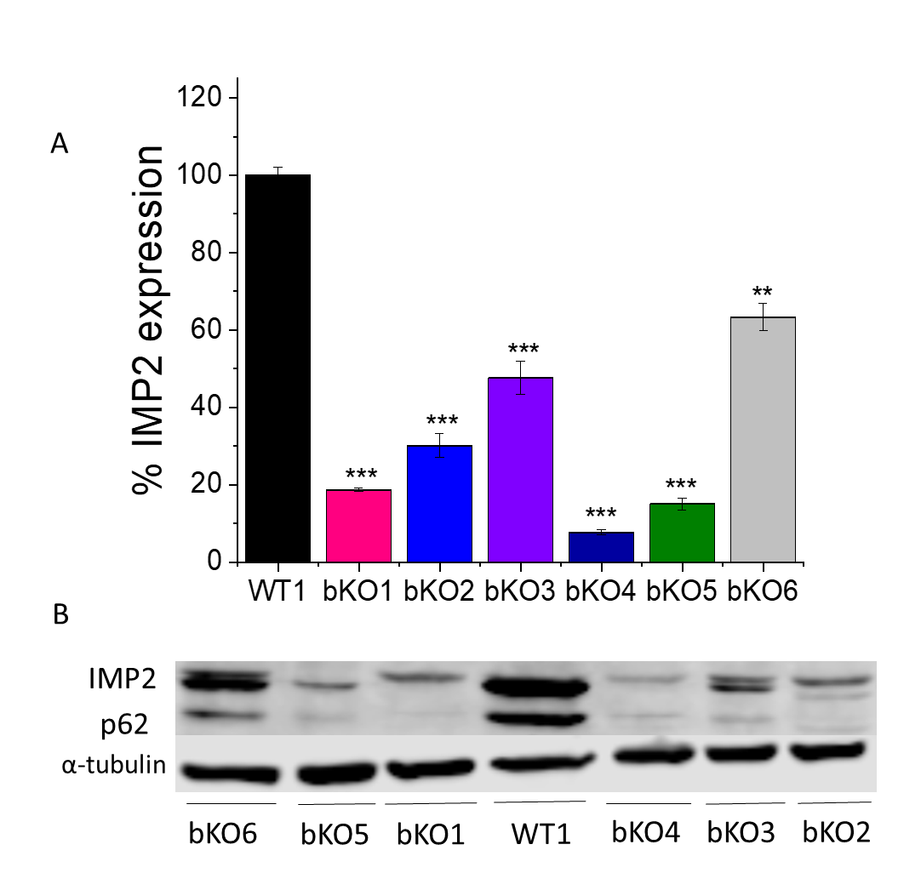
Supplementary Fig. 3. Western blot analyses of IMP2 knockout LLC1 clones resulting from CRISPR/Cas9 approach. (A) The protein levels of IMP2 and p62 were quantified in biallelic knockout (bKO) LLC1 clones and compared to wild-type (WT1)/LLC1 control cells. IMP2 (66 kDa) and its splice variant p62 (62 kDa) were analyzed against alpha-tubulin (55 kDa) serving as the housekeeping protein. (B) Representative western blots. The bars represent mean ± SEM. n=2 (duplicates). *p < 0.05, **p < 0.01, and ***p < 0.001 compared to values of WT1 cells.

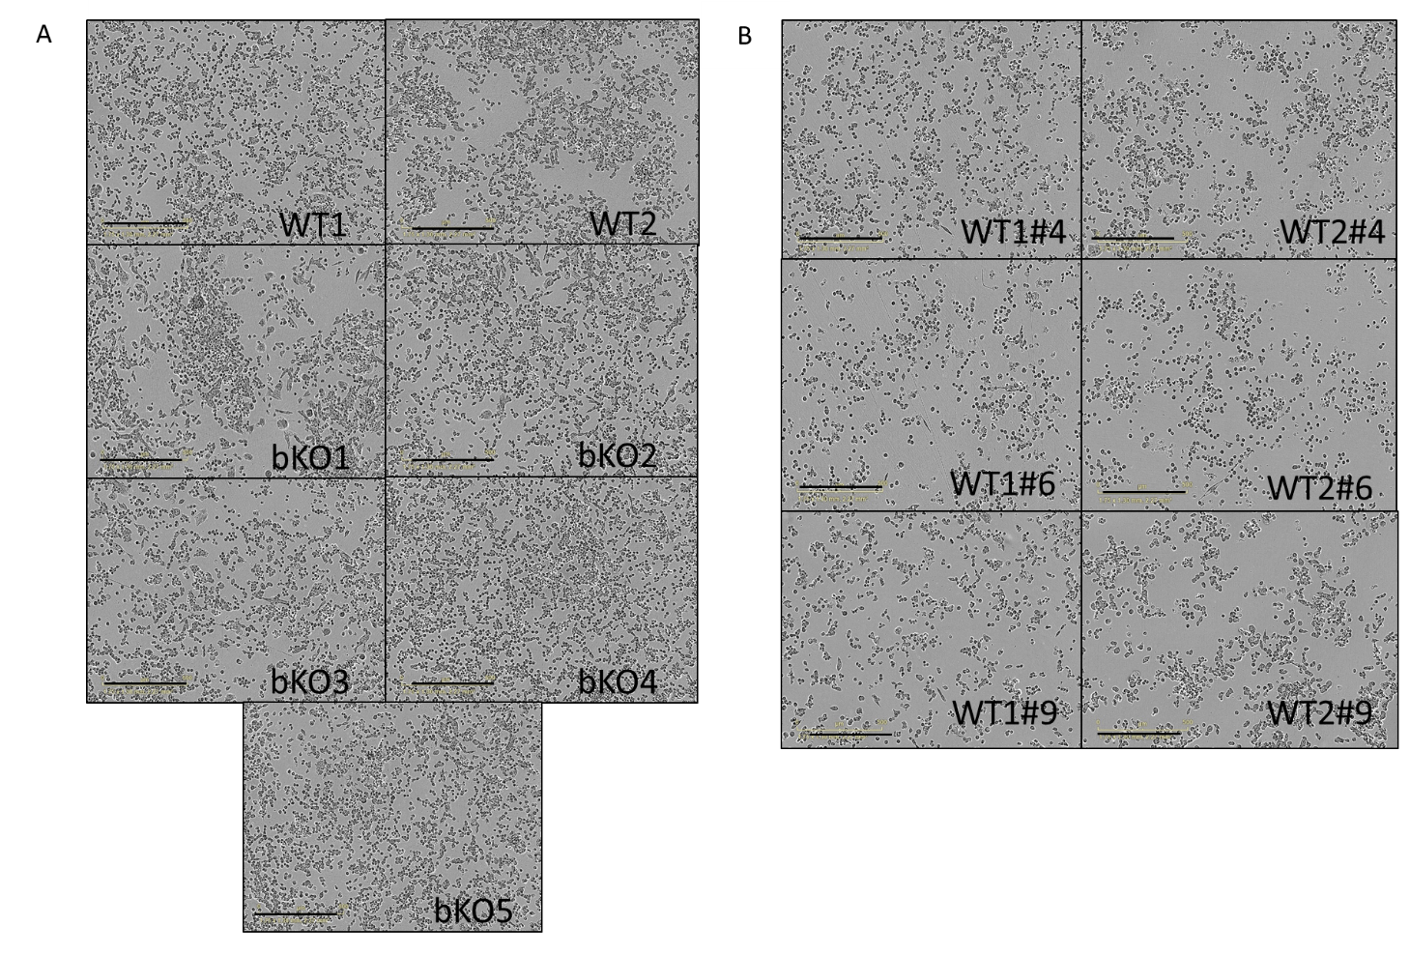
Supplementary Fig. 4. Microscopic images of wild-type and biallelic IMP2 knockout LLC1 cells and wild-type LLC1 cells upon IMP2 inhibitor treatment. (A) Wild-type and biallelic IMP2 knockout LLC1 cells at 48 h post-seeding. (B) The effects of IMP2 inhibitor compounds # 4, 6, and 9 at 30 µM after 48 h post-treatment. Images were obtained using the IncuCyte® S3 live cell imaging system; scale bar = 500 µm.

