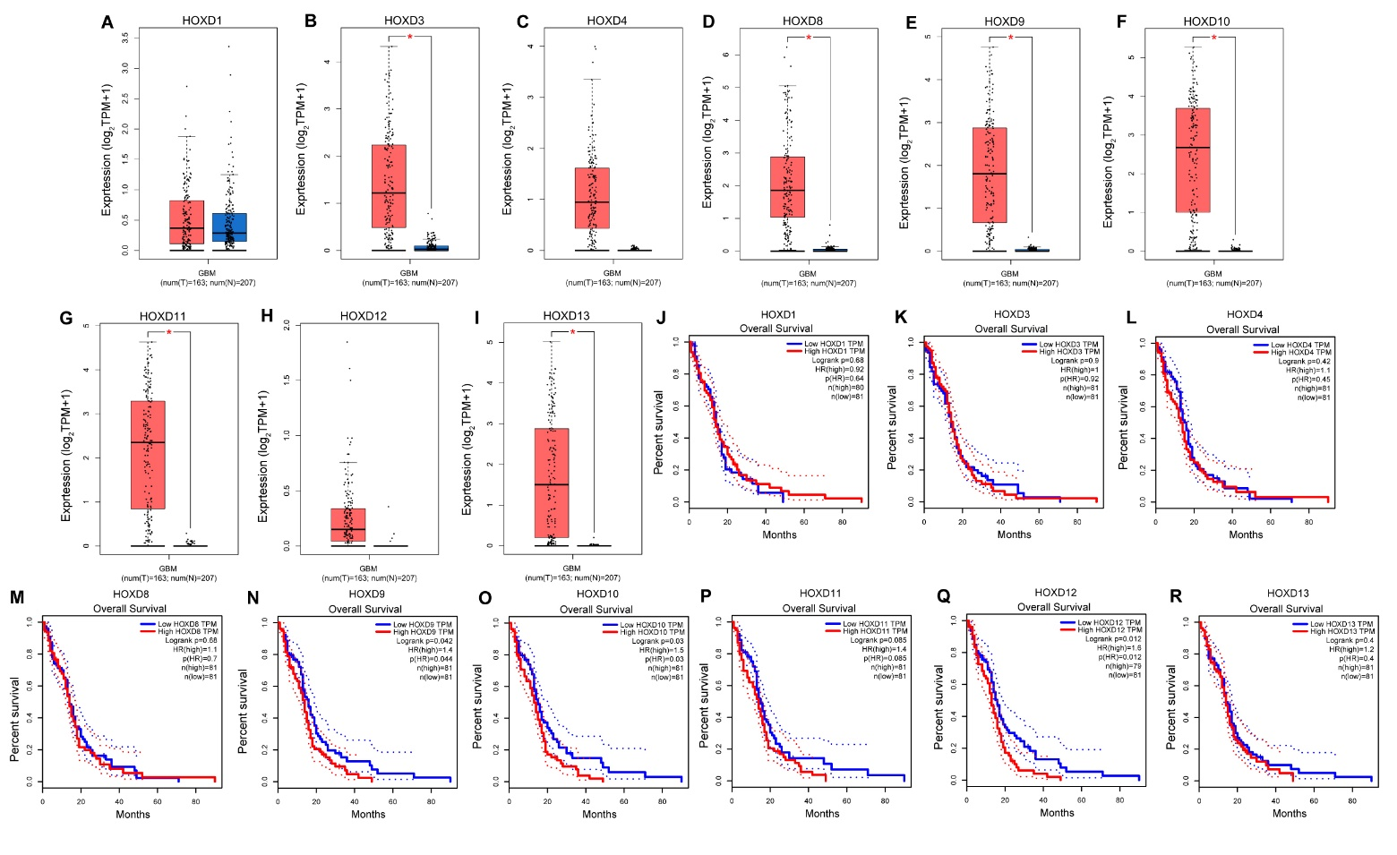
Supplementary Fig. 1. GEPIA online analyzed HOX family genes in the GBM dataset. (A-I) GEPIA online investigated the differential expression in the GBM dataset. (J-R) GEPIA online assessed the prognosis of the KM curve (OS) in the GBM dataset. The red square in the figure represents the tumor group (T); The blue squares represent the normal group (N). *P < 0.01, P (HR) < 0.05. GEPIA, Gene Expression Profiling Interactive Analysis; HOX, homeobox; GBM, Glioblastoma; KM, Kaplan-Meier; OS, overall survival; HR, hazard ratio.

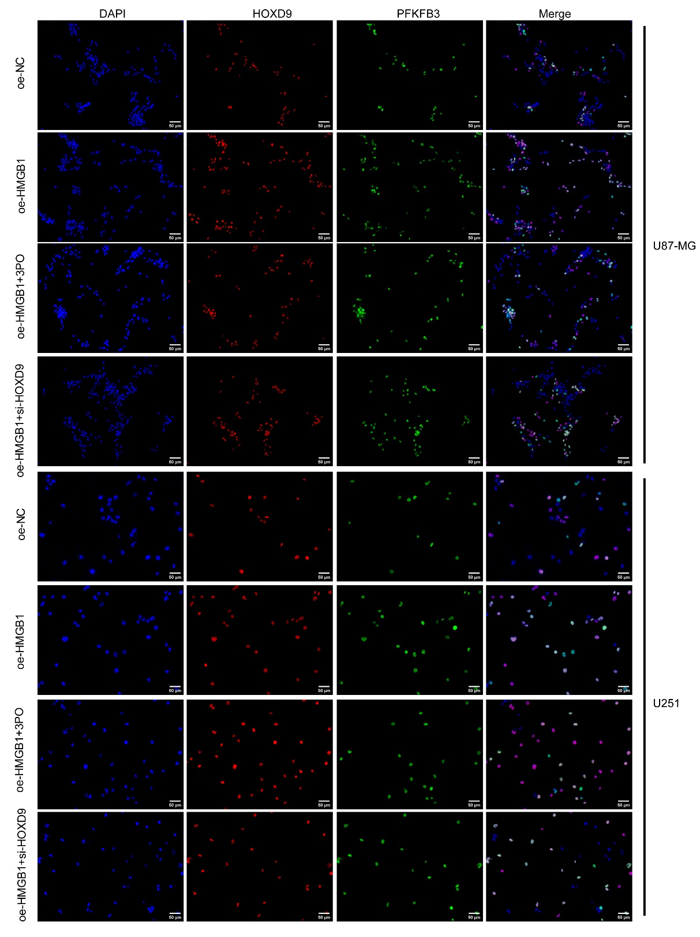
Supplementary Fig. 2. Representative images of HOXD9 and PFKFB3 expression in U87-MG and U251 cells detected using IF. Scale bar = 50 μm.

Supplementary Table 1. Patient Characteristics of GBM patients in the TCGA datasets.
Characteristic | levels | Low expression of HOXD9 | High expression of HOXD9 | P
n |  | 84 | 84
Gender, n (%) | Female | 32 (19%) | 27 (16.1%) | 0.518
 | Male | 52 (31%) | 57 (33.9%)
Age, n (%) | ≤60 | 44 (26.2%) | 43 (25.6%) | 1.000
 | >60 | 40 (23.8%) | 41 (24.4%)
IDH status, n (%) | WT | 73 (45.3%) | 76 (47.2%) | 0.747
 | Mut | 7 (4.3%) | 5 (3.1%)
OS event, n (%) | Alive | 16 (9.5%) | 16 (9.5%) | 1.000
 | Dead | 68 (40.5%) | 68 (40.5%)
DSS event, n (%) | Alive | 16 (10.3%) | 18 (11.6%) | 0.947
 | Dead | 60 (38.7%) | 61 (39.4%)
PFI event, n (%) | Alive | 14 (8.3%) | 18 (10.7%) | 0.556
 | Dead | 70 (41.7%) | 66 (39.3%)

