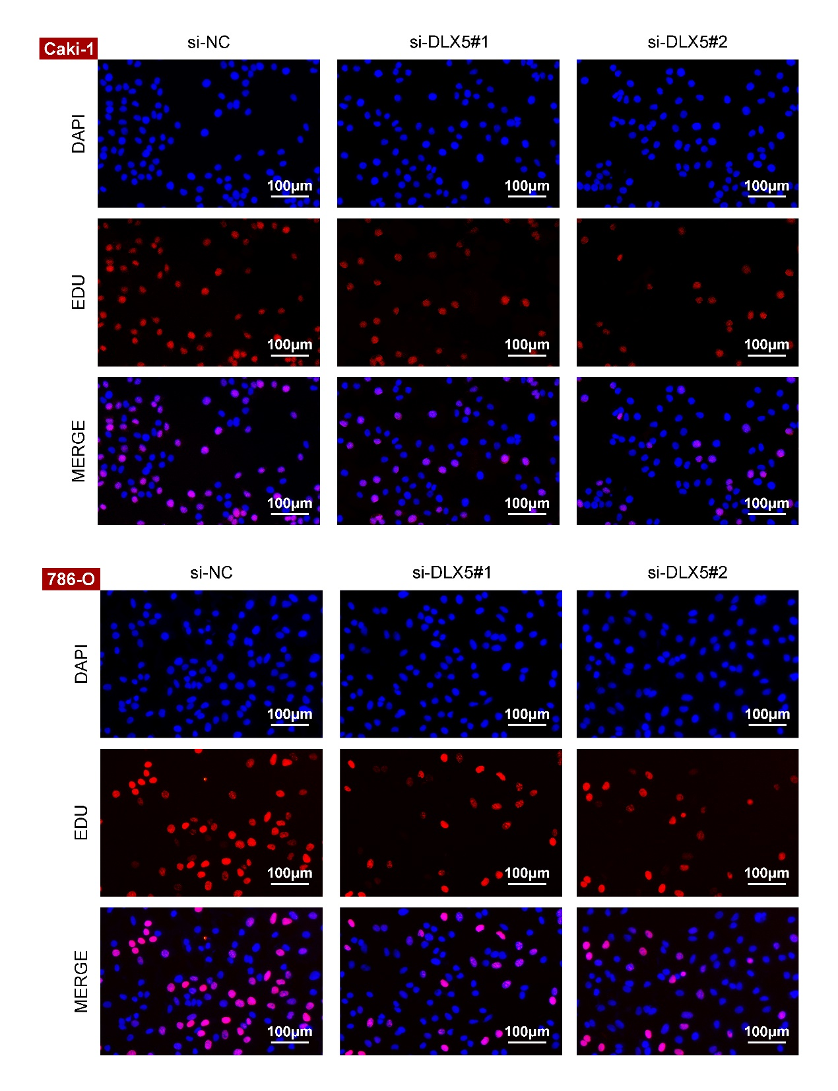
Fig. S1. Proliferation was assessed by 5-Ethynyl-2′-deoxyuridine (EdU) incorporation assay. Scale bars = 100μm. (corresponding to Fig. 2C)

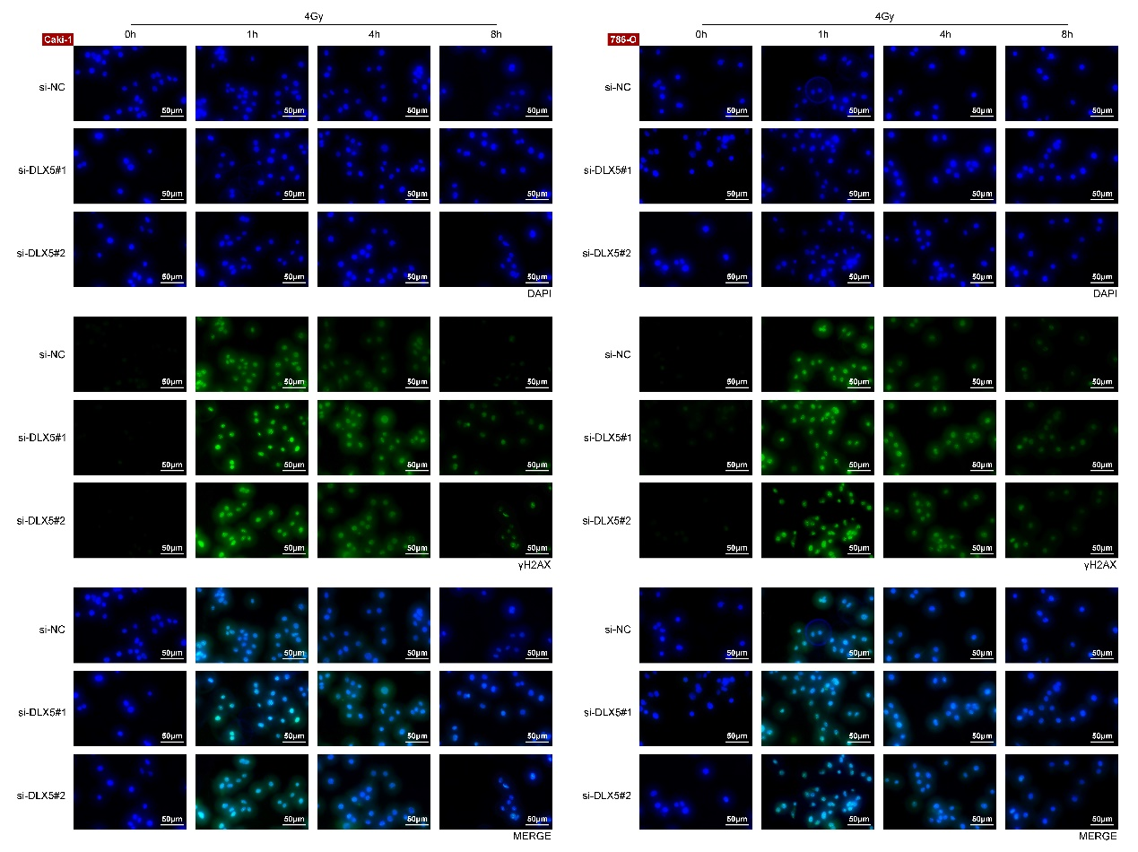
Fig. S2. The relative gamma histone H2AX (γH2AX) levels were detected by immunofluorescence (IF) in 786-O and Caki-1 cells. Scale bars = 50μm. (corresponding to Fig. 4A)

