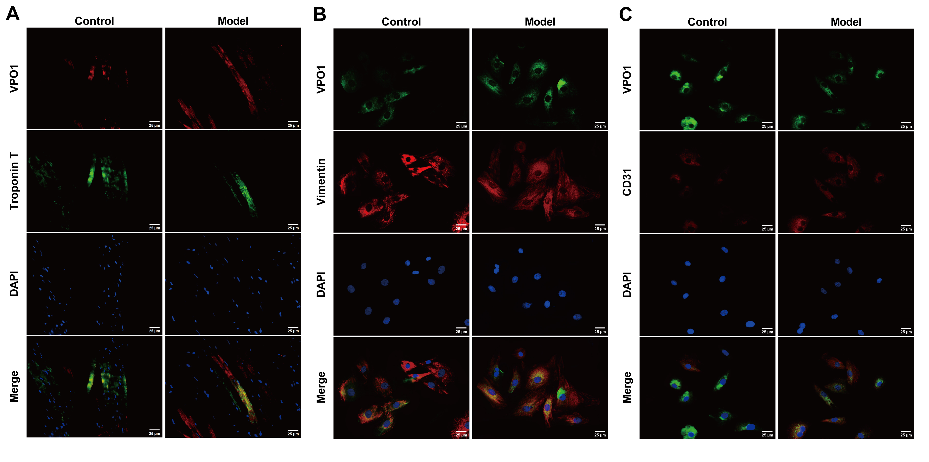
Figure S1. VPO1 expression in various cell types of rat heart. (A) IF detection for co-localization of VPO1 and Troponin T. Scale bar = 25 μm. (B) IF inspection for co-localization of VPO1 and vimentin. Scale bar = 25 μm. (C) IF measurement for co-localization of VPO1 and CD31. n = 5. Scale bar = 25 μm.

