Supplementary Material
s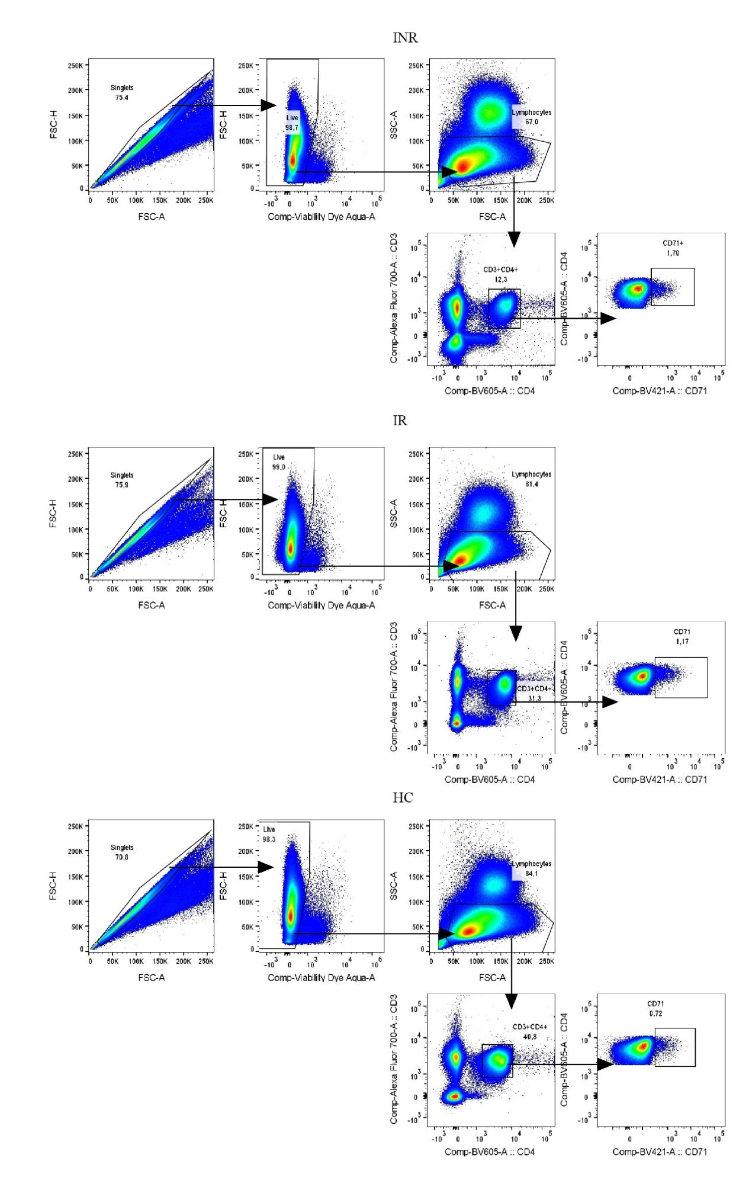
Supplementary Fig. 1A. Gating strategy for identifying activated/cycling CD4⁺ T-cells. Initially, single cells were identified. From these, viable cells were selected. The viable single cells were analyzed, and lymphocytes were identified. Subsequently, CD4⁺ T-cells were selected from the lymphocyte population. The proportion of activated/cycling CD4⁺ T-cells was determined based on their CD71 marker expression.

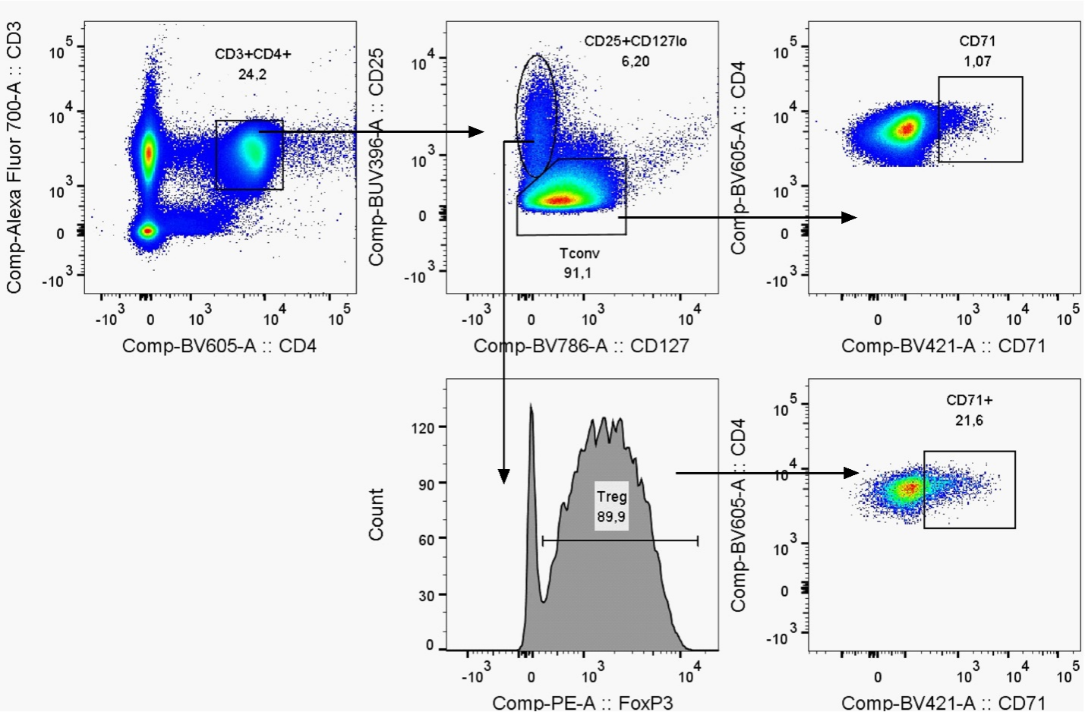
Supplementary Fig. 1B. Identification of activated/cycling cells within conventional (Tconv) and regulatory (Treg) CD4⁺ T-lymphocyte subsets. From the CD4⁺ T-cell pool, we identified the CD25^{–/lo}Tconv subset. For the Treg subset, we gated on CD25⁺CD127^{lo} cells, then identified FOXP3⁺ cells within this population as bona fide Tregs. The frequency of CD71⁺ activated/cycling cells was directly determined within both the Tconv and Treg subsets.

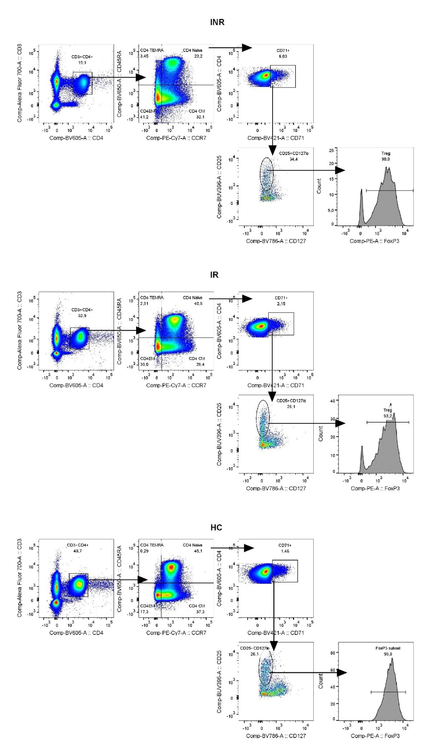
Supplementary Fig. 2. Gating strategy to determine regulatory T-lymphocyte frequency within activated/cycling CD4⁺ T-cell subsets. CD4⁺ T-cells were first divided into subsets based on expression of CD45RA and CCR7, identifying naive (CD45RA⁺CCR7⁺), central memory (CD45RA–CCR7⁺), effector memory (CD45RA–CCR7–), and TEMRA (CD45RA⁺CCR7–) populations. Activated/cycling (CD71⁺) cells were then identified within each CD4⁺ T-cell subset. Among the activated/cycling cells, CD25⁺CD127^{lo} cells were first gated, and FOXP3⁺ Tregs were subsequently identified within this population. The frequency of CD25⁺CD127^{lo}FOXP3⁺ Tregs was subsequently determined among activated/cycling cells within each CD4⁺ T-cell maturation subset.

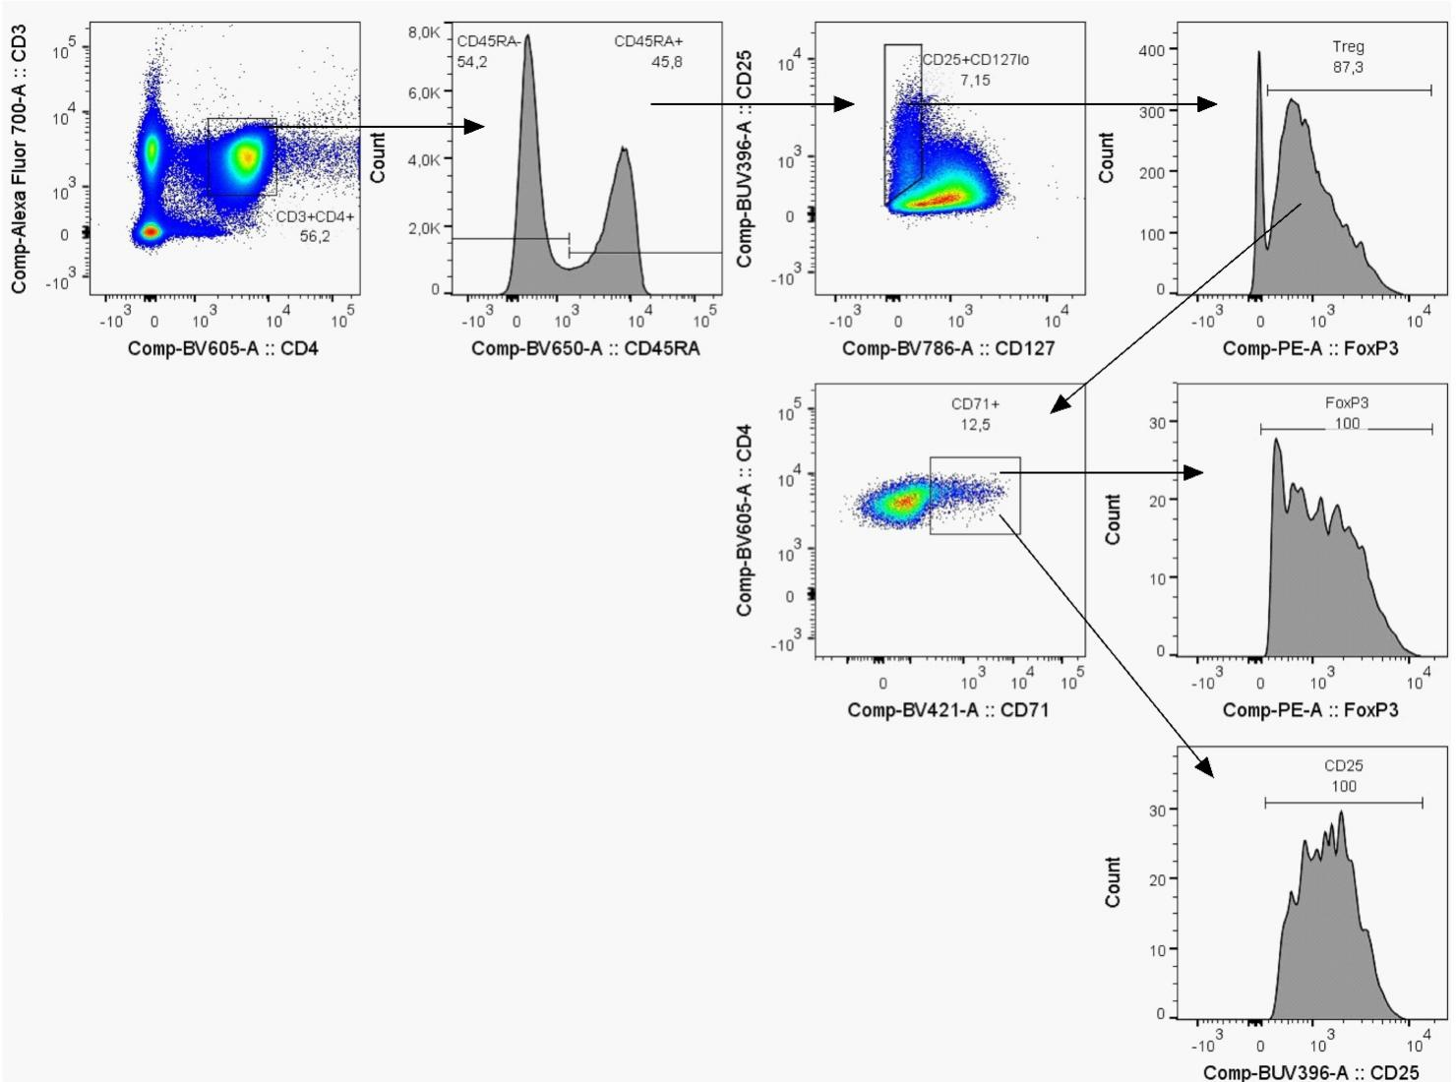
Supplementary Fig. 3. Gating strategy to assess FOXP3 and CD25 expression in activated/cycling naive and memory regulatory T-cells. The CD4⁺ T-cell pool was divided into naive (CD45RA⁺) and memory (CD45RA–) subsets. Within each subset, CD25⁺CD127^{lo} cells were first identified, and then FOXP3⁺ Tregs were gated. The frequency of activated/cycling (CD71⁺) cells was determined within the Treg populations, and the expression levels of FOXP3 and CD25 were assessed in these activated/cycling naive and memory Tregs.
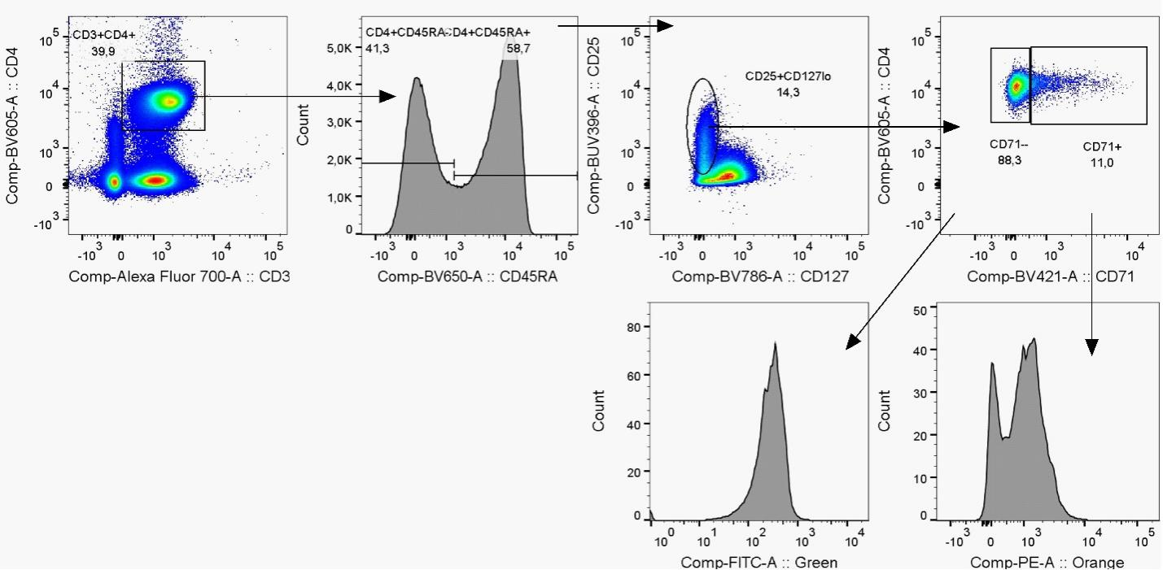
Supplementary Fig. 4. Gating strategy to assess mitochondrial characteristics in activated/cycling naive and memory regulatory T-cells. CD4⁺ T-cells were first divided into naive (CD45RA⁺) and memory (CD45RA–) subsets. Within each subset, CD25⁺CD127^{lo} Tregs were identified. Quiescent (CD71–) and activated/cycling (CD71⁺) cells were then distinguished within the Treg populations. Mitochondrial mass and transmembrane potential were evaluated in these Treg subsets using MitoTracker Green and MitoTracker Orange dyes, respectively.

