Supplementary Material
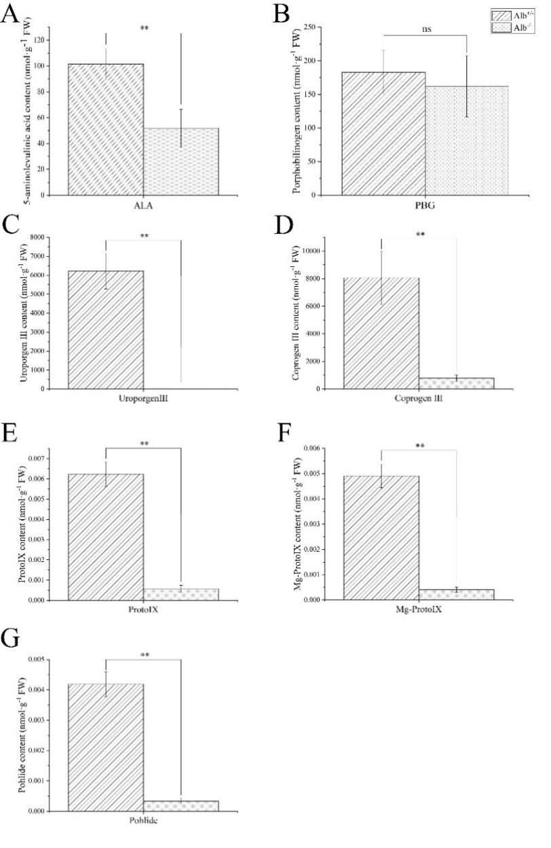
Fig. S1. Comparison of chlorophyll biosynthetic precursors between albino mutant and wild-type plants of daylily. (A) The content of aminolevulinic acid (ALA) (B) porphobilinogen (PBG) (C) uroporphyrinogen III (Urogen Ⅲ) (D) oproporphyrinogen III (Coprogen Ⅲ) (E) protoporphyrin IX (Proto Ⅸ) (F) magnesium protoporphyrin IX (Mg-Proto IX) (G) pchlide. Mean values ± SE (n = 3); Significant values *p<0.05, **p<0.01

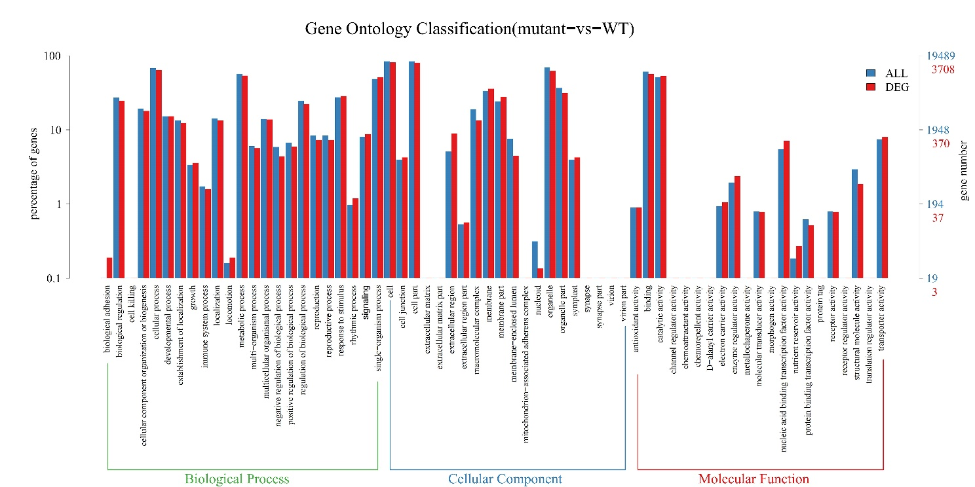
Fig. S2. Functional annotation of assembled sequences based on gene ontology (GO) categorization. (The unigenes are summarized into three main categories: cellular component, molecular function, and biological process. Blue represented all unigenes, and red represented differentially expressed unigenes between daylily albino mutant and wild-type plants. The right side of the Y-axis is the number of genes; the left side of the Y-axis is the percent of genes.)
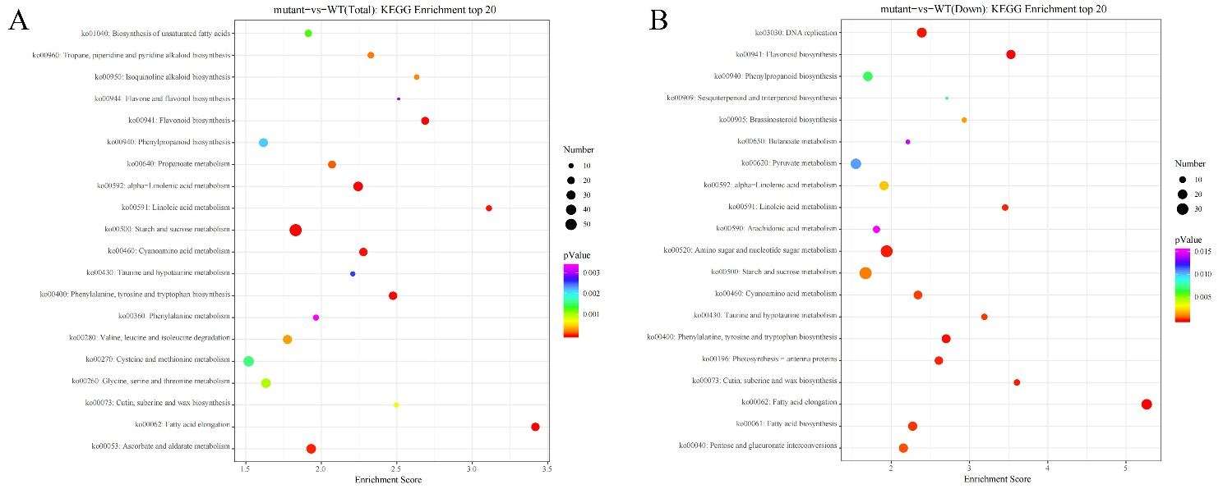
Fig. S3. KEGG enrichment of differentially expressed unigenes between daylily albino mutant and wild-type plants. (A) Total differentially expressed unigenes. (B) Down-regulated differentially expressed unigenes.
Table S1. Primers used for qPCR.
Gene name | Forward primer (5’-3’) | Reverse primer (5’-3’)
HfEF-1a | TCTCGCCGCCTCTCTCAAT | TTCAGCAGCTTCCTTCTCG
HfUBQ | AACGTGAAGGCCAAGATAC | GGACAGACGACCGACAGAC
DXS | GGGAAGCAATTCAAGACCAA | TCTGCAATTCCCACATCAAA
PORA | GCCTCTTTAGGCAGCACATC | CGGAGTTCTTGTTCCAGCTC
DXR | GGCGCACTTAGACGAAT | TCAGGGCATCAGCAACT
CLH2 | GCACTAGGCTACGCCAAAAC | CCGATGATGGCAGAGAATT
WRKY24 | TAGCTAGAGTCCGGGACGAA | CGGACGGTATCGCAAAGTAT
CRTISO | CAATGATTGGAGTCGTGGTG | GATTTTTGTACGCGGCACTT

Table S2. Comparison of chlorophyll and carotenoid content between albino mutants and wild-type plants of daylily.
Photosynthetic pigments | Wild Type content (mg·g⁻¹ FW) | Mutant content (mg·g⁻¹· FW)
Chla | 1.77 ± 0.19 | 0.042 ± 0.0073**
Chlb | 0.55 ± 0.04 | 0.016 ± 0.0030**
Total Chl | 2.32 ± 0.23 | 0.058 ± 0.0103**
Carotenoids | 0.86 ± 0.07 | 0.056 ± 0.0060**
Chla/Chlb | 3.19 ± 0.11 | 2.72 ± 0.16**
Mean values ± SE (n = 3); significant values *p<0.05, **p<0.01.
Table S3. Overview of transcriptomic assembly.
Items | Numbers
Unigene total length (bp) | 55899490 bp
No. of unigenes | 53479
Average length of unigenes (bp) | 1045.26 bp
N50 (bp) | 1542
GC contents (%) | 46.59 %
Table S4. Number of DEGs involved in different functional groups up-regulated or down-regulated by at least two times in the albino mutant compared with the wild-type control.
Pathway | Gene NO. | Representative genes
Down-regulated
Starch and sucrose metabolism | 14 | otsA, otsB, WAXY, glgP, malQ, MGAM, HK, sucrose-phosphate synthase, SPP, SUS, endoglucanase, beta-glucosidase, EGLC, beta-fructofuranosidase
Amino sugar and nucleotide sugar metabolism | 19 | chitinase, nagZ, HK, UAP1, USP, RGP, abfA, UXE, 1,4-beta-D-xylan synthase, UXS1, AXS, UGDH, RHM, UER1, cap1J, GAUT, GDP-L-fucose synthase, GMPP, GMDS
Glycolysis / Gluconeogenesis | 16 | HK, E5.1.3.15, FBP, PFK9, PFP, ALDO, GAPDH, PGAM,enolase, pyruvate kinase, aceE, aceF, pdhD, ALDH, ADH1_7, adh
Plant-pathogen interaction | 7 | CPK, Rboh, CALM, MPK4, RPS2, PBS1, KCS
Plant hormone signal transduction | 14 | AUX1, IAA, ARF, SAUR, ARR-A, DELLA, PYR/PYL, PP2C, SNRK2, BRI1, TCH4, CYCD3, JAZ, NPR1
Ribosome | 26 | RP-L2, RP-S20e, RP-L23e, RP-S4e, RP-L11e, RP-S29e, RP-L5e, RP-S2e, RP-L7e, RP-S11, RP-S14e, RP-S5e, RP-L7, RP-L7,RP-L13e, RP-L31e, RP-L37Ae, RP-L40e, RP-S3Ae, RP-S8e, RP-S27Ae, RP-S30e, RP-S7e, RP-S12e
Glycerophospholipid metabolism | 15 | plc, EPT1, LYPLA2, PCYT1, NMT, LYPLA2, DPPL, PLPP1_2_3, dgkA, plsC, GPAT1_2, GPAT, GPD1, cdsA, LCLAT1
Fatty acid elongation | 5 | NRBF1, KCS, KAR, HACD, CER10
Pyruvate metabolism | 11 | ppc, GLO1, pyk, ALDH, aceE, pdhD, pdhC, ACAT, ACACA, maeB, MDH1
Cysteine and methionine metabolism | 13 | cysM, cysK, PHGDH, metB, ahcY, metE, DNMT1, metK, TAT, aminocyclopropanecarboxylate oxidase, mdh, GSS, hom
Up-regulated
Starch and sucrose metabolism | 10 | alpha,alpha-trehalase, beta-amylase, otsB, otsA, HK, endoglucanase, beta-glucosidase, beta-fructofuranosidase, SUS, sucrose-phosphate synthase
Plant hormone signal transduction | 14 | AUX1, TIR1, IAA, ARF, SAUR, B-ARR, GID2, PYR, SnRK2, ABF, EBF1/2, EIN3, TCH4, TGA
Valine, leucine and isoleucine degradation | 9 | ilvE, BCKDHA, IVD, 3-methylcrotonyl-CoA carboxylase alpha subunit, ACAT,ALDH, ALDH6A1, HIBADH, fadA
Plant-pathogen interaction | 15 | CDPK, Rboh, CaMCML , FLS2, PTI6, RIN4, RPMI, RIN4, CTSF, MPK4, WRKY25, glycerol kinase, MPK3, RAR1, HSP90
Ascorbate and aldarate metabolism | 6 | MIOX, ALDH, GME, VTC2_5, monodehydroascorbate reductase (NADH), L-ascorbate peroxidase
Protein processing in endoplasmic reticulum | 13 | EDEM, Ero1, PDIs, HSP70, HSP90, HSP40, Shsf, Ubx, Doa10, UBE2J1, RNF5, UBE2D, CHIP
MAPK signaling pathway – plant | 10 | FLS2, P-type Cu+ transporter, ANP1, MPK4, MPK3, ACS1_2_6, MKS1, WRKY33, EIN3, EBF1_2
Peroxisome | 9 | PEX5, PEX19, PEX10, ACOX, ACAA1, AGT, PIPOX, HAO, CAT
Ubiquitin mediated proteolysis | 10 | UBE2D, UBE2J2, CHIP, COP1, PIRH2, PIAS, Apc10, F-box, DCAF, TRIP12
Glycerolipid metabolism | 12 | aldehyde dehydrogenase (NAD+); alcohol dehydrogenase (NADP+); glycerol kinase; glycerol-3-phosphate O-acyltransferase 1/2; acylglycerol lipase; 1-acyl-sn-glycerol-3-phosphate acyltransferase; phosphatidate phosphatase; diacylglycerol diphosphate phosphatase / phosphatidate phosphatase; triacylglycerol lipase; diacylglycerol kinase (ATP); 1,2-diacylglycerol 3-beta-galactosyltransferase; alpha-galactosidase

Table S5. Comparison of DEGs expression level between qPCR and RNAseq data.
Gene name | qrt-pcr log2FoldChange | RNA-seq log2FoldChange
DXS | -2.85 | -1.8
PORA | -0.98 | -2.11
DXR | 0.85 | 2.02
CLH2 | 1.15 | 1.09
WRKY24 | 2.30 | 3.66
CRTISO | -1.19 | -1.09

Table S6. Expression levels of Top 10 up- and down- regulated DEGs between albino mutant and wild-type seedlings
Gene name | Gene description | Fold change
Down-regulated
psbK | photosystem II PsbK protein | 0.0297
HSP26-A | Probable glutathione S-transferase HSP26-A | 0.0494
psbA | photosystem II P680 reaction center D1 protein | 0.0520
ispS | isoprene synthase | 0.0686
ndhA | NAD(P)H-quinone oxidoreductase subunit | 0.0713
CYP85A | Cytochrome P450 85A | 0.0995
CYP90B2 | cytochrome P450 90B2-like | 0.1086
psbQ | photosystem II oxygen-evolving enhancer protein 3 | 0.1236
psbB | photosystem II CP47 chlorophyll apoprotein | 0.1422
CHS | chalcone synthase | 0.0853
Up-regulated
bglB | beta-glucosidase | 340.8559
PGL | Polygalacturonase | 190.2541
AOS | Allene oxide synthase 1 | 117.53214
ATG8C | Autophagy-related protein 8C | 52.6850
LOX14 | Probable linoleate 9S-lipoxygenase 4 | 34.0857
HSP21 | Heat shock protein 21 | 22.4584
RPL40A | Ubiquitin-ribosomal protein eL40z fusion protein | 22.2241
adh | NADPH-dependent aldo-keto reductase | 16.0651
ACAA1 | acetyl-CoA acyltransferase 1 | 14.3047
rpoC | DNA-directed RNA polymerase subunit beta' | 13.9972

Table S7. Comparison of photosynthetic pigment content between Alb^{+/+} and Alb^{+/-} plants of daylily.
Photosynthetic pigments | Alb^{+/+}(mg·g⁻¹· FW) | Alb^{+/-}(mg·g⁻¹· FW)
Chla | 1.78 ± 0.16 | 1.20 ± 0.29*
Chlb | 0.60 ± 0.04 | 0.37 ± 0.09**
Total Chl | 2.39 ± 0.21 | 1.57 ± 0.24**
Carotenoids | 0.87 ± 0.04 | 0.56 ± 0.15**
Chla/Chlb | 2.94 ± 0.08 | 3.57 ± 1.93^{ns}
Mean values ± SE (n = 3); significant values *p<0.05, **p<0.01.
Table S8. Comparison of DEGs expression level between Alb^{+/+} and Alb^{+/-} plants.
Gene name | Alb^{+/+}(mg·g⁻¹· FW) | Alb^{+/-}(mg·g⁻¹· FW)
DXS | 1.32 ± 0.02 | 1.13 ± 0.12^{ns}
WRKY24 | 1.11 ± 0.23 | 0.14 ± 0.05*
Mean values ± SE (n = 3); significant values *p<0.05, **p<0.01.
Table S9 Expression levels of albino related DEGs between albino mutant and wild-type seedlings
Gene | Gene description | Phenotype | Fold change
SGR | Protein STAY-GREEN, chloroplastic | The levels of chlorophyll of plants overexpressing SGR reduced [75]. | 2
PORA | NADPH:protochlorophyllide oxidoreductase | The loss-of-function mutant was dwarfed, light green, grows on sucrose medium for 9 months[77, 86] | 0.2433
ALAD | δ-aminolevulinic acid dehydratase | Silencing of ALAD caused discrete yellow spots and necrosis in leaves and stems[78, 87] | 0.3~0.5
PPR | Putative pentatricopeptide repeat-containing protein | Albinism causes up-regulated expression of the PPR gene[76] | 5.05
DXS | 1-deoxy-D-xylulose-5-phosphate synthase | The loss-of-function mutant was albino and lethality at seedling stage[14, 88] | 0.67
ALB3 | 63 kDa inner membrane family protein | Leaf blades of the loss-of-function mutant was white or pale yellow, and the mutant was lethal at seedling stage[89, 90] | 0.8
NUS1 | Dehydrodolichyl diphosphate synthase | Involved in the regulation of chloroplast RNA metabolism and promotes the establishment of the plastid genetic system during early chloroplast development under cold stress conditions[29] | 0.78
DXR | 1-deoxy-D-xylulose 5-phosphate reductoisomerase | The loss-of-function mutant was albino, dwarf and defects in trichome initiation and stomata closure[23] | 2.2
CAO | chlorophyll a oxygenase | Leaf blades light green, dwarfed[91, 92] | 12.23, 11.08, 10.41
LCYE | lycopene epsilon-cyclase | Seedlings of the loss-of-function mutant were albino and the mature plants were light green[74, 93] | 0.6-0.8

