Supplementary Materials

Supplementary Table 1. Primer pairs for sexual identification and qRT-PCR validation.
Name | Forward primer (5’-3’) | Reverse primer (5’-3’)
Sexual identification marker | TGAGCTACAGCCACCCAAAT | GCCGTGCAGAAGTAACATAACA
amh | GAAGCGGTTCTTGGGTGAT | GGCCGAGGAGTTCATTAGTC
amhr2 | CACCGCATCTGTTGCCTTAT | GGTAGCAGTTCCCATTGTTTAG
cyp19a1 | ACCGAAGGGCACAAATATCA | CGATGTGCTTACCAACACAG
gsdf | GAAATGGTGCCTGTCGTCTA | TTGCTGGAGGTTGCTATGTC
foxl2 | GACGCAATGGCCTTAATGAT | ACGTATGAGTACGGTGGTTT
β-actin  GAPDH | TGTCTTCCCCTCCATTGTTG  GAAACCCGCCAAATACGA | GGATTCCCCTTTTGCTCTG  GCATCAAAGATGGAGGAGTGA

Supplementary Table 2. Statistics of various assemblies of the Nile tilapia genome.
Parameter | GCA_  013350305 | GCF_  000188235 | GCF_  001858045 | GCA_  922820385 | Our current study
 |  |  |  |  | Haplotype | Haplotype 1 | Haplotype 2
Sex | Female | Female | Female | Male | Male | Haplotype-X | Haplotype-Y
Contig N50 (bp) | 2,478,287 | 29,493 | 2,923,640 | 18,487,566 | 21,067,898 | 9,259,239 | 6,552,444
Scaffold N50 (bp) | 40,346,024 | 27,159,252 | 38,839,487 | 41,925,174 | 21,067,898 | 9,259,239 | 6,552,444
Scaffold number | 403 | 5678 | 2460 | 23 | 287 | 521 | 490
Genome Size (bp) | 993,468,885 | 927,696,114 | 1005,681,550 | 1055,593,462 | 1066,262,156 | 1015,069,178 | 1011,144,272
GC content | 40.6% | 35.6% | 40.7% | 40.8% | 40.8% | 40.8% | 40.8%

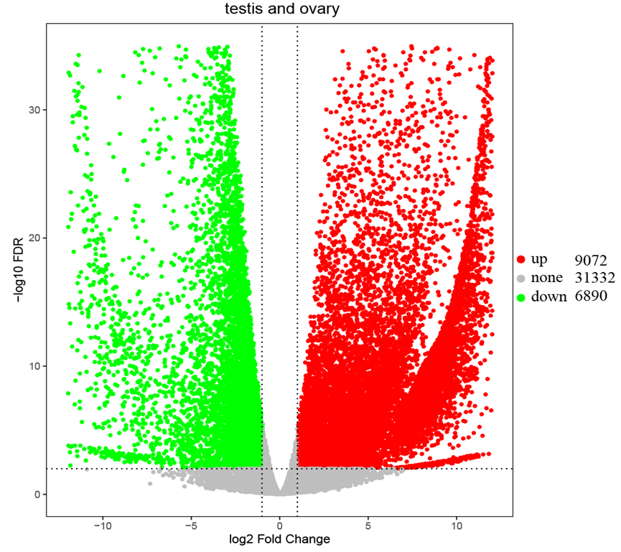
Supplementary Fig. 1. A volcano plot of differences in gene expression between testes and ovaries. Red dots stand for upregulation, representing testis-biased genes; Green dots stnd for downregulation, representing ovary-biased genes.

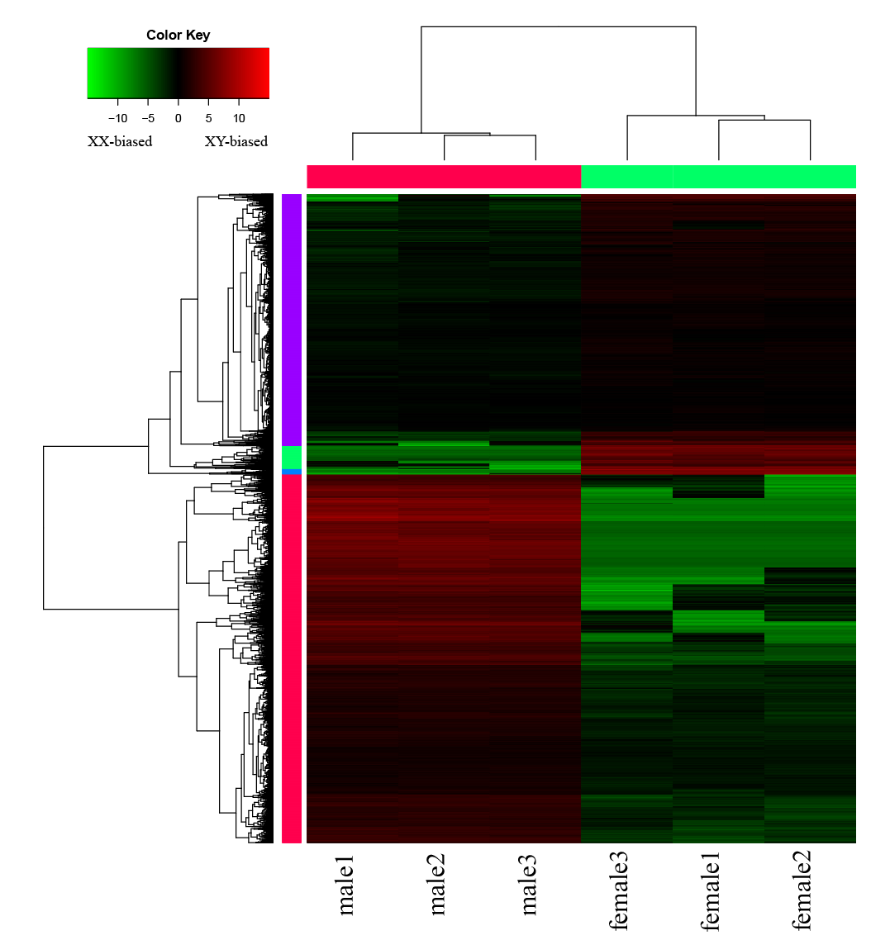
Supplementary Fig. 2. A heat map of differentially expressed genes (DEGs). Red colors represent high expression genes, while green colors represent low expression genes.

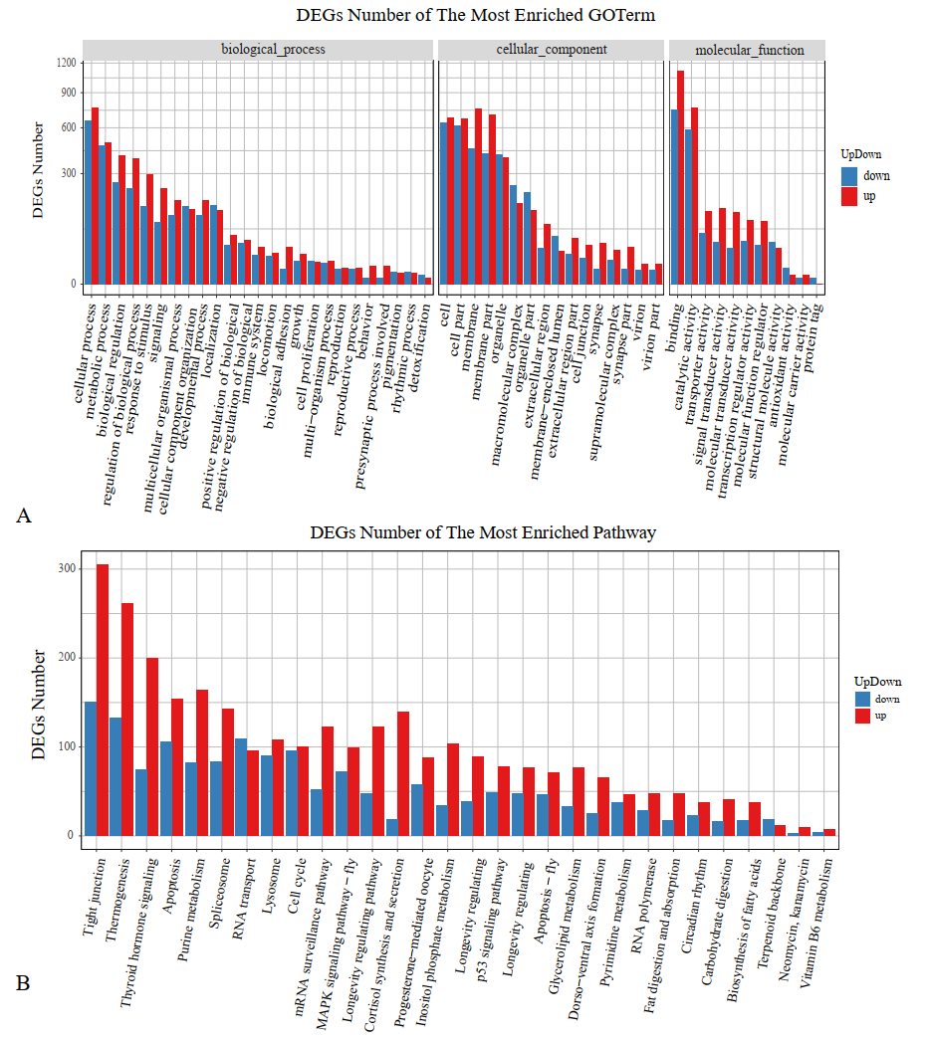
Supplementary Fig. 3. GO (A) and KEGG (B) enrichments of differentially expressed genes (DEGs).

