Supplemental file to
Immune response associated gene signatures in aortic dissection compared to aortic aneurysm

Supplementary Table 1. Primer sequences used for qPCR experiments.

Gene | Forward (5`-3`) | Reverse (5`-3`)
UBC | ACTCTGCACTTGGTCCTGC | GAATGCAACAACTTTATTGAAAGGA
CCL2 | GAGAGGCTGAGACTAACCCAGA | ATCACAGCTTCTTTGGGACACT
RNASE2 | GCCTTTAATCCACTGTAACCTCACA | GCTGGTGTCTGCGCATACCT
HAVCR2 | GACTCTAGCAGACAGTGGGATC | GGTGGTAAGCATCCTTGGAAAGG
CXCL8 | ACTCCAAACCTTTCCACCCC | CAAAAAGGCAGATACCTAATGACGA
IL-6R | TACCCCCAGGAGAAGATTCC | TTTTCTGCCAGTGCCTCTTT
FBLN1 | CAACTGCTCCATCAACGAGA | ATTCTCAGAGGCAGCTTGGA

Supplementary Table 2. A significant number of genes is differentially expressed when controls are compared to thoracic aortic dissection samples in different studies.
The information provided in OLS Table 2 is based on microarray gene expression data from our own study, and three publicly available transcriptomic studies for TAD. N for controls and TAD samples is given in the table, as is the number of differentially expressed genes (DEGs) between the groups (p-value <0.05).

Name | Study | Control (n) | TAD (n) | DEGs
C-TAD 1 | PRJNA90739 | 3 | 4 | 1970
C-TAD 2 | PRJNA229053 | 5 | 7 | 4550
C-TAD 3 | PRJNA612822 | 4 | 4 | 5191
C-TAD 4 | PRJNA642644 | 10 | 10 | 5245

Supplementary Table 3. 37 genes were found to be significantly dysregulated in at least three TAD studies.
OLS Table 3 gives an overview on DEGs found to be dysregulated (p-value <0.05) in the same direction in at least three TAD studies, based on an overlapping gene analysis. Gene name, log2 Fold change (log2FC) and p-values are shown. The table also indicates genes that were previously described in literature in the context of TAD.

Gene symbol | C-TAD 1 (log2FC) | C-TAD 1 (p-value) | C-TAD 2 (log2FC) | C-TAD 2 (p-value) | C-TAD 3 (log2FC) | C-TAD 3 (p-value) | C-TAD 4 (log2FC) | C-TAD 4 (p-value) | Identified in relation to TAD
ADAMTSL3 | -0.72 | 7.30E-03 | 0.65 | 2.81E-02 | -0.84 | 2.06E-02 | -0.53 | 1.89E-04 | Potentially
ANGPTL1 | NA | NA | -1.37 | 4.93E-02 | -1.92 | 2.46E-05 | -0.48 | 4.80E-02 | No
ASTN2 | NA | NA | -0.97 | 4.36E-02 | -0.88 | 2.28E-02 | -1.00 | 1.56E-04 | No
BVES | -2.83 | 2.08E-02 | 0.47 | 9.00E-04 | -1.84 | 4.83E-13 | -0.63 | 1.16E-03 | Potentially
C2orf88 | -2.38 | 1.75E-02 | NA | NA | -1.55 | 2.50E-05 | -0.90 | 1.12E-03 | Yes
CCDC146 | -0.82 | 4.58E-02 | 1.54 | 2.90E-03 | -0.73 | 4.39E-02 | -1.74 | 3.10E-13 | No
CCL2 | 1.82 | 4.76E-02 | 0.84 | 3.91E-03 | 2.01 | 1.49E-07 | 2.51 | 2.20E-12 | Yes
COL25A1 | NA | NA | -1.81 | 4.44E-02 | -1.70 | 1.11E-03 | -1.42 | 3.70E-03 | No
CXCL8 | 2.15 | 7.00E-03 | -1.29 | 7.42E-03 | 3.42 | 1.37E-08 | 2.73 | 9.43E-07 | Yes
DGKD | 0.14 | 1.74E-02 | 2.14 | 4.28E-02 | NA | NA | 0.70 | 2.05E-02 | Yes
DNAH14 | -2.78 | 1.41E-02 | -0.40 | 3.51E-02 | NA | NA | -1.12 | 3.88E-02 | No
FBLN1 | -0.80 | 6.20E-03 | -0.84 | 1.69E-03 | -0.85 | 3.31E-03 | -1.53 | 1.29E-08 | Yes
FBXL17 | -0.64 | 4.14E-02 | NA | NA | -0.73 | 1.07E-02 | -0.66 | 2.19E-04 | No
FERMT1 | -5.06 | 3.97E-02 | -1.22 | 1.38E-02 | 2.15 | 1.34E-04 | -1.02 | 3.30E-02 | Yes
HAVCR2 | 0.55 | 1.83E-02 | 0.46 | 4.05E-03 | 1.77 | 1.37E-05 | 0.89 | 8.10E-03 | No
IL6R | 0.43 | 4.17E-02 | NA | NA | 1.43 | 4.25E-08 | 1.59 | 6.90E-10 | Yes
LRRC1 | NA | NA | 0.28 | 1.53E-02 | -0.69 | 1.79E-02 | -0.67 | 1.54E-04 | Potentially
MLXIP | 0.14 | 2.99E-02 | NA | NA | 1.03 | 2.17E-04 | 0.86 | 1.91E-10 | No
NPL | 1.39 | 1.96E-02 | NA | NA | 1.70 | 2.37E-05 | 0.82 | 1.94E-02 | No
OGN | -2.45 | 1.64E-02 | NA | NA | -1.52 | 3.93E-04 | -1.76 | 8.40E-14 | Yes
PCDH7 | -3.29 | 3.83E-02 | 0.74 | 1.68E-03 | -1.25 | 6.50E-04 | -0.98 | 5.51E-14 | No
PLP1 | NA | NA | -2.06 | 4.84E-02 | -2.03 | 2.39E-09 | -2.90 | 6.66E-15 | No
PPM1B | -0.80 | 4.13E-02 | 0.55 | 3.58E-02 | -1.28 | 4.87E-06 | -0.68 | 5.69E-06 | No
PPP2R2B | -0.90 | 2.36E-02 | 1.57 | 1.33E-02 | -1.46 | 5.58E-05 | -1.22 | 2.79E-07 | No
PTPN20 | NA | NA | -2.54 | 2.66E-02 | -0.87 | 4.19E-02 | -0.65 | 2.37E-02 | No
RASSF4 | 1.56 | 2.99E-02 | NA | NA | 1.31 | 4.56E-07 | 0.61 | 8.35E-03 | No
RASSF9 | -0.75 | 1.78E-02 | NA | NA | -1.45 | 2.83E-04 | -1.04 | 6.77E-09 | No
RNASE2 | 0.34 | 3.71E-02 | 1.32 | 6.31E-03 | 1.24 | 1.22E-02 | 1.22 | 2.97E-02 | No
SMCHD1 | -0.87 | 4.62E-02 | NA | NA | -0.86 | 1.62E-02 | -0.29 | 1.93E-02 | No
SNX18 | NA | NA | -0.45 | 2.06E-02 | -0.66 | 2.06E-02 | -0.44 | 2.67E-02 | No
SREBF1 | NA | NA | 2.45 | 2.81E-02 | 0.90 | 1.73E-02 | 0.76 | 1.08E-02 | No
SRGAP2 | NA | NA | 1.87 | 1.98E-02 | 0.61 | 8.11E-03 | 0.37 | 6.08E-03 | No
STYX | NA | NA | -2.24 | 4.33E-04 | -0.73 | 2.36E-02 | -0.28 | 3.94E-02 | No
TMEM218 | -0.77 | 2.96E-02 | -1.35 | 3.28E-02 | NA | NA | -0.43 | 4.73E-02 | No
TRAF7 | NA | NA | 2.17 | 4.24E-02 | 0.65 | 2.78E-02 | 0.54 | 1.43E-02 | No
TRPC6 | NA | NA | -1.84 | 3.82E-02 | -1.29 | 3.10E-03 | -1.83 | 1.51E-11 | Potentially
ZNF365 | NA | NA | -0.73 | 4.40E-02 | -0.61 | 4.95E-02 | -0.76 | 4.26E-04 | No

Supplementary Table 4. Gene Ontology (GO) analysis argues for a role of immunological processes in TAD pathogenesis.
Significantly (p-value <0.05) affected biological processes (BP), cellular compartments (CC), and molecular functions (MF) (analyzed on gene level) found in at least three TAD studies. The GO identification numbers (GO IDs), description of the affected GO terms and identified core enrichment genes are listed. GO terms in light grey are immune-related pathways.

ONTOLOGY | ID | Description | p.adjust | Core enrichment genes
BP | GO:0006955 | immune response | 0.00023375 | CXCL8/CCL2/IL6R/RNASE2/HAVCR2
BP | GO:0006935 | chemotaxis | 0.00069751 | CXCL8/CCL2/IL6R/RNASE2
BP | GO:0042330 | taxis | 0.00069751 | CXCL8/CCL2/IL6R/RNASE2
BP | GO:0002685 | regulation of leukocyte migration | 0.00089386 | CXCL8/CCL2/IL6R
BP | GO:0002688 | regulation of leukocyte chemotaxis | 0.00089386 | CXCL8/CCL2/IL6R
MF | GO:0005126 | cytokine receptor binding | 0.00089386 | CXCL8/CCL2/IL6R
BP | GO:0019221 | cytokine-mediated signaling pathway | 0.00089386 | CXCL8/CCL2/IL6R
BP | GO:0030595 | leukocyte chemotaxis | 0.00089386 | CXCL8/CCL2/IL6R
BP | GO:0050900 | leukocyte migration | 0.00089386 | CXCL8/CCL2/IL6R
BP | GO:0050920 | regulation of chemotaxis | 0.00089386 | CXCL8/CCL2/IL6R
BP | GO:0060326 | cell chemotaxis | 0.00089386 | CXCL8/CCL2/IL6R
BP | GO:0097529 | myeloid leukocyte migration | 0.00089386 | CXCL8/CCL2/IL6R
BP | GO:0002684 | positive regulation of immune system process | 0.00093002 | CXCL8/CCL2/IL6R/HAVCR2
BP | GO:0009617 | response to bacterium | 0.00093002 | CXCL8/CCL2/IL6R/HAVCR2
BP | GO:0045321 | leukocyte activation | 0.00093002 | CXCL8/CCL2/RNASE2/HAVCR2
BP | GO:0009607 | response to biotic stimulus | 0.00048112 | CXCL8/CCL2/IL6R/RNASE2/HAVCR2
BP | GO:0043207 | response to external biotic stimulus | 0.00048112 | CXCL8/CCL2/IL6R/RNASE2/HAVCR2
BP | GO:0051707 | response to other organism | 0.00048112 | CXCL8/CCL2/IL6R/RNASE2/HAVCR2
MF | GO:0005198 | structural molecule activity | 0.00104293 | COL25A1/FBLN1/OGN/PLP1
BP | GO:0002682 | regulation of immune system process | 0.00116877 | CXCL8/CCL2/IL6R/HAVCR2
BP | GO:0032101 | regulation of response to external stimulus | 0.00116877 | CXCL8/CCL2/IL6R/HAVCR2
BP | GO:0098542 | defense response to other organism | 0.00210379 | CCL2/IL6R/RNASE2/HAVCR2
BP | GO:0030334 | regulation of cell migration | 0.00093002 | CXCL8/CCL2/IL6R
BP | GO:0001568 | blood vessel development | 0.00186003 | CXCL8/CCL2/IL6R
BP | GO:0001944 | vasculature development | 0.00186003 | CXCL8/CCL2/IL6R
BP | GO:0034097 | response to cytokine | 0.00255755 | CXCL8/CCL2/IL6R
BP | GO:0071345 | cellular response to cytokine stimulus | 0.00255755 | CXCL8/CCL2/IL6R
BP | GO:0002376 | immune system process | 0.00120279 | CXCL8/CCL2/IL6R/RNASE2/HAVCR2
BP | GO:0044419 | interspecies interaction between organisms | 0.00240558 | CXCL8/CCL2/IL6R/RNASE2/HAVCR2
BP | GO:0009605 | response to external stimulus | 0.00122011 | CXCL8/CCL2/IL6R/RNASE2/HAVCR2
BP | GO:0009889 | regulation of biosynthetic process | 0.00264614 | CXCL8/CCL2/HAVCR2/MLXIP/SREBF1
BP | GO:0072359 | circulatory system development | 0.00280505 | CXCL8/CCL2/IL6R
BP | GO:0010033 | response to organic substance | 0.0034163 | CXCL8/CCL2/IL6R/HAVCR2/SREBF1/DGKD
MF | GO:0005201 | extracellular matrix structural constituent | 0.00465616 | FBLN1/OGN
BP | GO:0002237 | response to molecule of bacterial origin | 0.00558659 | CXCL8/CCL2/HAVCR2
BP | GO:0002274 | myeloid leukocyte activation | 0.00558659 | CXCL8/RNASE2/HAVCR2
BP | GO:0032103 | positive regulation of response to external stimulus | 0.00558659 | CXCL8/IL6R/HAVCR2
BP | GO:0032496 | response to lipopolysaccharide | 0.00558659 | CXCL8/CCL2/HAVCR2
BP | GO:0045087 | innate immune response | 0.00558659 | CCL2/RNASE2/HAVCR2
BP | GO:0071216 | cellular response to biotic stimulus | 0.00558659 | CXCL8/CCL2/HAVCR2
BP | GO:0071219 | cellular response to molecule of bacterial origin | 0.00558659 | CXCL8/CCL2/HAVCR2
BP | GO:0071222 | cellular response to lipopolysaccharide | 0.00558659 | CXCL8/CCL2/HAVCR2
BP | GO:0042221 | response to chemical | 0.00585366 | CXCL8/CCL2/IL6R/RNASE2/HAVCR2/SREBF1/DGKD
BP | GO:0001525 | angiogenesis | 0.00603352 | CXCL8/CCL2
BP | GO:0035239 | tube morphogenesis | 0.00603352 | CXCL8/CCL2
BP | GO:0048514 | blood vessel morphogenesis | 0.00603352 | CXCL8/CCL2
BP | GO:0048646 | anatomical structure formation involved in morphogenesis | 0.00603352 | CXCL8/CCL2
BP | GO:0009891 | positive regulation of biosynthetic process | 0.00651011 | CXCL8/CCL2/MLXIP/SREBF1
BP | GO:0033993 | response to lipid | 0.00651011 | CXCL8/CCL2/HAVCR2/SREBF1
BP | GO:0071396 | cellular response to lipid | 0.00651011 | CXCL8/CCL2/HAVCR2/SREBF1
BP | GO:0071310 | cellular response to organic substance | 0.00769786 | CXCL8/CCL2/IL6R/HAVCR2/SREBF1
BP | GO:0048468 | cell development | 0.00818275 | COL25A1/FBLN1/TRPC6/PLP1
BP | GO:0048584 | positive regulation of response to stimulus | 0.00904424 | CXCL8/CCL2/IL6R/HAVCR2
BP | GO:0016070 | RNA metabolic process | 0.01215521 | RNASE2/HAVCR2/MLXIP/SREBF1
BP | GO:0051726 | regulation of cell cycle | 0.01251397 | CXCL8/CCL2
BP | GO:0006952 | defense response | 0.01274958 | CXCL8/CCL2/IL6R/RNASE2/HAVCR2
BP | GO:0034641 | cellular nitrogen compound metabolic process | 0.01274958 | RNASE2/HAVCR2/MLXIP/NPL/SREBF1
BP | GO:0010646 | regulation of cell communication | 0.01612103 | CXCL8/CCL2/IL6R/HAVCR2/SREBF1/DGKD/TRAF7/SRGAP2/STYX
BP | GO:0051270 | regulation of cellular component movement | 0.01636279 | CXCL8/CCL2/IL6R
BP | GO:2000145 | regulation of cell motility | 0.01636279 | CXCL8/CCL2/IL6R
BP | GO:0022402 | cell cycle process | 0.01650779 | CXCL8/CCL2
BP | GO:0040011 | locomotion | 0.01735517 | CXCL8/CCL2/IL6R/RNASE2
CC | GO:0062023 | collagen-containing extracellular matrix | 0.01737016 | COL25A1/FBLN1/OGN
BP | GO:0007186 | G protein-coupled receptor signaling pathway | 0.01899441 | CXCL8/CCL2
BP | GO:0016477 | cell migration | 0.01900409 | CXCL8/CCL2/IL6R
BP | GO:0040012 | regulation of locomotion | 0.01900409 | CXCL8/CCL2/IL6R
BP | GO:0031325 | positive regulation of cellular metabolic process | 0.01994649 | CXCL8/CCL2/IL6R/HAVCR2/MLXIP/SREBF1
BP | GO:0006984 | ER-nucleus signaling pathway | 0.0203352 | CXCL8/CCL2
BP | GO:0044260 | cellular macromolecule metabolic process | 0.02096489 | CXCL8/CCL2/IL6R/RNASE2/HAVCR2/MLXIP
BP | GO:0035295 | tube development | 0.02348291 | CXCL8/CCL2
BP | GO:0030030 | cell projection organization | 0.02363984 | COL25A1/TRPC6/PLP1
BP | GO:0030182 | neuron differentiation | 0.02363984 | COL25A1/TRPC6/PLP1
BP | GO:0031175 | neuron projection development | 0.02363984 | COL25A1/TRPC6/PLP1
BP | GO:0048666 | neuron development | 0.02363984 | COL25A1/TRPC6/PLP1
BP | GO:0120036 | plasma membrane bounded cell projection organization | 0.02363984 | COL25A1/TRPC6/PLP1
BP | GO:0001775 | cell activation | 0.02453693 | CXCL8/CCL2/RNASE2/HAVCR2
BP | GO:0007049 | cell cycle | 0.02501169 | CXCL8/CCL2
BP | GO:0044237 | cellular metabolic process | 0.02582932 | CXCL8/CCL2/IL6R/RNASE2/HAVCR2/MLXIP/NPL/SREBF1/DGKD
BP | GO:0023051 | regulation of signaling | 0.02708804 | CXCL8/CCL2/IL6R/HAVCR2/SREBF1/DGKD/TRAF7/SRGAP2/STYX
BP | GO:0031326 | regulation of cellular biosynthetic process | 0.02862641 | CXCL8/HAVCR2/MLXIP/SREBF1
BP | GO:0010557 | positive regulation of macromolecule biosynthetic process | 0.02972067 | CCL2/MLXIP/SREBF1
BP | GO:0031328 | positive regulation of cellular biosynthetic process | 0.02972067 | CXCL8/MLXIP/SREBF1
BP | GO:0010556 | regulation of macromolecule biosynthetic process | 0.03127255 | CCL2/HAVCR2/MLXIP/SREBF1
BP | GO:0040017 | positive regulation of locomotion | 0.03150838 | CXCL8/IL6R
BP | GO:0070848 | response to growth factor | 0.0350838 | CXCL8/CCL2
BP | GO:0071363 | cellular response to growth factor stimulus | 0.0350838 | CXCL8/CCL2
BP | GO:0009966 | regulation of signal transduction | 0.03912828 | CXCL8/CCL2/IL6R/HAVCR2
CC | GO:0031012 | extracellular matrix | 0.03928385 | COL25A1/FBLN1/OGN
BP | GO:0048522 | positive regulation of cellular process | 0.04065852 | CXCL8/CCL2/IL6R/HAVCR2/MLXIP/SREBF1/DGKD
BP | GO:0070887 | cellular response to chemical stimulus | 0.04148365 | CXCL8/CCL2/IL6R/HAVCR2
MF | GO:0005102 | signaling receptor binding | 0.04330046 | CXCL8/CCL2/IL6R
BP | GO:0048870 | cell motility | 0.04612006 | CXCL8/CCL2/IL6R
BP | GO:0051674 | localization of cell | 0.04612006 | CXCL8/CCL2/IL6R
BP | GO:0048583 | regulation of response to stimulus | 0.04815651 | CXCL8/CCL2/IL6R/HAVCR2
BP | GO:0006954 | inflammatory response | 0.04932211 | CXCL8/CCL2/IL6R/HAVCR2
MF | GO:0003676 | nucleic acid binding | 0.04952337 | RNASE2/MLXIP/SREBF1

Supplementary Fig. 1 shows an UMAP plot of scRNA-seq data.
The plot shows the distribution of the identified clusters. Each cluster is represented in an individual color. The clusters were identified in controls (n=3) and TAA (n=8).

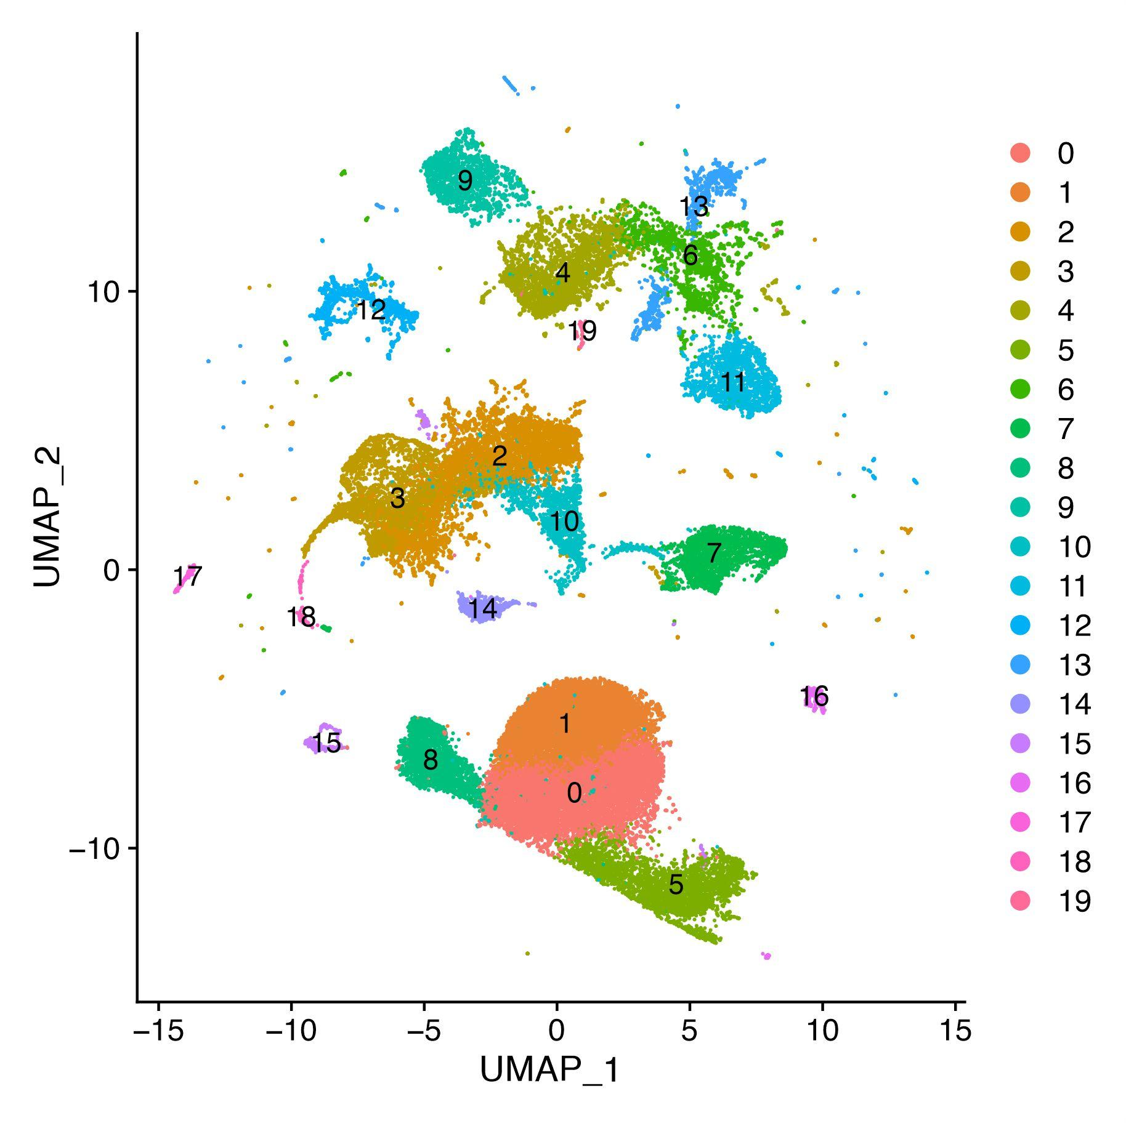

Supplementary Fig. 2. No significant differences in gene expression were identified between controls and TAA by scRNA-seq.
Figure 2 shows the gene expression of CCL2, RNASE2, HAVCR2, CXCL8, and IL6R between TAA and controls. Each panel represents one gene. The black horizontal line indicates the mean log2FC gene expression in all clusters. p-values were calculated with a two-sided t-test.
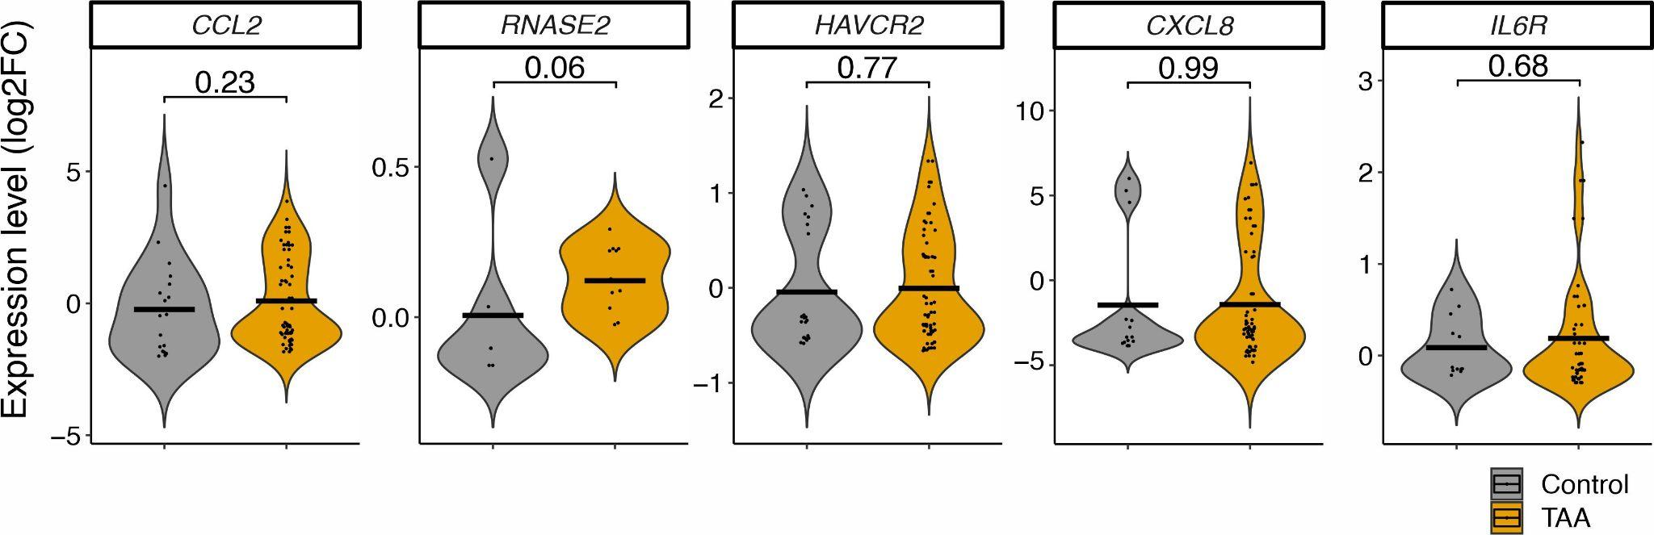

Supplementary Fig. 3. Reduced FBL1 gene expression is observed in TADs using qPCR.

Expression of FBLN1 in controls (n=6), and TADs (n=6) were normalized to UBC as a reference gene by the Bio-Rad CFX Manager software. The control group expression level is designated as 1, so values >1 indicate up-regulation. Each histogram represents the mean ± SE of six individual cell lines and three replicates per individual. Significant differences are marked as *** for p < 0.001.

