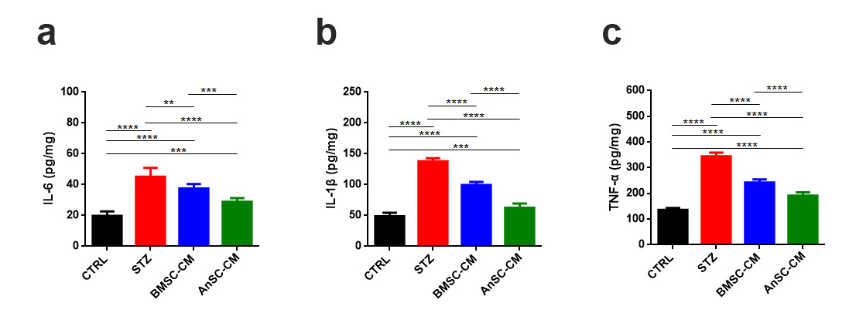
Supplementary Fig. 1
Effect of AnSC-CM on inflammatory factors in STZ-induced T1D mice. Levels of IL-6 (a), IL-1β (b) and TNF-α (c) in liver tissues. **p<0.01, ***p<0.001 and ****p<0.0001; mean ± SD; n = 8.

