Supplementary Material

The prognostic and immune significance of BZW2 in pan-cancer and its relationship with proliferation and apoptosis of cervical cancer

Supplementary Table
Supplementary Table 1. 33 kinds of cancer detailed names and sample information
Type | Description | Tumor samples (TCGA) | Normal samples (TCGA+GTEx)
ACC | Adrenocortical carcinoma | 79 | 258
BLCA | Bladder Urothelial Carcinoma | 406 | 40
BRCA | Breast invasive carcinoma | 1101 | 572
CESC | Cervical squamous cell carcinoma and endocervical adenocarcinoma | 306 | 22
CHOL | Cholangiocarcinoma | 35 | 9
COAD | Colon adenocarcinoma | 455 | 820
DLBC | Lymphoid Neoplasm Diffuse Large B-cell Lymphoma | 48 | 929
ESCA | Esophageal carcinoma | 163 | 1456
GBM | Glioblastoma multiforme | 153 | 2647
HNSC | Head and Neck squamous cell carcinoma | 504 | 44
KICH | Kidney Chromophobe | 65 | 114
KIRC | Kidney renal clear cell carcinoma | 532 | 161
KIRP | Kidney renal papillary cell carcinoma | 290 | 121
LAML | Acute Myeloid Leukemia | 150 | 0
LGG | Brain Lower Grade Glioma | 513 | 2642
LIHC | Liver hepatocellular carcinoma | 371 | 276
LUAD | Lung adenocarcinoma | 516 | 637
LUSC | Lung squamous cell carcinoma | 501 | 627
MESO | Mesothelioma | 87 | 0
OV | Ovarian serous cystadenocarcinoma | 376 | 180
PAAD | Pancreatic adenocarcinoma | 179 | 332
PCPG | Pheochromocytoma and Paraganglioma | 181 | 3
PRAD | Prostate adenocarcinoma | 498 | 297
READ | Rectum adenocarcinoma | 165 | 789
SARC | Sarcoma | 260 | 2
SKCM | Skin Cutaneous Melanoma | 471 | 1810
STAD | Stomach adenocarcinoma | 375 | 391
TGCT | Testicular Germ Cell Tumors | 134 | 361
THCA | Thyroid carcinoma | 512 | 712
THYM | Thymoma | 120 | 2
UCEC | Uterine Corpus Endometrial Carcinoma | 545 | 177
UCS | Uterine Carcinosarcoma | 57 | 142
UVM | Uveal Melanoma | 80 | 0
Supplementary Table 2. Correlation analysis between BZW2 expression and TIDE scores
Type (n) | BZW2_High |  |  | BZW2_Low |  |  | P-value
Type (n) | Responder | No benefits | Tide score  (mean ± sd) | Responder | No benefits | Tide score  (mean ± sd) | P-value
ACC (79) | 8 (20%) | 32 (80%) | 0.46 ± 0.92 | 12 (31%) | 27 (69%) | 0.50 ± 0.78 | 9.50E-01
BLCA (406) | 84 (41%) | 119 (59%) | 0.19 ± 0.83 | 71 (35%) | 132 (65%) | 0.36 ± 1.03 | 7.50E-02
BRCA (1101) | 171 (31%) | 380 (69%) | 0.38 ± 0.80 | 177 (32%) | 373 (68%) | 0.43 ± 0.92 | 3.30E-01
CESC (306) | 42 (27%) | 111 (73%) | 0.54 ± 0.88 | 53 (35%) | 100 (65%) | 0.46 ± 0.98 | 6.30E-01
CHOL (35) | 5 (28%) | 13 (72%) | 0.43 ± 0.59 | 7 (41%) | 10 (59%) | 0.33 ± 0.93 | 6.80E-01
COAD (455) | 95 (42%) | 133 (58%) | 0.20 ± 0.85 | 95 (42%) | 132 (58%) | 0.18 ± 0.97 | 8.40E-01
DLBC (48) | 9 (38%) | 15 (62%) | 0.30 ± 1.16 | 7 (29%) | 17 (71%) | 0.32 ± 1.04 | 9.80E-01
ESCA (163) | 34 (41%) | 48 (59%) | 0.34 ± 1.14 | 31 (38%) | 50 (62%) | 0.31 ± 1.16 | 7.20E-01
GBM (153) | 21 (27%) | 56 (73%) | 0.45 ± 0.85 | 39 (51%) | 37 (49%) | -0.07 ± 0.94 | 1.40E-03
HNSC (504) | 75 (30%) | 177 (70%) | 0.54 ± 0.93 | 77 (31%) | 175 (69%) | 0.41 ± 0.98 | 2.70E-01
KICH (65) | 14 (42%) | 19 (58%) | 0.22 ± 0.74 | 12 (38%) | 20 (62%) | 0.35 ± 0.85 | 4.20E-01
KIRC (532) | 78 (29%) | 188 (71%) | 0.51 ± 0.91 | 122 (46%) | 144 (54%) | 0.09 ± 0.98 | 3.80E-06
KIRP (290) | 46 (32%) | 99 (68%) | 0.42 ± 0.86 | 57 (39%) | 88 (61%) | 0.32 ± 0.96 | 3.90E-01
LAML (150) | 20 (27%) | 55 (73%) | 0.52 ± 0.81 | 30 (40%) | 45 (60%) | 0.21 ± 1.26 | 2.20E-01
LGG (513) | 72 (28%) | 185 (72%) | 0.35 ± 0.70 | 138 (54%) | 118 (46%) | -0.05 ± 0.69 | 5.60E-11
LIHC (371) | 43 (23%) | 143 (77%) | 0.45 ± 0.63 | 68 (37%) | 117 (63%) | 0.27 ± 0.72 | 1.10E-02
LUAD (516) | 80 (31%) | 178 (69%) | 0.77 ± 0.49 | 115 (45%) | 143 (55%) | 0.24 ± 1.80 | 2.90E-04
LUSC (501) | 79 (31%) | 172 (69%) | 0.74 ± 1.38 | 81 (32%) | 169 (68%) | 0.82 ± 1.68 | 4.80E-01
MESO (87) | 14 (32%) | 30 (68%) | 0.46 ± 1.19 | 21 (49%) | 22 (51%) | 0.15 ± 1.14 | 1.80E-01
OV (376) | 61 (32%) | 127 (68%) | 0.35 ± 0.91 | 60 (32%) | 128 (68%) | 0.31 ± 0.90 | 9.60E-01
PAAD (179) | 36 (40%) | 54 (60%) | 0.21 ± 1.00 | 37 (42%) | 52 (58%) | 0.26 ± 1.00 | 6.60E-01
PCPG (181) | 30 (33%) | 61 (67%) | 0.25 ± 0.56 | 47 (52%) | 43 (48%) | -0.03 ± 0.66 | 3.50E-03
PRAD (498) | 116 (47%) | 133 (53%) | 0.14 ± 0.69 | 95 (38%) | 154 (62%) | 0.30 ± 0.78 | 8.30E-03
READ (165) | 31 (37%) | 52 (63%) | 0.28 ± 0.79 | 40 (49%) | 42 (51%) | -0.03 ± 1.06 | 2.60E-02
SARC (260) | 20 (15%) | 110 (85%) | 0.68 ± 0.72 | 40 (31%) | 90 (69%) | 0.47 ± 0.94 | 2.40E-02
SKCM (471) | 42 (18%) | 194 (82%) | 0.86 ± 0.88 | 62 (26%) | 173 (74%) | 0.79 ± 1.06 | 3.50E-01
STAD (375) | 81 (43%) | 107 (57%) | 0.17 ± 0.98 | 57 (30%) | 130 (70%) | 0.48 ± 1.07 | 1.20E-03
TGCT (134) | 10 (15%) | 57 (85%) | 1.03 ± 1.00 | 32 (48%) | 35 (52%) | 0.05 ± 1.54 | 5.50E-04
THCA (512) | 71 (28%) | 185 (72%) | 0.40 ± 0.74 | 71 (28%) | 185 (72%) | 0.58 ± 0.93 | 8.20E-03
THYM (120) | 28 (47%) | 32 (53%) | -0.04 ± 1.06 | 22 (37%) | 38 (63%) | 0.42 ± 1.07 | 3.20E-02
UCEC (545) | 92 (34%) | 181 (66%) | 0.36 ± 0.84 | 110 (40%) | 162 (60%) | 0.27 ± 1.08 | 3.00E-01
UCS (57) | 15 (52%) | 14 (48%) | 0.07 ± 0.90 | 9 (32%) | 19 (68%) | 0.13 ± 0.58 | 7.10E-01
UVM (80) | 15 (38%) | 25 (62%) | 0.21 ± 0.55 | 12 (30%) | 28 (70%) | 0.59 ± 0.88 | 7.30E-02

Supplementary Figure
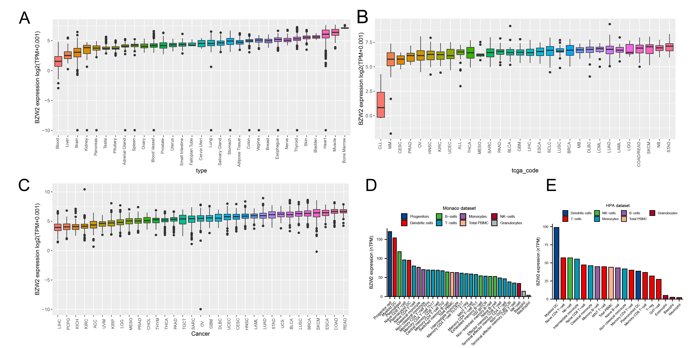
Supplementary Figure 1. (A) Expression level of BZW2 in normal tissues (GTEx datasets); (B) Expression levels of BZW2 in cancer cell lines (CCLE datasets); (C) Expression levels of BZW2 in cancers (TCGA datasets); (D) The expression level of BZW2 in immune cells was analyzed based on the Monaco dataset; (E) The expression level of BZW2 in immune cells was analyzed based on the HPA dataset.

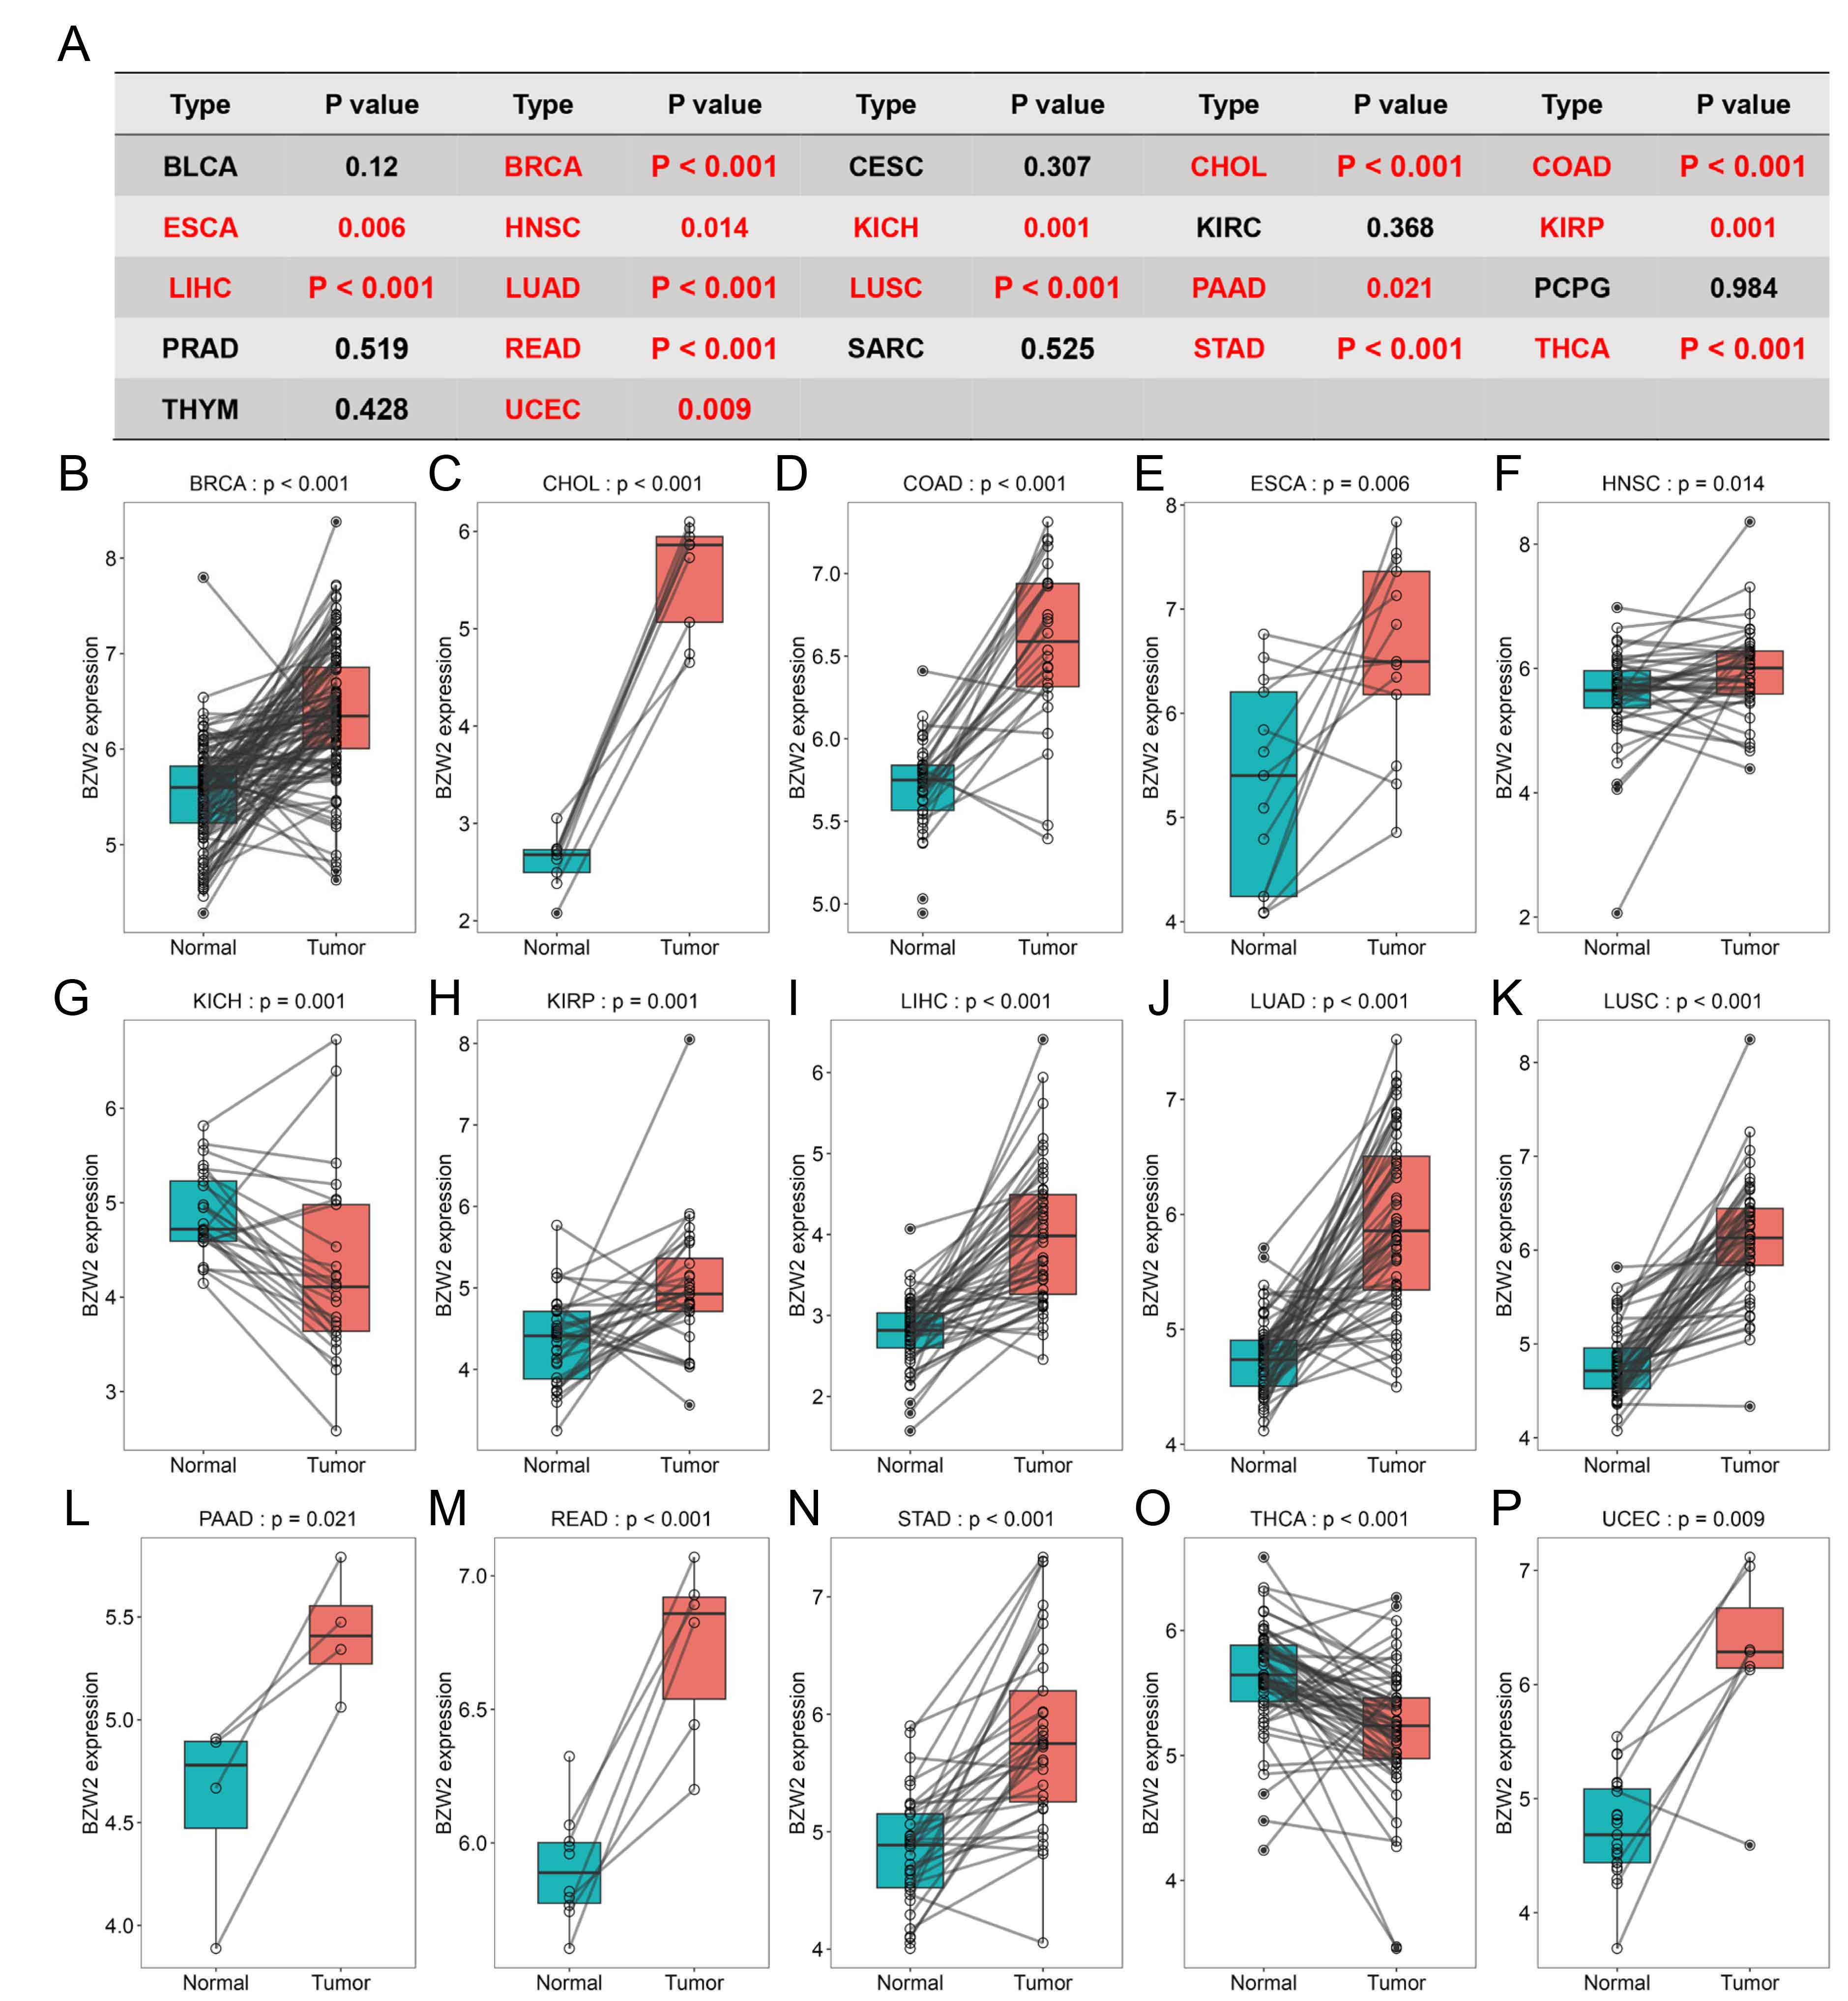
Supplementary Figure 2. BZW2 is upregulated in multiple cancer types based on the results of paired Student’s t-test (A) Overview of the results of paired Student’s t-test in 22 cancer types. Overview of the results of paired Student’s t-test in 22 cancer types. Results of paired Student’s t-test of BZW2 expression in tumor and paired adjacent normal tissues in The Cancer Genome Atlas datasets, including BRCA (B), CHOL (C), COAD (D), ESCA (E), HNSC (F), KICH (G), KIRP (H), LIHC (I), LUAD (J), LUSC (K), PAAD (L), READ (M), STAD (N), THCA (O) and UCEC.

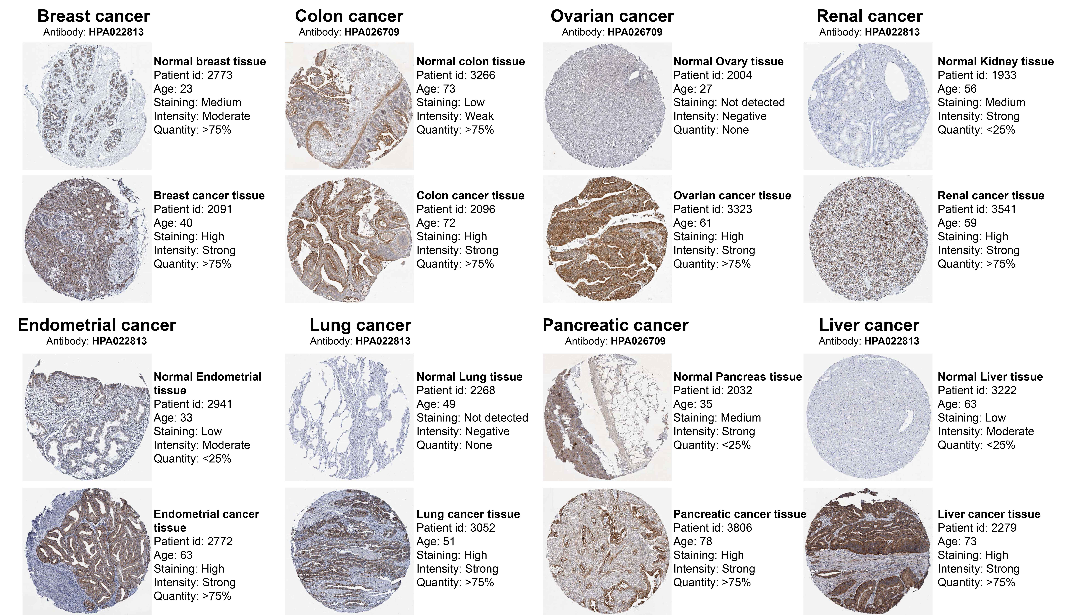
Supplementary Figure 3. IHC verification results of BZW2 protein expression (from HPA database).
Supplementary Figure 4. (A) Pan-cancer SNV mutational landscape of BZW2; (B) Correlation between BZW2 copy number variation and mRNA expression; Correlations between BZW2 expression and copy number variation in ESCA (C), HNSC (D), SARC (E) and READ (F); (G) Survival difference between CNV and wide.

Supplementary Figure 5. (A) Methylation differences of BZW2 in pan-cancer. Correlation analysis of BZW2 methylation levels and mRNA expression in cg25778479 (B) and cg22294755 (C). (D) Correlation between BZW2 and TMB in pan-cancer; (E) Correlation between BZW2 and MSI in pan-cancer; (F) Correlation between BZW2 expression and TP53 mutations in pan-cancer.

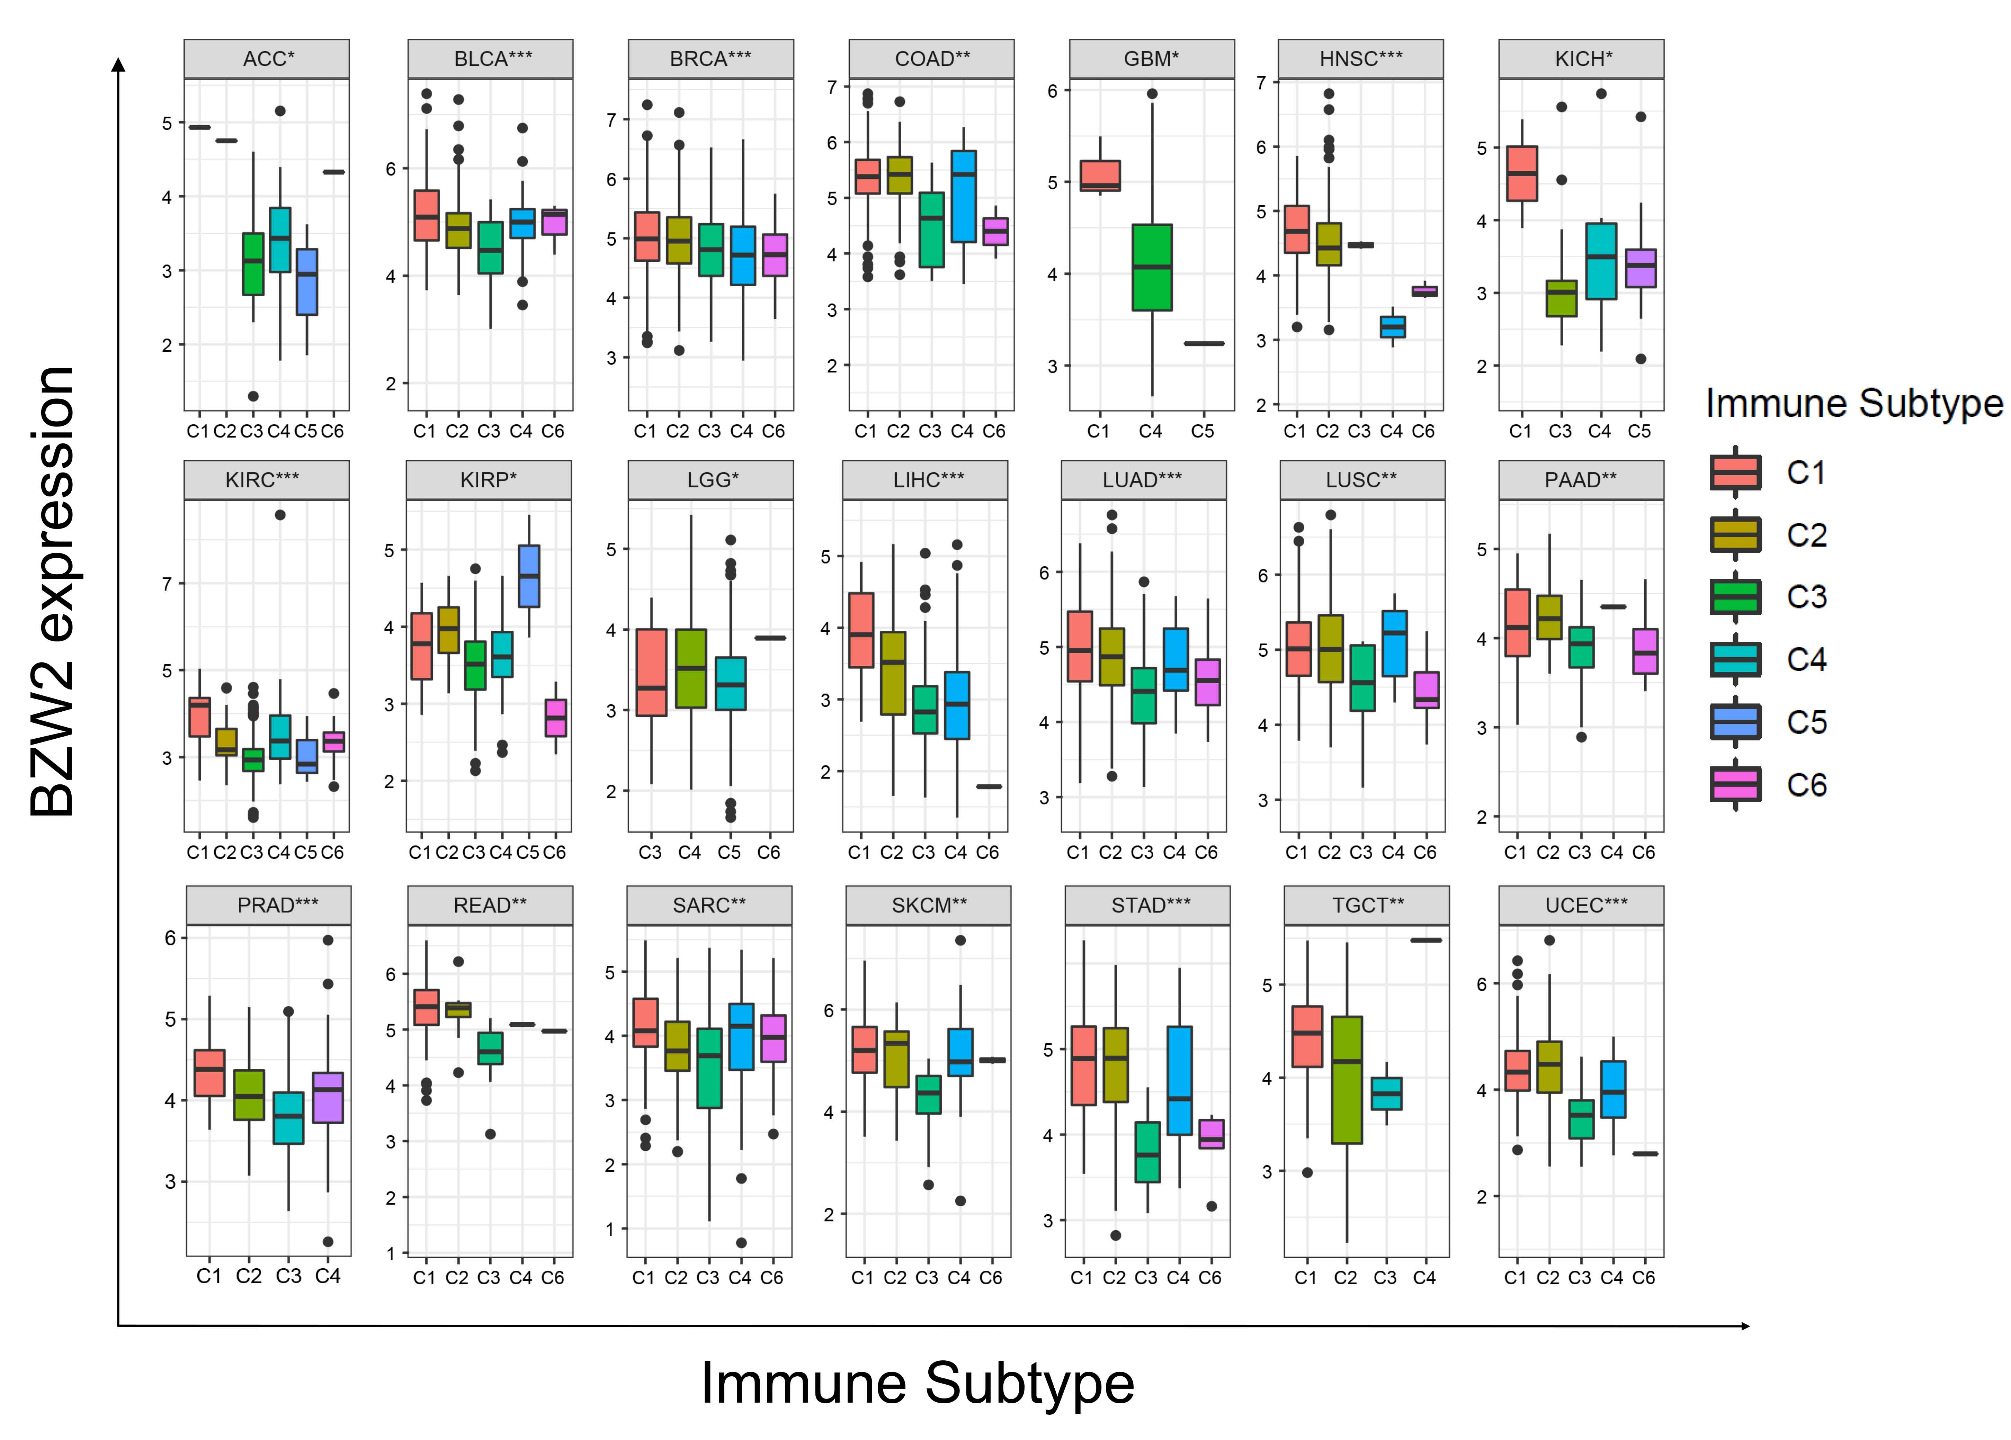
Supplementary Figure 6. Correlation between BZW2 mRNA expression and immune subtypes in pan-cancer; C1 (wound healing), C2 (IFN-gamma dominant), C3 (inflammatory), C4 (lymphocyte depleted), C5 (immunologically quiet), C6 (TGF-b dominant).

Supplementary Figure 7. (A) Correlation between BZW2 and TME signature genes in pan-cancer; (B) Correlation between BZW2 and immune cell infiltration in pan-cancer (ssGSEA); (C) Correlation between BZW2 and key immune checkpoints in pan-cancer; (D) Correlation between BZW2 and infiltration of four suppressive immune cells in pan-cancer.

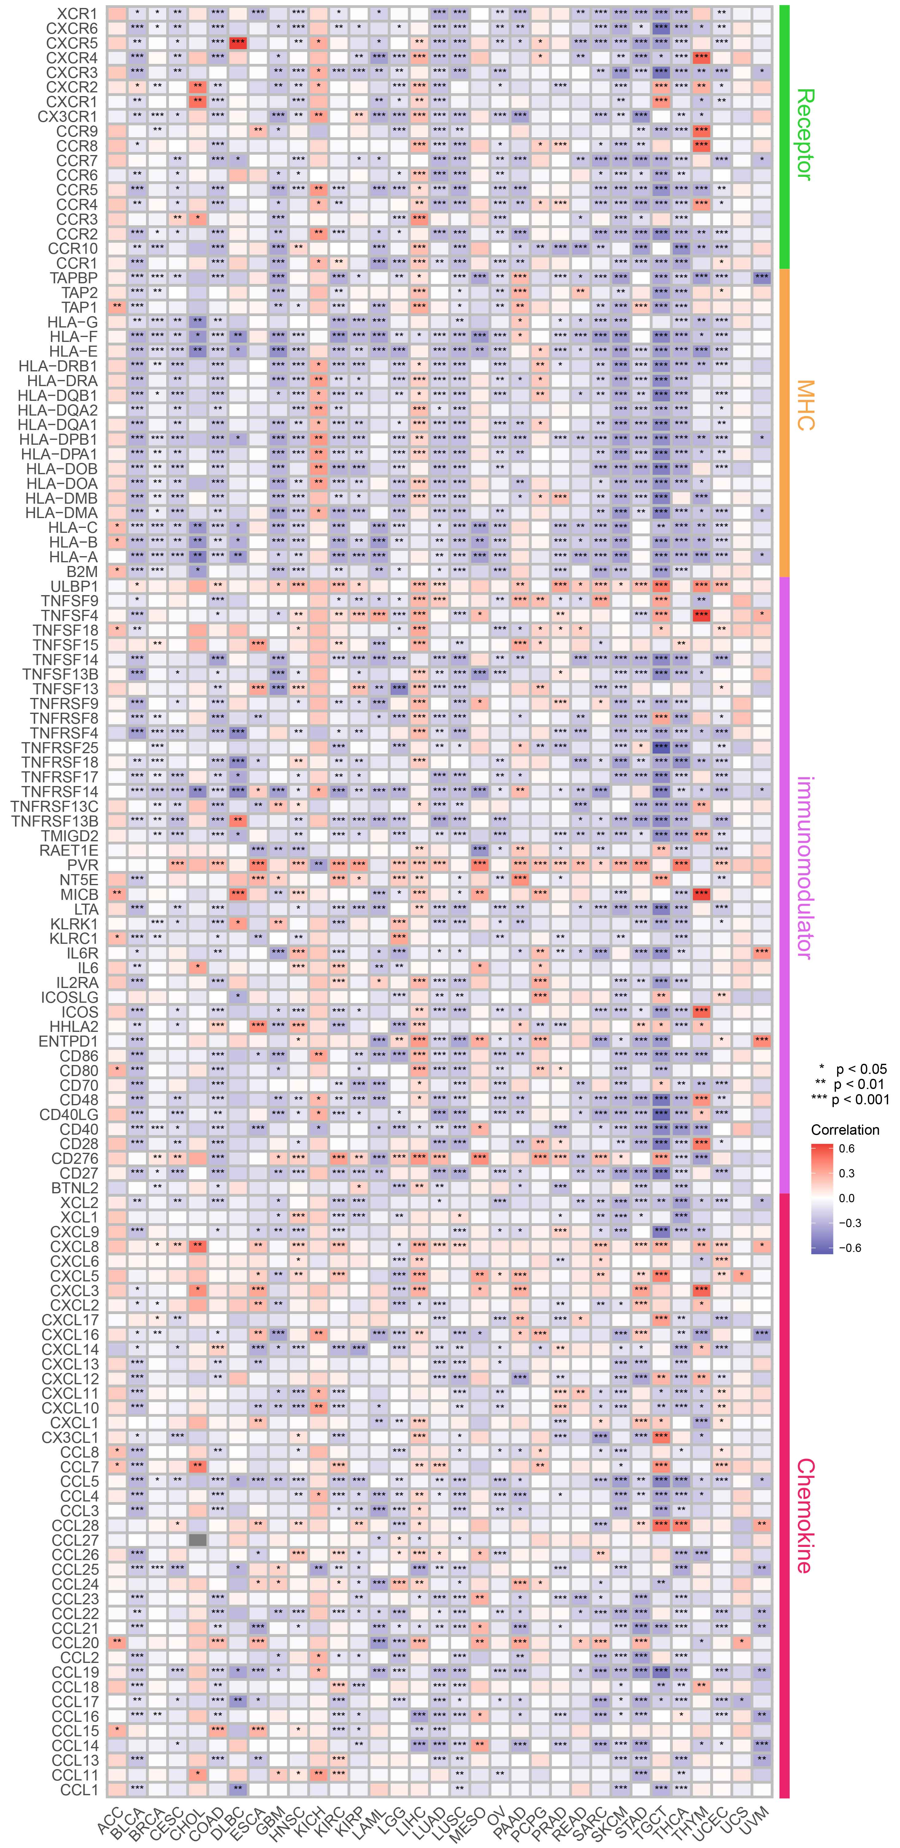
Supplementary Figure 8. Correlation analysis between BZW2 and 122 immune regulatory factors in pan-cancer.

Supplementary Figure 9. Correlation analysis between BZW2 and different steps of the cancer immune cycle in pan-cancer

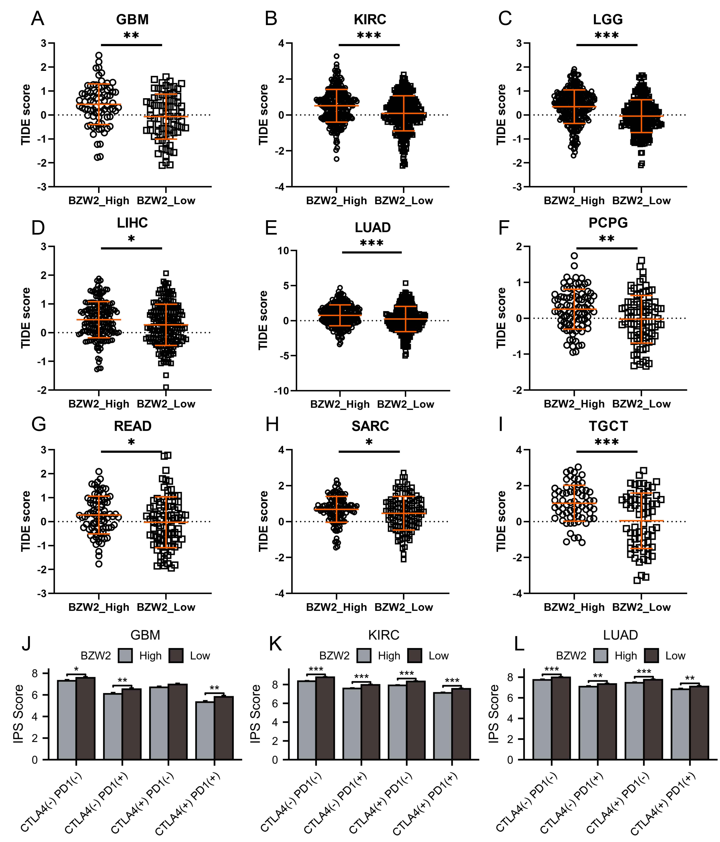
Supplementary Figure 10. TIDE algorithm evaluates the response rate of high and low expression of BZW2 to immunotherapy, including GBM (A), KIRC (B), LGG (C), LIHC (D), LUAD (E), PCPG (F), READ (G), SARC (H) and TGCT (I). IPS score evaluates the response rate of high and low expression of BZW2 to PD1, CTLA4 and combination therapy, including GBM (J), KIRC (K), LUAD (L)
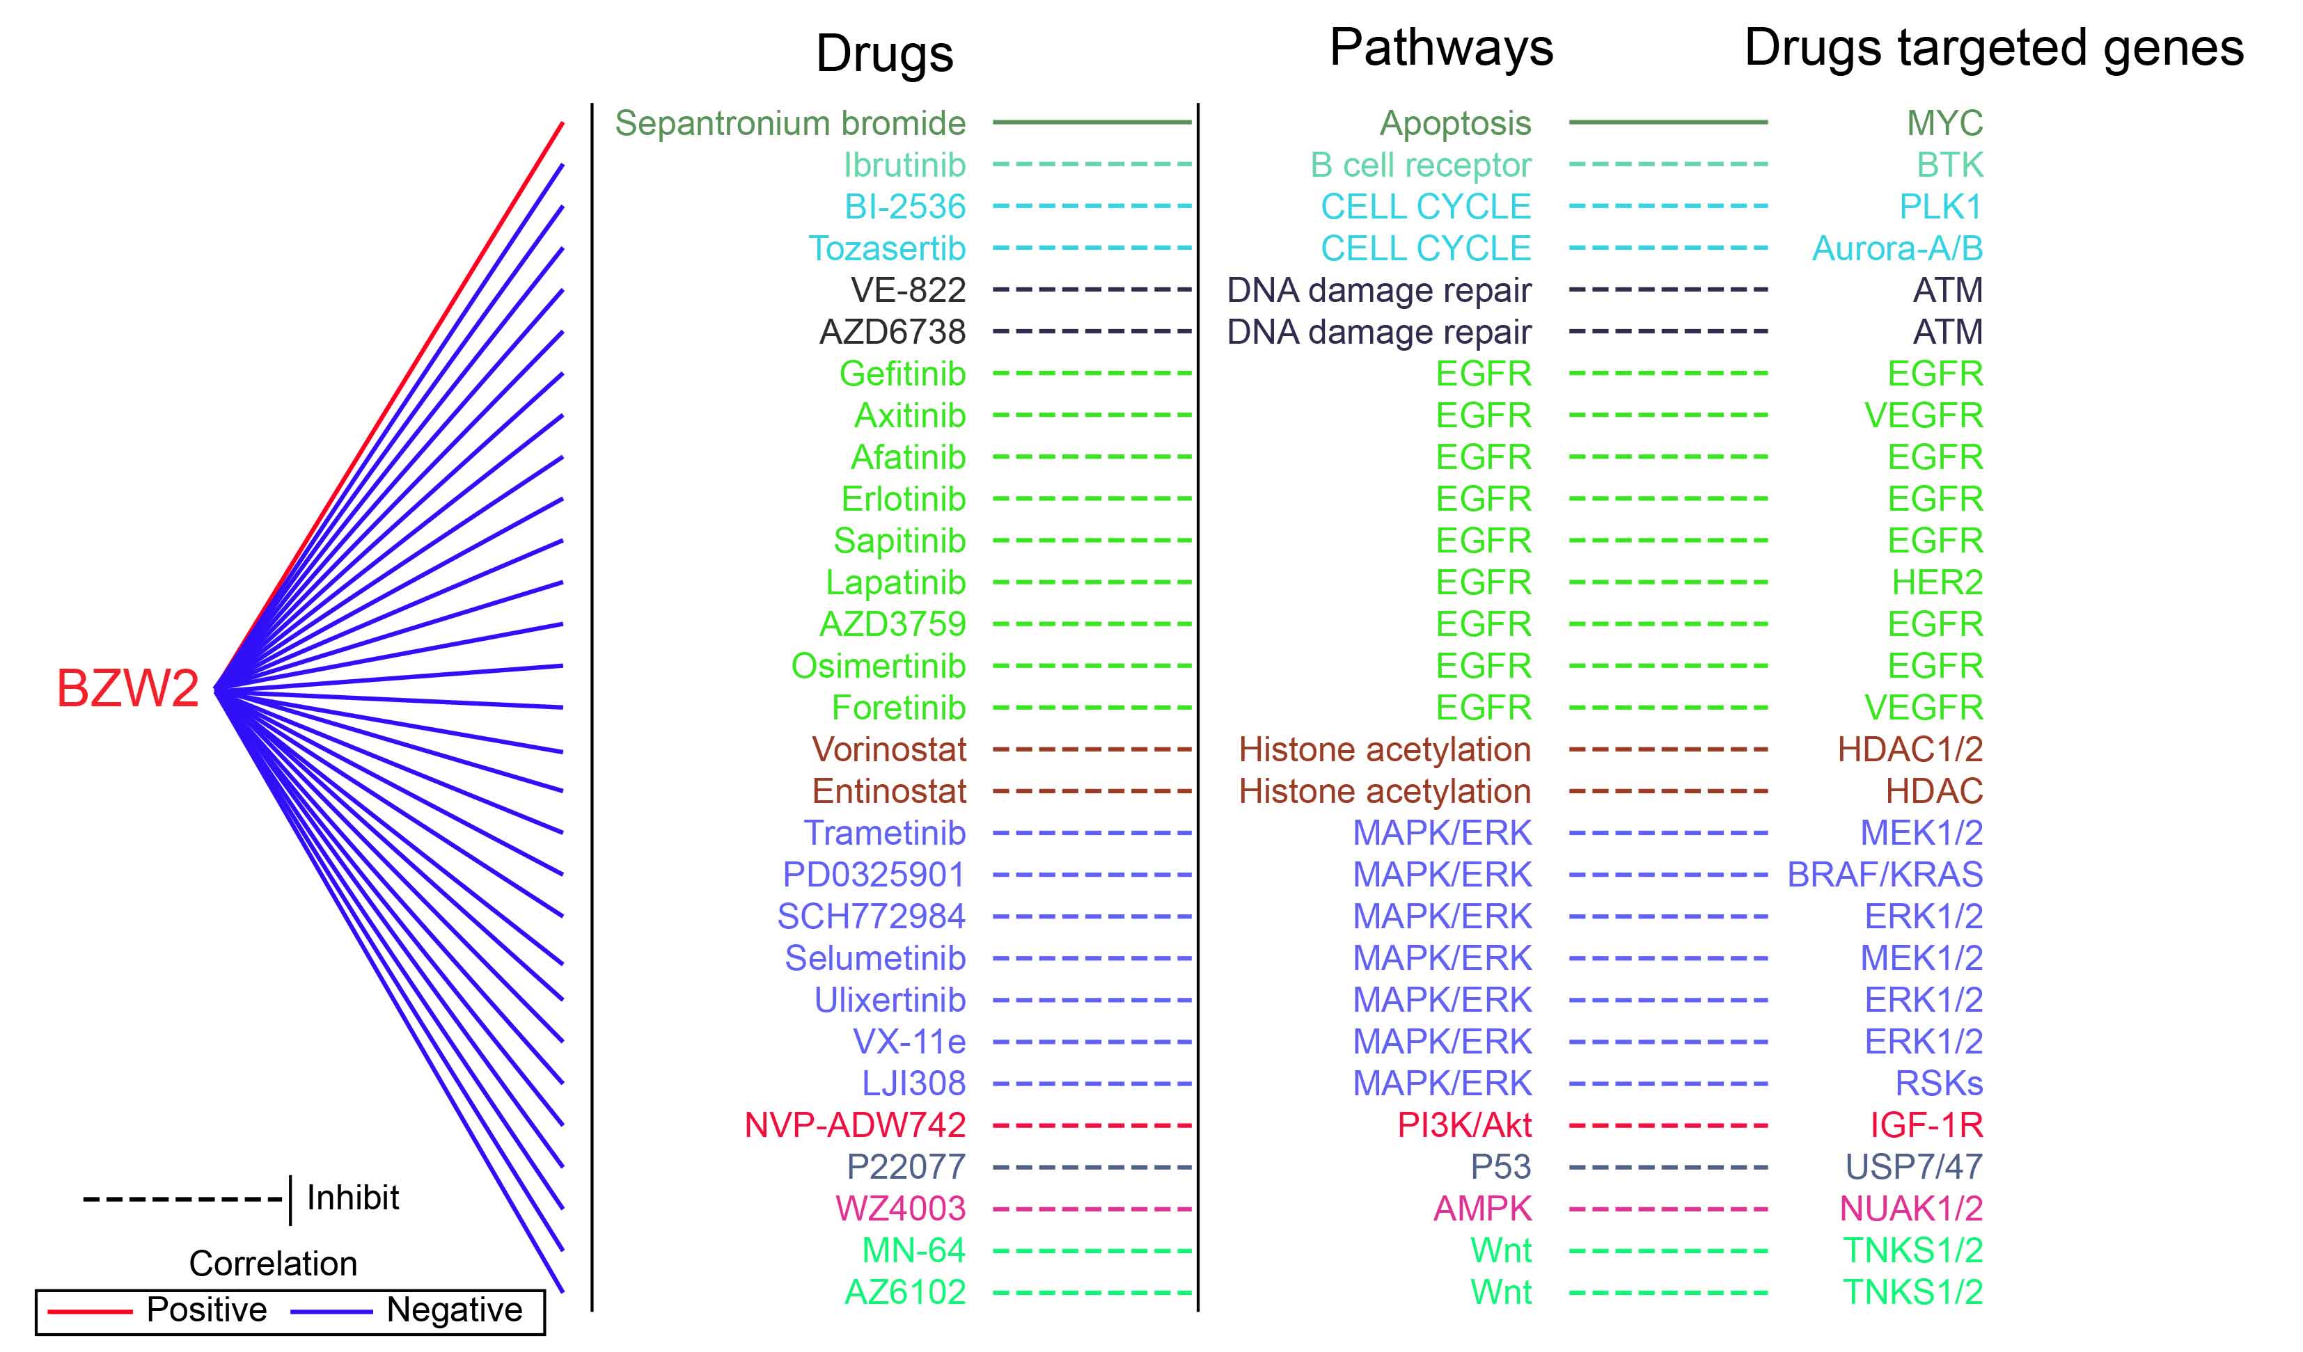
Supplementary Figure 11. Drug sensitivity analysis of BZW2.

Supplementary Figure 12. BZW2 univariate cox analysis results in pan-cancer. (A-D) Overall survival (OS), Disease specific survival (DSS), Disease free interval (DFI), Progression free interval (PFI). (B) Association of clinical features in BZW2 and CESC; (C) Association between BZW2 and GRADE staging in CESC; (D) Correlation between BZW2 and age of CESC patients.

