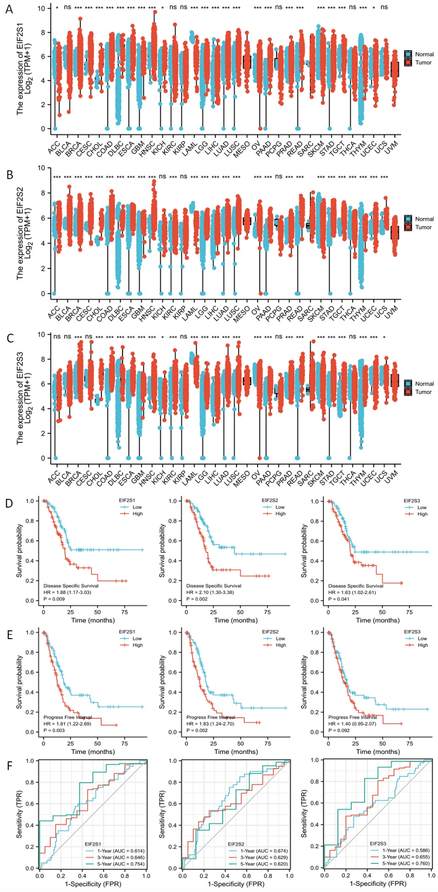

Supplementary Fig. 1: Expression of EIF2Ss in PAAD and their prognostic and diagnostic value. (A-C) Differentially expressed EIF2S1, EIF2S2, and EIF2S3 in various cancers between tumor and normal tissue. (D) DSS curves of low and high expressed of EIF2S1, EIF2S2, and EIF2S3 in PAAD. (E) PFI curves of low and high expressed of EIF2S1, EIF2S2, and EIF2S3 in PAAD. (F) The time-dependent ROC curves of EIF2S1, EIF2S2, and EIF2S3 for 1-year, 3-year, and 5-year overall survival in PAAD. *P < 0.01 and ***P < 0.001.

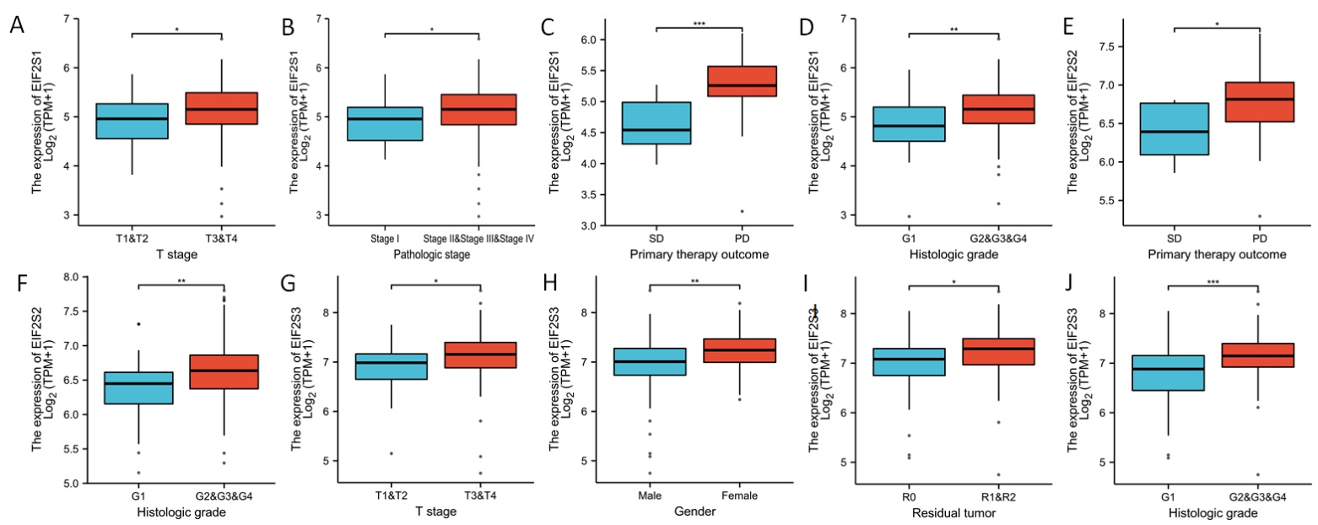
Supplementary Fig. 2: Expression of EIF2Ss in PAAD and their prognostic and diagnostic value. (A-D) Differentially expressed EIF2S1 in various clinicopathological characteristics of PAAD. (E-F) Differentially expressed EIF2S2 in various clinicopathological characteristics of PAAD. (G-J) Differentially expressed EIF2S3 in various clinicopathological characteristics of PAAD. *P < 0.01, **P < 0.01 and ***P < 0.001.

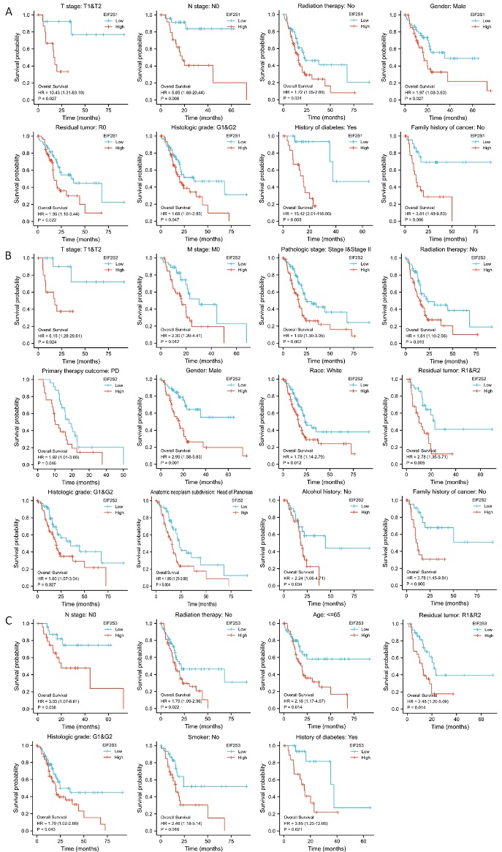

Supplementary Fig. 3: Expression of EIF2Ss in PAAD and their prognostic and diagnostic value. (A-C) OS curves indicated the prognostic value of EIF2S1, EIF2S2, and EIF2S3 in various clinicopathological characteristics of PAAD.

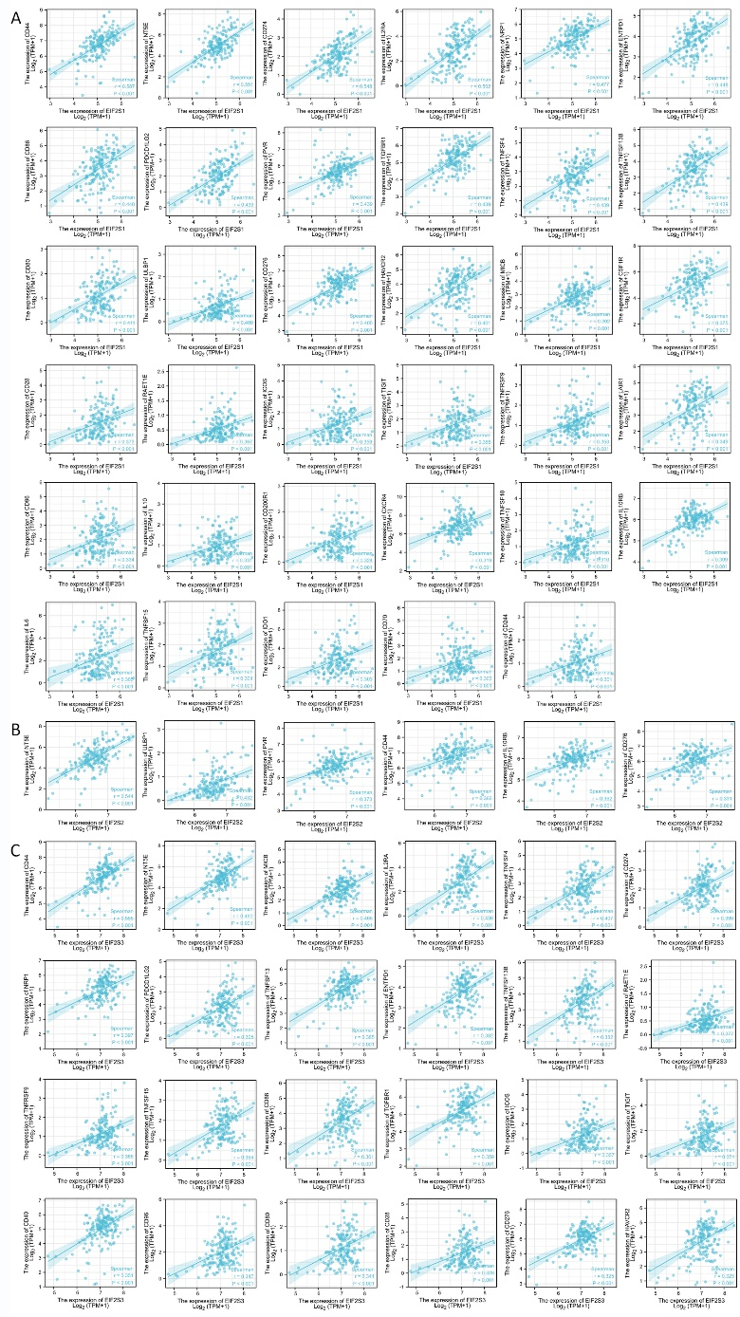
Supplementary Fig. 4: EIF2Ss correlations with immune checkpoints, subtypes, lymphocytes, and immunostimulators. (A-C) The correlation between the expression of EIF2S1, EIF2S2, and EIF2S3 with various immune checkpoints.

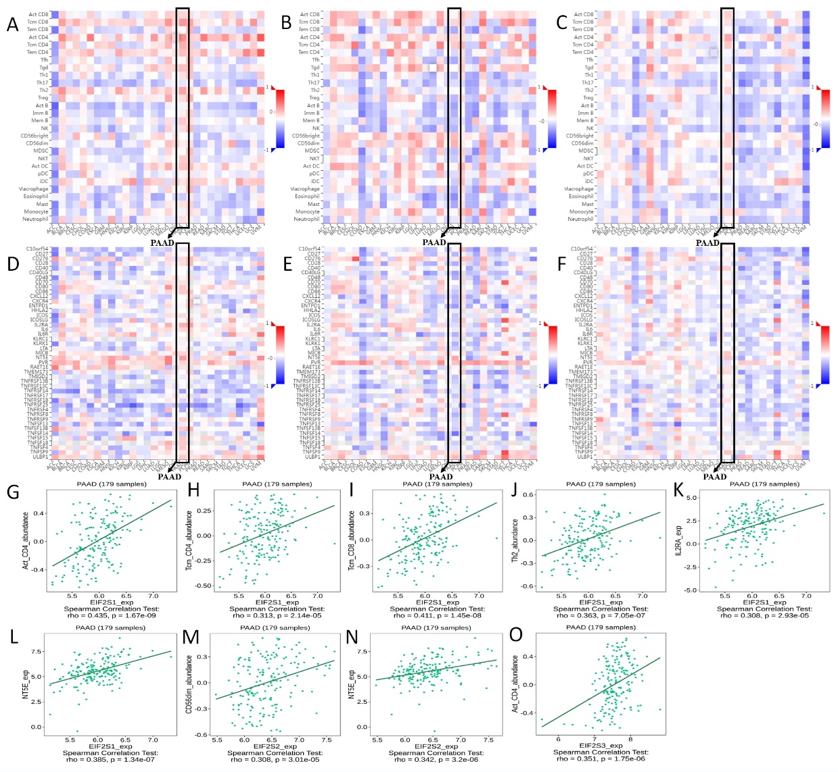
Supplementary Fig. 5: EIF2Ss correlations with immune checkpoints, subtypes, lymphocytes, and immunostimulators. (A-C) The correlation between EIF2Ss with lymphocytes in 30 types of cancers showed in the heatmap. (D-F) The correlation between EIF2Ss with immunostimulators in 30 types of cancers showed in the heatmap. (G-J) The correlation between the abundance of Act_CD4, Tcm_CD4, Tcm_CD8, and Th2 with the expression of EIF2S1. (K-L) The correlation between the IL2RA and NT5E with the expression of EIF2S1. (M-N) The correlation between the abundance of CD56dim and NT5E with the expression of EIF2S2. (O) The correlation between the abundance of Act_CD4 with the expression of EIF2S3.

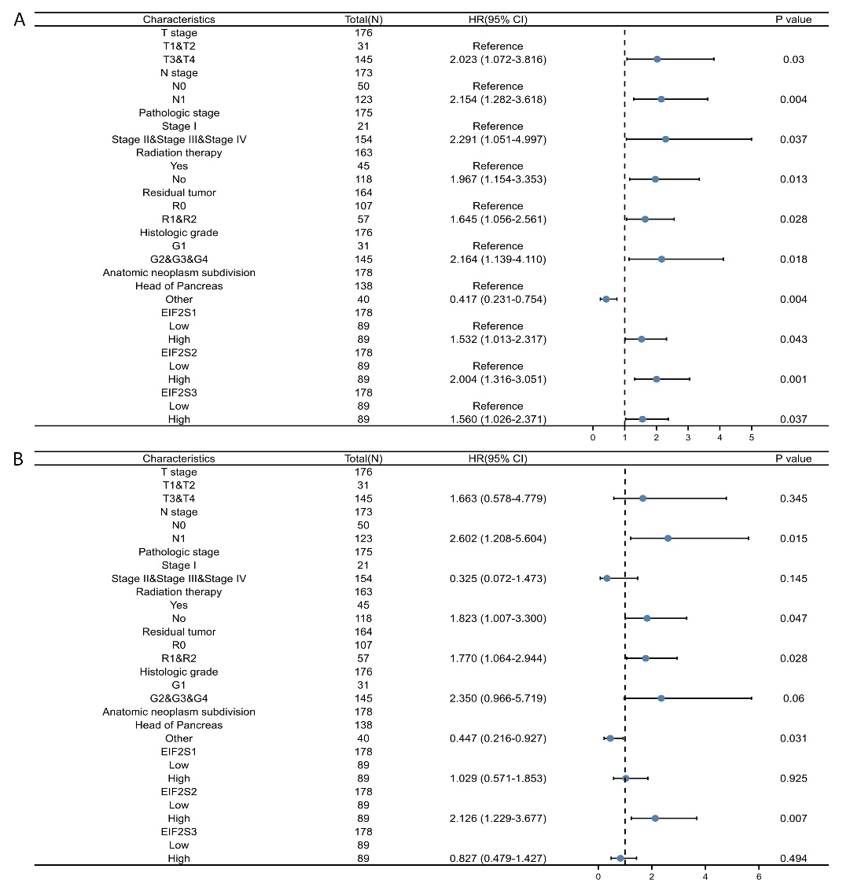
Supplementary Fig. 6: Construction of a nomogram for PAAD. (A) The forest plot summary of univariate cox regression analyses of important clinicopathologic features (T stage, N stage, Pathological stage, Radiation therapy, Residual tumor, histologic grade, Anatomic neoplasm subdivisions) and EIF2S1, EIF2S2, and EIF2S3. (B) The forest plot summary of multivariate cox regression analyses of important clinicopathologic features (T stage, N stage, Pathological stage, Radiation therapy, Residual tumor, histologic grade, Anatomic neoplasm subdivisions) and EIF2S1, EIF2S2, and EIF2S3.

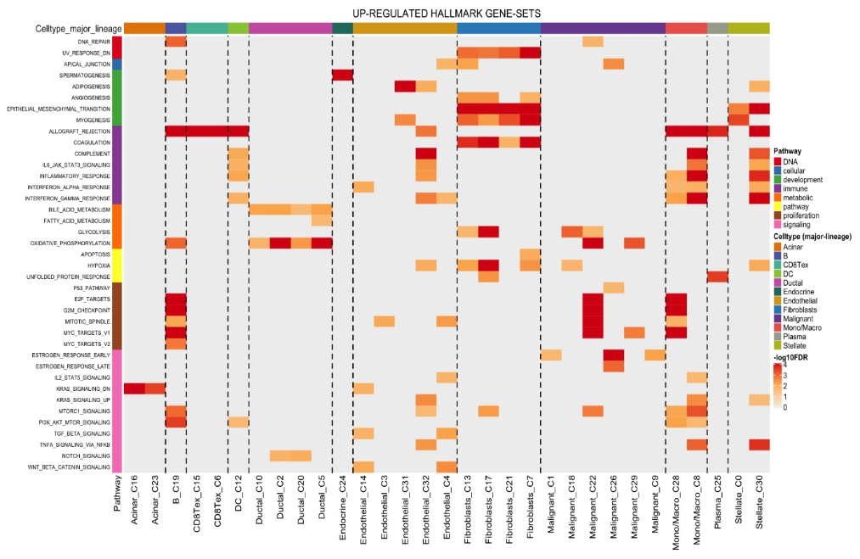
Supplementary Fig. 7: ScRNA-Seq analysis of EIF2S1, EIF2S2, and EIF2S3 in PAAD. Up-regulated hallmark gene sets in PAAD_CRA001160. (M) Up-regulated hallmark gene sets in PAAD_GSE111672.

s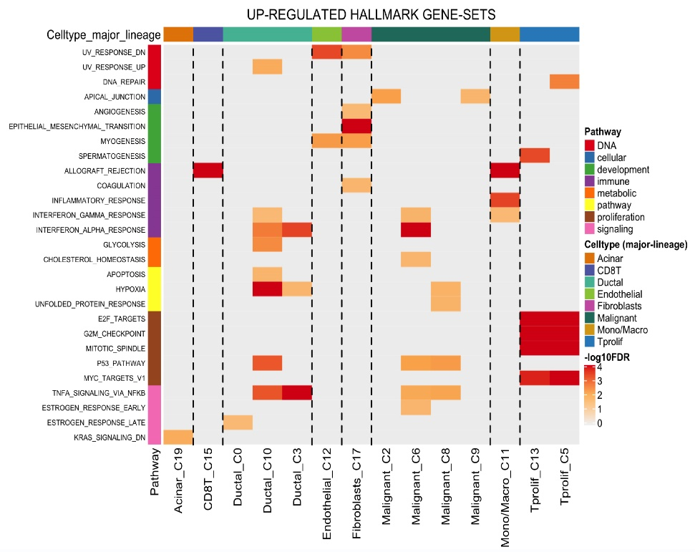
Supplementary Fig. 8: ScRNA-Seq analysis of EIF2S1, EIF2S2, and EIF2S3 in PAAD. Up-regulated hallmark gene sets in PAAD_GSE111672.

