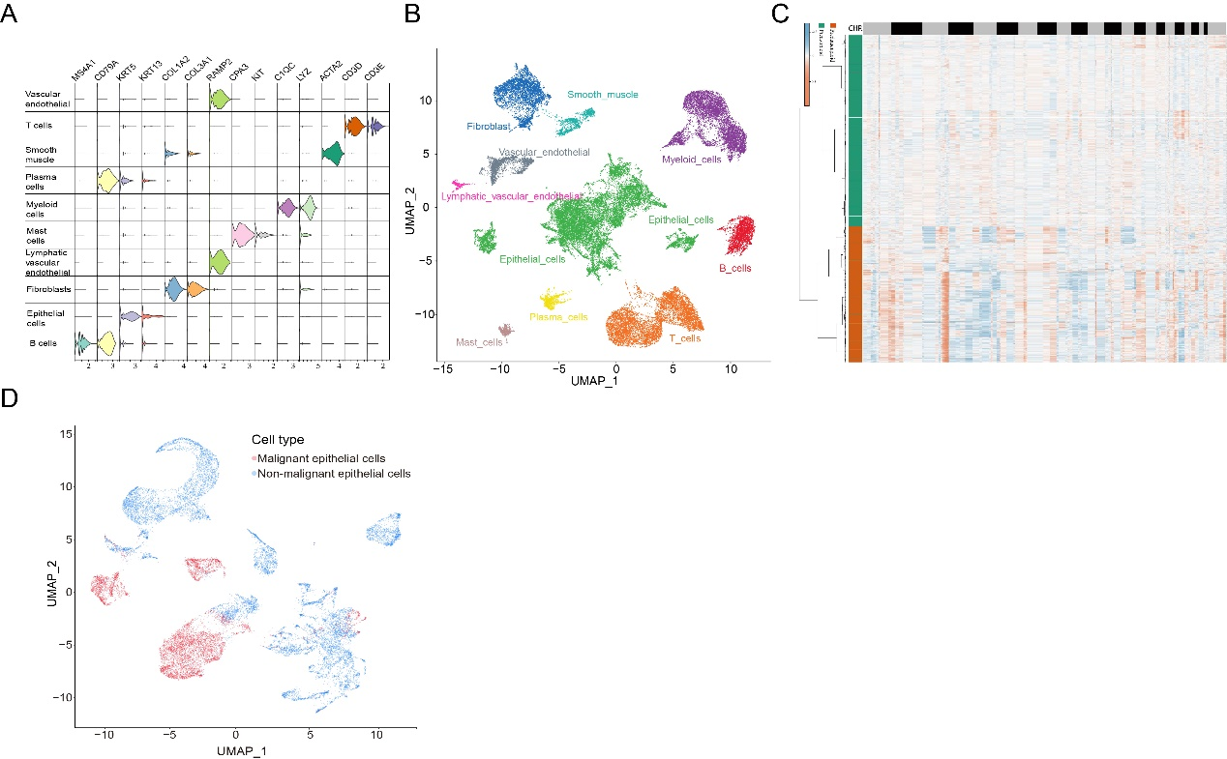
Supplementary Fig. 1. ScRNA-seq reveals malignant epithelial cells in different samples. (A) The violin plot showed the marker genes of different cells. (B) The UMAP plot showed different cell clusters in GSE188990. (C,D) UMAP plot and heatmap showed malignant epithelial cells predicted by copyKat.

