Supplementary material
Plants-occurring Anthraquinones as Photosensitive Compounds for
Photodynamic Method: A Critical Overview
Vanya Mantareva^{1,*}, Diana Braikova¹, Irina Lazarova², Tsanislava Genova³
¹Institute of Organic Chemistry with Centre of Phytochemistry, Bulgarian Academy of Sciences, 1113 Sofia, Bulgaria
²Faculty of Pharmacy, Medical University – Sofia, Dunay, 1000 Sofia, Bulgaria
³ Institute of Electronics, Bulgarian Academy of Sciences, 1784 Sofia, Bulgaria

*Correspondence: mantareva@yahoo.com; Vanya.Mantareva@orgchm.bas.bg (Vanya Mantareva)

Supplementary Table 1. The main anthraquinones and the plants sources.
The well – known NO-AQ | Chemical structures | Plants Families (Genus – species)
Alatinone | 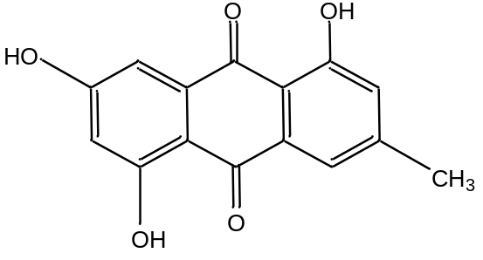 | Fabaceae (Senna - Senna alata syn: Cassia alata [1], [2]);
Alizarin | 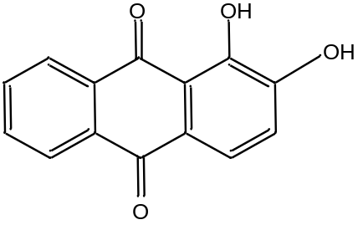 | Fabaceae (Senna - Senna obtusifolia syn:Cassia obtusifolia L.[3]);  Polygonaceae (Rheum - Rheum emodi [4]); Rubiaceae (Rubia - Rubia tinctorum L. [5], [6], [7], Rubia cordifolia L. [8], [9]); (Galium - Galium humifusum M. Bieb. [5]);
Aloe -Emodin | 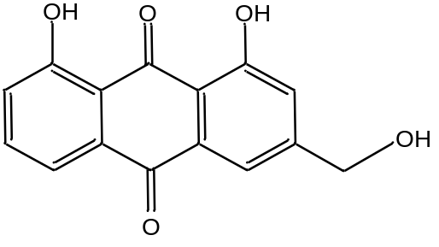 | Fabaceae (Cassia L.- C. absus,C. grandis,C. obtusifolia,C. abbreviata,C. acutifolia, C. alata,C. corymbosa,C. fastuosa, C. occidentalis, C. auriculata [1],[10],[11]); (Senna – Senna alexandrina [12]);  Asfodelacea (Aloe L. - Aloe Vera syn: Aloe barbadensis Miller [13], [14], Aloe ferox [15], Aloe excelsa [16]); (Asphodeline - A. baytopae E.Tuzlaci, A.brevicaulis (Bertol.) J.Gay ex Bake, A.lihurtzica (Scop.) Reichb., A.lutea (L.) Reichb. [17]); (Kniphofia - Kniphofia ensifolia Baker [18]); (Asphodelus L. - A. aestivus Brotero, A. cerasifer, A. fistulosus L., A. microcarpus Salzm. & Viv [19]); (Bulbine - B. abyssinica, B. frutescens [20]);  Polygonaceae (Rheum - Rheum palmatum, Rheum officinale Bail. [21], Rheum emodi syn: Rheum australe D.Don [22],[23]); (Reynoutria - Reynoutria japonica Houtt. [24], Polygonum multiflorum syn: Reynoutria multiflora Thunb. [25], [26]); (Fagopyrum - Fagopyrum tataricum L. Gaertn. [27]); (Genus Rumex - Rumex japonicus Houtt. [28]);  Araliaceae (Oplopanax - Oplopanax elatus Nakai - [29], [30]);  Rhamnaceae (Rhamnus - Rhamnus alpinus L. [31]); (Berchemia - B. floribunda [32]);  Saxifragaceae (Bergenia Moench. [33]);  Acanthaceae (Eremomastax - Eremomastax speciose (Hochst.) Cufod [34]);  Bignoniaceae (Oroxylum - Oroxylum indicum (L.) Vent. [35]);
Barbaloin, Isobarbaloin (aloin A,B) | 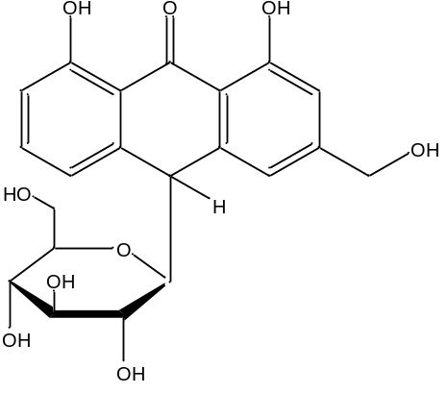 | Fabaceae (Cassia - Cassia fistula [10], [11], [36]);  Asfodelacea (Aloe - Aloe Vera [14], [37], [38], Aloe ferox [15], Aloe excelsa [16], Aloe arborescens [39]);
Cassialoin | 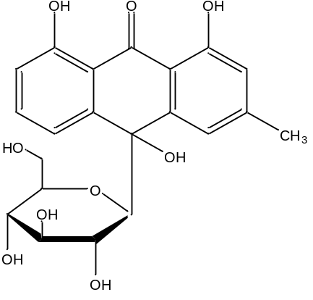 | Fabaceae (Senna - Cassia garrettiana syn: Senna garrettiana [1], [40]);  Polygonaceae (Rheum - Rheum australe [23]); (Rumex - Rumex dentatus L. [41], [42]);
Chrysophanol | 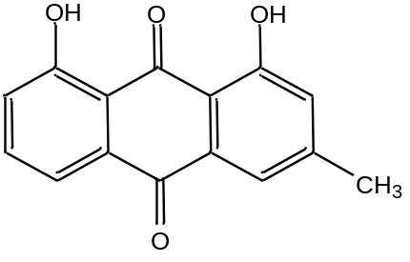 | Fabaceae (Cassia - C. garrettiana, C. javanica, C. siamea, C. tora, C. absus, C. abbreviata, C. acutifolia, C. alata, C. biflora, C. renigera [1],[10],[11]); (Senna - Senna alexandrina [12], Senna macranthera [43], Senna italica Mill. [44], Senna tora, S. longiracemosa [45]); (Sophera - S. flavescens [94]);  Asfodelacea (Aloe - Aloe Vera [13], [14], Aloe ferox [15], Aloe grandidentata Salm-Dyck [46], Aloe pulcherrima [47]); (Asphodeline- A. haytopae, A.brevicaulis A.lihurtzica, A.lutea [17]); (Bulbine - B. narcissifolia [48], B. natalensis [49], B. abyssinica [50] B. capitate [20]); (Kniphofia -K. isoetifolia Hochst. [51], Kniphofia ensifolia [18]); (Asphodelus - A. acaulis, A. albus, A. fistulosus, A. microcarpus [19]);  Polygonaceae (Rheum - Rheum palmatum, Rheum officinale [21], Rheum emodi [22]syn: Rheum australe [23]); (Reynoutria - Reynoutria japonica Houtt. [24], Polygonum multiflorum syn: Reynoutria multiflora [25], [26]); (Fagopyrum - Fagopyrum tataricum L. Gaertn. [27]); (Rumex -Rumex dentatus L. [42], Rumex abyssinicus [52], Rumex japonicus [28]);  Araliaceae (Oplopanax - Oplopanax elatus [29], [30]);  Rhamnaceae (Rhamnus -Rhamnus alpinus L. [31], Rhamnus heterophylla [53]); (Colubrina - Colubrina greggii [54]); (Berchemia -B. floribunda [32]);  Meliaceae (Walsura - Walsura trifoliata [55]);  Picramniaceae (Alvaradoa - Alvaradoa amorphoides [56]);  Podocarpaceae (Nageia - Nageia fleuryi syn: Podocarpus fleuryi [57]);  Dipterocarpaceae (Shorea - Shorea worthingtonii, Vatica - Vatica obscura [58]);  Actinidiaceae (Actinidia - Actinidia arguta Sieb. et Zucc. [59]);  Vitaceae (Cissus – Cissus modeccoides [60]);
Citreorosein | 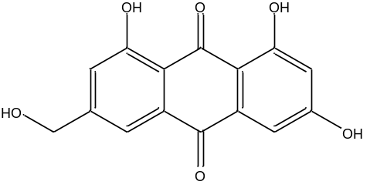 | Fabaceae (Cassia - Cassia nigricans [11], [61], [62]);  Polygonaceae (Rumex - Rumex abyssinicus [52]); (Reynoutria - Reynoutria japonica Houtt. [24], Polygonum multiflorum syn: Reynoutria multiflora [25], [26]); (Rheum - Rheum palmatum [63]);  Rhamnaceae (Rhamnus - Rhamnus heterophylla [53]);
Damnacanthal | 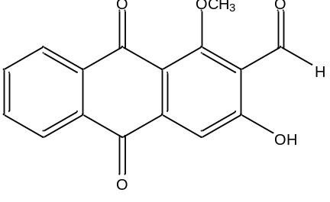 | Rubiaceae (Heterophyllaea - Heterophyllaea pustulata Hook f. [4], [62], [64]); (Morinda - Morinda citrifolia L. commonly known as ‘noni’[65], Morinda elliptica [4], [66], Morinda royoc [4], [7], M. pandurifolia [7], [67], Morinda lucida [7]); (Prismatomeris – P. malayana [7], [68], P. fragrans, P. Tetrandra [68]); (Pentas -P. micrantha, P. zanzibarica, P. lanceolate [69]); (Rennellia - Rennellia elliptica [7]);
Damnacanthol | 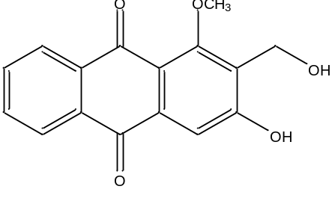 | Rubiaceae (Heterophyllaea - Heterophyllaea pustulata Hook f. [4], [62], [64]); (Morinda - Morinda lucida Benth. [70]); (Lasianthus - Lasianthus acuminatissimus MERR. [71]); (Knoxia Knoxia valerianoides [72]); (Prismatomeris - Prismatomeris malayana [68]); (Pentas -P. micrantha, P. lanceolata [69]);
Danthron (Chrysazin) | 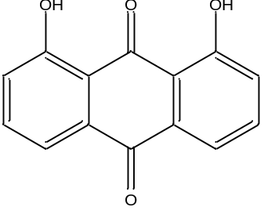 | Polygonaceae (Rheum -Rheum palmatum L. [73]);  Xyridaceae (Xyris - Xyris indica [74], Xyris semifuscata [75]);
Digiferruginol | 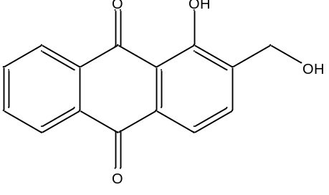 | Plantaginaceae (Digitalis [76]);  Rubiaceae (Morinda - Morinda parvifolia [77], Morinda officinalis [78]); (Coptosapelta - Coptosapelta tomentosa [79]); (Dimetia - Hedyotis capitellata syn: Dimetia capitellata [7], [80]); (Plocama - Plocama pendula [81]);
Emodin | 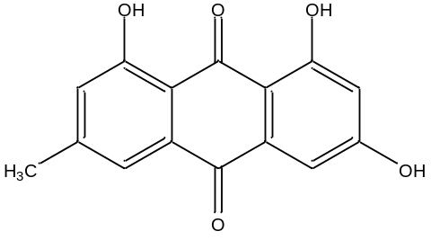 | Fabaceae (Cassia - C. laevigata,  C. fistula, C. nigricans, C. acutifolia, C. didymobotrya, C. javanica, C. multiglandulosa, C. nodosa, C. occidentalis, C. pudibunda, C. Sophera, C. spectabilis, [1], [10], [11]); (Senna - Senna alexandrina [12], Senna didymobotrya [45], Senna tora syn: Cassia tora Linn. [82]);  Asfodelacea (Aloe - Aloe Vera [13], [14], Aloe grandidentata [46]); (Asphodeline- A. haytopae, A.brevicaulis A.lihurtzica, A.lutea [17]); (Asphodelus - A. microcarpus [19]);  Polygonaceae (Rheum -Rheum palmatum, Rheum officinale [21], Rheum emodi [22], Rheum austral [23]); (Reynoutria - Reynoutria japonica Houtt. Syn: Polygonum cuspidatum [4], [24], Polygonum multiflorum syn: Reynoutria multiflora [25], [26]); (Fagopyrum - Fagopyrum tataricum L. Gaertn. [27]); (Rumex - Rumex dentatus L. [42], Rumex abyssinicus [52], Rumex japonicus [28]);  Rubiaceae (Rubia - Rubia cordifolia L. [8], [9]);  Rhamnaceae (Rhamnus - Rhamnus alpinus L. [31], Rhamnus frangula L.[83], Rhamnus heterophylla [53]);  Araliaceae (Oplopanax - Oplopanax elatus [29], [30]);  Actinidiaceae (Actinidia - Actinidia arguta [59]);  Amaranthaceae (Achyranthes [84]);  Vitaceae (Cissus – Cissus modeccoides [60]);  Hypericaceae (Hypericum – H. perforatum L. [85]);
Heterophylline | 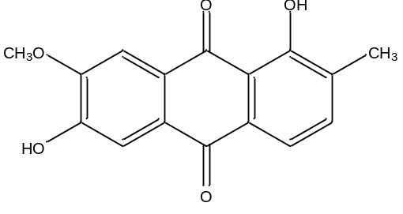 | Rubiaceae (Heterophyllaea - Heterophyllaea pustulata Hook f. [62], [64], Heterophyllaea lycioides (Rusby) Sandwith [86]);  Acanthaceae (Eremomastax - Eremomastax speciose [34]);
Lucidin | 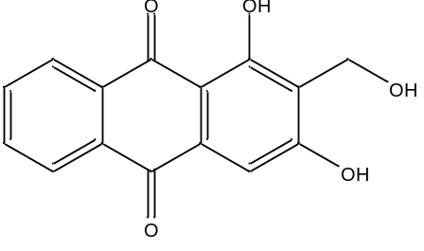 | Rubiaceae (Knoxia - Knoxia valerianoides [72]); (Morinda - Morinda lucida Benth [70], M. Pandurifolia [7], [67], Morinda royoc [7]); (Rubia - Rubia cordifolia L. [9], Rubia tinctorum L. [6], [7]);
Physcion (parietin) | 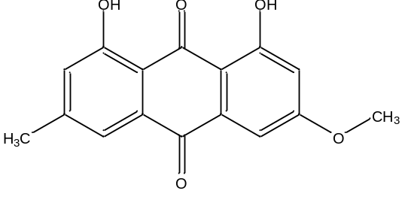 | Fabaceae (Cassia - C. Pudibundaa, C. marginata, C. racemose, C. sophera, C. siamea [10], [11]); (Senna - Senna alexandrina [12], Senna macranthera [43] Senna italica [44], Senna tora [45], Senna didymobotrya [45]);  Asfodelacea (Aloe - Aloe Vera [13], [14], Aloe Grandidentata [46]); (Asphodeline- A. haytopae, A.brevicaulis, A.lihurtzica, A.lutea [17]);  Polygonaceae (Rheum -Rheum palmatum, Rheum officinale [21], Rheum emodi [22], Rheum austral [23]); (Reynoutria - Reynoutria japonica Houtt. [24], Polygonum multiflorum syn: Reynoutria multiflora [25], [26]); (Fagopyrum - Fagopyrum tataricum L. Gaertn. [27]); (Rumex - Rumex dentatus L. [42], Rumex abyssinicus [52], Rumex japonicus [28]);  Rubiaceae (Rubia - Rubia cordifolia [9]); (Morinda - Morinda officinalis [78]);  Araliaceae (Oplopanax - Oplopanax elatus [29], [30]);  Rhamnaceae (Rhamnus - Rhamnus alpinus L. [31], Rhamnus heterophylla [53]); (Berchemia - B. floribunda [32]);  Vitaceae (Cissus – Cissus modeccoides [60]);
Purpurin | 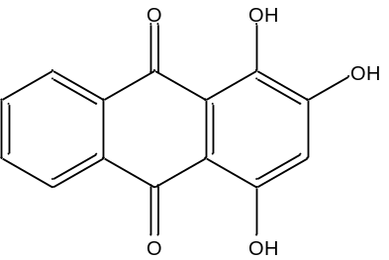 | Rubiaceae (Rubia - Rubia tinctorum L. [5], [6], [7], Rubia cordifolia L. [8], [9]); (Galium - Galium humifusum M. Bieb. [5], Relbunium hypocarpium syn:Galium hypocarpium [87]);
Pustuline | 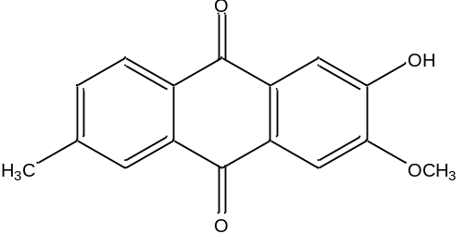 | Rubiaceae (Heterophyllaea - Heterophyllaea pustulata Hook f. [62], [64], Heterophyllaea lycioides (Rusby) Sandwith [86]); (Morinda - Morinda umbellata L. [88]);
Quinizarin | 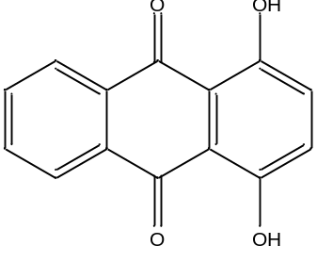 | Fabaceae (Senna - C. tora [89]);  Rubiaceae (Rubia - Rubia tinctorum L. [6]);  Rhizophoraceae (Rhizophora - Rhizophora mucronata Lam. [90]);  Verbenaceae (Tectona - Tectona grandis Linn. [91]);
Rhein | 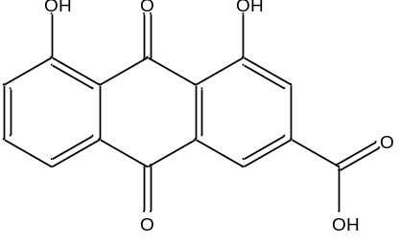 | Fabaceae (Cassia - C. angustifolia, C. didymobotrya, C. javanica, C. reticulataa, C. didymobotrya, C. fastuosa, C. occidentali [1], [10], [11]); (Senna - Senna alexandrina [12], S. Podocarpa [45]); (Cajanus - Cajanus cajan L. [92]);  Asfodelacea (Aloe - Aloe Vera [13], [14]); (Asphodeline - A. haytopae, A. brevicaulis, A. lihurtzica, A. lutea [17]);  Polygonaceae (Rheum - Rheum palmatum, Rheum officinale [21], Rheum emodi [22], Rheum austral [23]); (Reynoutria - Reynoutria japonica Houtt. [24], Polygonum multiflorum syn: Reynoutria multiflora [25], [26]); (Fagopyrum - Fagopyrum tataricum L. Gaertn. [27]); (Rumex - Rumex japonicus [28]);  Araliaceae (Oplopanax - Oplopanax elatus [29], [30]);  Rhamnaceae (Rhamnus - Rhamnus alpinus L. [31]);
Rubiadin | 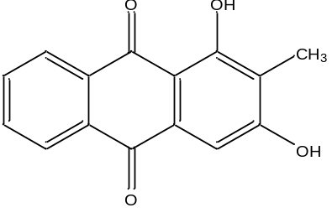 | Fabaceae (Cassia - C. auriculata [1], [11]);  Asfodelacea (Lilium - Lilium leucanthum [93]);  Rubiaceae Heterophyllaea - Heterophyllaea pustulata Hook f. [4],[62],[64], [93]); (Knoxia - Knoxia valerianoides[72], [93]); (Morinda - Morinda lucida [7], [70], Morinda elliptica, Morinda royoc [4], Morinda officinalis [7], [78], Morinda umbellata [88], [93], Morinda citrifolia [93], Morinda elliptica [66], [93], Morinda royoc [7]); (Rubia - Rubia cordifolia L.[9], Rubia peregrina, Rubia peregrina, Rubia tinctorum [93]); (Prismatomeris - Prismatomeris connata [95], Prismatomeris malayana [7], [68], [93], P. Tetrandra , P. sessiliflora, P. fragrans [68] ,[93]); (Pentas - P. micrantha, P. zanzibarica, P. lanceolate [69]); (Hymenodictyon - Hymenodictyon excelsum syn: Hymenodictyon orixense [93]); (Dimetia - Hedyotis capitellata syn: Dimetia capitellata ( [7], [80], [93]); (Scleromitrion- Hedyotis diffusa syn: Scleromitrion diffusum [93]); (Ophiorrhiza - Ophiorrhiza shendurunii [93], [96]); (Rennellia - Rennellia elliptica [7], [93]); (Plocama - Plocama pendula [7], [81]);  Asteraceae (Blumea - Blumea aromatica [93]);  Gesneriaceae (Rhynchotechum - Rhynchotechum vestitum [93]);  Meliaceae (Swietenia - Swietenia mahagoni [93]);
sor Soranjidiol | 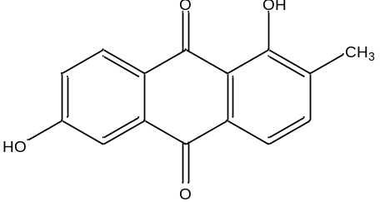 | Rubiaceae (Heterophyllaea -Heterophyllaea pustulata Hook f. [4], [62], [64], Heterophyllaea lycioides (Rusby) Sandwith [86], [97]); (Morinda - Morinda lucida [7], [70], Morinda elliptica [4], [66], Morinda royoc [4], [7], M. pandurifolia [7], [67], Morinda umbellate [88]); (Rubia -Rubia cordifolia L. [7]);

References
[1] Abdellatif NA, Abdelhameed RFA, Eltamany EE, Badr JM. Review on Phytochemical Constituents of the Genus Cassia. Records of Pharmaceutical and Biomeddical Sciences. 2023; 7(2): 93-110.
[2] Hemlata, Kalidhar SB. Alatinone, an anthraquinone from Cassia alata. Phytochemistry. 1993; 32(6): 1616-1617.
[3] Jeon JH, Song HY, Kim MG, Lee HS. Anticoagulant Properties of Alizarin and Its Derivatives Derived from the Seed Extract of Cassia obtusifolia. J. Korean Soc. Appl. Biol. Chem. 2009; 52: 163–167.
[4] Ntemafack A, Singh RV, Ali S, Kuiate JR, Hassan QP. Antiviral potential of anthraquinones from Polygonaceae, Rubiaceae and Asphodelaceae: Potent candidates in the treatment of SARS-COVID-19, A comprehensive review. South African Journal of Botany. 2022; 51: 146-155.
[5] Dabiri M, Salimi S, Ghassempour A, Rassouli A, Talebi M. Optimization of microwave-assisted extraction for alizarin and purpurin in Rubiaceae plants and its comparison with conventional extraction methods. Journal of separation science. 2005; 28(4): 387-96.
[6] Derksen GCH, van Beek TA, de Groot Æ, Capelle A. High-performance liquid chromatographic method for the analysis of anthraquinone glycosides and aglycones in madder root (Rubia tinctorum L.). Journal of Chromatography A. 1998; 816(2): 277-281.
[7] Martins D, Nunez CV. Secondary Metabolites from Rubiaceae Species. Molecules. 2015; 20: 13422-13495.
[8] Balachandran P, Ibrahim MA, Zhang J, Wang M, Pasco DS, Muhammad I. Crosstalk of Cancer Signaling Pathways by Cyclic Hexapeptides and Anthraquinones from Rubia cordifolia. Molecules. 2021; 26(3): 735.
[9] Humbare RB, Sarkar J, Kulkarni AA, Juwale MG, Deshmukh SH, Amalnerkar D, et al. Phytochemical Characterization, Antioxidant and Anti-Proliferative Properties of Rubia cordifolia L. Extracts Prepared with Improved Extraction Conditions. Antioxidants (Basel). 2022; 11(5): 1006.
[10] Dave H, Ledwani L. A review on anthaquinones isolated from Cassia species and their applications. Indian Journal of Natural Products and Resources. 2012; 3(3): 291-319.
[11] Khurm M, Wang X, Zhang H, Hussain SN, Qaisar MN, Hayat K, et al. The genus Cassia L.: Ethnopharmacological and phytochemical overview. Phytotherapy Research. 2020; 1–50.
[12] Alam P, Noman OM, Herqash RN, Almarfadi OM, Akhtar A, Alqahtani AS. Response Surface Methodology (RSM)-Based Optimization of Ultrasound-Assisted Extraction of Sennoside A, Sennoside B, Aloe-Emodin, Emodin, and Chrysophanol from Senna alexandrina (Aerial Parts): HPLC-UV and Antioxidant Analysis. Molecules. 2022; 27(1): 298.
[13] Kang S, Zhao X, Yue L, Liu L. Main anthraquinone components in Aloe vera and their inhibitory effects on the formation of advanced glycation end-products. Journal of Food Processing and Preservation. 2016; 1-9.
[14] Borges-Argáez R, Chan-Balan R, Cetina-Montejo L, Ayora-Talavera G, Sansores-Peraza P, Gómez-Carballo J, et al. In vitro evaluation of anthraquinones from Aloe vera (Aloe barbadensis Miller) roots and several derivatives against strains of influenza virus. Industrial Crops & Products. 2019; 132: 468–475.
[15] Kambizi L, Sultana N, Afolayan AJ. Bioactive Compounds Isolated from Aloe ferox.: A Plant Traditionally Used for the Treatment of Sexually Transmitted Infections in the EasternCape, South Africa. Pharmaceutical Biology. 2004; 42(8): 636-639.
[16] Coopoosamy RM, Magwa ML. Antibacterial activity of aloe emodin and aloin A isolated from Aloe excelsa. African Journal of Biotechnology. 2006; 5(11): 1092-1094.
[17] Keklik T, Sutlupinar N. Chemical investigation on the roots of yellow flowering asphodeline species in Turkey. J. Fac. Pharm. Istanbul Univ.1998; 32: 37-42.
[18] Dai Y, Harinantenaina L, Bowman JD, Da Fonseca IO, Brodie PJ, Goetz M, et al. Isolation of antiplasmodial anthraquinones from Kniphofia ensifolia, and synthesis and structure-activity relationships of related compounds. Bioorganic & Medicinal Chemistry. 2014; 22(1): 269–276.
[19] Malmir M, Serrano R, Caniça M, Silva-Lima B, Silva O. A Comprehensive Review on the Medicinal Plants from the Genus Asphodelus. Plants. 2018; 7(1): 20.
[20] Bodede O, Prinsloo G. Ethnobotany, phytochemistry and pharmacological significance of the genus Bulbine (Asphodelaceae). Journal of Ethnopharmacology. 2020; 260: 112986.
[21] Aichner D, Ganzera M. Analysis of anthraquinones in rhubarb (Rheum palmatum and Rheum officinale) by supercritical fluid chromatography. Talanta. 2015; 144: 124–1244.
[22] Arvindekar AU, Pereira GR, Laddha KS. Assessment of conventional and novel extraction techniques on extraction efficiency of five anthraquinones from Rheum emodi. Journal of Food Science and Technology. 2015; 52: 6574-6582.
[23] Hartanti D, Cahyani AN. Phytocheical and Pharmacological aspects of anthraquinones of Rheum australe D. Don. Jurnal Farmasi Sains dan Praktis. 2020; 6(2): 114-119.
[24] Liu S, Zhang R, Zhang X, Zhu S, Liu S, Yang J et al. The Invasive Species Reynoutria japonica Houtt. as a Promising Natural Agent for Cardiovascular and Digestive System Illness. Frontiers in Pharmacology. 2022; 13: 863707.
[25] Yuan K, Chen S, Chen X, Yao S, Wang X, Song H, et al. High effective extraction of selected anthraquinones from Polygonum multiflorum using ionic liquids with ultrasonicassistance. Journal of Molecular Liquids. 2020; 314: 113342.
[26] Xu Y, Yu X, Gui J, Wan Y, Chen J, Tan T, et al. Ultrasonic Solvent Extraction Followed by Dispersive Solid Phase Extraction (d-SPE) Cleanup for the Simultaneous Determination of Five Anthraquinones in Polygonum multiflorum by UHPLC-PDA. Foods. 2022; 11(3): 386.
[27] Yang W, Su Y, Dong G, Qian G, Shi Y, Mi Y et al. Liquid chromatography–mass spectrometry-based metabolomics analysis of flavonoids and anthraquinones in Fagopyrum tataricum L. Gaertn. (tartary buckwheat) seeds to trace morphological variations. Food Chemistry. 2020; 331: 127354.
[28] Sun Y, Lenon GB, Yang AWH. Rumex japonicus Houtt. A phytochemical, pharmacological, and pharmacokinetic review. Phytotherapy Research. 2020; 34(6): 1198-1215.
[29] Shikov AN, Pozharitskaya ON, Makarov VG, Yang W-Z, Guo D-A. Oplopanax elatus (Nakai) Nakai: chemistry, traditional use and pharmacology. Chinese Journal of Natural Medicines. 2014; 12(10): 721-729.
[30] Han L, Piao XC, Jiang J, Jiang XL, Yin CR, Lian ML. A high production of flavonoids and anthraquinones via adventitious root culture of Oplopanax elatus and evaluating antioxidant activity. Plant Cell, Tissue and Organ Culture (PCTOC). 2019; 137: 173-179.
[31] Genovese S, Tammaro F, Menghini L, Carlucci G, Epifanoa F, Locatellia M. Comparison of three different extraction methods and HPLC determination of the anthraquinones aloe-emodine, emodine, rheine, chrysophanol and physcione in the bark of Rhamnus alpinus L. (Rhamnaceae). Phytochemical Analysis. 2010; 21(3): 261–267.
[32] Wei X, Jiang JS, Feng ZM, Zhang PC. Anthraquinone-benzisochromanquinone dimers from the roots of Berchemia floribunda. Chemical and Pharmaceutical Bulletin (Tokyo). 2008; 56(9): 1248–1252.
[33] Koul B, Kumar A, Yadav D, Jin JO. Bergenia Genus: Traditional Uses, Phytochemistry and Pharmacology. Molecules. 2020; 25(23): 5555.
[34] Djouatsa YNN, Tsopgni WDT, Nguemfo EL, Kenou LB, Fouokeng Y, Mbeunkeu ABD, et al. Anthraquinones and other constituents from the roots of Eremomastax speciosa (Hochst.) Cufod. Biochemical Systematics and Ecology. 2021; 94: 104196.
[35] Jayaram K, Prasad MNV. Genetic diversity in Oroxylum indicum (L.) Vent. (Bignoniaceae), a vulnerable medicinal plant by random amplified polymorphic DNA marker. African Journal of Biotechnology. 2008; 7 (3): 254-262.
[36] Bahorun T, Neergheen V, Aruoma O. Phytochemical constituents of Cassia fistula. African Journal of Biotechnology. 2005; 4(13): 1530-1540.
[37] Mitra SS, Ghorai M, Nandy S, Mukherjee N, Kumar M, Radha, et al. Barbaloin: an amazing chemical from the ‘wonder plant’ with multidimensional pharmacological attributes. Naunyn -Schmiedeberg's Archives of Pharmacology. 2022; 395(12): 1525–1536.
[38] Groom QJ, Reynolds T. Barbaloin in Aloe Species. Planta Medica. 1986; 53 (4): 345–8.
[39] Gutterman Y, Chauser-Volfson E. The distribution of the phenolic metabolites barbaloin, aloeresin and aloenin as a peripheral defense strategy in the succulent leaf parts of Aloe arborescens. Biochemical Systematics and Ecology. 2000; 28 (9): 825-838.
[40] Kimura Y, Sumiyoshi M, Taniguchi M, Baba K. Antitumor and antimetastatic actions of anthrone-Cglucoside, cassialoin isolated from Cassia garrettiana heartwood in colon 26-bearing mice. Cancer Science. 2008; 99(11): 2336-2348.
[41] Zhu JJ, Zhang CF, Zhang M, Bligh SWA, Yang L, Wang ZM, et al. Separation and identification of three epimeric pairs of new C-glucosyl anthrones from Rumex dentatus by on-line high performance liquid chromatography–circular dichroism analysis. Jurnal of Chromatography A. 2010; 1217(33): 5384–5388.
[42] Khaliq T, Akhter S, Sultan P,Hassan QP. Critical review on Rumex dentatus L. a strong pharmacophore and the future medicine: Pharmacology, phytochemical analysis and traditional uses. Heliyon. 2023; 9(3): e14159.
[43] Branco A, Pinto AC, Shripsema J, Braz-Filho R. Anthraquinones from the bark of Senna macranthera. Annals of the Brazilian Academy of Sciences. 2011; 83(4): 1159-1164.
[44] Yagi S, El Tigani S, Ali M, Elkhidir I, Mohammed A. Chemical Constituents and Insecticidal Activity of Senna italica Mill. from the Sudan. International Letters of Chemistry and Physics and Astronomy. 2013; 9(2): 146–151.
[45] Oladeji OS, Adelowo FE, Oluyori AP. The genus Senna (Fabaceae): A review on its traditional uses, botany, phytochemistry, pharmacology and toxicology. South African Journal of Botany. 2021; 138: 1-32.
[46] Ibrahim TA, Fiki NMEL, Shehata IA, Sleem AA, Shoukry MM. Phytochemical and Biological Investigation of Aloe Grandidentata Salm-Dyck. Medicinal chemistry. 2013, 4(1): 298-302.
[47] Abdissa D, Geleta G, Bacha K, Abdissa N. Phytochemical investigation of Aloe pulcherrima roots and evaluation for its antibacterial and antiplasmodial activities. PLoS ONE. 2017; 12(3): e0173882.
[48] Qhotsokoane-Lusunzi MA, Karuso P. Secondary metabolites from Basotho medicinal plants. I. Bulbine narcissifolia. Journal of Natural Products. 2001; 64(10): 1368–1372.
[49] Bae JY, Ali Z, Khan IA. Phytochemical Constituents of Bulbine Natalensis (Asphodelaceae). Planta Medica. 2016; 82: PC13.
[50] Wanjohi JM, Yenesew A, Midiwo JO, Heydenreich M, Peter MG, Dreyer M, et al. Three dimeric anthracene derivatives from the fruits of Bulbine abyssinica. Tetrahedron. 2005; 61(10): 2667–2674.
[51] Meshesha M, Deyou T, Tedla A, Abdissa N. Chemical constituents of the roots of Kniphofia isoetifolia Hochst. and evaluation for antibacterial activity. Journal of Pharmacy & Pharmacognosy Research. 2017; 5(6): 345–353.
[52] Emam JA, Yaya EE, Choudhary MI, Yousuf S, Gebremedihn TM. In vitro antifungal, anti-inflammatory and cytotoxic activities of Rumex abyssinicus rhizome extract and bioassay-guided isolation of cytotoxic compounds from Rumex abyssinicus. Bulletin of the Chemical Society of Ethiopia. 2022; 36(4): 879-892.
[53] Wang L. Chemical constituents from Rhamnus heterophylla. Chinese Traditional and Herbal Drugs.2019; (24): 5217-5222.
[54] García-Sosa K, Villarreal-Alvarez N, Lübben P, Peña-Rodríguez LM. Chrysophanol, an Antimicrobial Anthraquinone from the Root Extract of Colubrina greggii. Journal of the Mexican Chemical Society. 2006; 50(2): 76-78.
[55] Ramana LV, Apparao KMC, Rao BN, Rao MSA. New phenolic Constituents from bark of Walsura trifoliate. Journal of Pharmacognosy and Phytochemistry. 2017; 6(6): 1314–1316.
[56] Quintal-Novelo Q, Torres-Tapia LW, Moo-Puc R, Peraza-Sanchez SR. Cytotoxic Constituents from the Stem Bark of Alvaradoa amorphoides. Journal of the Mexican Chemical Society. 2015; 59(3) 211–214.
[57] Deng Z, Sheng F, Yang S-Y, Liu Y, Zou L, Zhang L-L. A comprehensive review on the medicinal usage of Podocarpus species: Phytochemistry and pharmacology. Journal of Ethnopharmacology. 2023; 310: 116401.
[58] Geevananda YA, Gunawardana P, Kumar NS, Sultanbawa MUS. Three hydroxy ellagic acid methyl ethers, chrysophanol and scopoletin from Shorea worthingtonii and Vatica obscura. Phytochemistry. 1979; 18(6): 1017–1019.
[59] Yu-hong Y, Xin L, Jian Y, Chang-jiang L, Zong-li K. Isolation, Purification and Detection of Anthraquinone Compounds from the Root of Actinidia arguta Sieb. et Zucc. Food Science. 2014; 35(16): 124-127. (In Chinese)
[60] Tin NN, Duy TH, Binh NT, Tuyet NTA. Anthraquinones and phenolic compounds from Cissus Modeccoides. Ho Chi Minh City University of Eeducation - journal of science. 2022; 19(3): 524-530.
[61] Georges K, Jayaprakasam B, Dalavoy SS, Nair MG. Pest-managing activities of plant extracts and anthraquinones from Cassia nigricans from Burkina Faso. Bioresource Technology. 2008; 99(6): 2037-2045.
[62] Konigheim BS, Comini LR, Grasso S, Aguilar JJ, Marioni J, Montoya SN, et al. Determination of non-toxic and subtoxic concentrations of potential antiviral natural anthraquinones. Latin American Journal of Pharmacy. 2012; 31(1): 51-56.
[63] Li L, Cun Z, Yong-Qing X, Dong-Dong C, Guo-Fang T, Yun W. Two new compounds from the Roots of Rheum palmatum. Chinese Journal of Natural Medicines. 2011; 9(6): 0410−0413.
[64] Montoya SCN, Comini LR, Vittar BR, Fernández IM, Rivarola VA, Cabrera JL. Phototoxic effects of Heterophyllaea pustulata (Rubiaceae). Toxicon. 2008; 51(8): 1409– 1415.
[65] Ee GCL, Wen YP, Sukari MA, Go R, Lee HL. A new anthraquinone from Morinda citrifolia roots. Natural Product Research. 2009; 23(14): 1322–1329.
[66] Ali AM, Ismail NH, Mackeen MM, Yazan LS, Mohamed SM, Ho ASH, Lajis NH. Antiviral, Cyototoxic And Antimicrobial Activities of Anthraquinones Isolated from The Roots of Morinda Elliptica. Pharmaceutical Biology. 2000, 38(4): 298–301.
[67] Ruksilp T, Sichaem J, Khumkratok S, Siripong P, Tip-pyang S. Anthraquinones and an iridoid glycoside from the roots of Morinda pandurifolia. Biochemical Systematics Ecology. 2011; 39: 888–892.
[68] The Son N. An overview of the genus Prismatomeris: Phytochemistry and biological activity. Bulletin of Faculty of Pharmacy, Cairo University. 2017; 55 (1): 11-18.
[69] Sweelam HM, Abd-Alla HI, Abdelwahab AB, Gabr MM, Kirsch G. Secondary Metabolites and Biological Activity of Pentas Species: A minireview. Journal of Advanced Research. 2018; 10: 21–30.
[70] Kouamé BKFP, Kabran AF, Daouda B, Zon D, Awa NTK, Diomandé GGD, et al. A new anthraquinone from Morinda lucida Benth. European Journal of Biomedical and Pharmaceutical Sciences. 2019; 6(11): 72-77.
[71] Li B, Zhang D-M, Luo Y-M, Chen X-G. Three New and Antitumor Anthraquinone Glycosides from Lasianthus acuminatissimus MERR. Chemical and Pharmaceutical Bulletin. 2006; 54(3): 297—300.
[72] Yang X, Chou G, Ji L, Han L, Zhu E. Anthraquinones from the Roots of Knoxia valerianoides and their Anticancer Activity. Latin American Journal of Pharmacy. 2013; 32(1): 96-100.
[73] Huang Q, Lu G, Shen HM, Chung MCM, Ong CN. Anti-Cancer Properties of Anthraquinones from Rhubarb. Medicinal Research Reviews. 2007; 27(5): 609 – 630.
[74] Khuniad C, Thitikornpong W, Palanuvej C, Ruangrungsi N. Pharmacognostic evaluation and chrysazin quantitation of Xyris indica flowering heads. Pharmacognosy Journal. 2014; 6(4): 16-22.
[75] Fournier G, Bercht CAL, Paris RR, Paris MR. 3-Methoxychrysazin, a new anthraquinone from. Xyris semifuscata. Phytochemistry. 1975; 14: 2099.
[76] Kreis W. The Foxgloves (Digitalis) Revisited. Planta Med. 2017; 83: 962–976.
[77] Chang P, Lee KH. Cytotoxic Antileukemic Anthraquinones from Morinda Parvifolia. Phyrochemistry. 1984; 23 (8): 1733-1736.
[78] Hai-Long Z, Qing-Wen Z, Xiao-Qi Z, Wen-Cai Y; Yi-Tao W. Chemical Constituents from the Roots of Morinda officinalis. Chinese Journal of Natural Medicines. 2010; 8(3): 192-195.
[79] Erwin E, Dari AK, Pratiwi DR, Bohari B, Rahmadi A. An anthraquinone derivative from Coptospella tomentosa (Blume) root (Merung). Eurasian Journal of Biosciences. 2020; 14 (2): 3015-3017.
[80] Ahmad R, Shaari K, Lajis NH, Hamzah AS, Ismail NH, Kitajima M. Anthraquinones from Hedyotis capitellata. Phytochemistry. 2005; 66(10): 1141-1147.
[81] Fraga BM, Quintana N, Díaz CE. Anthraquinones from natural and transformed roots of Plocama pendula. Chemistry & Biodiversity. 2009, 6, 182–192.
[82] Lee NH, Lee SM, Song DH, Yang JY, Lee HS. Antimicrobial Effect of Emodin Isolated from Cassia tora Linn. Seeds against Food-Borne Bacteria. J Appl Biol Chem. 2013; 56(3): 187−189.
[83] Akkol EK, Tatlı II, Karatoprak GŞ, Ağar OT, Yücel C, Sobarzo-Sánchez E, et al. Is Emodin with Anticancer Effects Completely Innocent? Two Sides of the Coin. Cancers. 2021; 13(11): 2733.
[84] Izhaki I. Emodin – a secondary metabolite with multiple ecological functions in higher plants. New Phytologist. 2002; 155(2): 205–217.
[85] Pradeep M, Kachlicki P, Franklin G. Simultaneous determination of naphtodianthrones, emodin, skyrin and new bisanthrones in Hypericum perforatum L. in vitro shoot cultures. Industrial Crops and Products. 2020; 144: 112003.
[86] Dimmer JA, Montoya SCN, Mendoza CS, Cabrera JL. Photosensitizing anthraquinones from Heterophyllaea lycioides (Rubiaceae). Phytochemistry. 2017; 137: 94-10.
[87] Careaga VP, Guerrero AB, Siracusano G, Maier MS. High performance liquid chromatography as a micro-destructive technique for the identification of anthraquinone red dyestuffs in cultural heritage objects. Chemistry Teacher International.2023; 5(1): 1–9.
[88] Chiou CT, Hsu RU, Lin LC. Isolation and Cytotoxic Effect of Anthraquinones from Morinda umbellate. Planta Medica. 2014; 80: 1113–1117.
[89] Hoi-Seon L. Inhibitory Effects of Quinizarin Isolated from Cassia tora Seeds Against Human Intestinal Bacteria and Aflatoxin B1 Biotransformation. Journal of Microbiology and Biotechnology. 2003; 13(4): 529–536.
[90] Sachithanandam V, Lalitha P, Parthiban A, Muthukumaran J, Jain M, Misra R, et al. A comprehensive in silico and in vitro studies on quinizarin: a promising phytochemical derived from Rhizophora mucronata Lam. Journal of Biomolecular Structure and Dynamics. 2022; 40(16): 7218-7229.
[91] Kopa TK, Tchinda AT, Tala MF, Zofou D, Jumbam R, Wabo HK, et al. Antiplasmodial anthraquinones and hemisynthetic derivatives from the leaves of Tectona grandis (Verbenaceae). Phytochemistry Letters. 2014; 8: 41 – 45.
[92] Balida LAP, Regalado JTA, Teodosio JJR, Dizon KAH, Sun Z, Zhan ZQ, et al. Antibiotic Isoflavonoids, Anthraquinones, and Pterocarpanoids from Pigeon Pea (Cajanus cajan L.) Seeds against Multidrug-Resistant Staphylococcus aureus. Metabolites. 2022; 12(4): 279.
[93] Watroly MN, Sekar M, Fuloria S, Gan SH, Jeyabalan S, Wu YS, et al. Chemistry, Biosynthesis, Physicochemical and Biological Properties of Rubiadin: A Promising Natural Anthraquinone for New Drug Discovery and Development. Drug Design, Development and Therapy. 2021; 15: 4527-4549.
[94] Ding P-L, Hou A-J, Chen D-F. Three new isoprenylated flavonoids from the roots of Sophora flavescens. Journal of Asian Natural Products Research. 2005, 7(3): 237–243.
[95] Peng Z, Fang G, Peng F, Pan Z, Su Z, Tian W, et al. Effects of Rubiadin isolated from Prismatomeris connata on anti‐hepatitis B virus activity in vitro. Phytotherapy Research. 2017; 31(12): 1962–1970.
[96] Taher M, Shaari SS, Susanti D, Arbain D, Zakaria ZA. Genus Ophiorrhiza: A Review of Its Distribution, Traditional Uses, Phytochemistry, Biological Activities and Propagation. Molecules. 2020; 25(11): 2611.
[97] Dimmer J, Cabral FV, Sabino CP, Silva CR, Núñez-Montoya SC, Cabrera JL, et al. Natural anthraquinones as novel photosentizers for antiparasitic photodynamic inactivation. Phytomedicine. 2019; 61: 152894.

