Supplementary data

Figure S1.
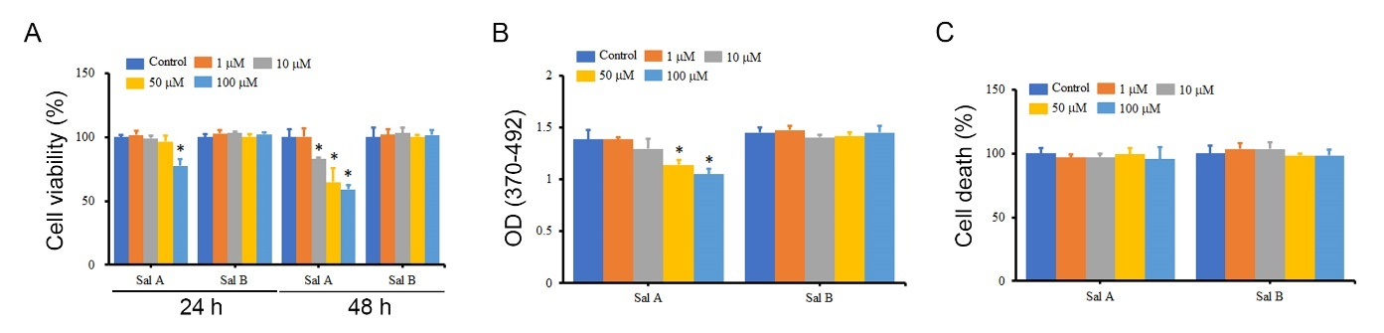
Supplementary Fig.1. The effects of Sal A and Sal B on the viability, proliferation, and death of A375 cells. A375 cells were treated with different concentrations of Sal A and Sal B for 24 h and 48 h, and the impact on cell viability (A), cell proliferation (B), and cell death (C) was measured using WST-1, BrdU incorporation assay, and LDH release, respectively. *P < 0.05 compared with the control group.

Figure S2.
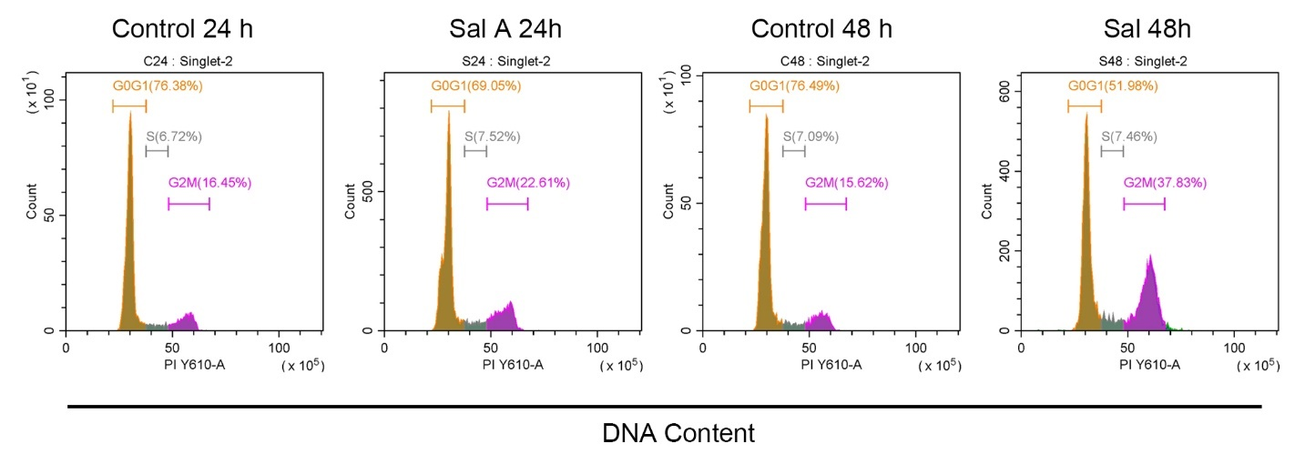
Supplementary Fig. 2. The effect of Sal A on the cell cycle of A375 cells. A375 cells were treated with 50 μM Sal A for 24 h and 48 h, fixed and stained with PI, and the cell cycle was analyzed using flow cytometry.

Figure S3.
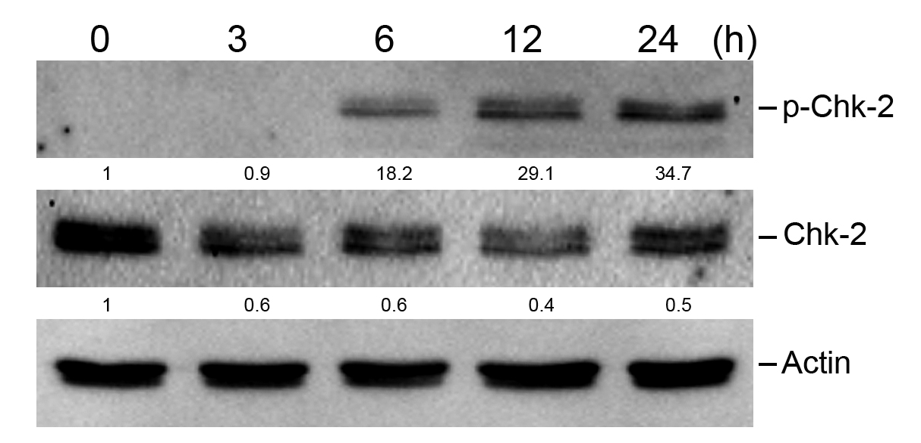
Supplementary Fig. 3. Effect of Sal A on the expression of phospho-Chk2 in melanoma cells. A2058 cells were treated with 50 μM Sal A for 3-24 h, and cell extracts were collected. Levels of phospho-Chk-2 and Chk-2 were analyzed using western blotting.

Figure S4.
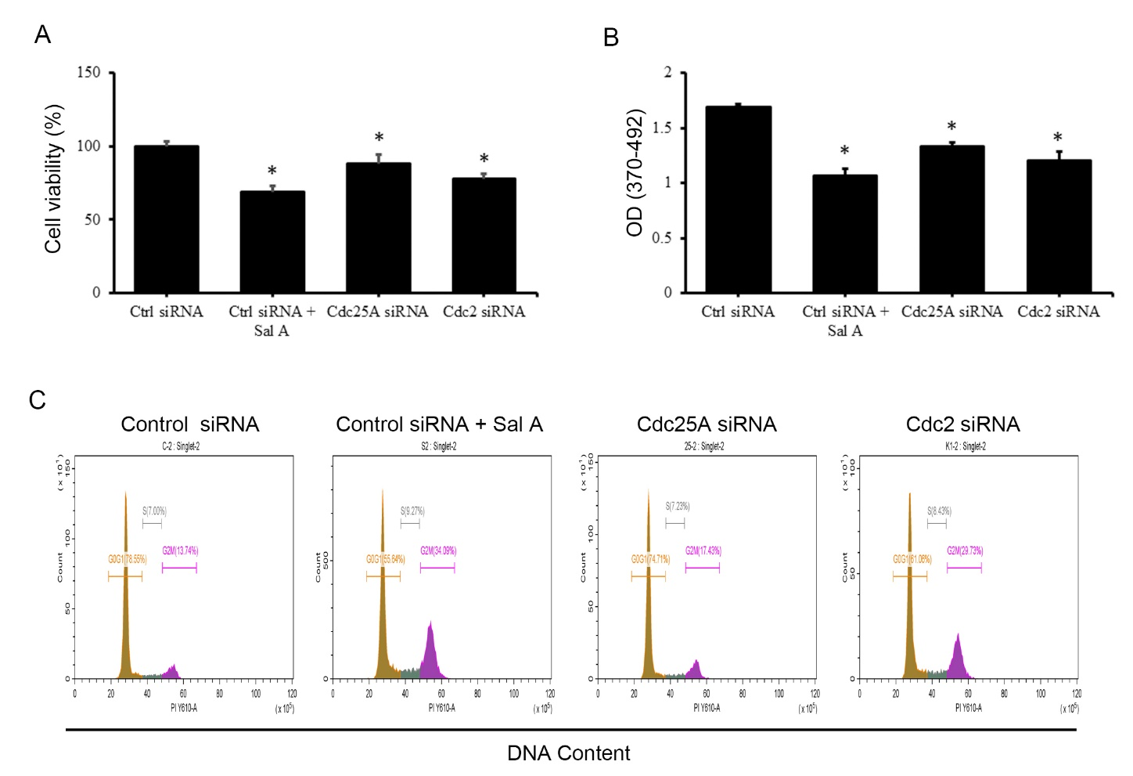
Supplementary Fig. 4. The effects of Cdc25A and Cdc2 siRNA on the cell cycle of A375 cells. A375 cells were transfected with Cdc25A or Cdc2 siRNA for 48 h, and cell viability (A) and cell proliferation (B) and the influence on the cell cycle (C) were measured using WST-1, BrdU incorporation assay, and PI staining, respectively. *P < 0.05 compared with the control group.
Figure S5.
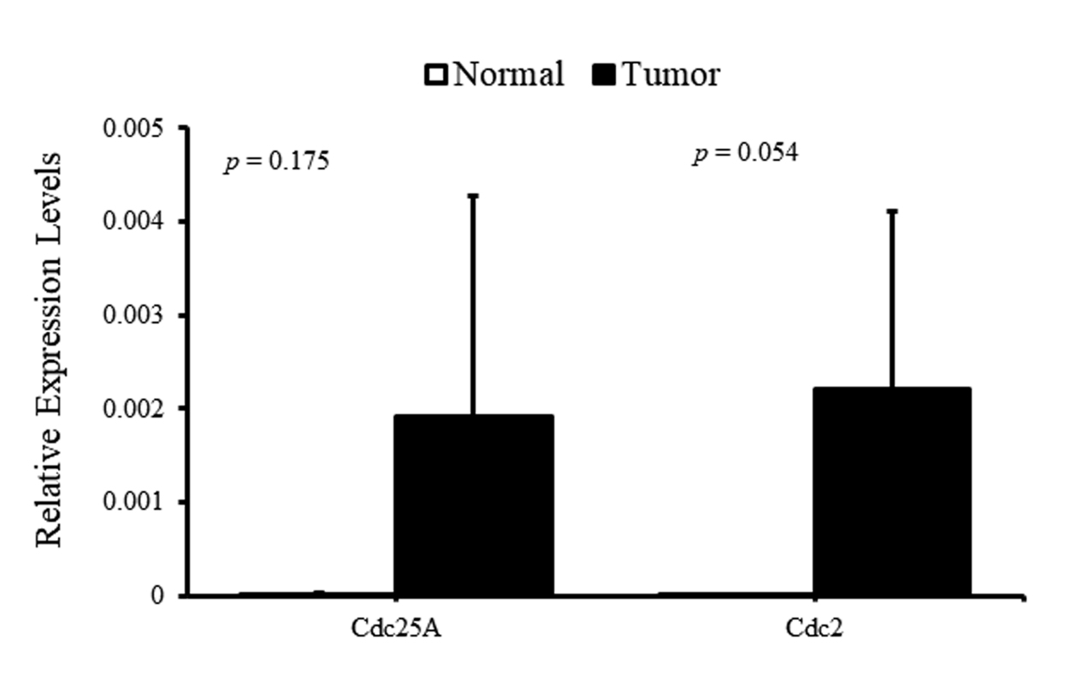

Supplementary Fig. 5. Gene expression of Cdc25A and Cdc2 in malignant melanoma. The gene expression levels of Cdc25A and Cdc2 were examined using real-time PCR in a melanoma cDNA tissue array.

