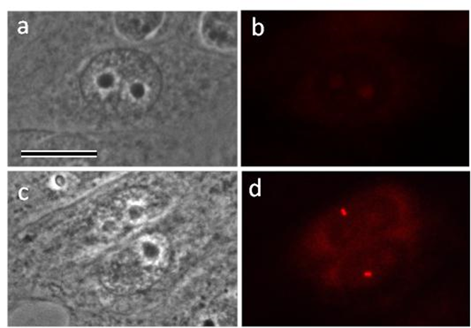
Supplementary Fig. 1. The appearance of Aurora A in the centrosome region does not in all cases depend on the size of the nucleus. a, b – cell with a large nucleus and Aurora A-negative centrosome; c, d – two cells with nuclei smaller than the cell shown in the upper images, but with strongly positive centrosomes of Aurora A. a, c – phase contrast; b, d – immunofluorescent labeling with antibodies to Aurora A. Scale bar: 10 µm.
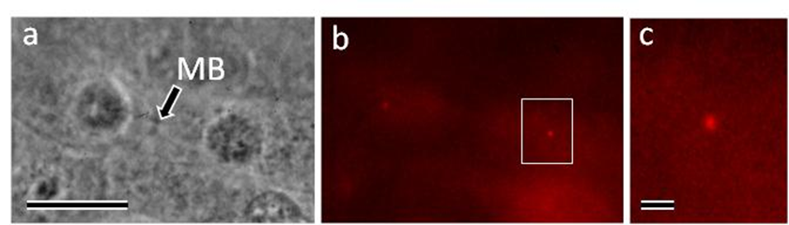
Supplementary Fig. 2. Aurora A does not disappear immediately after mitosis and is present in the centrosome region even after midbody formation. a – phase contract; b – immunofluorescent labeling with anti-Aurora A antibodies; c – centrosome region at high magnification. MB – midbody. Scale bar: 10 µm for a and b and 1 µm for c.

