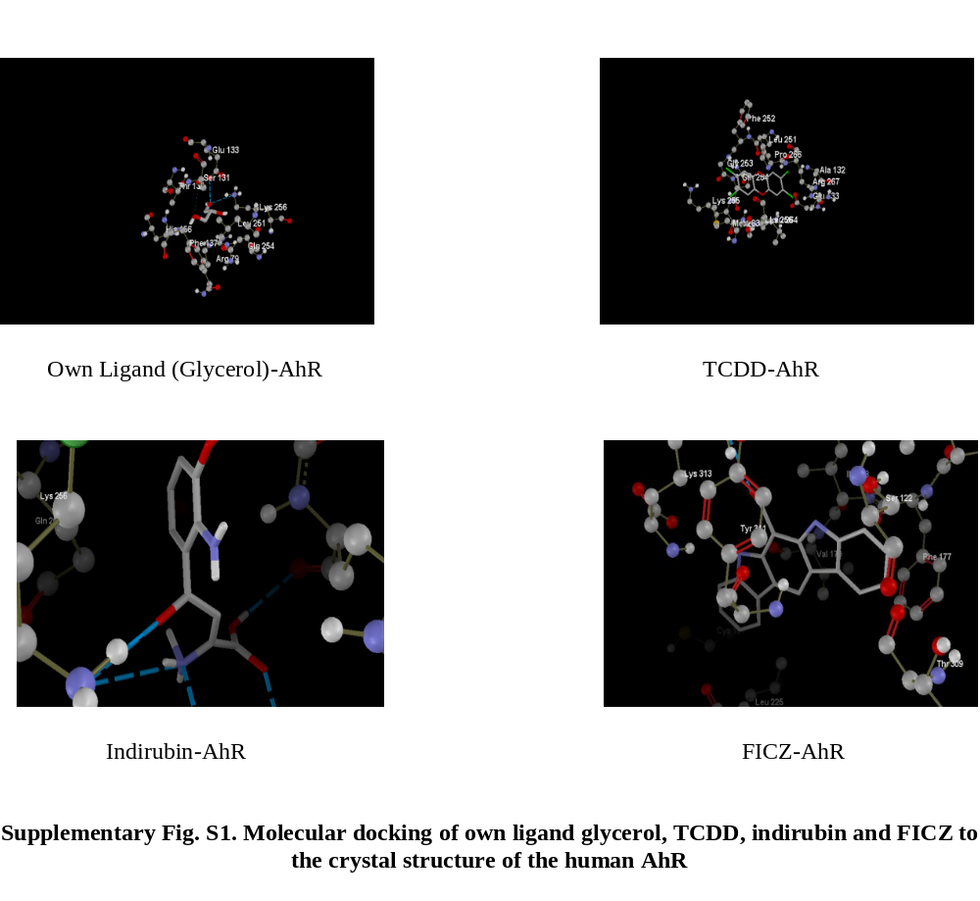Abbreviations: TCDD, 2,3,7,8- tetrachlorodibenzo-p-dioxin; FICZ, 6-formylindolo[3,2-b]carbazole.

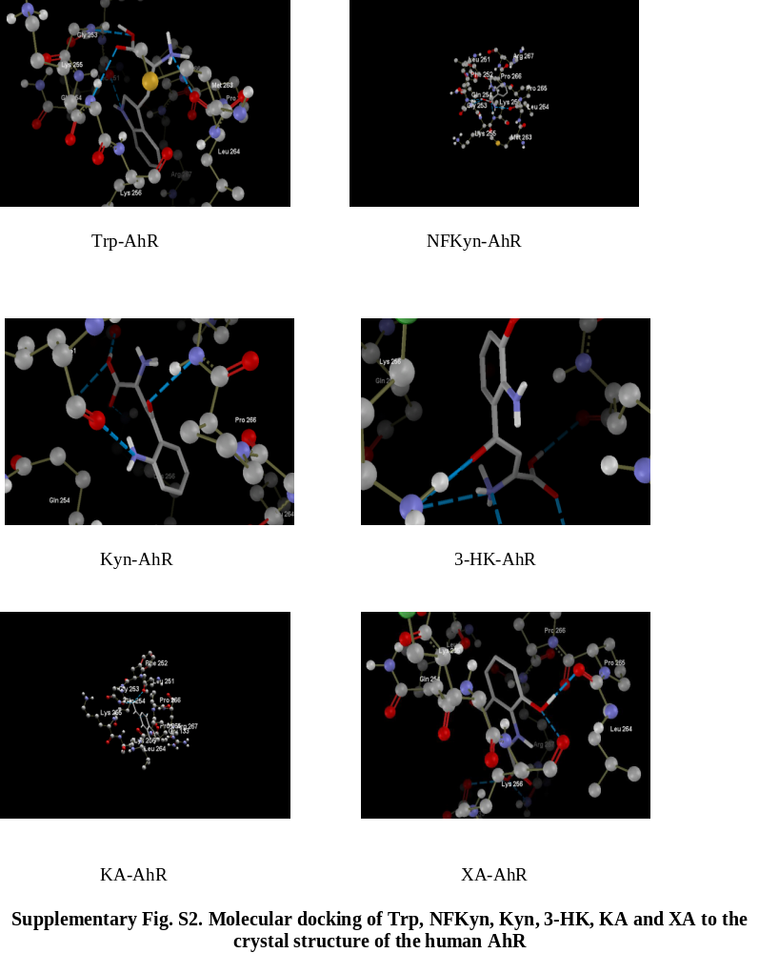Abbreviations: Trp, tryptophan; NFKyn, N-formylkynurenine; Kyn, kynurenine; 3-HK, 3-hydroxykynurenine; KA, kynurenic acid; XA, xanthurenic acid.

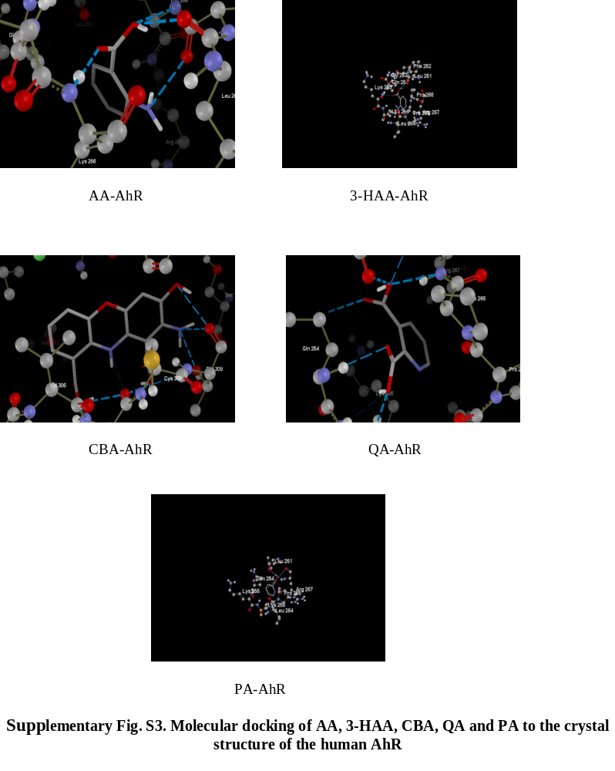Abbreviations: AA, anthranilic acid; 3-HAA, 3-hydroxyanthranilic acid; CBA, cinnabarinic acid; QA, quinolinic acid; PA, picolinic acid.

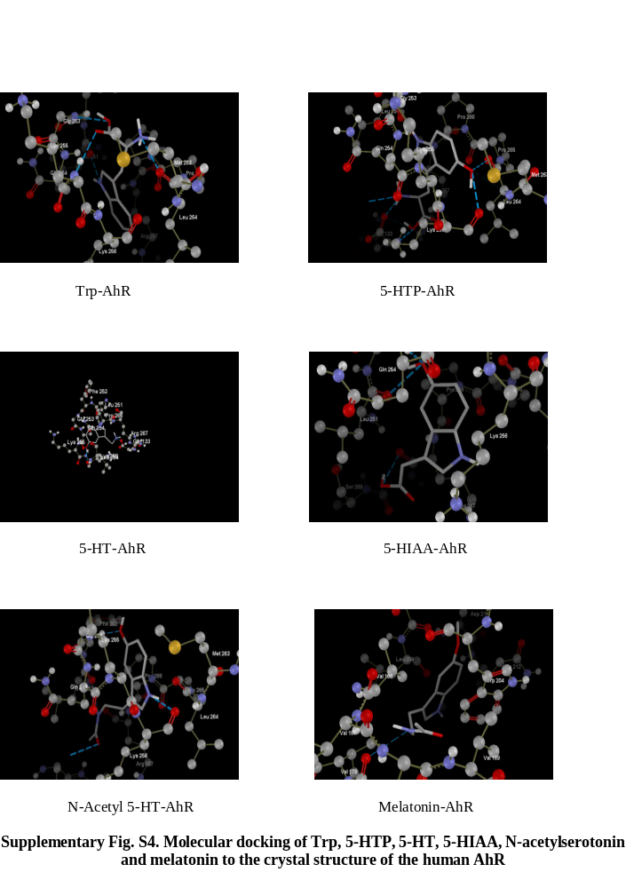Abbreviations: Trp, tryptophan; 5-HTP, 5-hydroxytryptophan; 5-HT, 5-hydroxytryptamine, 5-HIAA, 5-hydroxyindoleacetic acid.

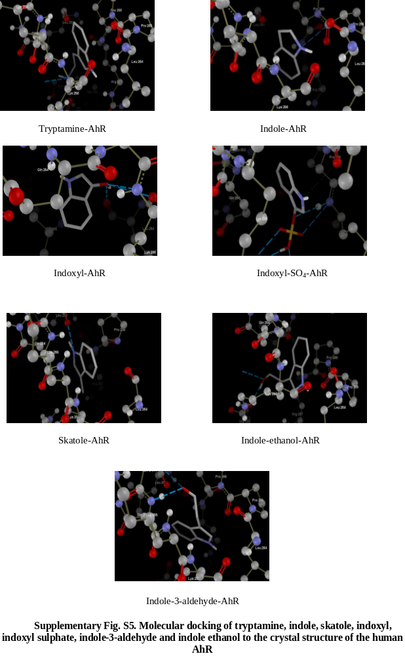
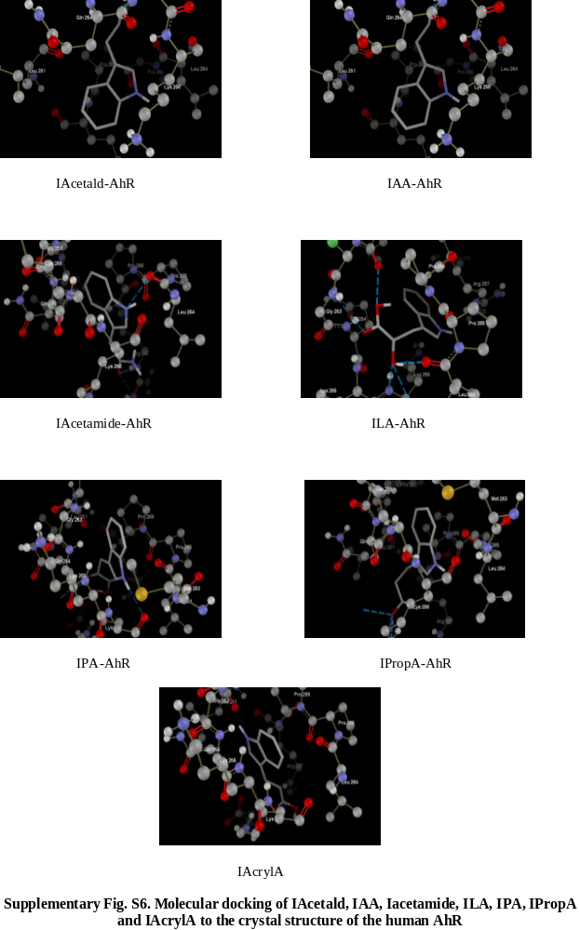 Abbreviations: IAcetald, indole acetaldehyde; IAA, indole acetic acid; IAcetamide, indole acetamide; ILA, indole lactic acid; IPA indole pyruvic acid; IPropA, indole propionic acid; IAcrylA, indole acrylic acid.

