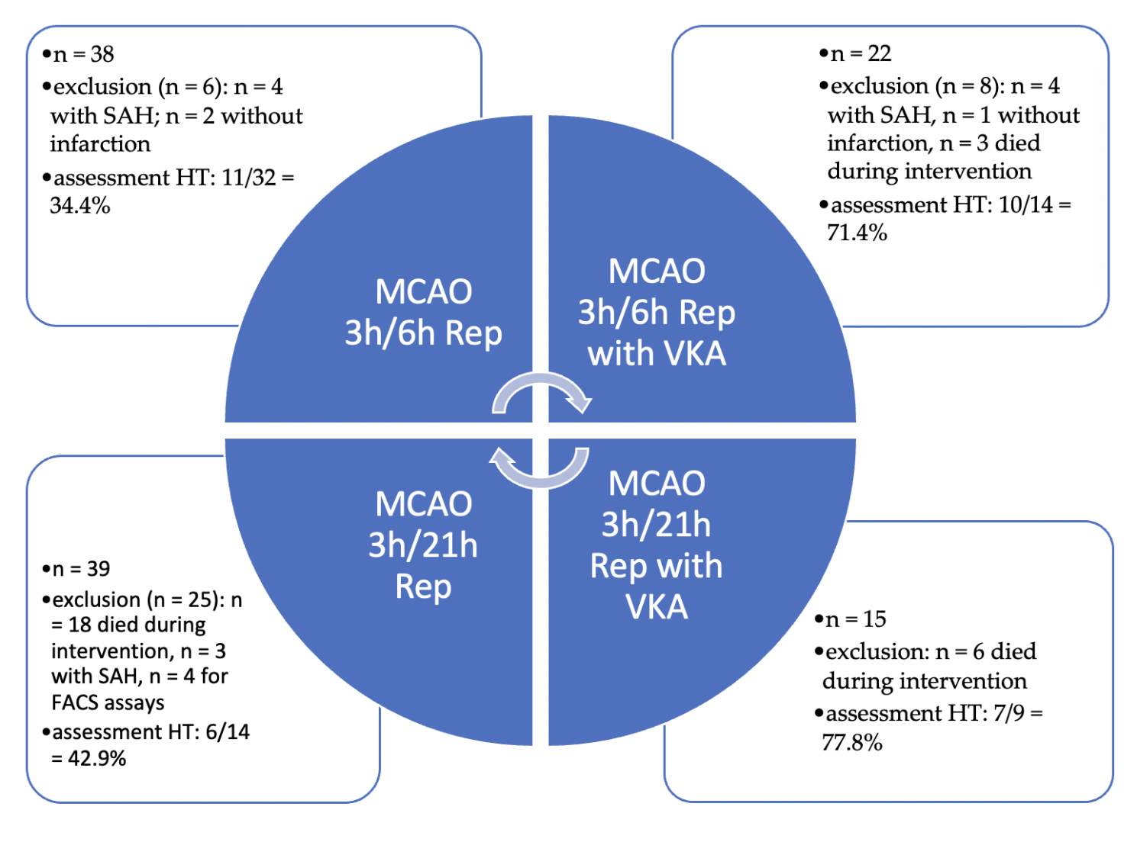
Supplementary Fig. 1. Study design. C57BL/6 mice underwent middle cerebral artery occlusion (MCAO) for 3 hours either in the absence or presence of a vitamin-K-antagonist (VKA). Mice were observed for either 6 hours (3h/6h Rep) or 24 hours (3h/24h Rep) afterischemia onset.

