Supplementary Material

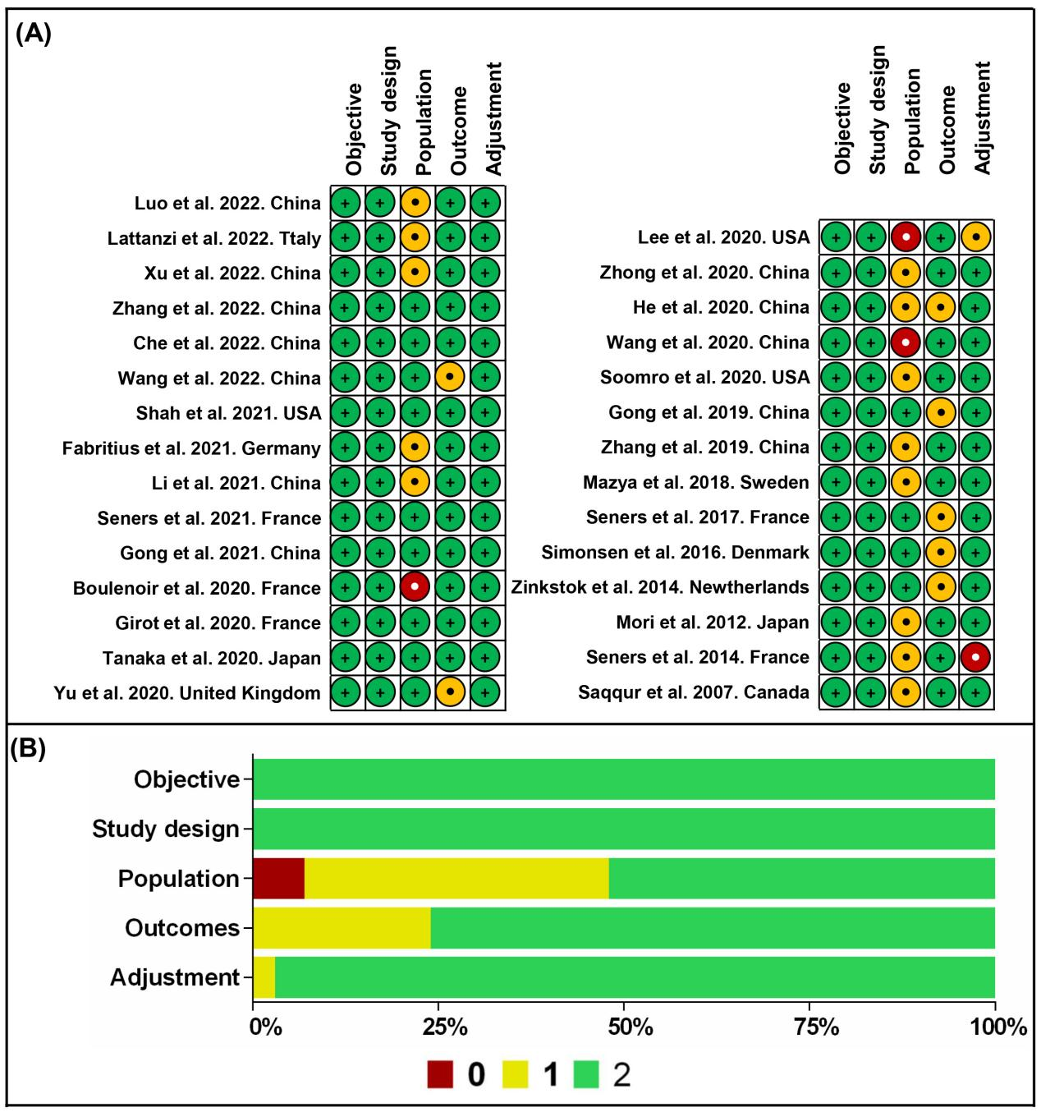
Supplementary Fig. 1. Quality assessment of included studies. (A) Authors’ judgement about each item quality for each included study; (B) Aggregated scores of quality assessment presented as percentages across all included studies.

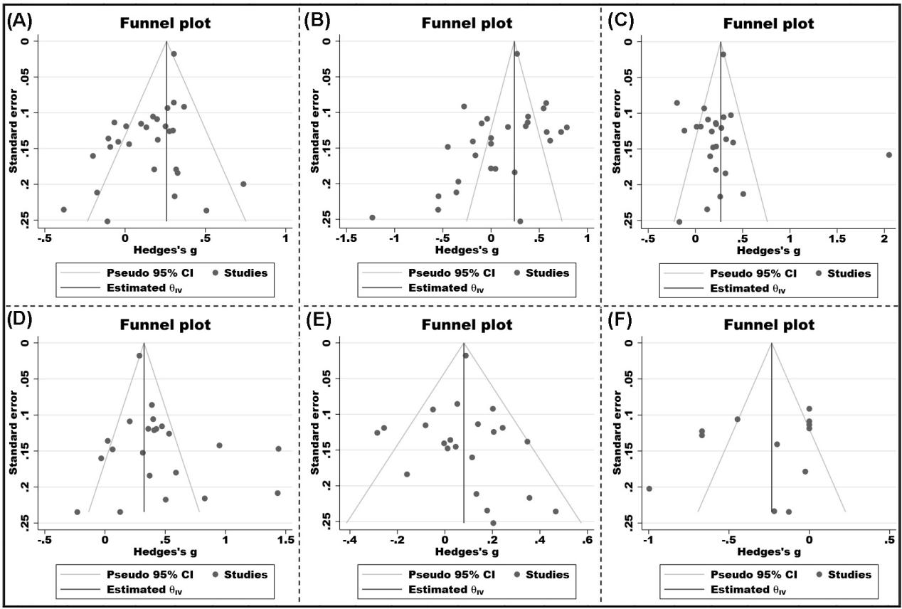
Supplementary Fig. 2. Funnel plots of (A) Age; (B) Initial NIHSS; (C) Systolic blood pressure; (D) Serum glucose (E) Onset to treatment time; (F) ASPECT. NIHSS indicates National Institutes of Health Stroke Scale; ASPECT indicates Alberta Stroke Early CT score.

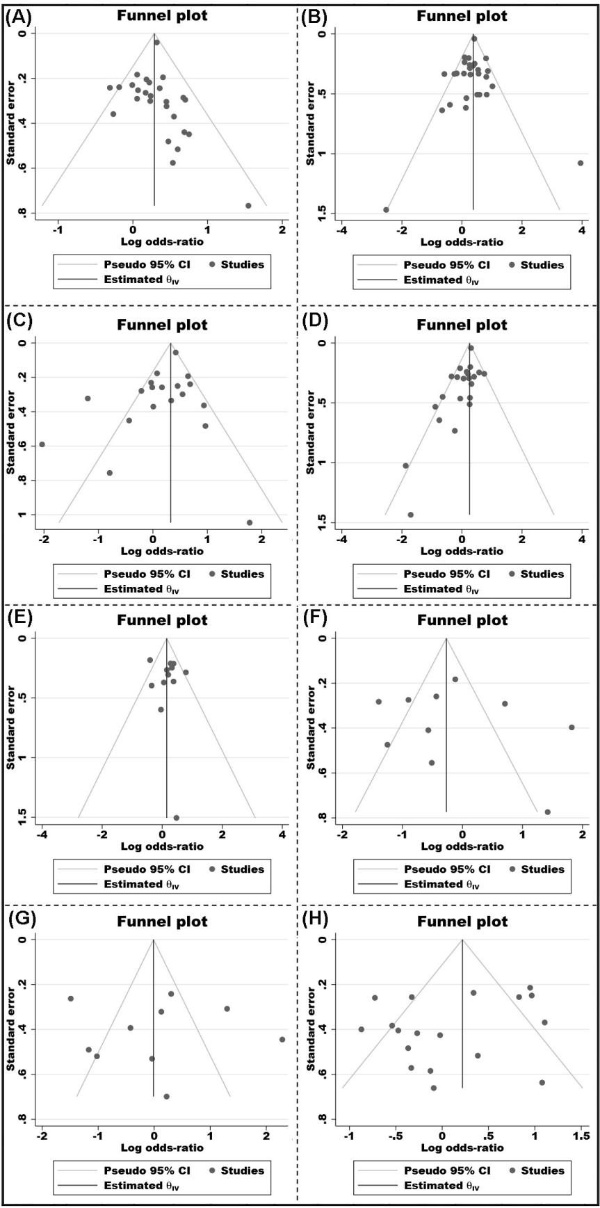
Supplementary Fig. 3. Funnel plots of (A) Hypertension; (B) Diabetes mellitus; (C) Etiology atherosclerosis; (D) Atrial fibrillation; (E) Bridging; (F) Successful recanalization; (G) Lesion location-IVT; (H) Lesion location-EVT. IVT indicates intravenous thrombolysis, and EVT indicates endovascular therapy.

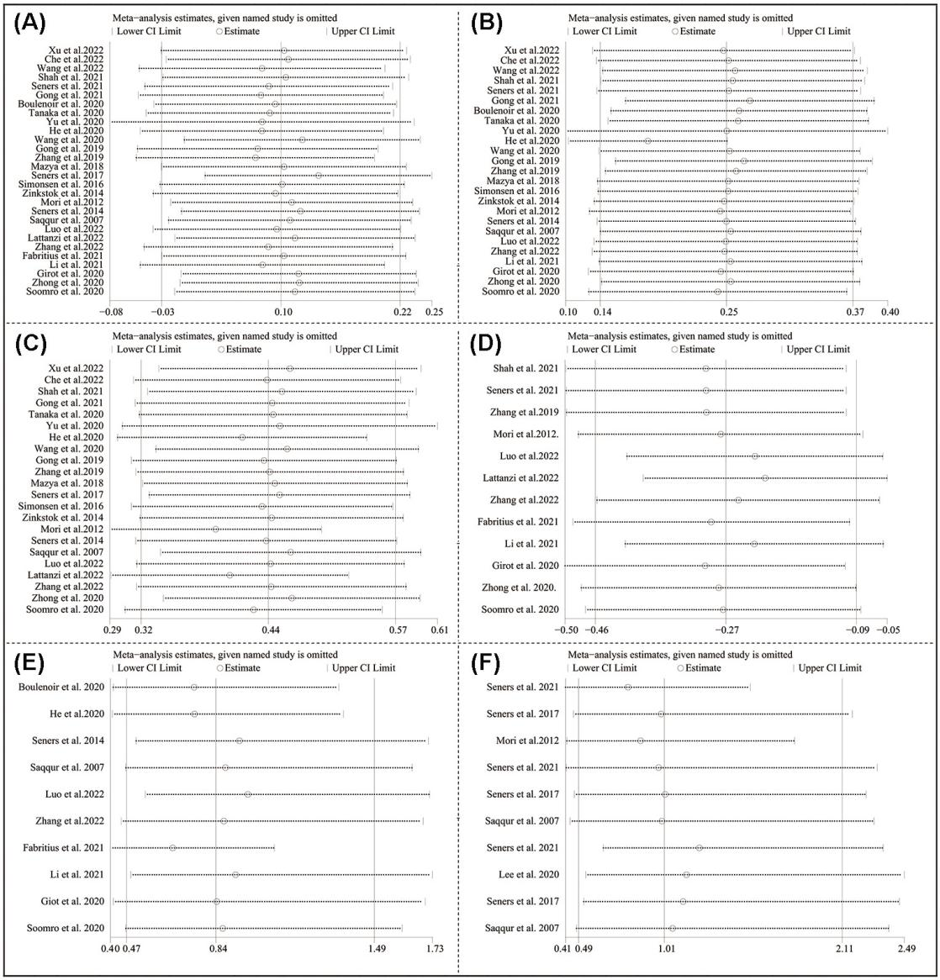
Supplementary Fig. 4. Sensitivity analysis of (A) Initial NIHSS; (B) Systolic blood pressure; (C) Serum glucose; (D) ASPECT; (E) Successful recanalization; (F) Lesion location-IVT. NIHSS indicates National Institutes of Health Stroke Scale; ASPECT indicates Alberta Stroke Early CT score; IVT indicates intravenous thrombolysis.

