 | Philips |  | GE |  |  | Philips |  | GE |  |  | Philips |  | GE
 | FD g>1.00 |  | FD g>1.35 |  |  | log FC g>1.00 |  | log FC g>1.35 |  |  | FDC g>1.00 |  | FDC g>1.35
ICBM-DTI 81 | Vol % | g | Vol % | g |  | Vol % | g | Vol % | g |  | Vol % | g | Vol % | g
Body of corpus callosum | - | - | 2.20 | 1.479 |  | 0.53 | 1.068 | 9.61 | 1.895 |  | 2.16 | 1.090 | 5.83 | 1.876
Splenium of corpus callosum | 11.01 | 1.247 | 7.68 | 1.622 |  | 9.49 | 1.094 | 15.52 | 1.882 |  | 23.20 | 1.226 | 13.30 | 1.863
Superior corona radiata R | - | - | 0.36 | 1.460 |  | - | - | - | - |  | - | - | - | -
Cingulum (cingulate gyrus) R | - | - | - | - |  | - | - | - | - |  | 0.17 | 1.067 | 0.34 | 1.675
Tapetum L | - | - | - | - |  | - | - | - | - |  | 30.17 | 1.097 | - | -

Supplementary Table 1: Differences between ET and PD from the Philips and GE scanners separately, reported for effect-size (large effect g>1.00 and g>1.35 for Philips and GE, respectively). Vol%: volumes (in %) covered from the cluster inside the corresponding white matter atlas area; g: mean effect-size values inside the clusters.

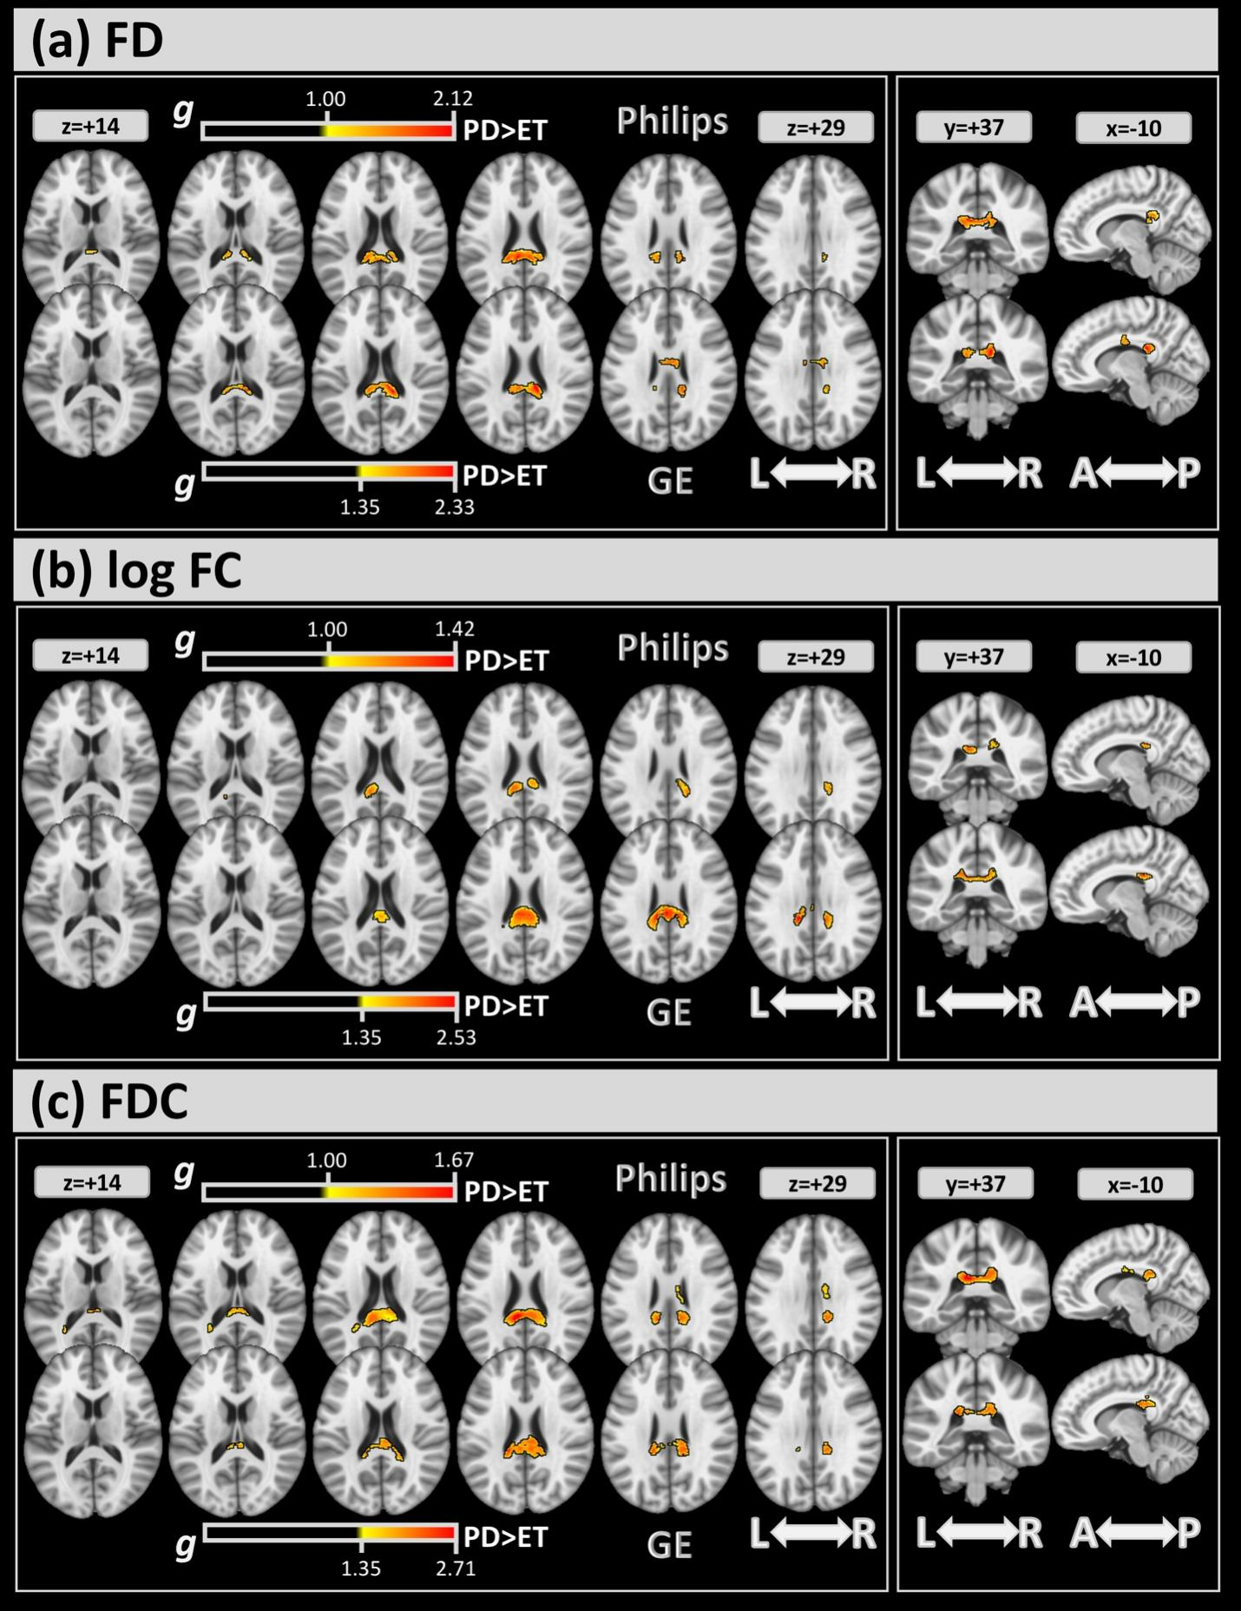

Supplementary Figure 1: FBA analysis for GE and Philips scanners separately: significant clusters of differences between the two groups at large effect-sizes (g>1.00 and g>1.35 for Philips and GE, respectively) were detected. These results confirm the findings in Figure 2 and Table 2.

