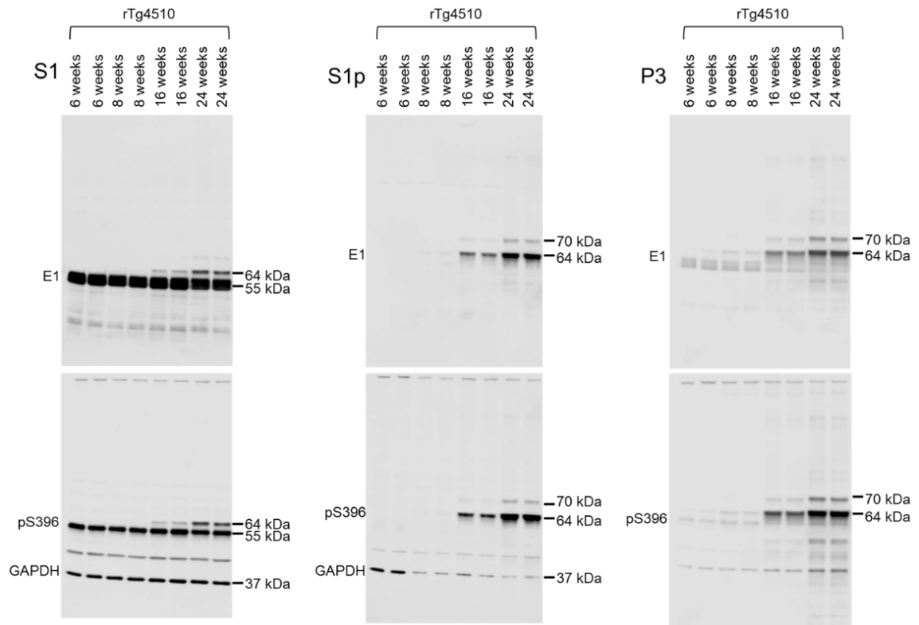
Supplementary Fig. 1. Age-dependent increase in hyperphosphorylated tau species in rTg4510 mice. Brain samples from rTg4510 mice euthanized at different ages (6, 10, 16, 24 weeks, n = 2 per age) were separated into soluble (S1), precipitate S1 (S1p) and sarkosyl-insoluble pellet (P3) fractions by differential centrifugation and analyzed by western blot for total human tau (E1) and phosphorylated tau at pS396 epitope. GAPDH was used for normalization of S1 and S1p blots. The S1 and S1p E1 blots were re-probed with pS396 and GAPDH. The P3 E1 blot was re-probed with pS396. Normal phosphorylated and non-phosphorylated human 0N4R tau is displayed at 55 kDa, hyperphosphorylated 0N4R tau is mobility-shifted and displayed at 64 and 70 kDa.

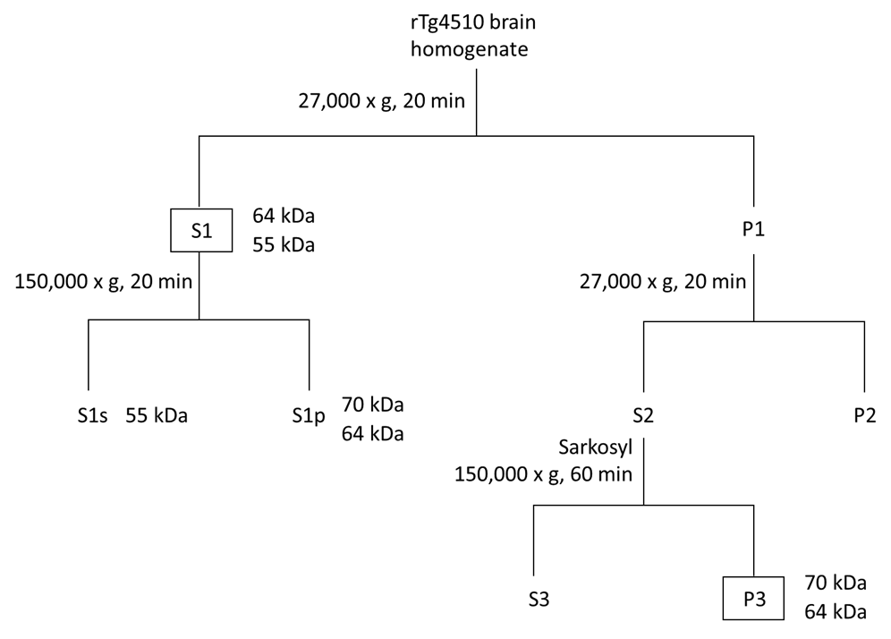
Supplementary Fig. 2. Separation of different tau species from rTg4510 brains by differential centrifugation and sarkosyl fractionation. Brain homogenates were separated into Tris-buffered saline (TBS)-extractable (S1), S1 precipitate (S1p), and sarkosyl-insoluble pellet (P3) fractions. Brain homogenates were separated by centrifugation at 27,000 × g for 20 min at 4 ℃ in S1 fraction. The pellet (P1) was re-homogenized in 5 volumes of high salt/sucrose buffer and centrifuged as above. The supernatant (S2) was collected and incubated with 1% sarkosyl for 1 h at 37 ℃, followed by centrifugation at 150,000 × g for 1 h at 4 ℃ to obtain sarkosyl-insoluble pellet (P3). S1 fraction was separated by further centrifugation at 150,000 × g for 20 min at 4 °C to obtain the precipitate (S1p) fraction. S1 contains soluble 55 and 64 kDa tau species. The low speed soluble 64 kDa tau species precipitate under high-speed centrifugation in S1p, are characterized as oligomeric and regarded as pre-tangle tau equivalent. P3 contains sarkosyl-insoluble 64 and 70 kDa tau species which are characterized as fibrillary and regarded as NFTs equivalent as reported [1].

Reference

[1] Sahara N, DeTure M, Ren Y, Ebrahim AS, Kang D, Knight J, et al. Characteristics of TBS-extractable hyperphosphorylated tau species: aggregation intermediates in rTg4510 mouse brain. Journal of Alzheimer's Disease. 2013; 33: 249–263.

