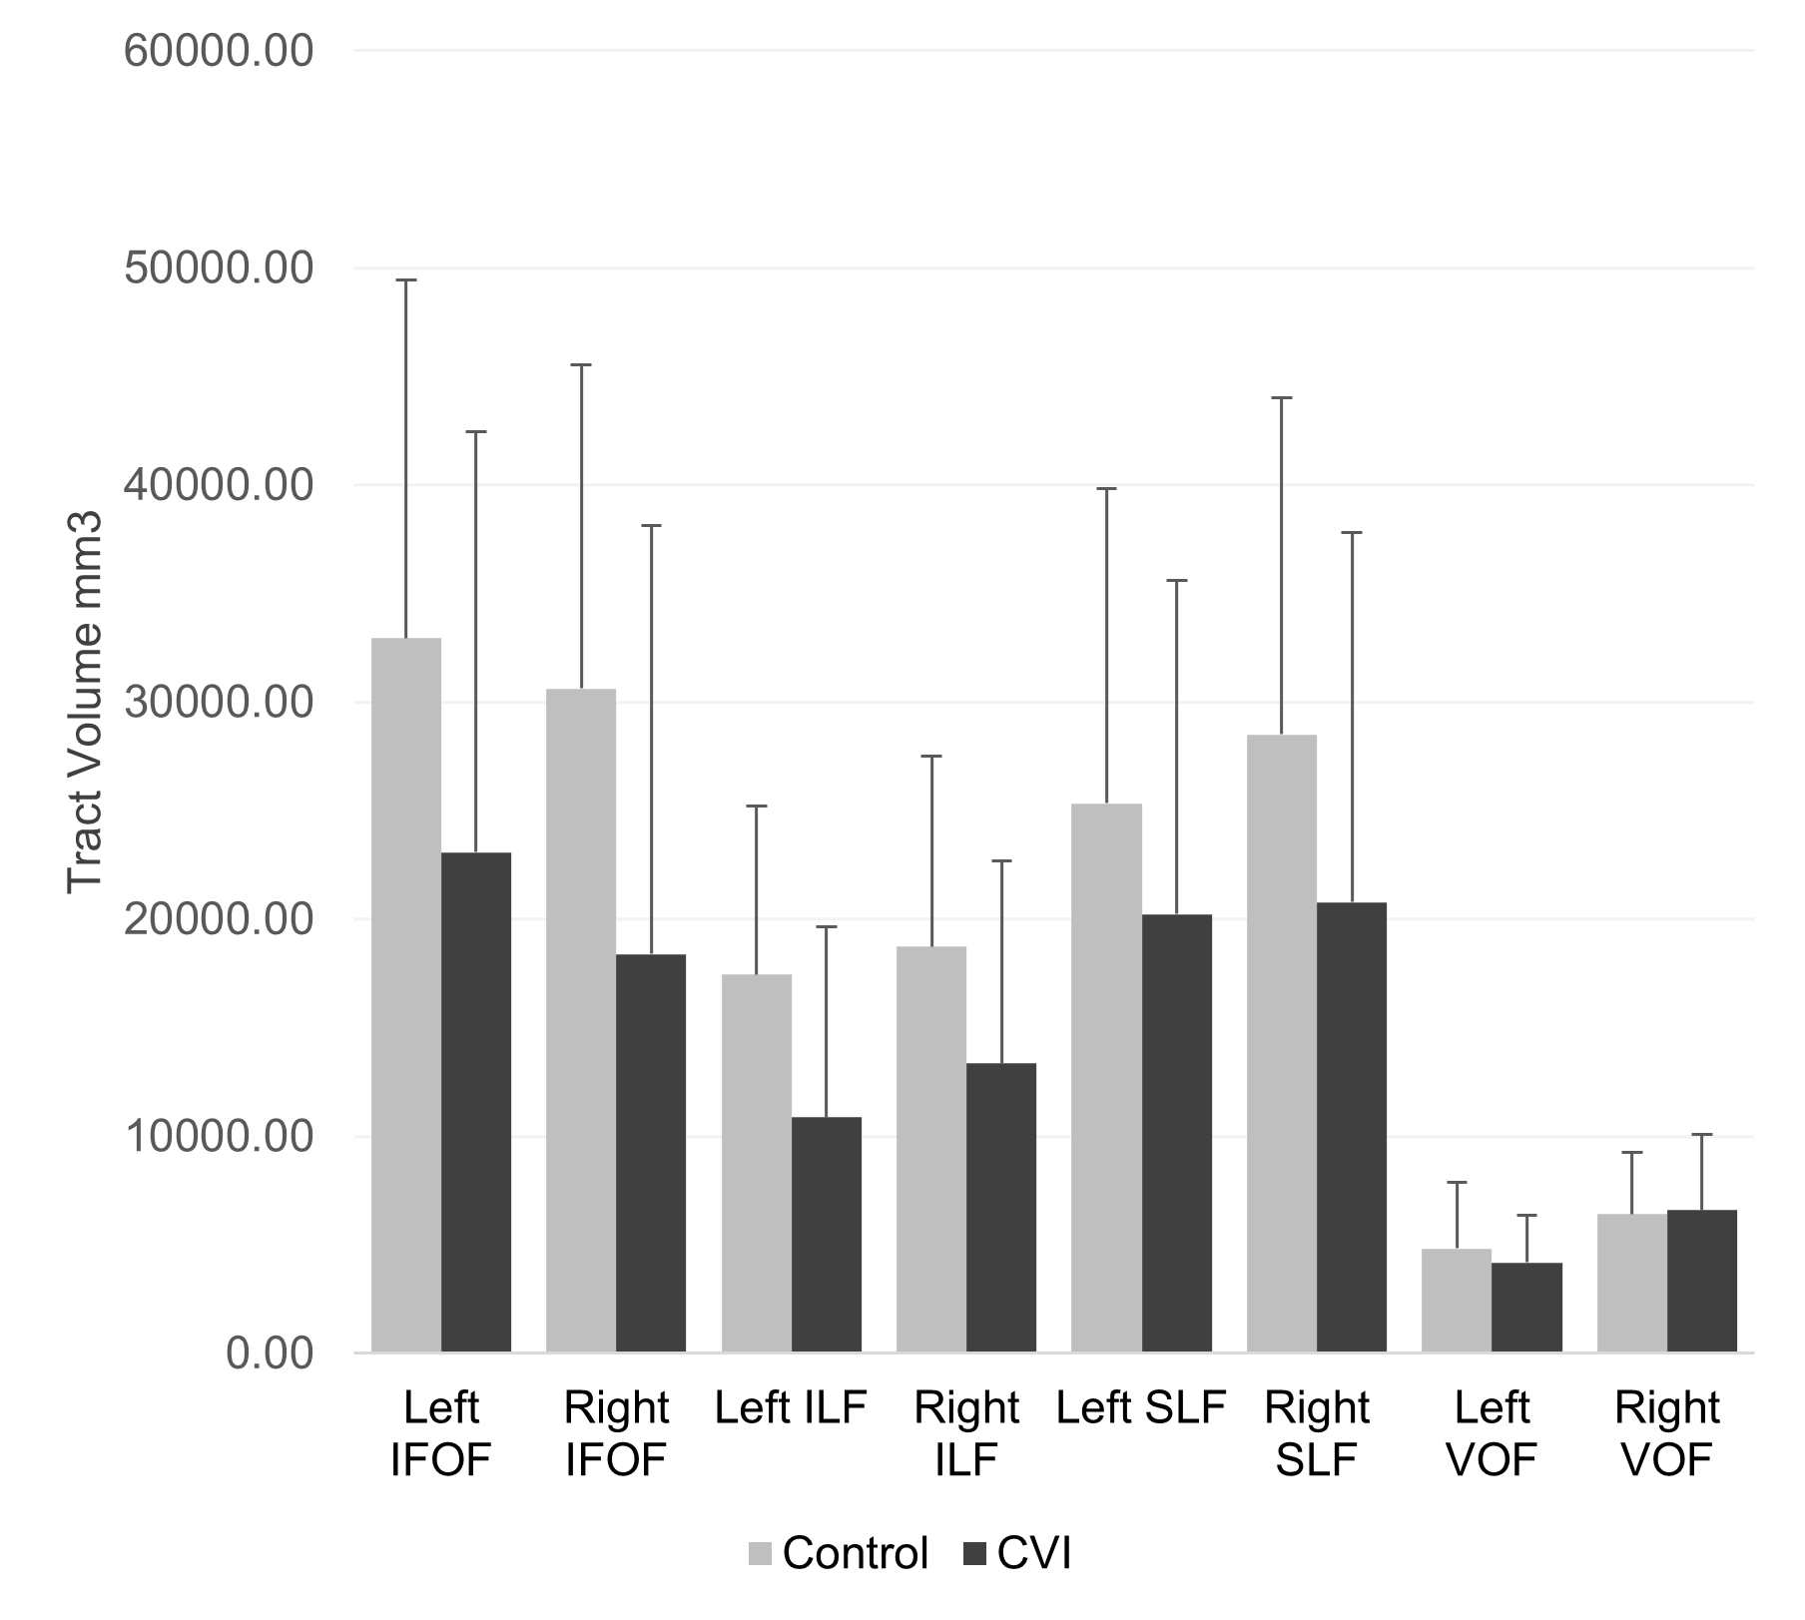
Supplementary Fig. 1. Group comparisons in tract volume adjusted for age (ANCOVA). Note: raw data shown for ease of visualization, but for statistical analyses, adjusted for intracranial volume using residuals. Although volumes appear to be reduced in C

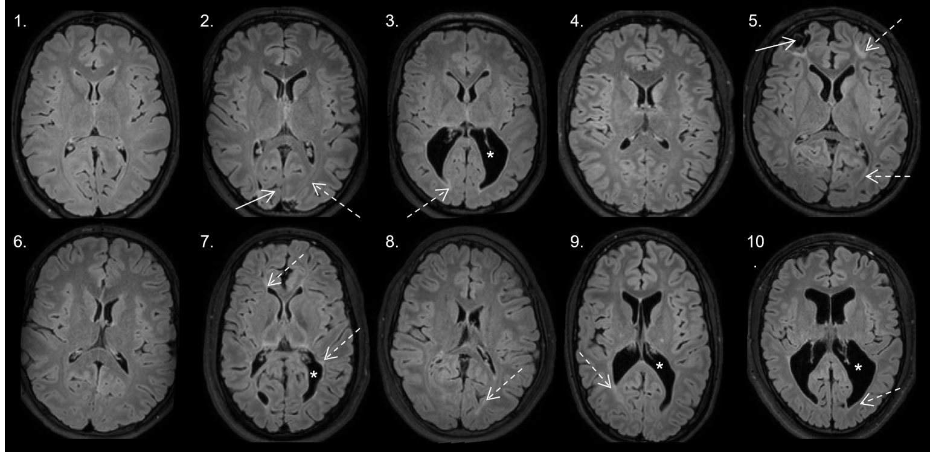
Supplementary Fig. 2. Axial FLAIR for each of the participants with CVI. The numbers correspond to the participants in Table 1. Note the heterogeneous extent and distribution of white matter lesions (hyperintensities – examples are indicated by dashed arrows), varying degrees of ventriculomegaly (e.g., presence of large lateral ventricles particularly seen in participants 3, 7, 9, and 10 – indicated by asterisks, as well as the presence of cortical abnormalities in participants 2 and 5 (indicated by solid white arrow).

 |  | Control |  |  |  | CVI |  |  |  | Effect of Age |  |  | Effect of Group
QA | Tract | Mean | S.D. | Min | Max | Mean | S.D. | Min | Max | Type III SS | F | p-value | Type III SS | F | p-value
 | L SLF I | 0.23 | 0.08 | 0.13 | 0.39 | 0.27 | 0.10 | 0.15 | 0.49 | 0.007133 | 0.97 | 0.3337 | 0.004361 | 0.6 | 0.448
 | L SLF II | 0.22 | 0.05 | 0.15 | 0.31 | 0.27 | 0.10 | 0.18 | 0.49 | 2.8E-07 | 0 | 0.9943 | 0.010418 | 1.94 | 0.1782
 | L SLF III | 0.20 | 0.05 | 0.14 | 0.29 | 0.27 | 0.10 | 0.18 | 0.49 | 4.77E-05 | 0.01 | 0.9261 | 0.016931 | 3.14 | 0.0919
 | R SLF I | 0.24 | 0.07 | 0.14 | 0.41 | 0.27 | 0.07 | 0.18 | 0.40 | 0.00442 | 0.87 | 0.3599 | 0.001586 | 0.31 | 0.5813
 | R SLF II | 0.25 | 0.07 | 0.14 | 0.44 | 0.28 | 0.10 | 0.20 | 0.47 | 0.004684 | 0.74 | 0.3998 | 0.00086 | 0.14 | 0.7164
 | R SLF III | 0.21 | 0.05 | 0.14 | 0.30 | 0.27 | 0.09 | 0.18 | 0.45 | 0.000145 | 0.03 | 0.8656 | 0.013552 | 2.73 | 0.1125
MD | Tract | Mean | S.D. | Min | Max | Mean | S.D. | Min | Max | Type III SS | F | p-value | Type III SS | F | p-value
 | L SLF I | 0.14 | 0.02 | 0.11 | 0.18 | 0.17 | 0.02 | 0.14 | 0.21 | 8.49E-05 | 0.17 | 0.6814 | 0.00484 | 9.84 | 0.0045
 | L SLF II | 0.11 | 0.02 | 0.07 | 0.14 | 0.13 | 0.03 | 0.09 | 0.17 | 0.0006 | 1.3 | 0.2674 | 0.003268 | 7.07 | 0.0147
 | L SLF III | 0.12 | 0.02 | 0.09 | 0.15 | 0.14 | 0.03 | 0.10 | 0.20 | 0.000371 | 0.6 | 0.4483 | 0.000728 | 1.17 | 0.2916
 | R SLF I | 0.14 | 0.02 | 0.10 | 0.17 | 0.17 | 0.03 | 0.12 | 0.23 | 0.00024 | 0.39 | 0.5395 | 0.004024 | 6.5 | 0.0176
 | R SLF II | 0.11 | 0.02 | 0.09 | 0.15 | 0.12 | 0.02 | 0.09 | 0.15 | 2E-08 | 0 | 0.9947 | 0.000382 | 1 | 0.3277
 | R SLF III | 0.13 | 0.02 | 0.09 | 0.17 | 0.15 | 0.02 | 0.12 | 0.18 | 0.00036 | 0.82 | 0.374 | 0.004631 | 10.6 | 0.0036
AD | Tract | Mean | S.D. | Min | Max | Mean | S.D. | Min | Max | Type III SS | F | p-value | Type III SS | F | p-value
 | L SLF I | 0.29 | 0.05 | 0.22 | 0.37 | 0.36 | 0.06 | 0.28 | 0.47 | 8.01E-05 | 0.03 | 0.8635 | 0.021834 | 8.23 | 0.0085
 | L SLF II | 0.22 | 0.03 | 0.15 | 0.30 | 0.27 | 0.07 | 0.19 | 0.37 | 0.00292 | 1.34 | 0.2607 | 0.014017 | 6.41 | 0.0194
 | L SLF III | 0.25 | 0.04 | 0.19 | 0.30 | 0.30 | 0.06 | 0.22 | 0.41 | 0.000984 | 0.45 | 0.5118 | 0.003683 | 1.67 | 0.2111
 | R SLF I | 0.30 | 0.04 | 0.21 | 0.36 | 0.34 | 0.07 | 0.25 | 0.48 | 0.001959 | 0.68 | 0.4181 | 0.017186 | 5.96 | 0.0224
 | R SLF II | 0.23 | 0.03 | 0.18 | 0.30 | 0.25 | 0.05 | 0.18 | 0.31 | 0.000108 | 0.07 | 0.7994 | 0.000528 | 0.32 | 0.5761
 | R SLF III | 0.26 | 0.04 | 0.19 | 0.36 | 0.31 | 0.05 | 0.25 | 0.41 | 0.002301 | 1.15 | 0.2953 | 0.019712 | 9.85 | 0.0048
RD | Tract | Mean | S.D. | Min | Max | Mean | S.D. | Min | Max | Type III SS | F | p-value | Type III SS | F | p-value
 | L SLF I | 0.07 | 0.01 | 0.05 | 0.09 | 0.08 | 0.02 | 0.06 | 0.12 | 8.74E-05 | 0.53 | 0.4753 | 0.000929 | 5.59 | 0.0265
 | L SLF II | 0.05 | 0.01 | 0.03 | 0.07 | 0.06 | 0.02 | 0.04 | 0.10 | 9.47E-05 | 0.7 | 0.4131 | 0.000705 | 5.19 | 0.0333
 | L SLF III | 0.06 | 0.01 | 0.04 | 0.08 | 0.07 | 0.02 | 0.04 | 0.09 | 0.000174 | 0.79 | 0.3853 | 0.000103 | 0.46 | 0.5041
 | R SLF I | 0.07 | 0.01 | 0.05 | 0.09 | 0.08 | 0.01 | 0.06 | 0.10 | 1.24E-06 | 0.01 | 0.927 | 0.000877 | 6.04 | 0.0216
 | R SLF II | 0.05 | 0.01 | 0.04 | 0.07 | 0.06 | 0.01 | 0.04 | 0.07 | 2.51E-05 | 0.26 | 0.6139 | 0.000318 | 3.32 | 0.0826
 | R SLF III | 0.06 | 0.01 | 0.04 | 0.08 | 0.07 | 0.01 | 0.05 | 0.09 | 1.99E-05 | 0.16 | 0.6972 | 0.001017 | 7.94 | 0.01
FA | Tract | Mean | S.D. | Min | Max | Mean | S.D. | Min | Max | Type III SS | F | p-value | Type III SS | F | p-value
 | L SLF I | 0.78 | 0.02 | 0.74 | 0.80 | 0.76 | 0.05 | 0.65 | 0.82 | 0.000317 | 0.28 | 0.6035 | 0.000436 | 0.38 | 0.5429
 | L SLF II | 0.80 | 0.02 | 0.77 | 0.82 | 0.79 | 0.03 | 0.72 | 0.82 | 5.57E-05 | 0.11 | 0.7436 | 0.00034 | 0.67 | 0.4221
 | L SLF III | 0.79 | 0.01 | 0.76 | 0.81 | 0.78 | 0.04 | 0.74 | 0.83 | 0.000813 | 1.39 | 0.252 | 0.000197 | 0.34 | 0.5675
 | R SLF I | 0.78 | 0.02 | 0.74 | 0.81 | 0.76 | 0.02 | 0.73 | 0.80 | 0.000241 | 0.69 | 0.413 | 0.000375 | 1.08 | 0.3089
 | R SLF II | 0.80 | 0.02 | 0.76 | 0.83 | 0.78 | 0.01 | 0.76 | 0.80 | 0.000459 | 1.55 | 0.2265 | 0.00113 | 3.82 | 0.064
 | R SLF III | 0.78 | 0.01 | 0.75 | 0.81 | 0.77 | 0.03 | 0.73 | 0.81 | 0.000224 | 0.52 | 0.4771 | 0.000163 | 0.38 | 0.543
Volume | Tract | Mean | S.D. | Min | Max | Mean | S.D. | Min | Max | Type III SS | F | p-value | Type III SS | F | p-value
 | L SLF I | 10864.31 | 8405.00 | 3515.75 | 32156.20 | 7924.52 | 6501.81 | 361.38 | 19195.80 | 1.84E+08 | 3.51 | 0.073 | 8057216 | 0.15 | 0.6985
 | L SLF II | 11975.53 | 6625.18 | 2529.62 | 24371.40 | 10735.59 | 5737.84 | 3166.62 | 18326.00 | 84094964 | 2.28 | 0.1456 | 619586 | 0.02 | 0.898
 | L SLF III | 7186.66 | 4585.94 | 275.63 | 17125.50 | 7412.02 | 5660.20 | 643.13 | 16947.90 | 69727253 | 3.34 | 0.0826 | 19514773 | 0.93 | 0.3452
 | R SLF I | 8992.95 | 5236.16 | 1684.38 | 16065.90 | 7432.07 | 5924.55 | 1610.88 | 20102.20 | 43564456 | 1.59 | 0.2199 | 4971057 | 0.18 | 0.6742
 | R SLF II | 12474.46 | 8006.20 | 496.13 | 28260.80 | 10791.39 | 7983.16 | 410.38 | 20469.80 | 3.43E+08 | 7.06 | 0.0147 | 18531866 | 0.38 | 0.5433
 | R SLF III | 12301.04 | 4887.82 | 3105.38 | 20292.10 | 8816.31 | 7251.39 | 618.63 | 19348.90 | 1055439 | 0.03 | 0.8604 | 69442769 | 2.08 | 0.1631
Supplementary Table 1. Group means and ANCOVA results for the three subdivisions of the SLF in control and CVI groups. Group comparisons are adjusted for the potential effects of age.

 |  | Age |  |  | CVI group
Volume | Tract | Type III SS | F | p | Type III SS | F | p
 | L IFOF | 1.14E+09 | 4.71 | 0.0411 | 1.01E+09 | 2.07 | 0.1502
 | L ILF | 1.4E+08 | 2.56 | 0.1234 | 5.02E+08 | 4.59 | 0.021
 | L SLF | 9.7E+08 | 5.65 | 0.0262 | 7.93E+08 | 2.31 | 0.122
 | L VOF | 24305794 | 3.71 | 0.0664 | 378845.6 | 0.03 | 0.9715
 | R IFOF | 3.61E+08 | 1.5 | 0.2335 | 1.8E+09 | 3.73 | 0.0394
 | R ILF | 2.07E+08 | 3.42 | 0.0774 | 5.42E+08 | 4.49 | 0.0226
 | R SLF | 1.07E+09 | 5.64 | 0.0263 | 1.43E+09 | 3.78 | 0.038
 | R VOF | 10514683 | 1.11 | 0.3036 | 4522862 | 0.24 | 0.79
Supplementary Table 2 ANCOVA results for comparisons of tract volume between control, CVI-PVL, and CVI-nonPVL groups adjusting for the potential effects of age.

 |  | Age |  |  | CVI group
QA | Tract | Type III SS | F | p | Type III SS | F | p
 | L IFOF | 0.004284 | 0.82 | 0.3762 | 0.012151 | 1.16 | 0.3329
 | L ILF | 0.010347 | 2.53 | 0.1254 | 0.006992 | 0.85 | 0.4385
 | L SLF | 0.015028 | 2.72 | 0.1127 | 0.025429 | 2.3 | 0.1227
 | L VOF | 0.019191 | 3.96 | 0.0586 | 0.013308 | 1.37 | 0.2734
 | R IFOF | 0.012684 | 2.25 | 0.1471 | 0.00521 | 0.46 | 0.6355
 | R ILF | 0.02376 | 5.43 | 0.029 | 0.006193 | 0.71 | 0.5035
 | R SLF | 0.010987 | 2.27 | 0.1456 | 0.01402 | 1.45 | 0.2558
 | R VOF | 0.020737 | 4.91 | 0.0369 | 0.022568 | 2.67 | 0.0906
Supplementary Table 3. ANCOVA results for comparisons of QA between control, CVI-PVL, and CVI-nonPVL groups adjusting for the potential effects of age.

 |  | Age |  |  | CVI group
AD | Tract | Type III SS | F | p | Type III SS | F | p
 | L IFOF | 7.48E-05 | 0.03 | 0.868 | 0.027194 | 5.14 | 0.0147
 | L ILF | 0.000166 | 0.05 | 0.8184 | 0.049412 | 8.01 | 0.0023
 | L SLF | 0.000801 | 0.26 | 0.6134 | 0.032644 | 5.35 | 0.0124
 | L VOF | 9.32E-05 | 0.06 | 0.8048 | 0.007956 | 2.67 | 0.0908
 | R IFOF | 7.19E-05 | 0.06 | 0.8032 | 0.03582 | 15.84 | <.0001
 | R ILF | 0.000698 | 0.29 | 0.5947 | 0.024509 | 5.11 | 0.0146
 | R SLF | 5.15E-05 | 0.02 | 0.8924 | 0.0537 | 9.76 | 0.0009
 | R VOF | 0.000655 | 0.27 | 0.609 | 0.007287 | 1.49 | 0.2453
Supplementary Table 4 ANCOVA results for comparisons of AD between control, CVI-PVL, and CVI-nonPVL groups adjusting for the potential effects of age.
 |  | Age |  |  | CVI group
RD | Tract | Type III SS | F | p | Type III SS | F | p
 | L IFOF | 0.000152 | 0.84 | 0.3698 | 0.002929 | 8.09 | 0.0023
 | L ILF | 1.8E-06 | 0 | 0.96 | 0.010656 | 7.62 | 0.0029
 | L SLF | 6.11E-05 | 0.31 | 0.5839 | 0.000693 | 1.75 | 0.1961
 | L VOF | 0.000224 | 0.44 | 0.5154 | 0.005969 | 5.83 | 0.009
 | R IFOF | 0.00032 | 1.02 | 0.3239 | 0.006167 | 9.8 | 0.0008
 | R ILF | 0.002403 | 3.46 | 0.0758 | 0.009595 | 6.9 | 0.0045
 | R SLF | 3.37E-06 | 0.02 | 0.8849 | 0.001948 | 6.18 | 0.0071
 | R VOF | 7.57E-05 | 0.1 | 0.7574 | 0.00065 | 0.42 | 0.6622
Supplementary Table 5 ANCOVA results for comparisons of RD between control, CVI-PVL, and CVI-nonPVL groups adjusting for the potential effects of age.

 |  | Age |  |  | CVI group
MD | Tract | Type III SS | F | p | Type III SS | F | p
 | L IFOF | 2.84E-05 | 0.05 | 0.8223 | 0.00822 | 7.47 | 0.0033
 | L ILF | 2.7E-05 | 0.02 | 0.8784 | 0.020391 | 9.06 | 0.0013
 | L SLF | 0.000214 | 0.29 | 0.5939 | 0.005566 | 3.79 | 0.0376
 | L VOF | 4.56E-05 | 0.07 | 0.7986 | 0.006581 | 4.82 | 0.0179
 | R IFOF | 8.27E-05 | 0.23 | 0.6397 | 0.013079 | 17.79 | <.0001
 | R ILF | 0.001721 | 1.63 | 0.2151 | 0.013802 | 6.52 | 0.0057
 | R SLF | 1.31E-05 | 0.02 | 0.8875 | 0.011211 | 8.76 | 0.0015
 | R VOF | 0.000205 | 0.19 | 0.6692 | 0.001815 | 0.83 | 0.4497
Supplementary Table 6 ANCOVA results for comparisons of MD between control, CVI-PVL, and CVI-nonPVL groups adjusting for the potential effects of age.

 |  | Age |  |  | CVI group
FA | Tract | Type III SS | F | p | Type III SS | F | p
 | L IFOF | 0.001168 | 1.91 | 0.1812 | 0.001997 | 1.63 | 0.2186
 | L ILF | 9.97E-05 | 0.07 | 0.7894 | 0.009228 | 3.38 | 0.0517
 | L SLF | 4.49E-05 | 0.11 | 0.7484 | 0.001649 | 1.94 | 0.1671
 | L VOF | 0.000626 | 0.45 | 0.5101 | 0.014035 | 5.02 | 0.0155
 | R IFOF | 0.001453 | 1.2 | 0.284 | 0.009552 | 3.96 | 0.0334
 | R ILF | 0.006796 | 5.68 | 0.0258 | 0.013919 | 5.82 | 0.009
 | R SLF | 4.58E-06 | 0.02 | 0.8965 | 0.000683 | 1.29 | 0.2944
 | R VOF | 0.000524 | 0.16 | 0.6904 | 0.00143 | 0.22 | 0.8027
Supplementary Table 7 ANCOVA results for comparisons of FA between control, CVI-PVL, and CVI-nonPVL groups adjusting for the potential effects of age.

 |  | Age |  |  | CVI type
Imaging Outcome | Tract | Type III SS | F | p | Type III SS | F | p
AD | L SLF I | 0.001941 | 0.92 | 0.3466 | 0.037159 | 8.84 | 0.0014
AD | L SLF II | 0.001441 | 0.84 | 0.3705 | 0.025584 | 7.45 | 0.0038
AD | L SLF III | 0.000939 | 0.4 | 0.5322 | 0.003746 | 0.81 | 0.4606
AD | R SLF I | 4.51E-05 | 0.02 | 0.8907 | 0.032689 | 6.99 | 0.0042
AD | R SLF II | 0.000162 | 0.11 | 0.7451 | 0.00507 | 1.7 | 0.208
AD | R SLF III | 0.000757 | 0.39 | 0.5385 | 0.023097 | 5.96 | 0.0089
FA | L SLF I | 3.87E-05 | 0.03 | 0.855 | 0.001865 | 0.82 | 0.4511
FA | L SLF II | 0.000184 | 0.42 | 0.526 | 0.002168 | 2.46 | 0.111
FA | L SLF III | 0.000602 | 1.23 | 0.2816 | 0.002574 | 2.63 | 0.0983
FA | R SLF I | 0.000157 | 0.44 | 0.5148 | 0.000441 | 0.61 | 0.5498
FA | R SLF II | 0.000459 | 1.48 | 0.2378 | 0.001131 | 1.82 | 0.1875
FA | R SLF III | 3.13E-05 | 0.08 | 0.7854 | 0.000933 | 1.13 | 0.3406
MD | L SLF I | 0.000454 | 1.05 | 0.3151 | 0.006737 | 7.82 | 0.0026
MD | L SLF II | 0.000372 | 0.87 | 0.3615 | 0.00445 | 5.22 | 0.015
MD | L SLF III | 0.000321 | 0.5 | 0.487 | 0.000982 | 0.77 | 0.4781
MD | R SLF I | 4.1E-07 | 0 | 0.9778 | 0.006944 | 6.68 | 0.0051
MD | R SLF II | 1.28E-06 | 0 | 0.9528 | 0.001225 | 1.71 | 0.2055
MD | R SLF III | 0.000149 | 0.34 | 0.5667 | 0.00498 | 5.65 | 0.0109
QA | L SLF I | 0.012814 | 1.81 | 0.1921 | 0.017052 | 1.2 | 0.3189
QA | L SLF II | 0.000674 | 0.17 | 0.6839 | 0.044148 | 5.59 | 0.0118
QA | L SLF III | 7.63E-05 | 0.02 | 0.8869 | 0.055152 | 7.51 | 0.004
QA | R SLF I | 0.007268 | 1.44 | 0.2424 | 0.007244 | 0.72 | 0.4985
QA | R SLF II | 0.005395 | 0.97 | 0.3374 | 0.022302 | 2 | 0.162
QA | R SLF III | 0.002127 | 0.46 | 0.5042 | 0.025984 | 2.82 | 0.0821
RD | L SLF I | 9.88E-05 | 0.57 | 0.4574 | 0.00094 | 2.72 | 0.0871
RD | L SLF II | 9.89E-05 | 0.69 | 0.4143 | 0.00071 | 2.49 | 0.108
RD | L SLF III | 0.000134 | 0.63 | 0.4367 | 0.000499 | 1.18 | 0.3298
RD | R SLF I | 1.86E-05 | 0.14 | 0.7147 | 0.00123 | 4.52 | 0.0221
RD | R SLF II | 2.18E-05 | 0.23 | 0.6384 | 0.000415 | 2.17 | 0.1401
RD | R SLF III | 2.1E-05 | 0.16 | 0.6966 | 0.001018 | 3.79 | 0.0392
Volume | L SLF I | 2.63E+08 | 5.35 | 0.0301 | 1.34E+08 | 1.36 | 0.2762
Volume | L SLF II | 1.09E+08 | 3.19 | 0.0895 | 89875129 | 1.31 | 0.291
Volume | L SLF III | 66148380 | 3.05 | 0.0968 | 25196486 | 0.58 | 0.5689
Volume | R SLF I | 78705819 | 3.12 | 0.0905 | 84024533 | 1.67 | 0.2109
Volume | R SLF II | 3.53E+08 | 7.4 | 0.0132 | 84092038 | 0.88 | 0.4295
Volume | R SLF III | 20270135 | 0.7 | 0.411 | 1.98E+08 | 3.44 | 0.051
Supplementary Table 8. ANCOVA results for comparisons of tract outcomes for the SLF subdivisions between control, CVI-PVL, and CVI-nonPVL groups adjusting for the potential effects of age.

