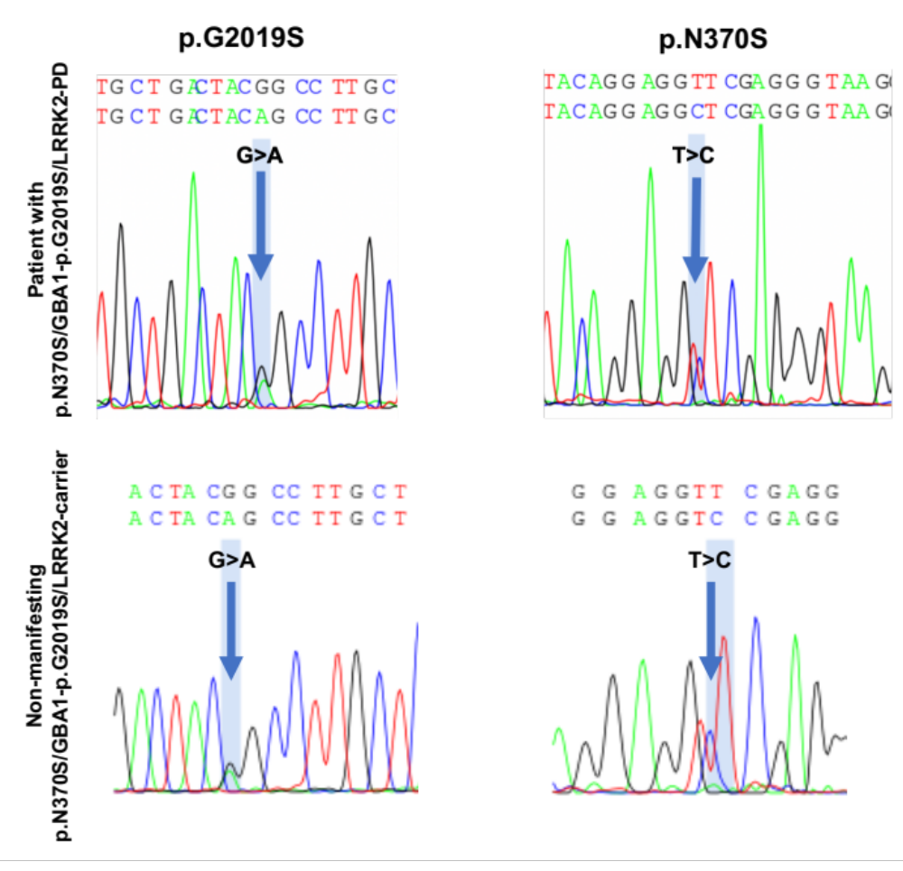
Supplementary Fig. 1. Graphical image (electropherogram) of the nucleotide sequence of the LRRK2 gene and the GBA1 gene in a patient with p.N370S/GBA1-p.G2019S/LRRK2-PD and non-manifesting p.N370S/GBA1-p.G2019S/LRRK2-carrier. Visualization was carried out using the Poly Peak Parser program [39].

