Supplementary Methods
Validation analysis
The selection of the structural resolution parameter$γ$and temporal resolution parameter$ω$is crucial before optimizing the modularity function of the multilayer network (1). The parameter $γ$ controls the size and number of communities within the network layer, with larger $γ$ denotes more communities. The parameter $ω$ controls the number of communities across layers; larger $ω$ = fewer communities. To exclude the interfering factors of the parameter settings on the results. We repeated the analysis with different values for parameters $γ∈$(0.95, 1, 1.05) and $ω∈$ (0.95, 1, 1.05) of the multilayer modularity algorithm. Similarly, we optimized the modularity function 50 times for each pair of parameters.

Supplementary Results
Demographic characteristics
Supplementary Table 1: Baseline characteristics of participants
 | Mild-to-moderate deficits  (N =30) | Severe motor deficits  (n=16) | Healthy controls  (N = 35) | p value
Age (years) | 59.97 ± 11.10 | 60.06 ± 9.74 | 56.90 ± 5.45 | 0.333
Gender (male/female) | 23/7 | 11/5 | 18/13 | 0.307
Module Allegiance Matrix
Tables 2-4 represented the values of module loyalty for each group.
Supplementary Table 2: MAM of HCs
Mild-to-moderate deficits | SMN | VN | AN | DMN | SN
SMN | 0.64926688 | 0.355749 | 0.35676119 | 0.1885401 | 0.38717203
VN | 0.355749 | 0.6251084 | 0.28099543 | 0.36185631 | 0.34450228
AN | 0.35676119 | 0.28099543 | 0.54191517 | 0.40314339 | 0.33614177
DMN | 0.1885401 | 0.36185631 | 0.40314339 | 0.6293854 | 0.3757149
SN | 0.38717203 | 0.34450228 | 0.33614177 | 0.3757149 | 0.45793546
Supplementary Table 3: MAM of stroke with mild-to-moderate motor deficits
Mild-to-moderate deficits | SMN | VN | AN | DMN | SN
SMN | 0.53629641 | 0.36417094 | 0.33903527 | 0.23019149 | 0.34026654
VN | 0.36417094 | 0.62397098 | 0.26828824 | 0.31526707 | 0.31465089
AN | 0.33903527 | 0.26828824 | 0.48680498 | 0.38392294 | 0.3350491
DMN | 0.23019149 | 0.31526707 | 0.38392294 | 0.54432677 | 0.35256808
SN | 0.34026654 | 0.31465089 | 0.3350491 | 0.35256808 | 0.42974417
Supplementary Table 4: MAM of stroke with severe motor deficits
Severe deficits | SMN | VN | AN | DMN | SN
SMN | 0.55686364 | 0.3459305 | 0.38160586 | 0.23895085 | 0.36245007
VN | 0.3459305 | 0.61474286 | 0.3091099 | 0.35790686 | 0.31833063
AN | 0.38160586 | 0.3091099 | 0.47632219 | 0.3599274 | 0.33985813
DMN | 0.23895085 | 0.35790686 | 0.3599274 | 0.55851639 | 0.34687711
SN | 0.36245007 | 0.31833063 | 0.33985813 | 0.34687711 | 0.46037839

Tables 5-7 showed the comparison of module loyalty of networks within each group. Independent sample t test was used for statistical analysis. After correction of false discovery rate, p < 0.05 was considered statistically significant.
Supplementary Table 5: Comparison of module loyalty in HC group
 | SMN-SMN | VN-VN | AN-AN | DMN-DMN | SN-SN
SMN-VN | 1.5*10⁻¹⁴ | 1.5*10⁻¹¹ | 4.8*10⁻⁹ | 2.7*10⁻¹² | 1.0*10⁻⁴
SMN-AN | 1.8*10⁻¹⁷ | 2.4*10⁻¹³ | 1.7*10⁻¹¹ | 2.2*10⁻¹⁴ | 1.6*10⁻⁶
SMN-DMN | 3.8*10⁻²⁸ | 4.7*10⁻²³ | 6.5*10⁻²⁵ | 1.8*10⁻²⁴ | 5.1*10⁻²⁴
SMN-SN | 5.5*10⁻¹⁸ | 4.1*10⁻¹³ | 1.6*10⁻¹¹ | 2.4*10⁻¹⁴ | 7.2*10⁻⁶
VN-AN | 1.1*10⁻²¹ | 2.5*10⁻¹⁷ | 6.8*10⁻¹⁷ | 1.7*10⁻¹⁸ | 3.0*10⁻¹³
VN-DMN | 6.6*10⁻¹⁵ | 1.1*10⁻¹¹ | 3.2*10⁻⁹ | 1.7*10⁻¹² | 1.0*10⁻⁴
VN-SN | 8.0*10⁻²¹ | 1.2*10⁻¹⁵ | 3.5*10⁻¹⁵ | 5.6*10⁻¹⁷ | 8.8*10⁻¹¹
AN-DMN | 7.0*10⁻¹⁴ | 2.3*10⁻¹⁰ | 1.4*10⁻⁷ | 3.2*10⁻¹¹ | 0.008
AN-SN | 1.0*10⁻²¹ | 2.6*10⁻¹⁶ | 2.5*10⁻¹⁶ | 1.0*10⁻¹⁷ | 1.8*10⁻¹²
DMN-SN | 2.1*10⁻¹⁸ | 1.6*10⁻¹³ | 4.1*10⁻¹² | 9.1*10⁻¹⁵ | 1.0*10⁻⁶
Supplementary Table 6: Comparison of module loyalty in mild-to-moderate motor deficits group
 | SMN-SMN | VN-VN | AN-AN | DMN-DMN | SN-SN
SMN-VN | 3.7*10⁻⁵ | 1.9*10⁻⁷ | 0.4*10⁻⁴ | 8.8*10⁻⁶ | 0.015
SMN-AN | 1.1*10⁻⁶ | 6.1*10⁻⁹ | 6.4*10⁻⁶ | 1.3*10⁻⁷ | 7.3*10⁻⁵
SMN-DMN | 1.9*10⁻⁹ | 5.2*10⁻¹¹ | 2.7*10⁻⁹ | 2.3*10⁻¹⁰ | 1.4*10⁻⁹
SMN-SN | 3.0*10⁻⁷ | 2.1*10⁻⁹ | 1.2*10⁻⁶ | 2.7*10⁻⁸ | 2.1*10⁻⁶
VN-AN | 8.7*10⁻⁸ | 1.3*10⁻⁹ | 3.5*10⁻⁷ | 1.5*10⁻⁸ | 1.2*10⁻⁶
VN-DMN | 9.8*10⁻⁶ | 8.6*10⁻⁸ | 9.1*10⁻⁵ | 2.6*10⁻⁶ | 0.002
VN-SN | 2.4*10⁻⁷ | 2.2*10⁻⁹ | 1.1*10⁻⁶ | 3.2*10⁻⁸ | 4.8*10⁻⁶
AN-DMN | 1.8*10⁻⁵ | 6.7*10⁻⁸ | 0.2*10⁻⁴ | 2.7*10⁻⁶ | 0.009
AN-SN | 2.5*10⁻⁷ | 1.9*10⁻⁹ | 8.0*10⁻⁷ | 2.1*10⁻⁸ | 7.0*10⁻⁷
DMN-SN | 9.8*10⁻⁷ | 6.2*10⁻⁹ | 7.1*10⁻⁶ | 1.2*10⁻⁷ | 4.4*10⁻⁵

Table 7: Comparison of module loyalty in severe motor deficits group
 | SMN-SMN | VN-VN | AN-AN | DMN-DMN | SN-SN
SMN-VN | 7.0*10⁻¹⁰ | 7.4*10⁻¹³ | 7.9*10⁻⁸ | 2.0*10⁻¹⁰ | 3.7*10⁻⁷
SMN-AN | 2.4*10⁻⁸ | 1.6*10⁻¹¹ | 7.6*10⁻⁶ | 7.1*10⁻⁹ | 4.5*10⁻⁵
SMN-DMN | 6.0*10⁻¹⁷ | 1.7*10⁻¹⁹ | 4.6*10⁻¹⁹ | 7.7*10⁻¹⁸ | 1.3*10⁻¹⁹
SMN-SN | 9.4*10⁻¹¹ | 4.7*10⁻¹⁴ | 5.5*10⁻¹⁰ | 1.6*10⁻¹¹ | 1.2*10⁻⁹
VN-AN | 7.2*10⁻¹³ | 8.2*10⁻¹⁶ | 4.6*10⁻¹³ | 1.2*10⁻¹³ | 5.7*10⁻¹³
VN-DMN | 5.7*10⁻⁸ | 1.0*10⁻¹⁰ | 2.2*10⁻⁵ | 2.4*10⁻⁸ | 1.0*10⁻⁴
VN-SN | 2.3*10⁻¹¹ | 2.9*10⁻¹⁴ | 4.4*10⁻¹⁰ | 5.7*10⁻¹² | 1.0*10⁻⁹
AN-DMN | 4.5*10⁻¹¹ | 2.6*10⁻¹⁴ | 1.4*10⁻¹⁰ | 8.4*10⁻¹² | 1.7*10⁻¹⁰
AN-SN | 1.9*10⁻¹² | 1.2*10⁻¹⁵ | 2.2*10⁻¹³ | 2.4*10⁻¹³ | 5.7*10⁻¹⁴
DMN-SN | 4.9*10⁻¹¹ | 2.8*10⁻¹⁴ | 3.7*10⁻¹⁰ | 7.8*10⁻¹² | 1.1*10⁻⁹

Validation analysis
The results of the correlation analysis indicate that the results of the dynamic indicators obtained with different $γ$ and $ω$ parameter settings are closely correlated, suggesting that the main results are robust (Supplementary Figure 1-2).
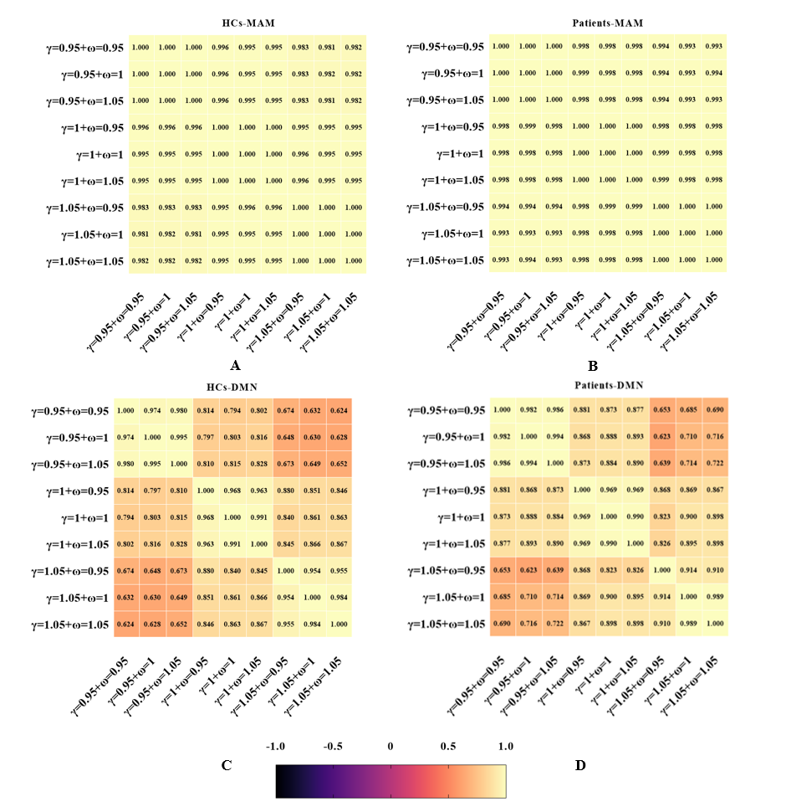
Supplementary Figure 1. Pearson correlation analysis between flexibility and MAM obtained from different parameter combinations. A-B: MAM; C-D: flexibility. The value in the heat map indicates the degree of correlation, and the color bar also indicates the degree of correlation, in which the light colors represent positive correlations, and the lighter color represents the higher degree of correlation. Abbreviations: HCs = Health Controls; MAM: Module loyalty matrix; DMN: Default mode network.
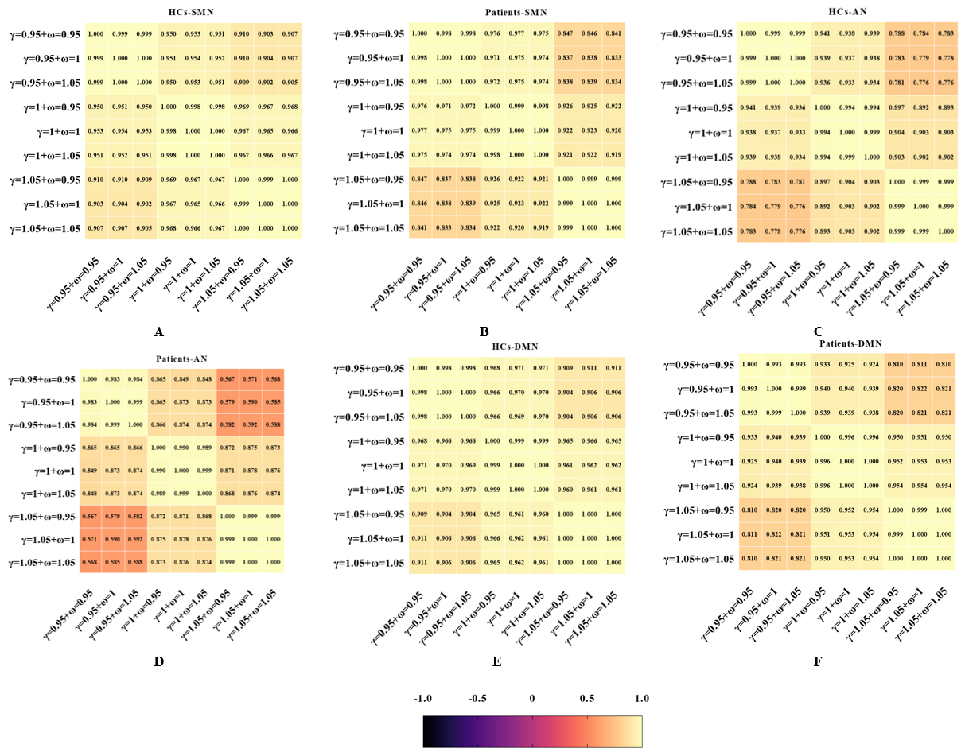
Supplementary Figure 2. Pearson correlation analysis between recruitment obtained from different parameter combinations. The value in the heat map indicates the degree of correlation, and the color bar also indicates the degree of correlation, in which the light colors represent positive correlations, and the lighter color represents the higher degree of correlation. Abbreviations: HCs = Health Controls; SMN: Sensorimotor network; DMN: Default mode network; AN: Attention network.

Results of regression analyses to remove the ceiling effect
To avoid a ceiling effect (2), patients with no lower limb motor function impairment (FMA-L= 34 points) were not included in the regression analyses. Significant predictive relationships were still shown in patients with mild to moderate motor impairment, suggesting that the main results were stable and not significantly affected by the ceiling effect (See Supplementary Figure 3).

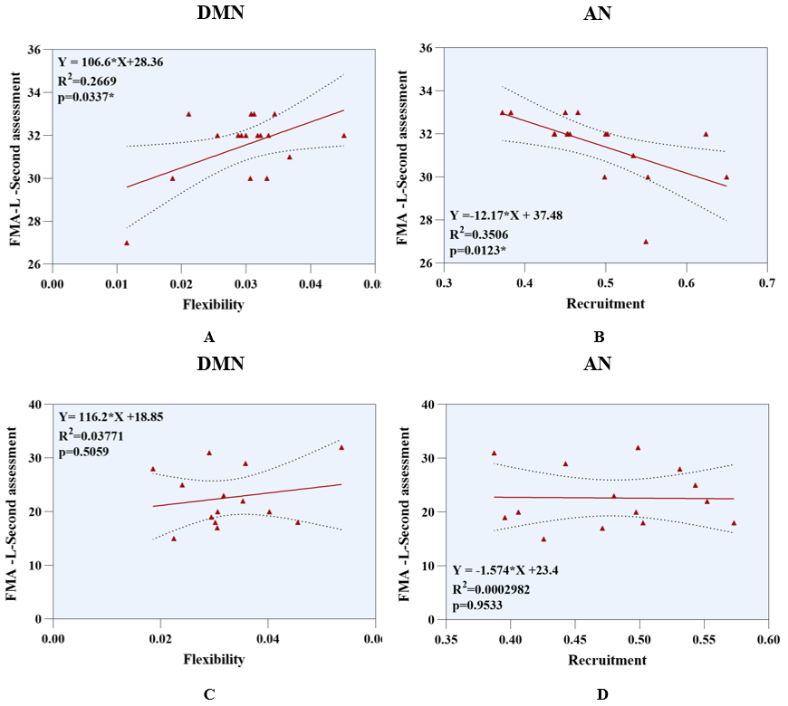
Supplementary Figure 3. Results of the regression analysis to remove the ceiling effect. A: Increased flexibility of DMN after stroke is predictive of improvement in lower limb motor function in patients with mild-to-moderate motor impairment. B: Higher recruitment coefficients of AN represent worse lower limb prognosis in patients with mild-to-moderate motor deficits. C-D: No association was found between dynamic indicators and lower limb motor outcomes in patients with severe motor impairment after stroke. Abbreviations: DMN: Default mode network; AN: Attention network.

Supplementary References
- Mucha PJ, Richardson T, Macon K, Porter MA, Onnela JP. Community structure in time-dependent, multiscale, and multiplex networks. Science. (2010) 328:876-878. doi: 10.1126/science.1184819.
- Gladstone DJ, Danells CJ, Black SE. The Fugl-Meyer assessment of motor recovery after stroke: a critical review of its measurement properties. Neurorehabil Neural Repair. (2002) 16: 232-240. doi: 10.1177/154596802401105171.

