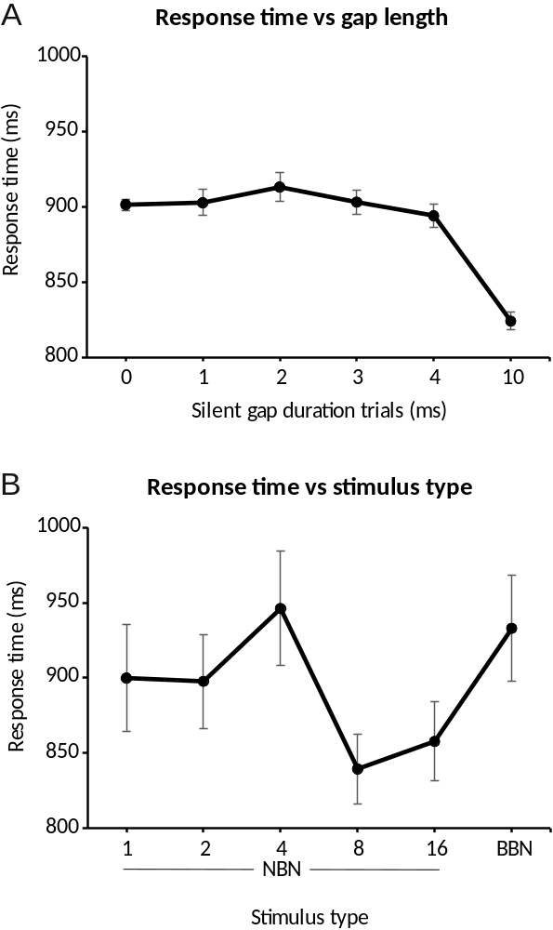

Supplementary Fig. 1. Response times on the gap detection task. (A), mean ± SE response times for different gap duration trials across all participants (n = 18) and all stimulus types. (B), mean ± SE response times for different stimulus types trials across all participants (n = 18) and all gap duration trials.

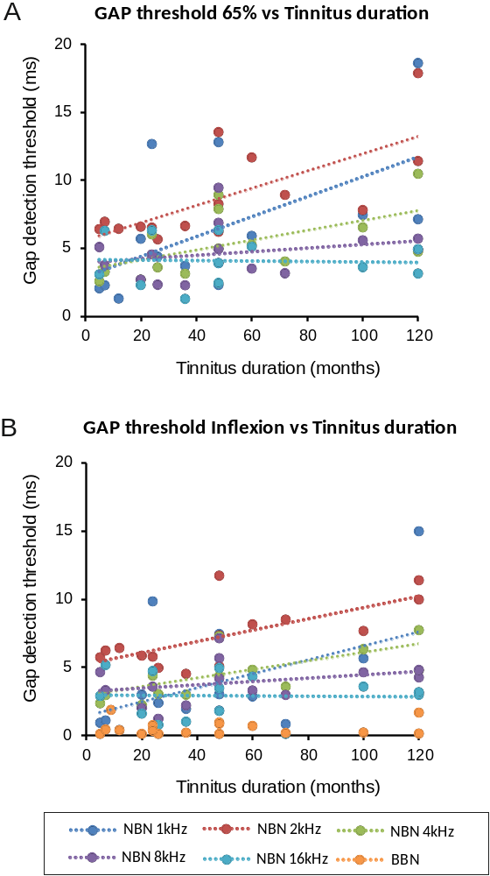

Supplementary Fig. 2. Correlation between Gap detection thresholds and tinnitus suffering duration. (A), Threshods at 65% performance. Spearman’s Coefficient (rho); p-value NBN 1kHz 0.683, p = 0.007; NBN 2kHz 0.691, p = 0.004; NBN 4kHz 0.645, p = 0.013; NBN 8kHz 0.331, p = 0.27; NBN 16kHz 0.116, p = 0.72. (B) Thresholds at 65% performance. NBN 1kHz 0.506, p = 0.054; NBN 2kHz 0.644, p = 0.01; NBN 4kHz 0.747, p = 0.002; NBN 8kHz 0.309, p = 0.28; NBN 16kHz -0.026, p = 0.93; BBN 0.107; p = 0.68.

