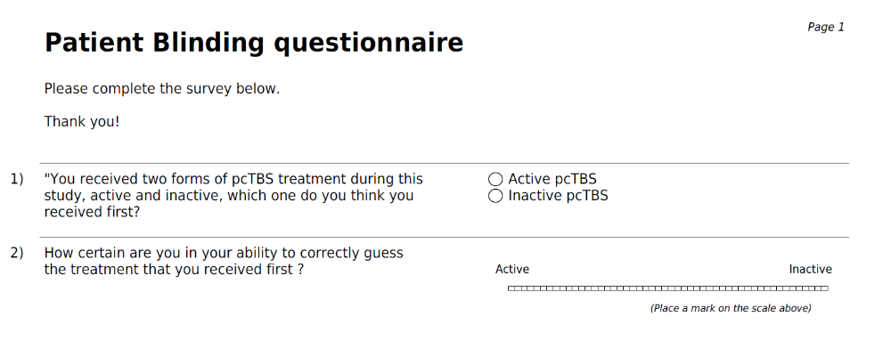Figure 1. The blinding survey . The patient blinding questionnaire was completed electronically by all the study participants after the study session was completed.

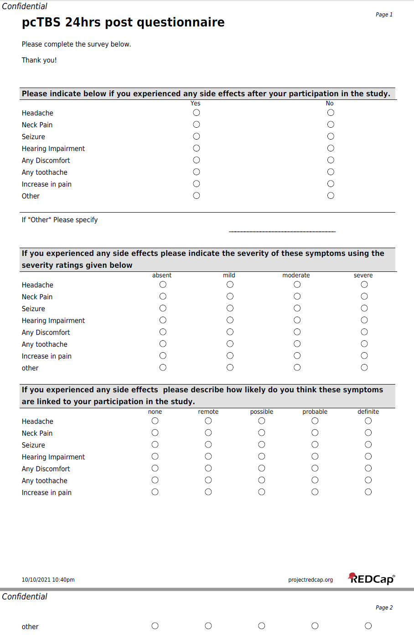
Figure 2 Safety Questionnaire. 24 hours after the study session was completed , all the study participants completed the safety questionnaire electronically.

