Supplementary Results
A 3-way ANOVA was conducted on the factors of time (pre vs. post), location (frontal, central, parietal, occipital), and group (tRNS vs. sham) across all frequency bands. In terms of main effects, there was a main effect of location in all four frequencies: theta (F(1.332,62.592) = 162.135, p < 0.001, η²_{p} = 0.775), alpha (F(1.563,73.481) = 18.488, p < 0.001, η²_{p} = 0.282), beta (F(1.533,72.043) = 4.911, p = 0.017, η²_{p} = 0.095), as well as gamma (F(1.294,60.799) = 22.794, p < 0.001, η²_{p} = 0.327). For time, there was a significant effect of time in alpha frequency only (theta: F(1,47) = 1.254, p = 0.269, η²_{p} = 0.026; alpha: F(1,47) = 5.187, p = 0.027, η²_{p} = 0.099; beta: F(1,47) = 2.291, p = 0.137, η²_{p} = 0.046; gamma: F(1,47) = 0.935, p = 0.339, η²_{p} = 0.019). And for group, there was a significant effect of group only in gamma band (theta: F(1,47) = 0.015, p = 0.903, η²_{p} = 3.164 e⁻⁴; alpha: F(1,47) = 0.093, p = 0.762, η²_{p} = 0.002; beta: F(1,47) = 1.898, p = 0.175, η²_{p} = 0.039; gamma: F(1,47) = 4.063, p =0.05, η²_{p} = 0.080).
For interactions, there was a significant interaction between time and location in theta band only (theta: F(1.634,76.806) = 4.384, p = 0.022, η²_{p} = 0.085; alpha: F(1.868,87.808) = 1.905, p = 0.158, η²_{p} = 0.039; beta: F(1.804,84.777) = 0.895, p = 0.403, η²_{p} = 0.019; gamma: F(1.819,85.512) = 1.973, p = 0.149, η²_{p} = 0.040), and interaction between location and group in theta, alpha, and gamma bands (theta: F(1.332,62.592) = 4.713, p = 0.024, η²_{p} = 0.091; alpha: F(1.563,73.481) = 3.948, p = 0.033, η²_{p} = 0.077; beta: F(1.533,72.043) = 2.398, p = 0.111, η²_{p} = 0.049; gamma: F(1.294,60.799) = 9.773, p = 0.001, η²_{p} = 0.172). There was no interaction between time and group (theta: F(1,47) = 0.629, p = 0.432, η²_{p} =0.013; alpha: F(1,47) = 2.554, p = 0.117, η²_{p} = 0.052; beta: F(1,47) = 2.384, p = 0.129, η²_{p} = 0.048; gamma: F(1,47) = 2.538, p =0.118, η²_{p} = 0.051). The 3-way interaction was also not significant (theta: F(1.634,76.806) = 1.424, p = 0.246, ƞ_{p}² < 0.001; alpha: F(1.868,87.808) = 1.540, p = 0.221, ƞ_{p}² < 0.001 beta: F(1.804,84.777) = 0.174, p = 0.818, ƞ_{p}² < 0.001 gamma: F(3.000,141.000) = 0.418, p = 0.284, ƞ_{p}² < 0.001).
The most important variable (“time” by “group”) is also not significant in all four frequency bands either (theta: F(1,47) = 0.629, p = 0.432, ƞ_{p}² < 0.001; alpha: F(1,47) = 2.554, p = 0.117, ƞ_{p}² = 0.001; beta: F(1,47) = 2.384, p = 0.129, ƞ_{p}² = 0.002; gamma: F(1,47.000) = 2.171, p = 0.118, ƞ_{p}² = 0.003). Together, these results suggest that tRNS does not really modulate EEG oscillations when participants are not actively engaged in a cognitive task (Supplementary Figure).
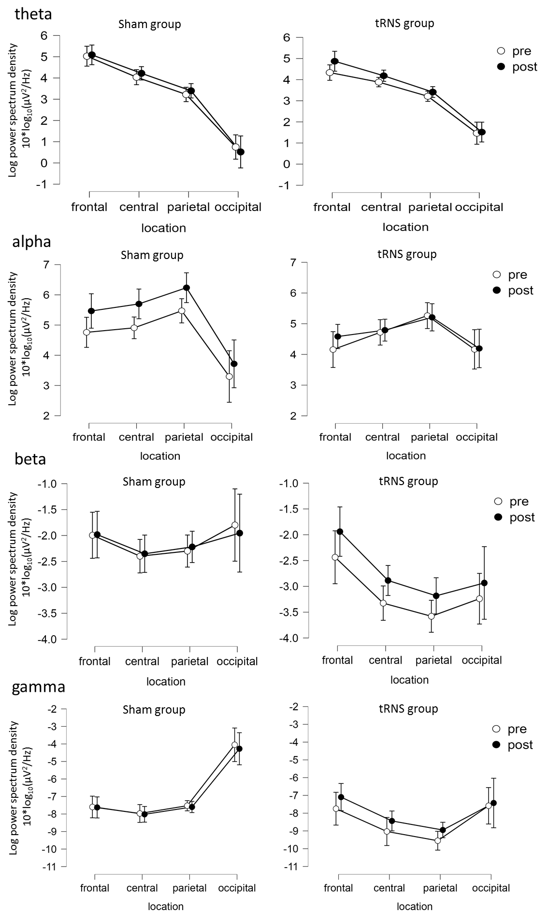
Supplementary Fig. 1: EEG changes by different frequency bands. Locations are shown on the X axis, log power spectrum density is shown on the Y axis. Pre- and post-tRNS power are denoted by open and solid circles, respectively. The interaction between time (pre vs. post) and group (sham vs. tRNS) was not significant in all four frequency bands.

