Tests of Normality for Demographic Data
Two tests of normality, Kolmogorov-Smirnov and Shapiro-Wilk, were conducted for the demographic data for both cases and controls. The null hypothesis of both tests states that the data is taken from normally distributed data, therefore a p-value >0.05 (displayed as ‘Sig.’ in this table from SPSS calculations) confirms this null hypothesis of normal distribution.
As demonstrated in the table below, ‘Birth Gestational Age’ and ‘Age at EEG’ showed data with a non-normal distribution (Sig, <0.05). The ‘Age at EEG’ data was log-transformed to normality so a parametric significance test (Two-sample T-test) was then used to compare the two groups. Median and Range were still used as the most useful descriptive statistics given the skew of the data. The ‘Birth Gestational Age’ data was not able to be transformed to normality and so Median, Range and Mann-Whitney U tests were used for statistical analysis.
Both ‘Corrected Gestational Age’ and ‘Birth Weight’ show some borderline significance (Sig. close to 0.05), particularly in the case group, with different results seen between the two normality tests. Overall, we assessed the tests to suggest normally distributed data and so Mean, standard deviation and a Two-sample T-test were used for statistical analysis.
Visual inspection of histograms and Q-Q plots was also used to confirm the data distribution.

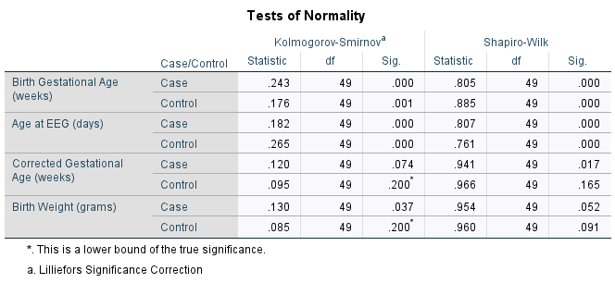
Supplementary Material Table 1 – Tests of Normality

Persyst Seizure Detector Settings
The Persyst neonatal SDA settings can be adapted for each centre, with adjustments according to the standard montages in use. We used four different settings in this study. Channel mapping of similarly placed electrodes was required to adapt GOSH cEEG recordings to match montages recognised by the seizure detector and give it as much information as possible (see Fig. 1 below). The neonatal SDA was run on five randomly selected case and control cEEG recordings initially to test the channel mapping and study settings, before processing each case and control cEEG clip. The majority of cEEG clips in both groups used setting 1 (see Fig. 1); 75% of cases and 71% of controls (p = 0.647).
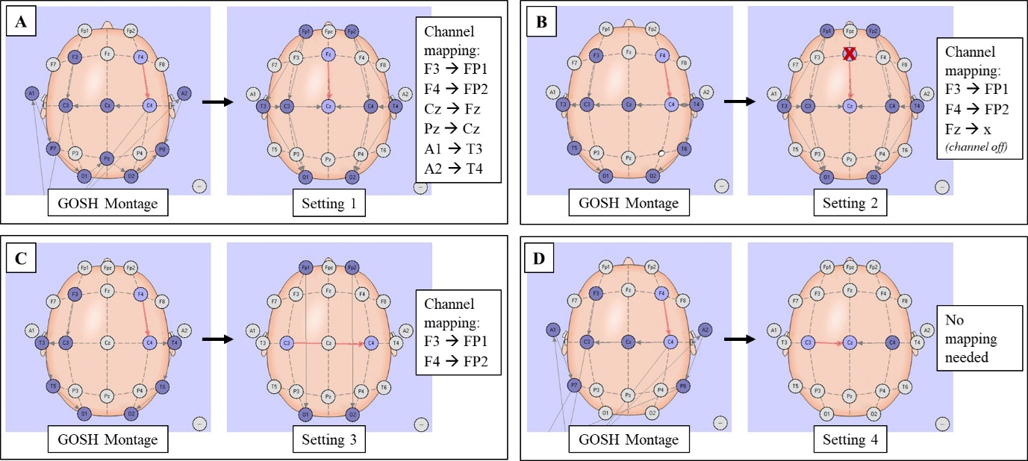
Supplementary Material Fig. 1 - Channel mapping.
Each panel A-D shows how the four montages in clinical use at GOSH montages were adapted to be read by the Persyst neonatal seizure detector. Left of each panel: GOSH montage from recordings. Right of each panel: channel mapping input to produce montages read by Persyst SDA (Settings 1 to 4). Purple electrodes: used in montage. White electrodes: not in use. Red X (Panel B): Fz channel switched off in Setting 2.

Persyst Seizure Detector Output
To select the output trends, the ‘SeizureProbability (Neonatal)’ calculation engine was added and the ‘SeizureProbabilityP14’ and ‘SeizureEventsP14’ trends were selected and displayed in the Persyst trends panel. The ‘SeizureProbabilityP14’ trend produced a graph of seizure probability against time, represented as blue bars in the Persyst trends panel. A data file of the seizure probability at each second of the recording was also downloaded. The ‘SeizureEventsP14’ trend alerts the reviewer to segments where the seizure probability had risen above a user selected threshold, represented as red bars in the Persyst trends panel. Two display options are shown below:
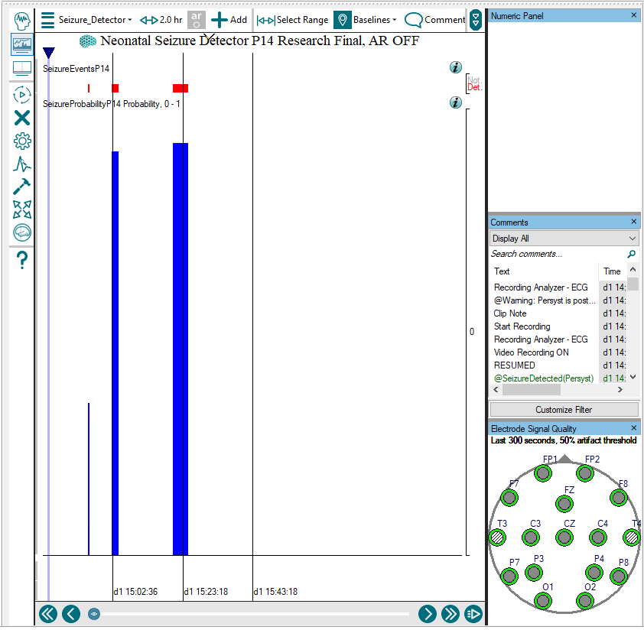
A
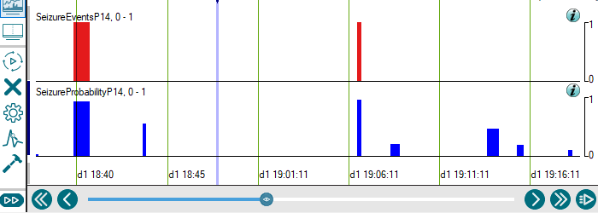
B
Supplementary Material Fig. 2 – Persyst Seizure Detector Output
The Persyst neonatal seizure detector output is displayed with two trends selected – ‘SeizureProbabilityP14’ (blue bars) and ‘SeizureEventsP14’ (red bars). Two different display options are shown (A) and (B).

