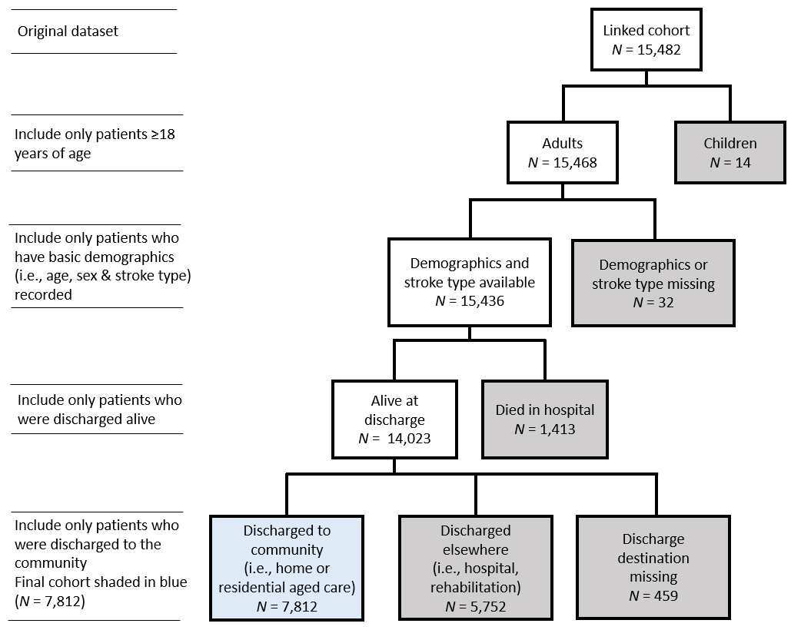
Figure 1. Final cohort selection process. Boxes shaded in grey indicate excluded registrants. TIA, Transient ischaemic attack.

Supplemental Acknowledgements
Co-investigators and other contributors to the Australian Stroke Clinical Registry (does not include authors)
The following people are acknowledged for their contribution to collecting hospital data on the patients registered in AuSCR or their participation on various governance committees:

Steering and Management Committee
Geoffrey Donnan MD (Stroke Division, The Florey Institute of Neuroscience and Mental Health VIC)

Steering Committee
Julie Bernhardt PhD (The Florey Institute of Neuroscience and Mental Health VIC); Paul Bew (The Prince Charles Hospital QLD); Christopher Bladin MD, MBBS, FRACP (Box Hill Hospital VIC, site investigator); Greg Cadigan BN (Queensland State-wide Stroke Clinical Network QLD);
Helen Castley MBBS (Royal Hobart Hospital Tasmania, site investigator); David Dunbabin MBBS FRACP FAFRM (Royal Hobart Hospital, TAS); Anne Gordon (The Royal Children’s Hospital Melbourne VIC); Andrew Granger (Osborne Park Hospital WA); Niall Johnson (Australian Commission on Safety and Quality in Health Care); Erin Lalor PhD (National Stroke Foundation VIC); Andrew Lee MBBS FRACP (Flinders Medical Centre, South Australia); Richard Lindley PhD (The George Institute for Global Health NSW); Mark Mackay MBBS, FRACP (Royal Children’s Hospital VIC, site investigator); Sandra Martyn (Health Statistics Centre Queensland Health QLD); John McNeil PhD (Monash University VIC); Sandy Middleton, PhD (Nursing Research Institute, St Vincent’s Health Australia NSW, Australian Catholic University NSW); Michael Pollack MBBS, FAFRM (RACP), FACRM, FFPM (ANZCA), MMedSci (Clin Epi) (Hunter Stroke Service NSW); Peter Somerford (Public Health Division of the WA Health Department WA); Mark Simcocks BSc (VIC, Consumer Representative); Frances Simmonds MSc(Med), (Australasian Rehabilitation Outcomes Centre NSW)

Management Committee
Steven Faux FAFRM (RACP) (St Vincent’s Health Australia NSW); Kelvin Hill BAppSci (Stroke Foundation VIC); Christopher Price (National Stroke Foundation)

Site Investigators
Pradeep Bambery MD, FRCP(G), FRACP (Bundaberg Hospital QLD); Tim Bates MBBS, FRACP (Swan District Hospital WA); David Blacker MBBS, FRACP (Sir Charles Gairdner Hospital WA); Ernie Butler MBBS FRACP (Peninsula Health VIC); Sean Butler FIMLS, BM Hons, MRCP(UK), FRACP (Prince Charles Hospital QLD); Douglas Crompton MA, PhD, MBBS, FRACP (Northern Hospital VIC); Carolyn De Wytt MRCP (UK), MB BCH DUBL, FRACP (Greenslopes Private Hospital QLD); David Douglas MBBS, M Admin, FRACGP, FAFRM (RACP) (Ipswich Hospital QLD); Martin Dunlop MBBS, FACRM (Cairns Base Hospital QLD); Paula Easton BPhty (Hons) (Mackay Hospital QLD); Sharan Ermel RN (Div1) (Bendigo Health VIC); Nisal Gange MBBS, AMC CERT (Toowoomba Hospital QLD); Richard Geraghty MBBS, FRACP (Redcliffe Hospital QLD); Melissa Gill BAppSc (SpPath) (Armidale Hospital, NSW); Graham Hall MBBS, FRACP (Princess Alexandra Hospital QLD); Geoffrey Herkes MBBS, PhD, FRACP (Royal North Shore Hospital NSW); Karen Hines BHIM (Caboolture Hospital QLD); Francis Hishon RN (Redland Hospital QLD); James Hughes BMed, FRACP (Tamworth Hospital NSW); Joel Iedema MBBS, FRACP (Redland Hospital QLD); Martin Jude MBBS, FRACP (Wagga Wagga Hospital NSW); Paul Laird MBBS, FRACP (Rockhampton Hospital QLD); Graham Mahaffey RN (Hervey Bay Hospital QLD); Suzana Milosevic MD, FRACP, AMC CERT (Logan Hospital QLD); Peter O’Brien MBBS, DIP RANZCOG, FRACMA, FACRRM (Warrnambool Hospital VIC); Stephen Read MBBS, PhD, FRACP (Royal Brisbane and Women’s Hospital QLD); Fiona Ryan BAppSc (SpPath), MHlthSc (Orange Hospital and Bathurst Hospitals NSW); Arman Sabet MD, FRACP, BSc (Gold Coast Hospital and Robina Hospital QLD); Noel Saines MBBS, FRACP (The Wesley Hospital QLD); Eva Salud MD, AMC CERT (Gympie Hospital QLD); Amanda Siller MBBS, FRACP (Queen Elizabeth II Jubilee Hospital QLD); Christopher Staples MD (Mater Adults QLD); Richard White MD, FRCP, FRACP. (Townsville Hospital QLD); Andrew Wong MBBS, PhD (Royal Brisbane and Women’s Hospital QLD)

Staff at The Florey Institute of Neuroscience and Mental Health VIC
Leonid Churilov, Alison Dias, Adele Gibbs, Brenda Grabsch, Francis Kung, Joyce Lim, Karen Moss, Sabrina Small, Renee Stojanovic, Steven Street, Emma Tod

