Supplementary Fig. 1. Risk of bias assessments for included studies:
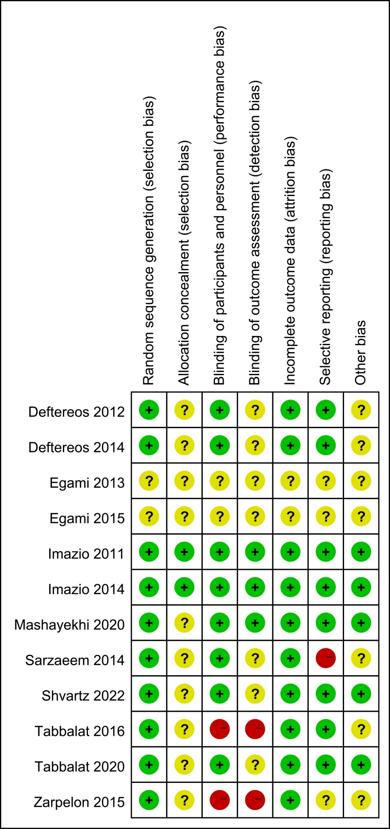
Plus/green suggests low-risk bias, question mark/yellow shows uncertain risk of bias, minus/red indicates a potentially high risk of bias

