Predicting Thromboembolism in Hospitalized Patients with Ventricular Mural Thrombus

Figure and Table Legends 2
Supplementary Figure 3
Supplementary Table 10

Figure and Table Legends
Supplementary Fig. 1. Flow diagram to show the inclusion and exclusion criteria. 498 patients were found with ventricular thrombus and 338 patients were included in the analysis. †Others included 5 patients who had a suspected diagnosis of thrombophilia at discharge. N, numbers of patients.
Supplementary Fig. 2. Changes in 46 factors with the penalty parameter (Lambda).
Supplementary Fig. 3. ROC curves of Model 1 for predicting the risk of thromboembolism. (A) Training set. (B) Validation set. ROC, receiver operating characteristic; AUC, area under the ROC curve.
Supplementary Fig. 4. ROC curves of Model 1 and Model 2 for predicting the risk of thromboembolism. (A) Training set. (B) Validation set. ROC, receiver operating characteristic.
Supplementary Fig. 5. Calibration plots for predicting the risk of thromboembolism in the validation set of Model 1. (A) Training set. (B) Validation set. X-axis, bootstrap-predicted probability; Y-axis, actual probability.
Supplementary Fig. 6. Calibration plots for predicting the risk of thromboembolism in the validation set of Model 2. (A) Training set. (B) Validation set. X-axis, bootstrap-predicted probability; Y-axis, actual probability.
Supplementary Fig. 7. DCA of the novel nomogram for predicting the risk of thromboembolism in Model 1 and Model 2. (A) Training set. (B) Validation set. X-axis, bootstrap-predicted probability; Y-axis, actual probability; DCA, decision curve analysis.
Supplementary Table 1. Main factors at discharge with the reference of baseline value in the training group and validation group
Variables are presented as n (%).
Abbreviations: N, numbers of patients; FDP, fibrin degradation products; NT-proBNP, N-Terminal pro-brain natriuretic peptide.

Supplementary Figure
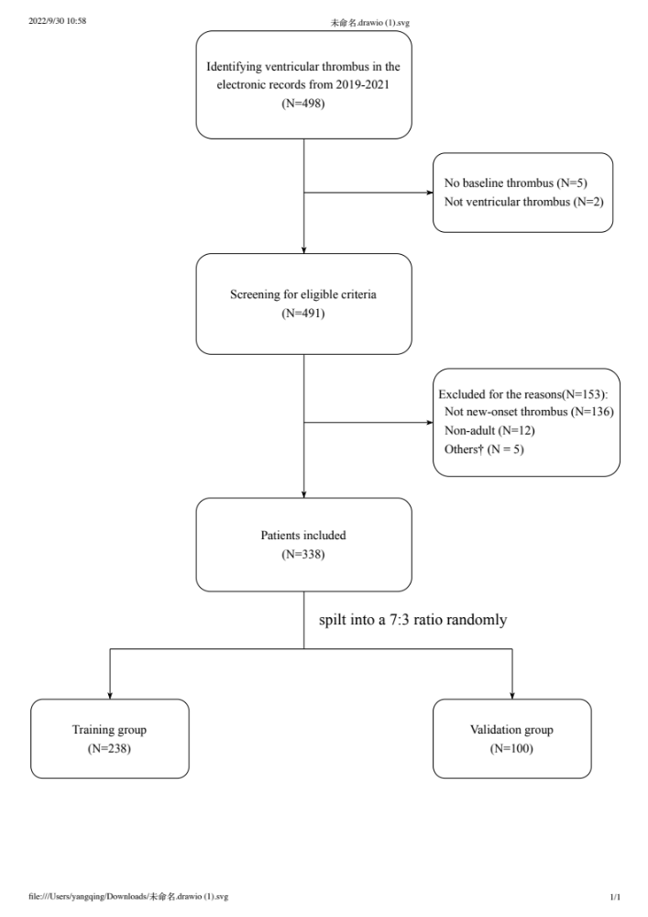

Supplementary Fig. 1. Flow diagram to show the inclusion and exclusion criteria. 498 patients were found with ventricular mural thrombus and 338 patients were included in the analysis. †Others included 5 patients who had a suspected diagnosis of thrombophilia at discharge. N, numbers of patients.

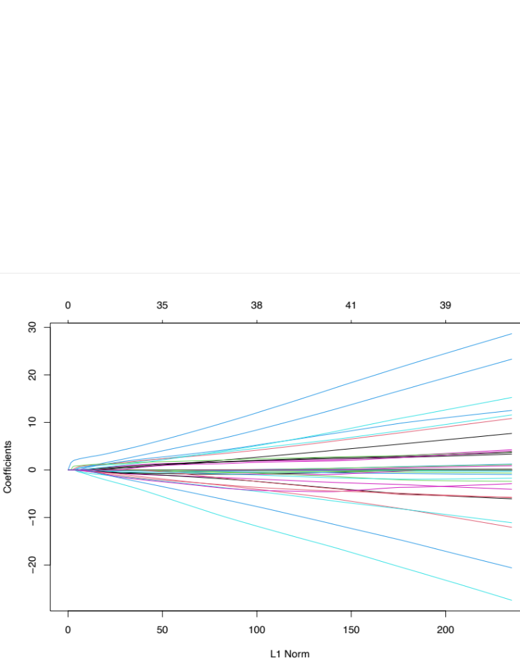
Supplementary Fig. 2. Changes in 46 factors with the penalty parameter (Lambda).

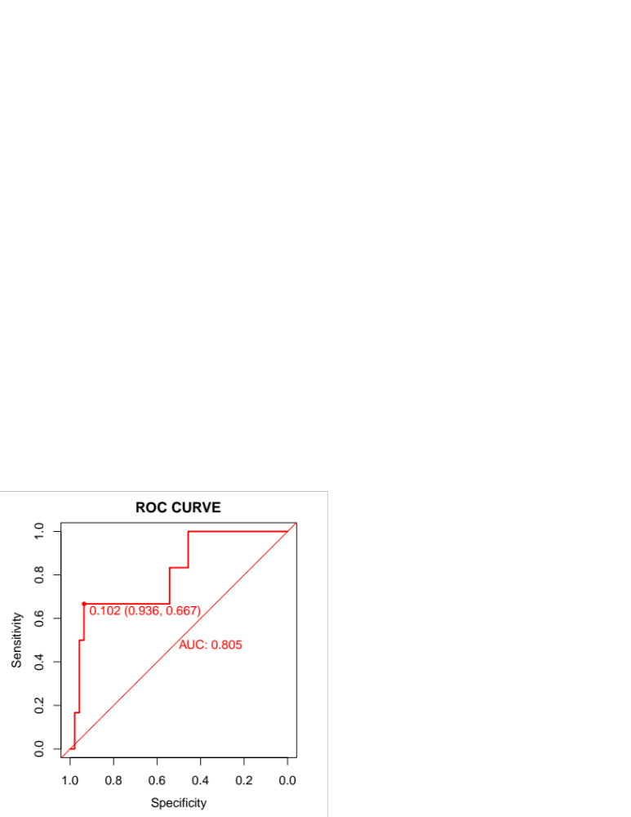
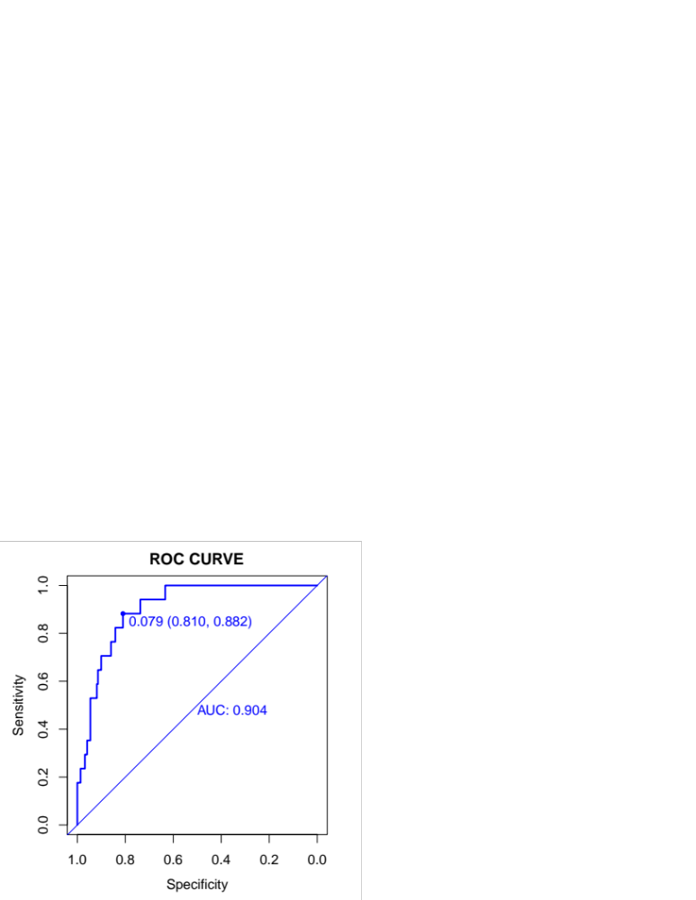
(A)
(B)

Supplementary Fig. 3. ROC curves of Model 1 for predicting the risk of thromboembolism. (A) Training set. (B) Validation set. ROC, receiver operating characteristic; AUC, area under the ROC curve.

(B)
(A)
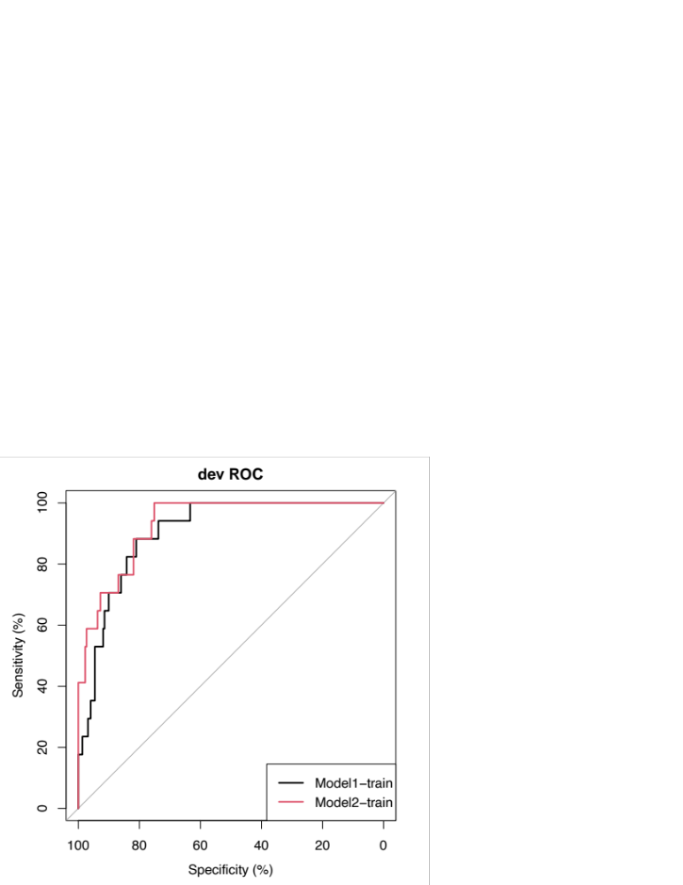
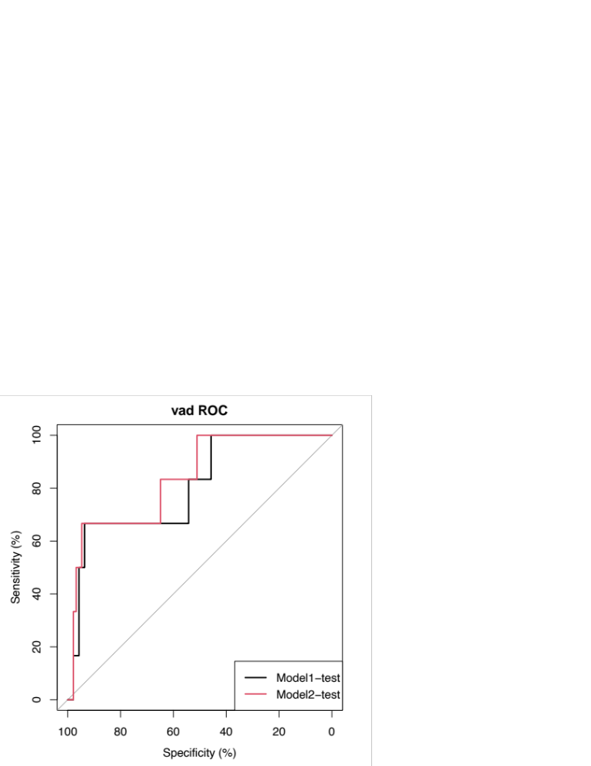

Supplementary Fig. 4. ROC curves of Model 1 and Model 2 for predicting the risk of thromboembolism. (A) Training set. (B) Validation set. ROC, receiver operating characteristic.

(A)
(B)
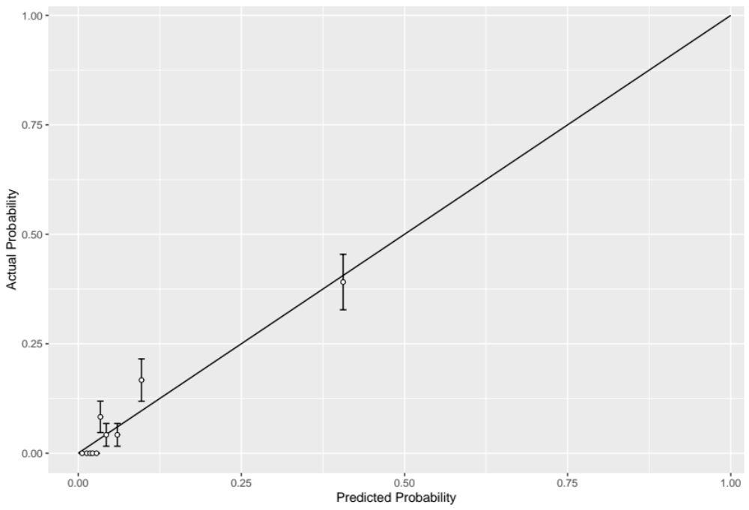

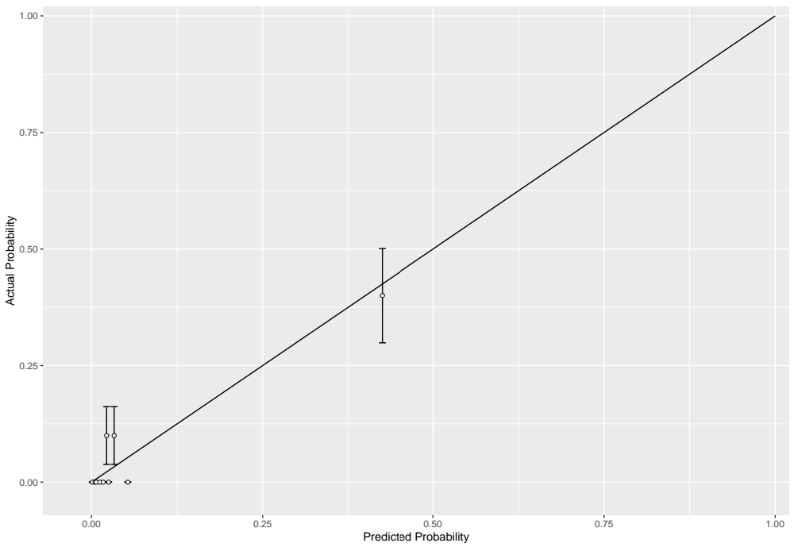

Supplementary Fig. 5. Calibration plots for predicting the risk of thromboembolism in the validation set of Model 1. (A) Training set. (B) Validation set. X-axis, bootstrap-predicted probability; Y-axis, actual probability.

(A)
(B)
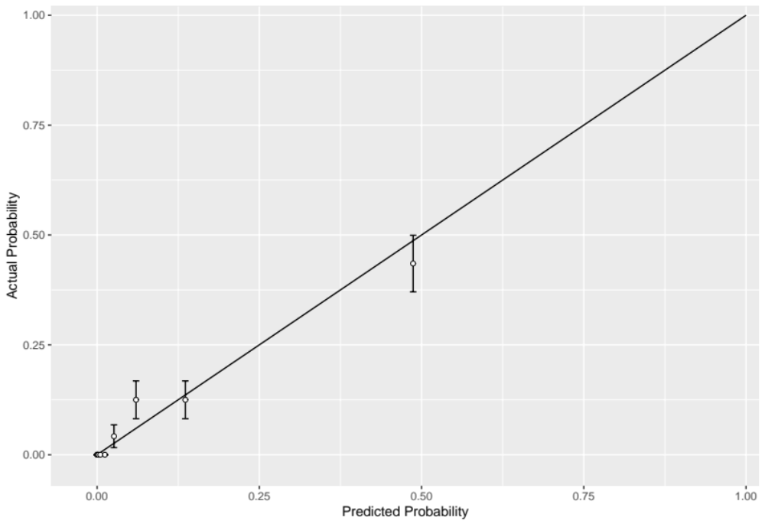

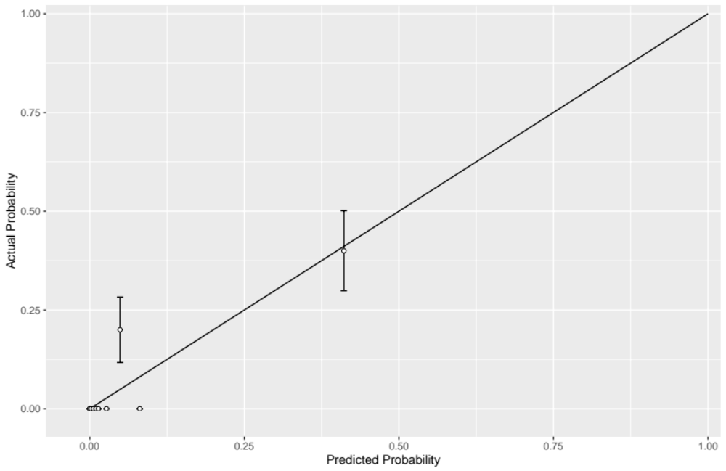

Supplementary Fig. 6. Calibration plots for predicting the risk of thromboembolism in the validation set of Model 2. (A) Training set. (B) Validation set. X-axis, bootstrap-predicted probability; Y-axis, actual probability.

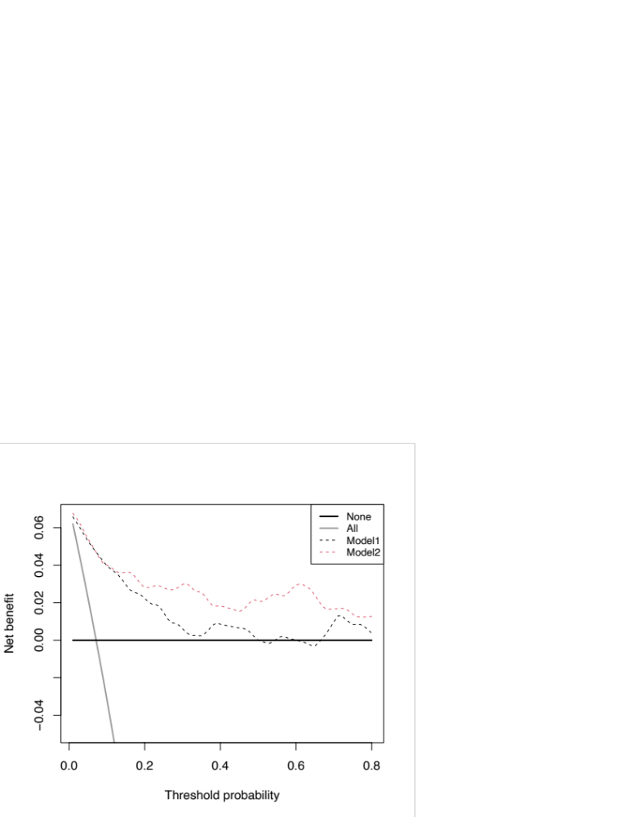
(B)
(A)

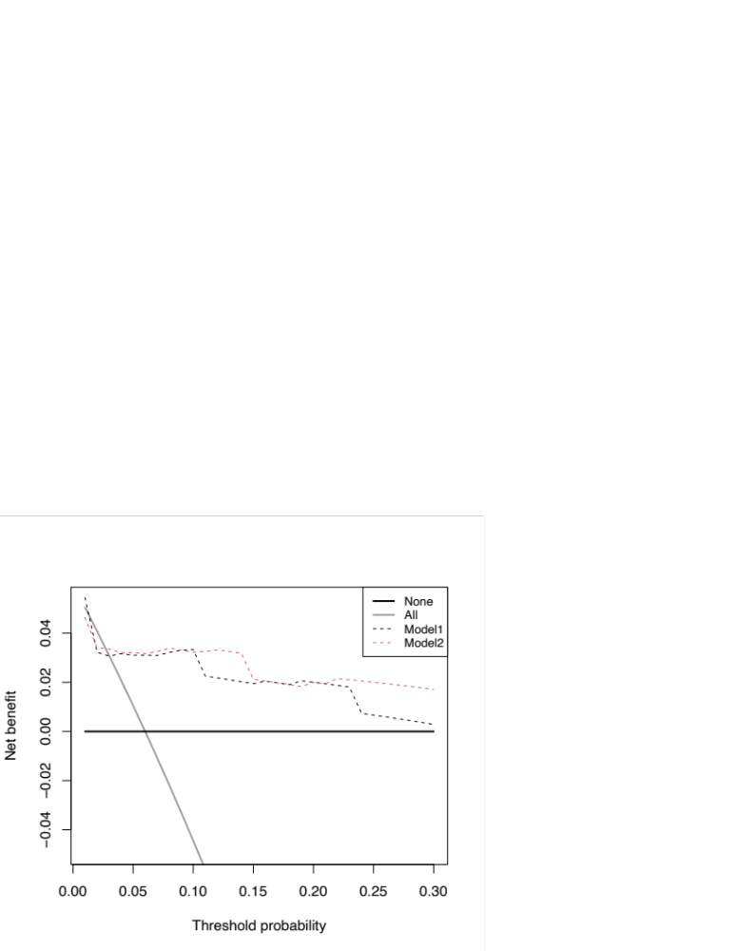

Supplementary Fig. 7. DCA of the novel nomogram for predicting the risk of thromboembolism in Model 1 and Model 2. (A) Training set. (B) Validation set. X-axis, bootstrap-predicted probability; Y-axis, actual probability; DCA, decision curve analysis.

Supplementary Table

Supplementary Table 1. Main factors at discharge with the reference of baseline value in the training group and validation group
 | Total  (N=338) | Training group  (N=238) | Validation group  (N=100) | P value
D-dimer, ug/ml |  |  |  | 0.937
-1 ~ +1fold | 201 (59.5) | 143 (60.1) | 58 (58)
+1fold~ | 42 (12.4) | 29 (12.2) | 13 (13)
~-1fold | 95 (28.1) | 66 (27.7) | 29 (29)
FDP, ug/ml |  |  |  | 0.392
-1 ~ +1fold | 277 (82) | 191 (80.3) | 86 (86)
+1fold~ | 26 (7.7) | 21 (8.8) | 5 (5)
~-1fold | 35 (10.4) | 26 (10.9) | 9 (9)
NT-proBNP, pg/ml |  |  |  | 0.140
-1 ~ +1fold | 177 (52.4) | 122 (51.3) | 55 (55)
+1fold~ | 38 (11.2) | 32 (13.4) | 6 (6)
~-1fold | 123 (36.4) | 84 (35.3) | 39 (39)
Variables are presented as n (%).
Abbreviations: N, numbers of patients; FDP, fibrin degradation products; NT-proBNP, N-Terminal pro-brain natriuretic peptide.

