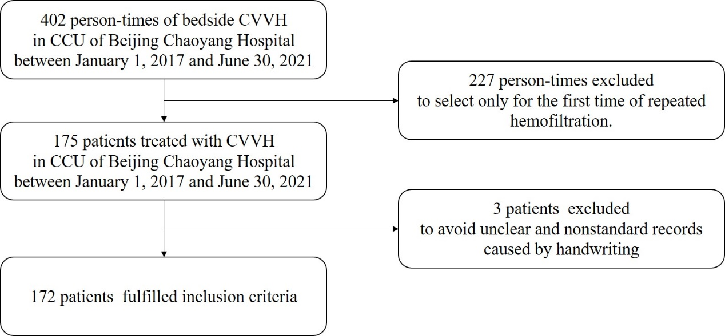
Supplementary Fig. 1. The flow chart of screened patients.

Supplementary Fig. 2. The calibration curve. Hosmer–Lemeshow test (χ2 = 5.032, P value for lack of fit = 0.754).

Supplementary Fig. 3. Decision curve for model.

