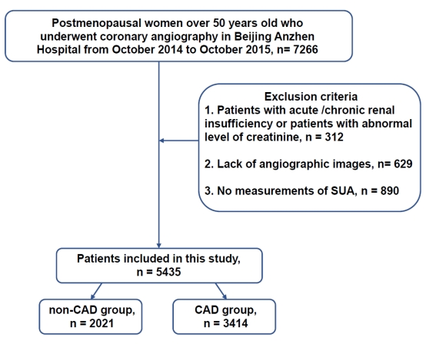
Supplementary Fig. 1. Flow chart.

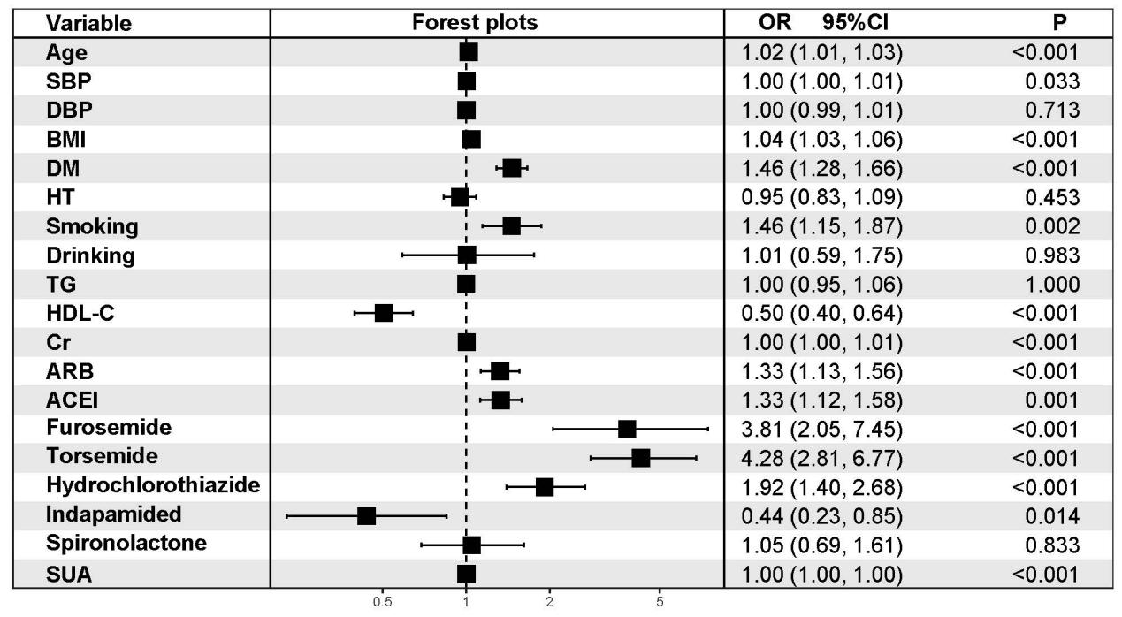
Supplementary Fig. 2. Multivariate logistic regression analyses for SUA (Model 4). SBP, systolic blood pressure; DBP, diastolic blood pressure; BMI, body mass index; DM, diabetes mellitus; HT, hypertension; TG, triglycerides; HDL-C, high density lipoprotein cholesterol; Cr, creatinine; ARB angiotensin receptor blocker, ACEI angiotensin converting enzyme inhibitor; OR, odds ratio; CI, confidence interval; SUA, Serum uric acid.
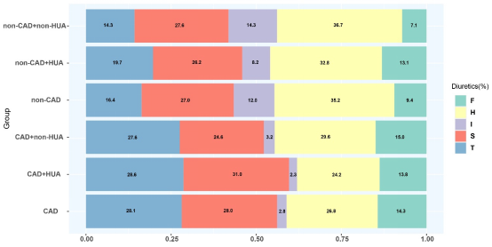
Supplementary Fig. 3. The using ratio of diuretics in the different population. CAD, coronary artery disease; HUA, hyperuricemia; SUA, serum uric acid; F, furosemide; H, hydrochlorothiazide; I, indapamide; S, spironolactone; T, torsemide.

